Knowledge Hub – Redux Architecture Guide
Sep 29, 2026 · @Durai

Overview
KnowledgeHub is a React 19 + TypeScript app that keeps all shared state in one Redux Toolkit store with two slices, auth and articles. Users log in, see dashboard stats, browse articles, open one, and like or favourite it.
Layer | Technology
UI | React 19, TypeScript, Vite
Routing | React Router 7
State management | Redux Toolkit 2.13, react-redux 9.3
HTTP client | axios
Mock API | json-server 0.17 on port 3001, data in data/db.json

Architectural diagram
The app has four layers, and components never call the API directly: they dispatch to the store, and thunks in the store call json-server.
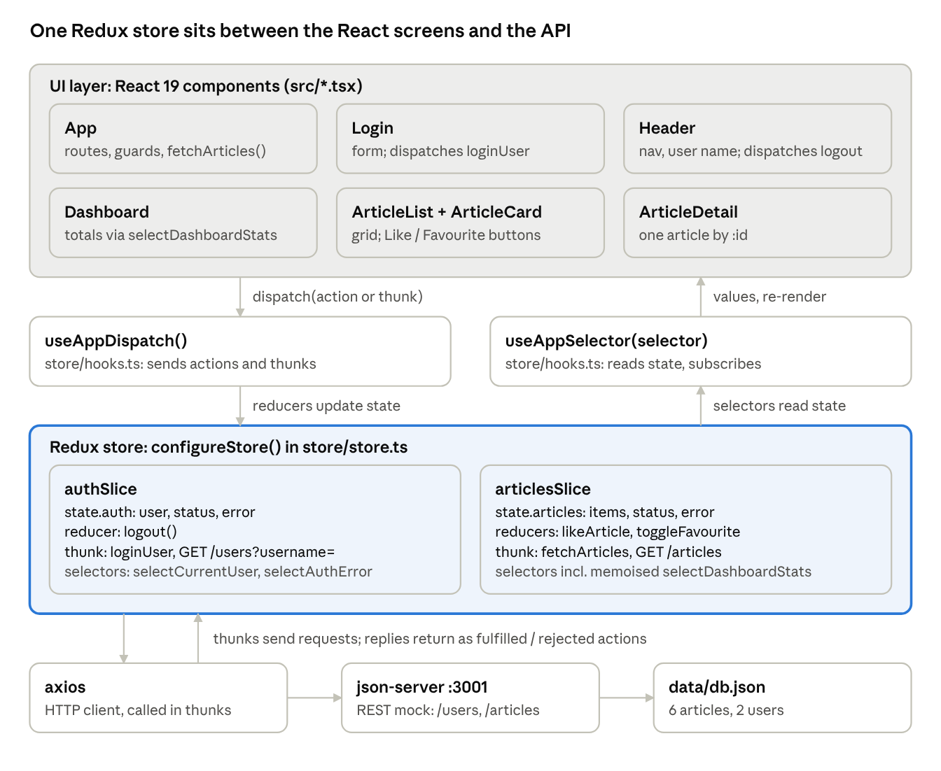
KnowledgeHub architecture · 4 layers
Writes go down the left (dispatch → reducers); reads come up the right (selectors → re-render). Only the two thunks touch the network.

Data flow and user–system flows
Data moves one way: the user acts, a component dispatches, the store updates, and every subscribed component re-renders. Only login and loading articles reach json-server.
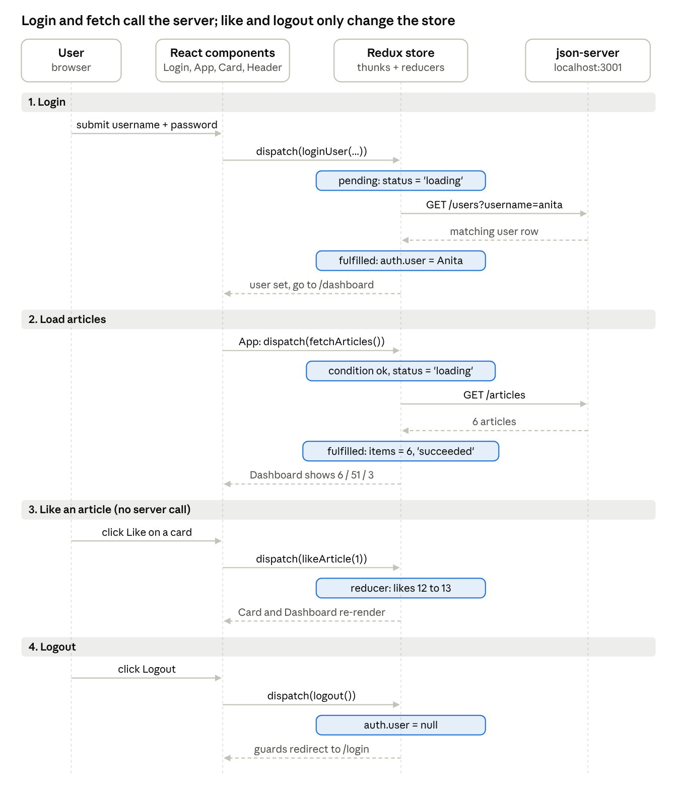
Data flow · login, load, like, logout
Solid arrows are calls; dashed arrows are replies or re-renders. Tinted boxes are the state changes you can watch in Redux DevTools, for example auth/login/pending then auth/login/fulfilled.

User navigation and route guards
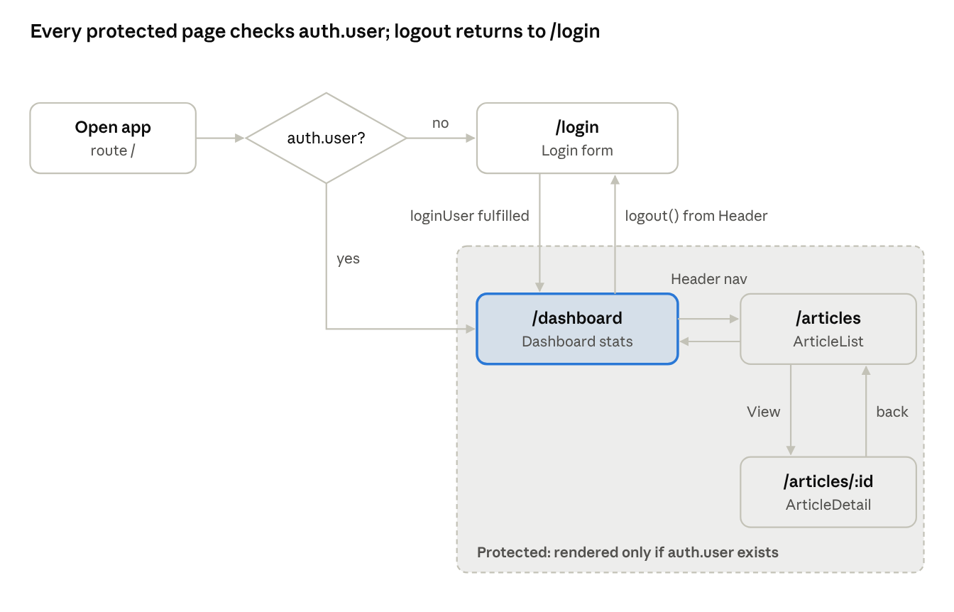
User navigation · route guards in App.tsx
App.tsx re-reads auth.user on every store change, so login and logout redirect without any callback props. Any unknown URL shows NotFound.

Components, hooks and state management
Every component reads from the store with selectors and writes with dispatched actions; only form fields stay in local state.

Components
Component | Route | Reads from store | Dispatches | Local state
App | layout | selectCurrentUser | fetchArticles() once a user exists | none
Login | /login | selectAuthStatus, selectAuthError | loginUser({username, password}) | username, password
Header | shown when logged in | selectCurrentUser | logout() | none
Dashboard | /dashboard | selectCurrentUser, selectArticlesLoading, selectArticlesError, selectDashboardStats | nothing | none
ArticleList | /articles | selectAllArticles, selectArticlesLoading, selectArticlesError | nothing | none
ArticleCard | inside ArticleList | nothing (gets article as a prop) | likeArticle(id), toggleFavourite(id) | none
ArticleDetail | /articles/:id | selectArticleById(state, id), loading, error | likeArticle(id), toggleFavourite(id) | none
Footer, NotFound | all / * | nothing | nothing | none
App, Header and Dashboard take no props; they read what they need from the store. ArticleCard gets its article as a prop because the parent list already has the data.

Hooks
Hook | Source | What it does here
useAppSelector | store/hooks.ts (typed useSelector) | Reads a slice of state; the component re-renders only when that value changes
useAppDispatch | store/hooks.ts (typed useDispatch) | Sends actions and thunks to the store
useEffect | React | In App: triggers fetchArticles() when user becomes non-null
useState | React | In Login: the two form fields
useNavigate | React Router | Login → /dashboard after success; ArticleCard → /articles/:id
useParams | React Router | ArticleDetail reads :id from the URL

State management
The state tree has two branches:
state
├── auth
│ ├── user: User | null
│ ├── status: 'idle' | 'loading' | 'failed'
│ └── error: string | null
└── articles
├── items: Article[]
├── status: 'idle' | 'loading' | 'succeeded' | 'failed'
└── error: string | null
Redux Toolkit piece | Where | Why it is used
configureStore | store/store.ts | Creates the store; adds thunk middleware and DevTools support
createSlice | both slice files | Reducers + auto-generated action creators in one place; Immer allows "mutating" code
createAsyncThunk | loginUser, fetchArticles | Wraps an axios call and dispatches pending / fulfilled / rejected
rejectWithValue | both thunks | Sends a readable error message into state.*.error
condition option | fetchArticles | Skips the request if articles are already loading or loaded; stops StrictMode double fetch
.unwrap() | Login | Lets the form await the thunk and navigate only on success
createSelector | selectDashboardStats | Memoises the three totals so they are recalculated only when items changes
RootState, AppDispatch | store/store.ts | Types inferred from the store, used by the typed hooks
Like and favourite update the store only; nothing is written back to db.json. A natural next exercise is a PATCH /articles/:id thunk.

How to run and project structure
npm install
npm run server # json-server on :3001
npm run dev # Vite on :5173
Login: anita / anita123 or rahul / rahul123. Install the Redux DevTools browser extension to watch each action.
File | Purpose
src/main.tsx | Entry point; wraps the app in <Provider store> and <BrowserRouter>
src/App.tsx | Route table and guards; loads articles after login
src/store/store.ts | configureStore, RootState, AppDispatch
src/store/hooks.ts | Typed useAppDispatch, useAppSelector
src/features/auth/authSlice.ts | Auth state, loginUser thunk, logout, selectors
src/features/articles/articlesSlice.ts | Articles state, fetchArticles thunk, likeArticle, toggleFavourite, selectors
src/Login.tsx, Header.tsx, Dashboard.tsx, ArticleList.tsx, ArticleCard.tsx, ArticleDetail.tsx, Footer.tsx, NotFound.tsx | Components; each file opens with a comment explaining its role
src/types.ts | Article and User types
data/db.json | Mock data: 6 articles, 2 users
Checked on a running build: wrong password shows the error, dashboard shows 6 articles / 51 likes / 3 favourites, a like and a favourite move it to 53 / 4, detail page and logout work, and only one GET /articles fires.

