PROGRAM:

<html>

<head>

<title>exe1</title>

</head>

<body>

<b>WELCOME</b><br>

welcome 2 the webpage......

</body>

</html>

OUTPUT:

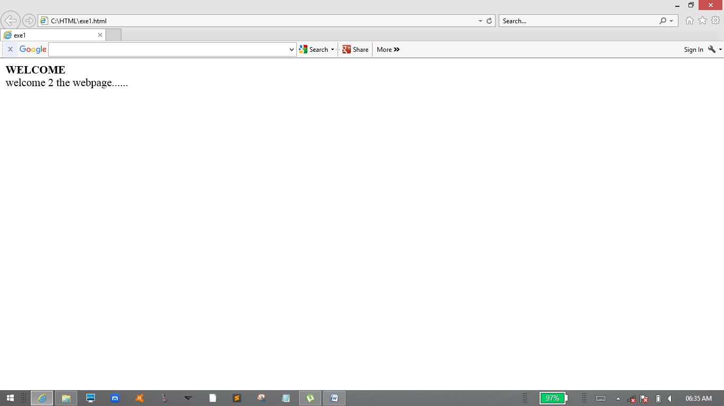

PROGRAM:

<html>

<head>

<title>exe2</title>

</head>

<body>

<h1>HI</h1>

My Name is Durairaj M

</body>

</html>

OUTPUT:

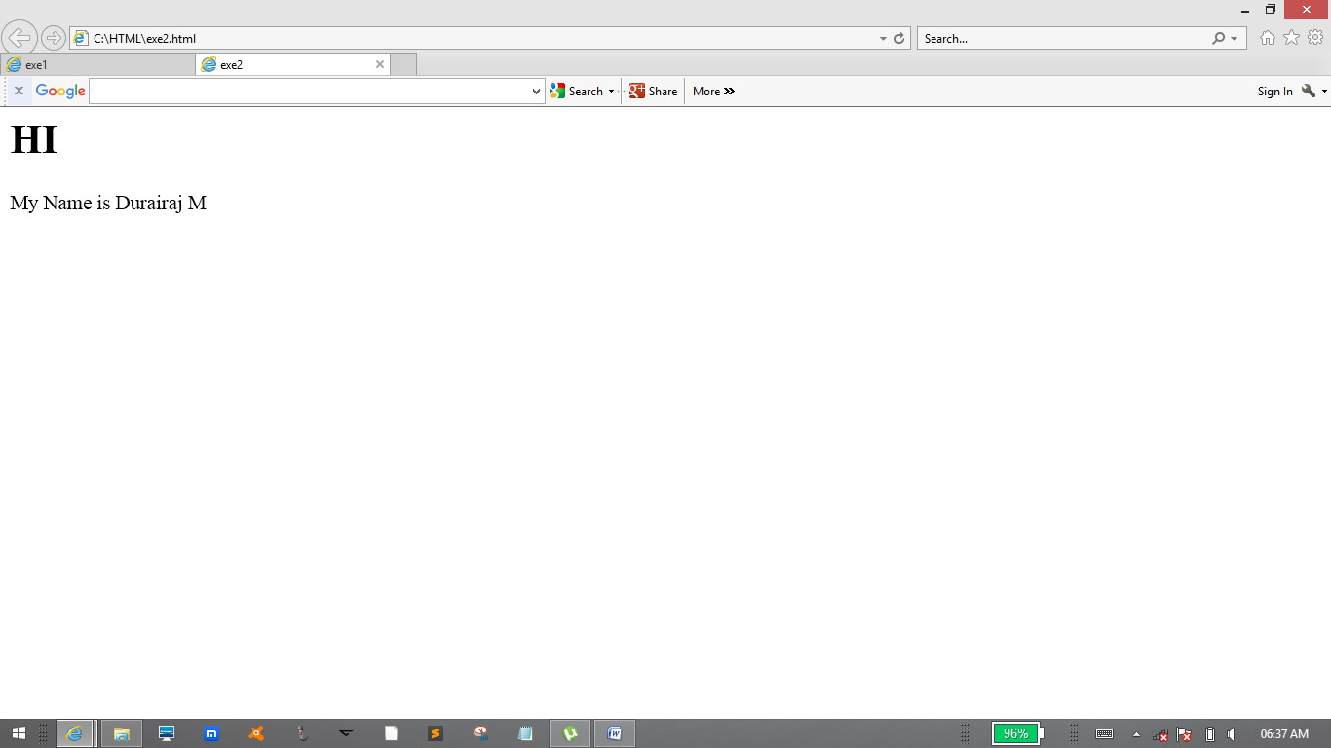

PROGRAM:

<html>

<head>

<title>exe3</title>

</head>

<body>

<h1>HELLO</h1>

Hi Guys how are u?!!!

</body>

</html>

OUTPUT:

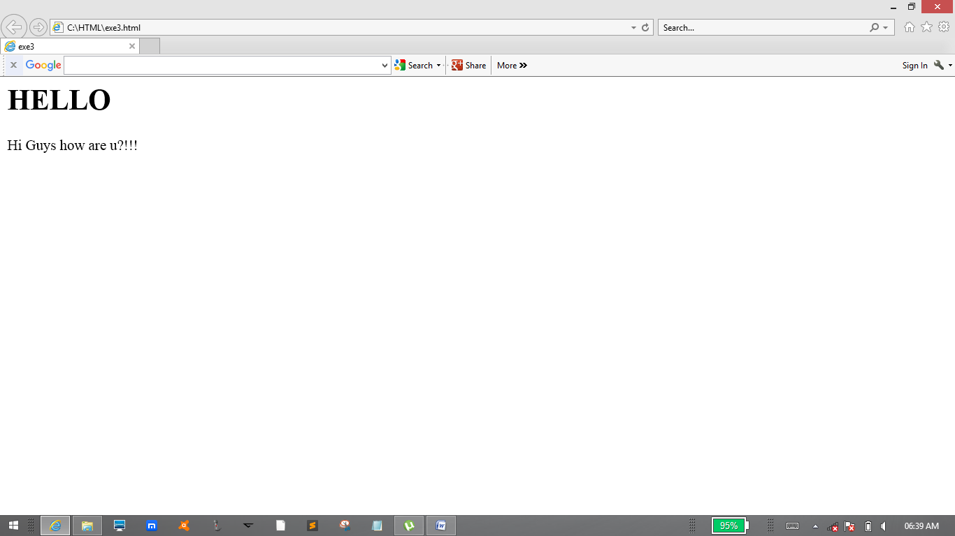

PROGRAM:

<html>

<head>

<title>exe4</title>

</head>

<body>

<h1>Durairaj M</h1>

<br>

<p>Btech IT</p>

</body>

</html>

OUTPUT:

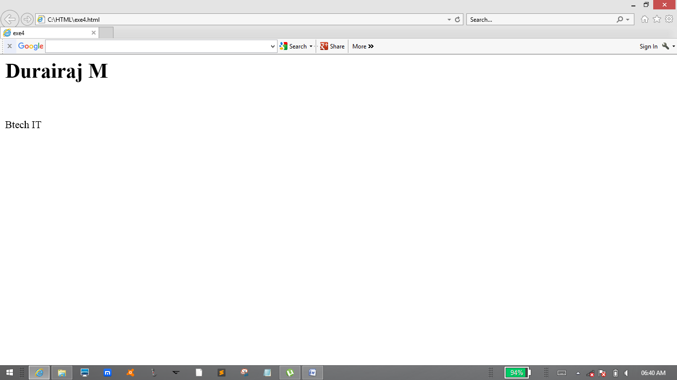

PROGRAM:

<html>

<head>

<title>exe5</title>

</head>

<body>

<h1>Durairaj M</h1>

<h2>Durairaj M</h2>

<h3>Durairaj M</h3>

<h4>Durairaj M</h4>

<h5>Durairaj M</h5>

<h6>Durairaj M</h6>

Durairaj M

</body>

</html>

OUTPUT:

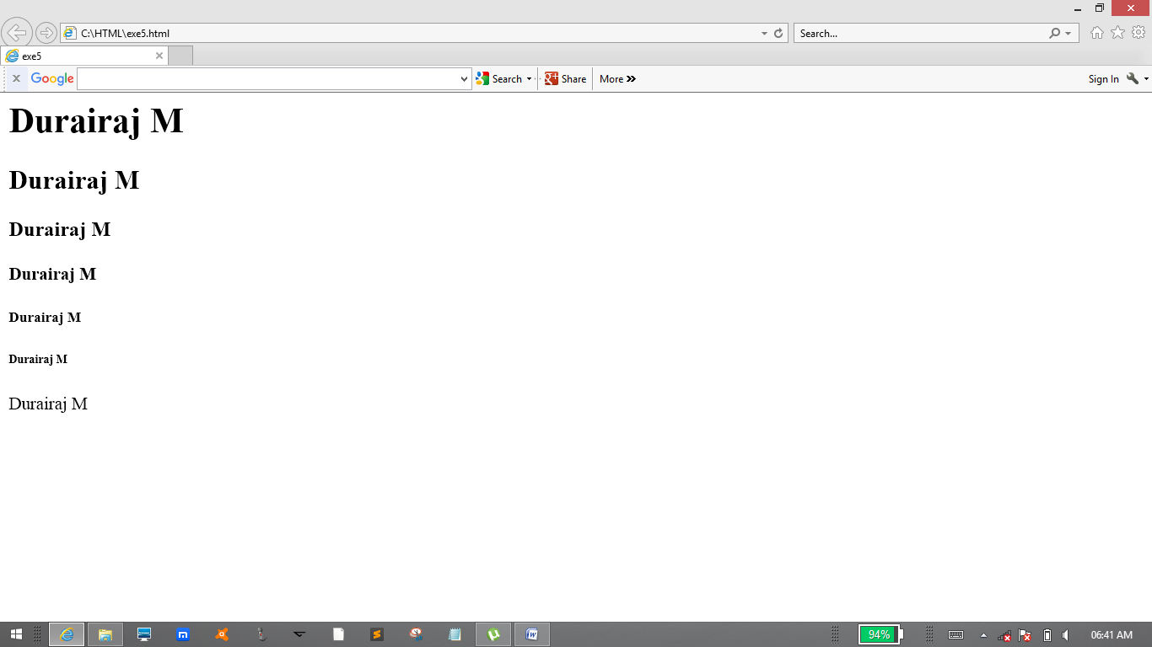

PROGRAM:

<html>

<head>

<title>exe6</title>

</head>

<body>

Durairaj<b> M</b><br>

<i>Durairaj M</i><br>

<strong>Durairaj M</strong><br>

web<sup>2</sup>web<br>

web<sub>2</sub>web<br>

<del>Durairaj M</del><br>

<code>html is uesd for designing the web pages</code>

</body>

</html>

OUTPUT:

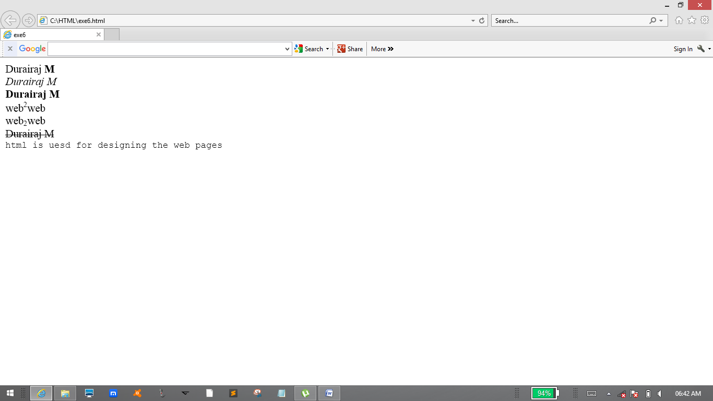

PROGRAM:

<html>

<head>

<title>exe7</title>

</head>

<body>

<h1>Durairaj M</h1>

<br>

Durai<br>

Raj M

</body>

</html>

OUTPUT:

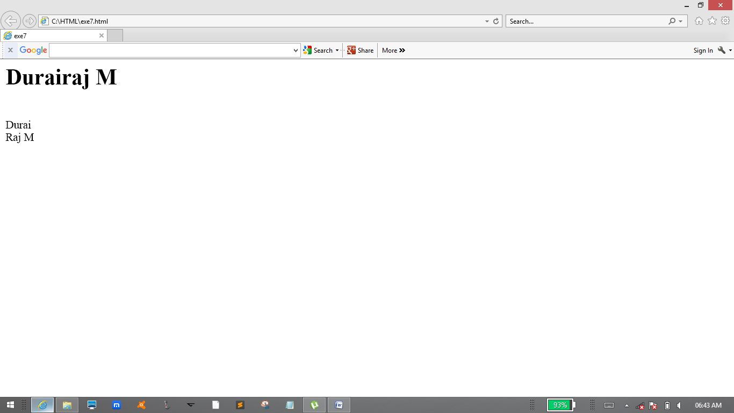

PROGRAM:

<html>

<head>

<title>exe8</title>

</head>

<body>

<h1>Durairaj M</h1>

<pre>Btech IT</pre>

</body>

</html>

OUTPUT:

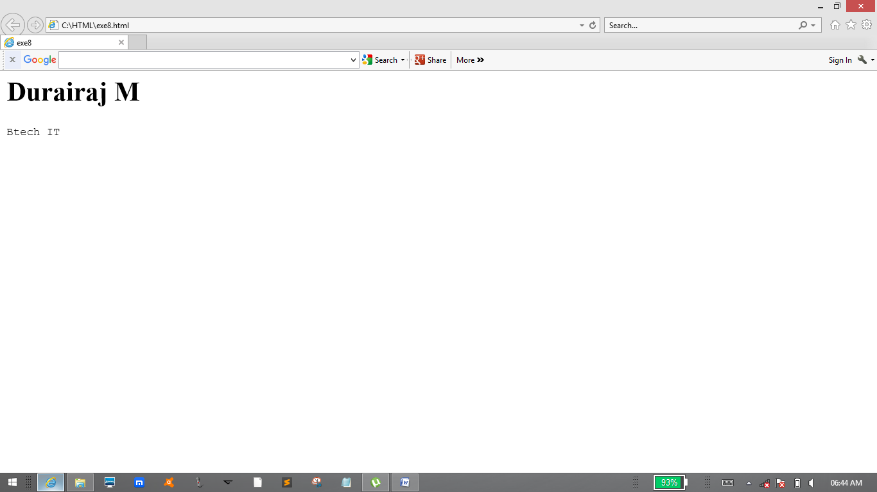

PROGRAM:

<html>

<head>

<title>exe9</title>

</head>

<body>

<h1>Durairaj M</h1>

<h6 style ="text-align:right;">Btech IT</h6>

</body>

</html>

OUTPUT:

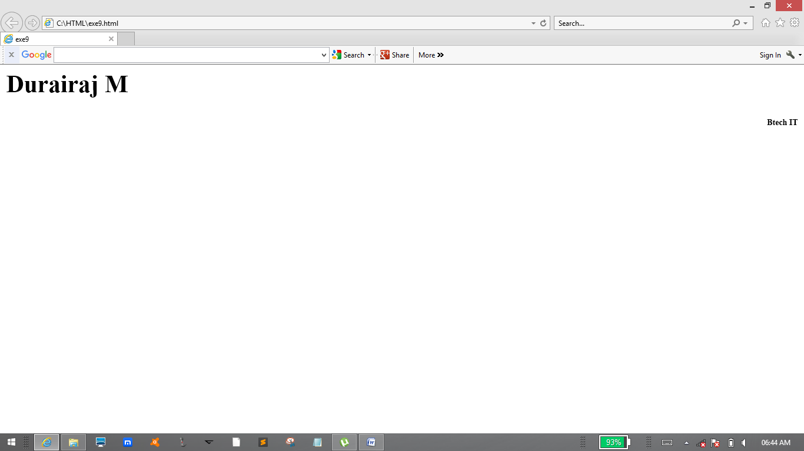

PROGRAM:

<html>

<head>

<title>exe10</title>

</head>

<body>

<p>HI</p>

<p style ="color:blue;">Iam Durairaj M</p>

<p style ="color:violet;">Btech IT</p>

<p style ="font-size:45px;">RIT</p>

</body>

</html>

OUTPUT:

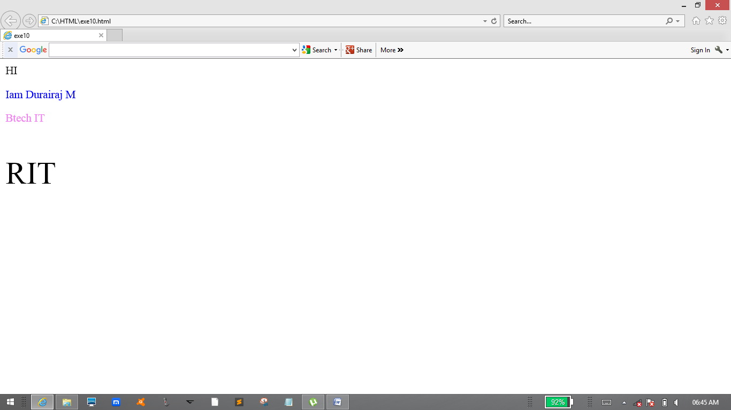

PROGRAM:

<html>

<head>

<title>exe1</title>

</head>

<body>

<a href="https://www.github.com">vist github.com!</a>

</body>

</html>

OUTPUT:

