PROGRAM:

<html>

<head>

<title>exe1</title>

</head>

<body>

<a href="https://mail.google.com/mail/ca/u/0/#inbox">Send Mail</a><br>

<a href="exe12.html" download>downlaod</a>

</body>

</html>

OUTPUT:

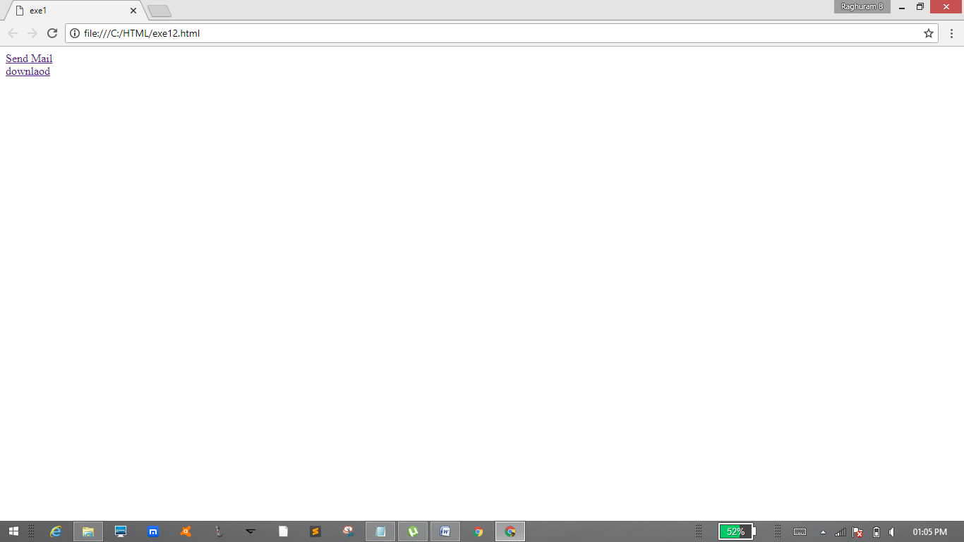

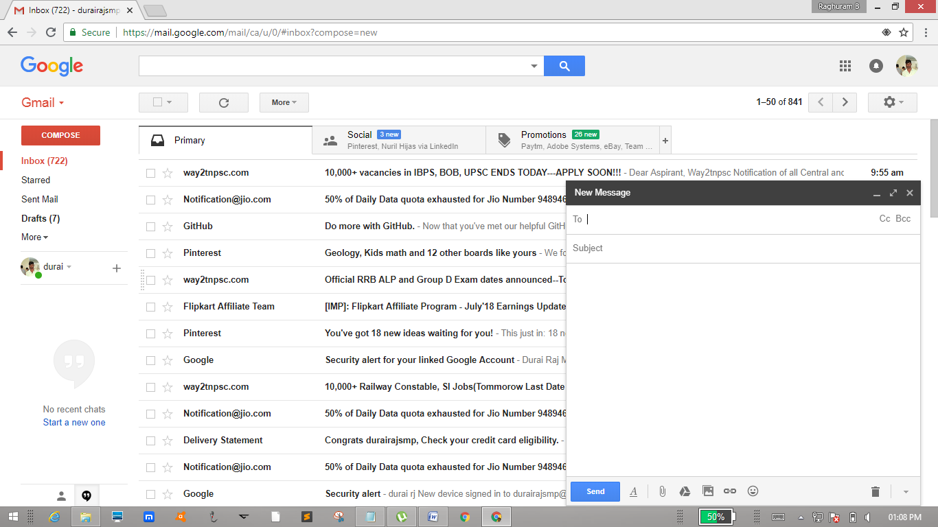

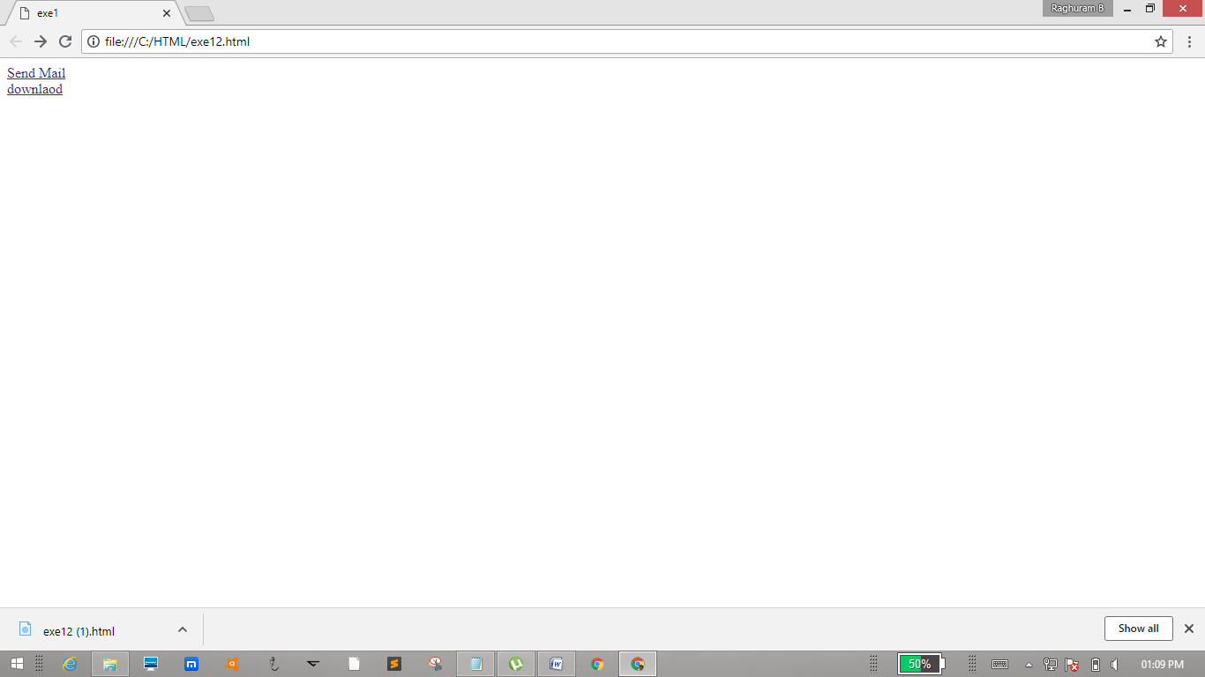

PROGRAM:

<html>

<head>

<title>exe13</title>

</head>

<comment>

This tag is concept that includes in html

</comment>

</html>

OUTPUT:

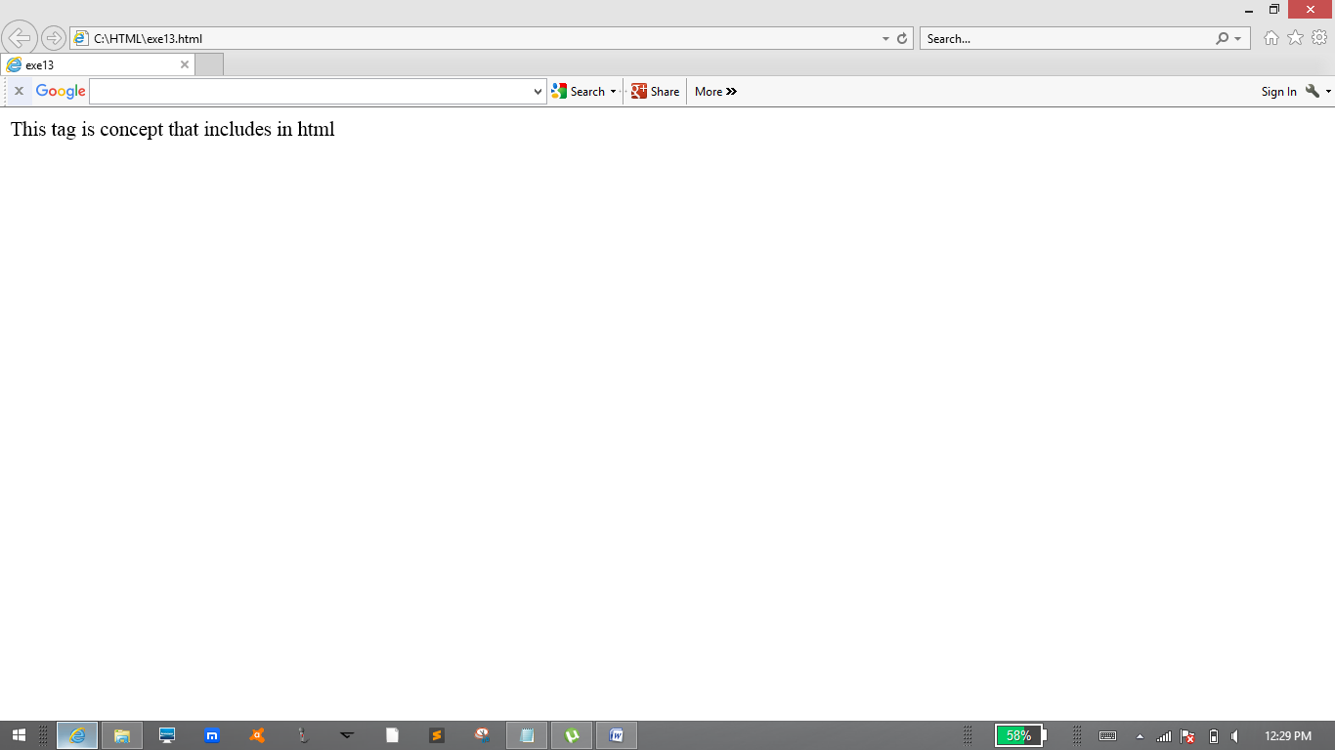

PROGRAM:

<!--unordered list-->

<html>

<head>

<title>exe14</title>

</head>

<b><dt>Durairaj M</dt></b>

<ul style="list-style-type:circle" >

<li>Btech IT</li>

<li>RIT</li>

<li>Chennai</li>

<ul style="list-style-type:square">

<b><dt>Durairaj M</dt></b>

<li>Btech IT</li>

<li>RIT</li>

<li>Chennai</li>

</ul>

</ul>

</html>

OUTPUT:

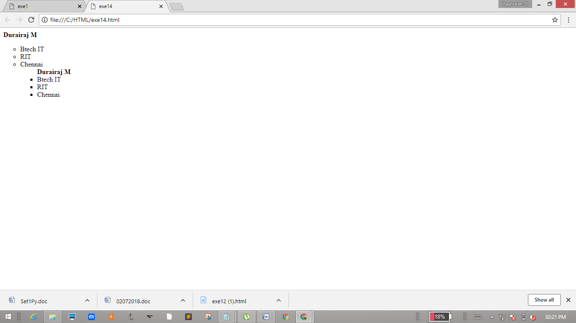

PROGRAM:

<!--ordered list-->

<html>

<head>

<title>exe14</title>

</head>

<b><dt>Durairaj M</dt></b>

<ol >

<li>Btech IT</li>

<li>RIT</li>

<li>Chennai</li>

<ol <b><dt>Durairaj M</dt></b>

<li>Btech IT</li>

<li>RIT</li>

<li>Chennai</li>

</ol>

</ol>

</html>

OUTPUT:

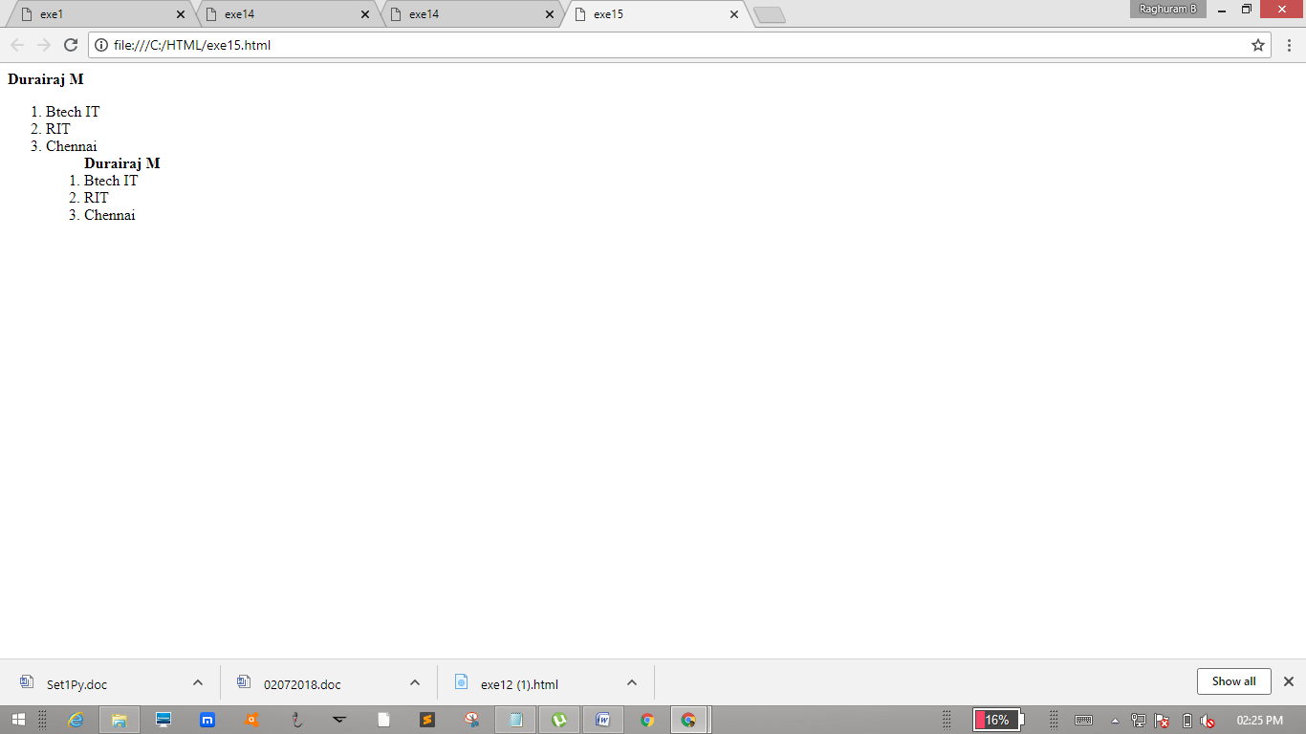

PROGRAM:

<!--Definition list-->

<html>

<head>

<title>exe16</title>

</head>

<body>

<dl>

<dt>Durairaj M</dt>

<dd>Btech IT</dd>

<dd>RIT</dd>

</dl>

</body>

</html>

OUTPUT:

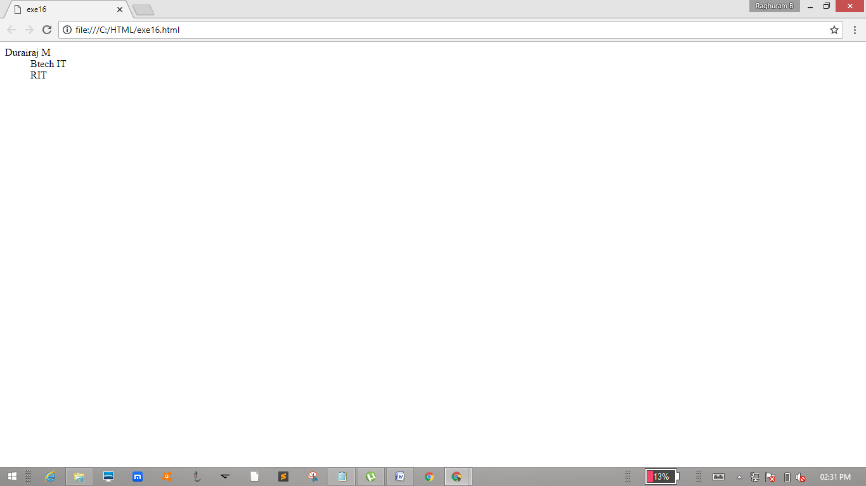

PROGRAM:

<!--Image tag-->

<html>

<head>

<title>exe17</title>

</head>

<p align="center">rj</p>

<center><img src ="rj.jpg" height="200"width="150"border"10"></center>

</html>

