PROGRAM:  
<!DOCTYPE html>

<html>

<body>

<p>javascript 1</p>

<p id="rj"></p>

</body>

</html>

OUTPUT:  
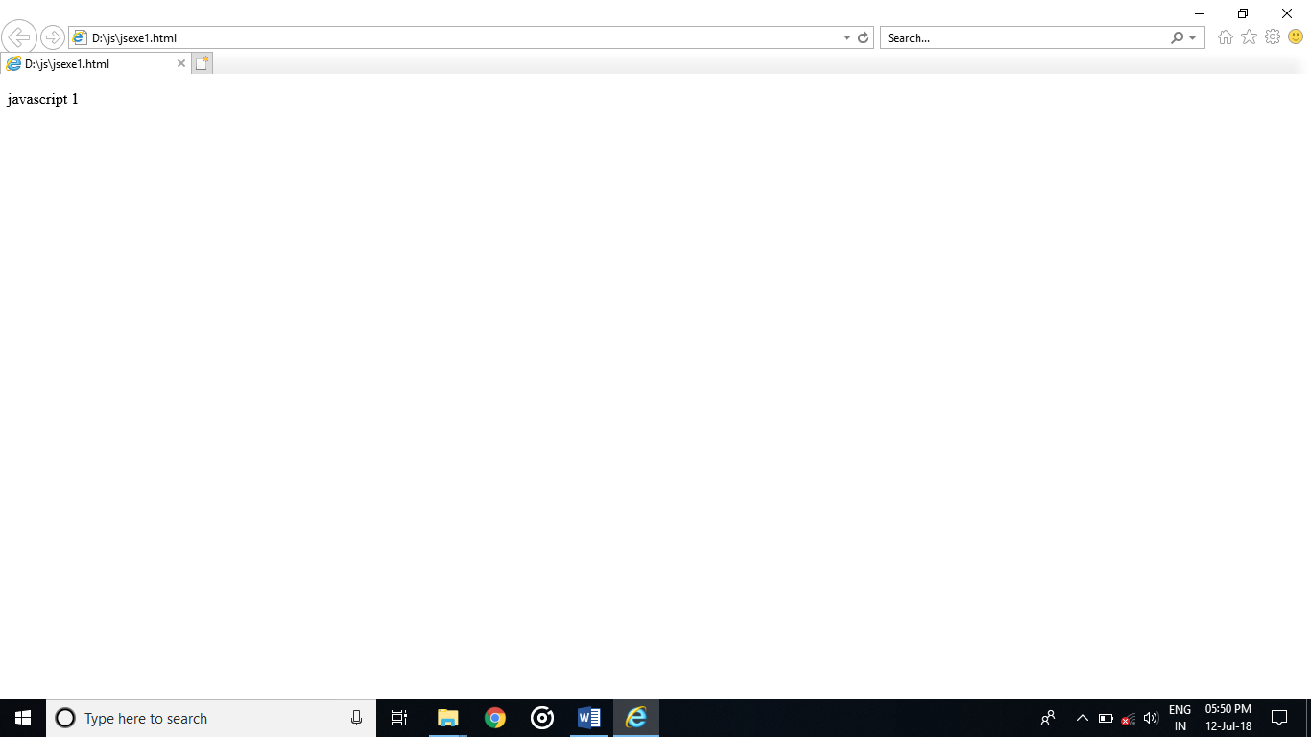

PROGRAM:  
<!--javascript location-->

<html>

<body>

<p><b><i>click below</i></b></p>

<button onclick="myFunction()">click here</button>

<script>

function myFunction()

{

alert("virus download");

}

</script>

</body>

</html>

OUTPUT:  
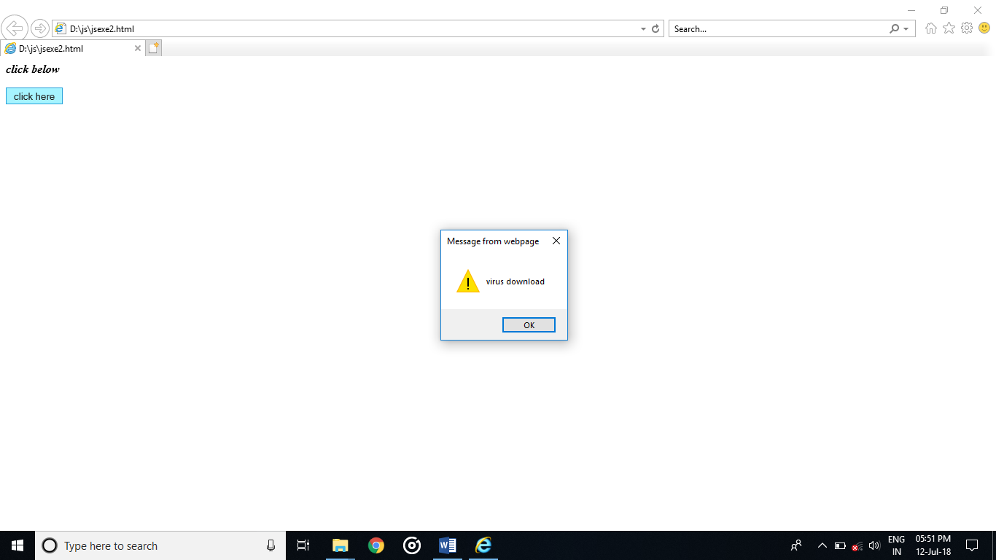

PROGRAM:

<!-- java scriptexternal-->

<html>

<head>

<script src="rj.js">

</script>

</head>

<body>

<input type="button" onclick="popup()" value="click here">

</input>

</body>

</html>

PROGRAM IN EXTERNAL:

function popup()

{

alert("Hiiii am Duraiiiiiii")

}

OUTPUT:

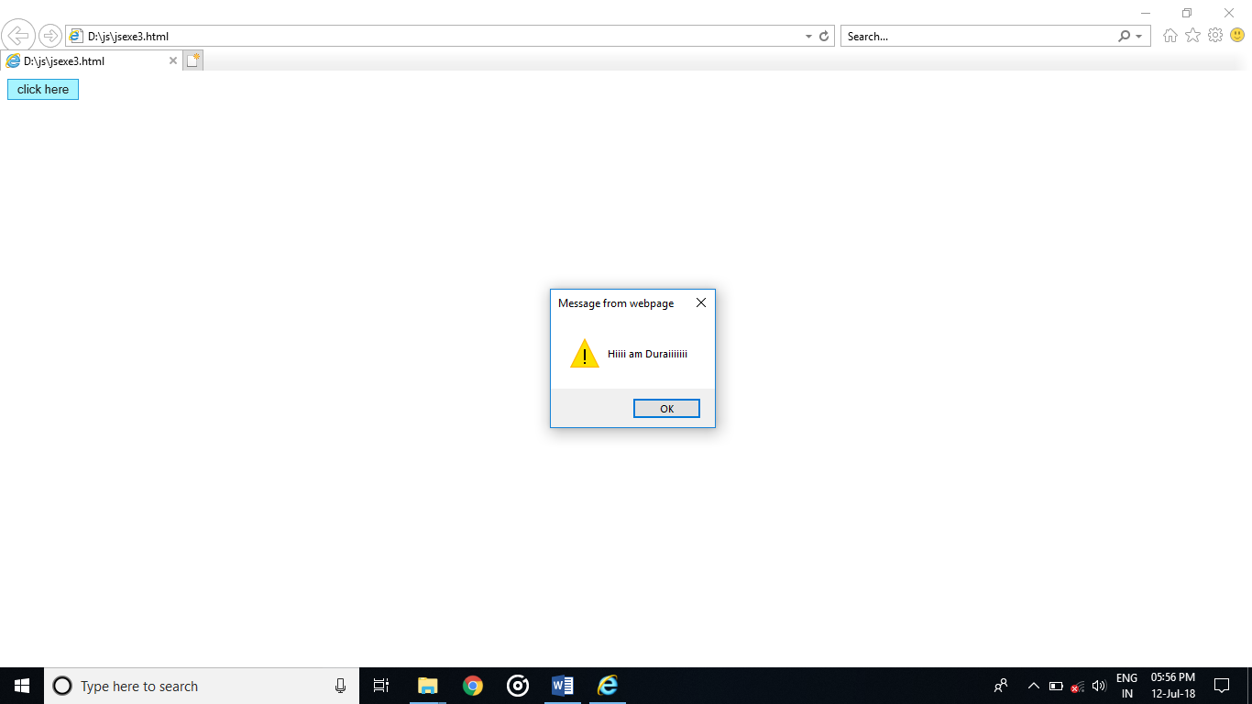

PROGRAM:  
<!--javascript operators-->

<html>

<body>

<h2><i>The + Operator</i></h2>

<p id="d"></p>

<script>

var x =6;

var y =7;

var z=x + y;

document.getElementById("d").innerHTML = z;

</script>

</body>

</html>

OUTPUT:

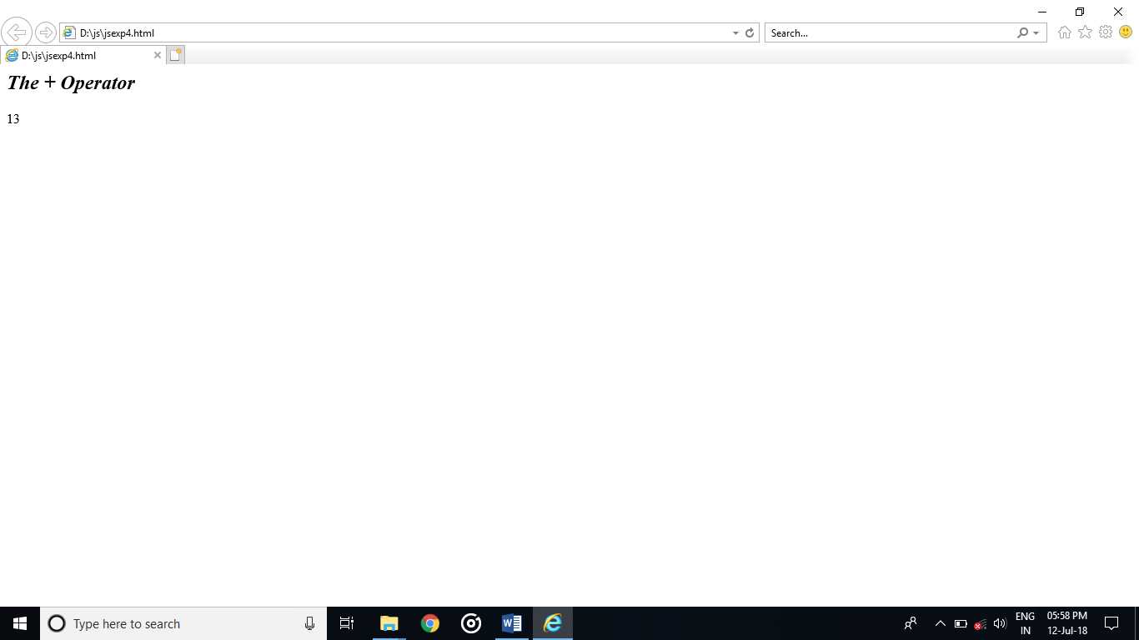

PROGRAM:  
<!--javascript-->

<html>

<body>

<h2>JavaScript Variables</h2>

<p id="add"></p>

<script>

var x = 5;

var y = 5;

var total = x + y;

document.getElementById("add").innerHTML =

"The total is: " + total;

</script>

</body>

</html>

OUTPUT:

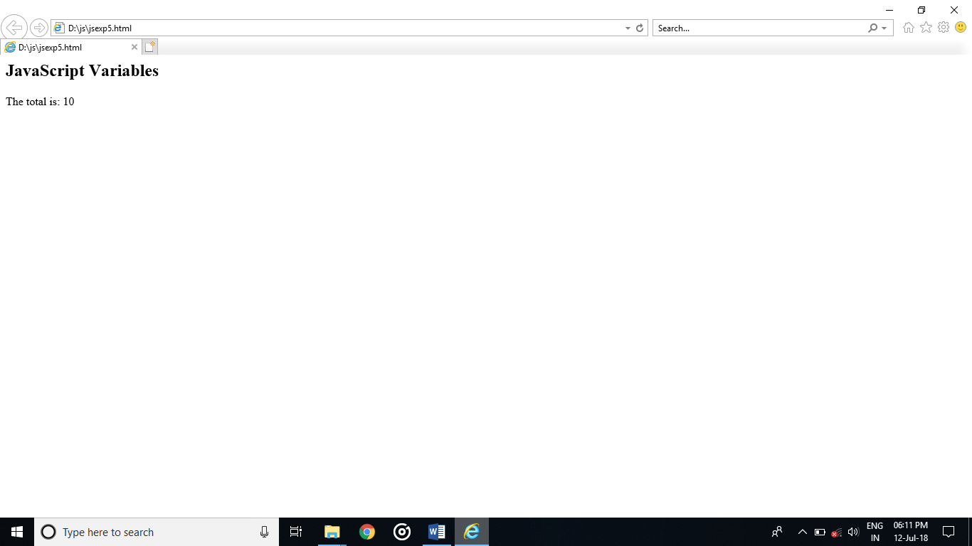

PROGRAM:  
<!--date and time-->

<html>

<body>

<button onclick="this.innerHTML=Date()">click to display date and time</button>

</body>

</html>

OUTPUT:  
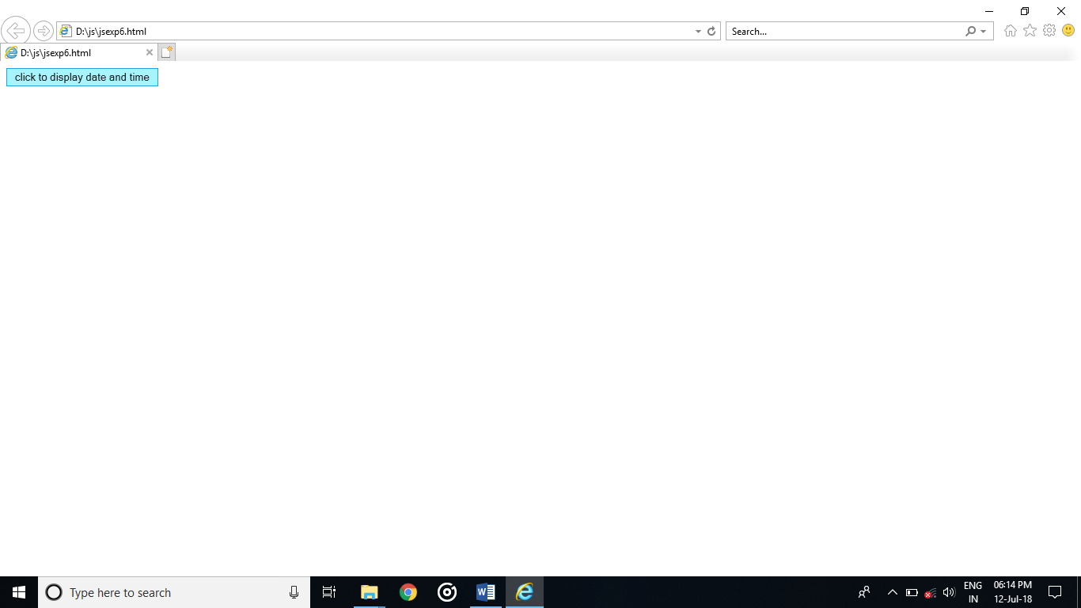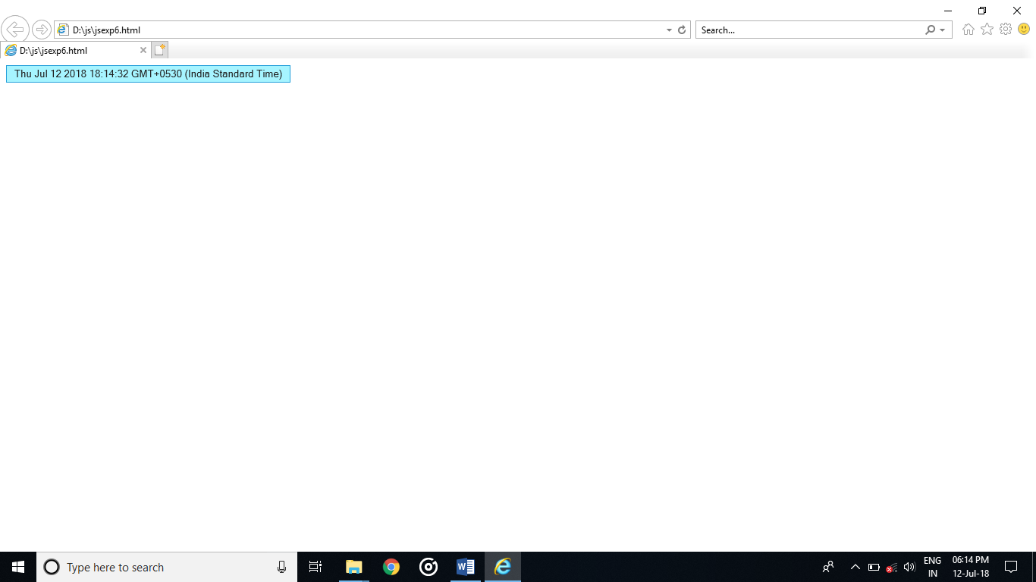

PROGRAM:  
<!DOCTYPE html>

<html>

<body>

<p>display untime if time is more than 10 PM</p>

<p id="rj">untime</p>

<script>

if (new Date().getHours() < 22) {

document.getElementById("rj").innerHTML = "so normal hours";

}

</script>

</body>

</html>

OUTPUT:

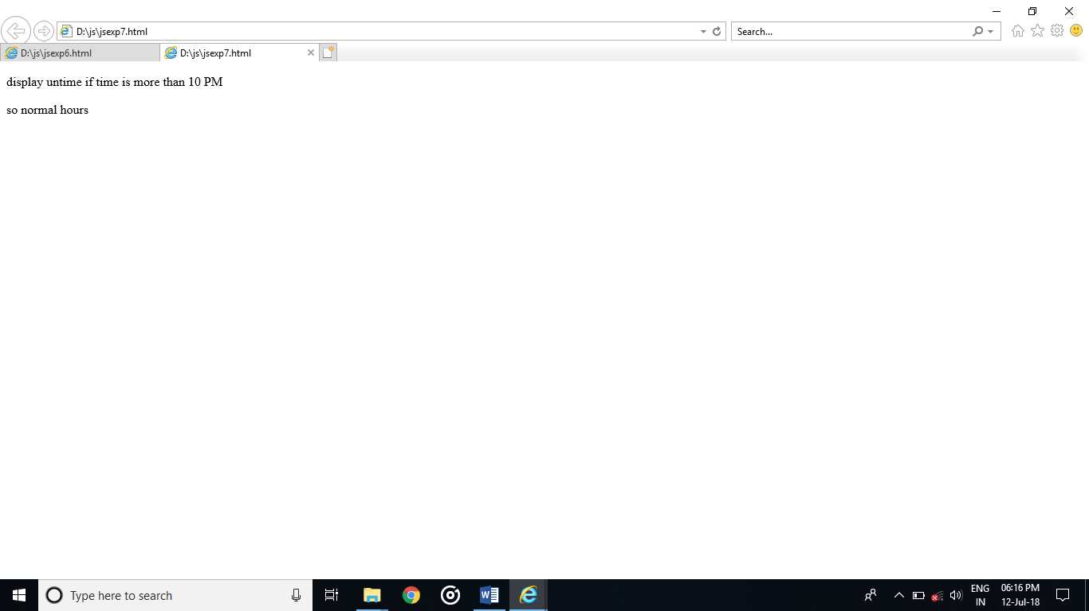

PROGRAM:  
<!DOCTYPE html>

<html>

<body>

<p>hiii there</p>

<button onclick="myFunction()">click</button>

<p id="d"></p>

<script>

function myFunction() {

var now;

var time = new Date().getHours();

if (time < 10) {

now = "gud mrg";

} else if (time < 16) {

now = "gud aftrn";

} else {

now = "gud ni8";

}

document.getElementById("d").innerHTML = now;

}

</script>

</body>

</html>

OUTPUT:  
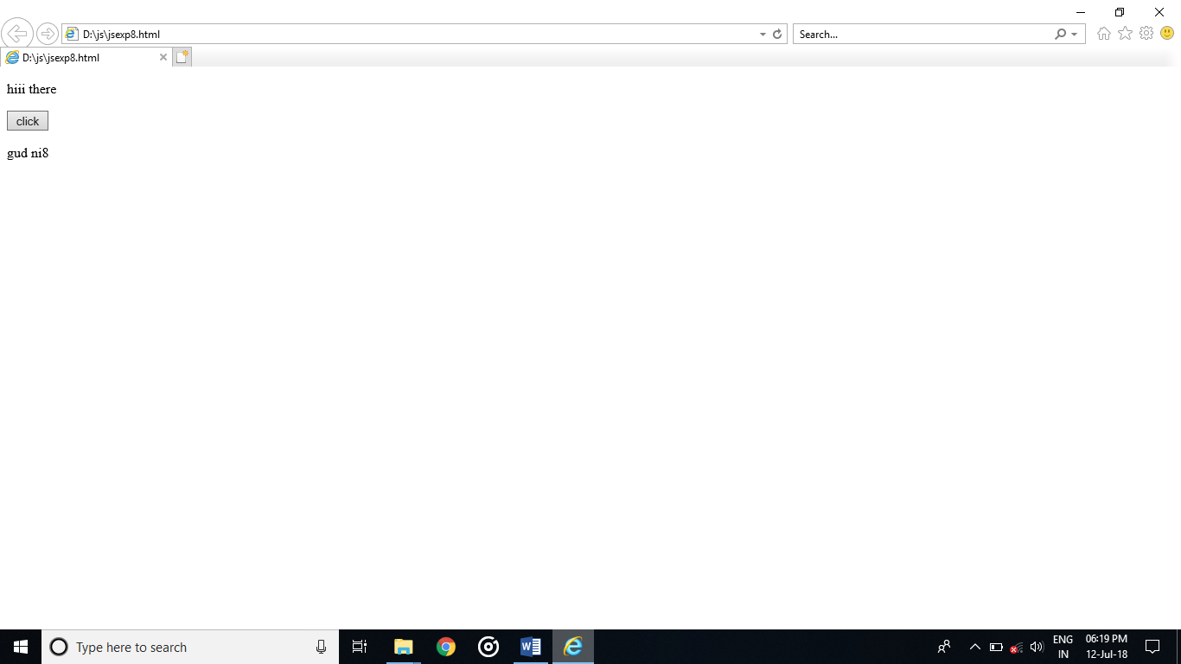

PROGRAM:  
<!DOCTYPE html>

<html>

<body>

<h2><i>JavaScript while</i></h2>

<p id="d"></p>

<script>

var text = "";

var i = 1;

while (i <= 20) {

text += "<br>the current value" + i;

i++;

}

document.getElementById("d").innerHTML = text;

</script>

</body>

</html>

OUTPUT:  
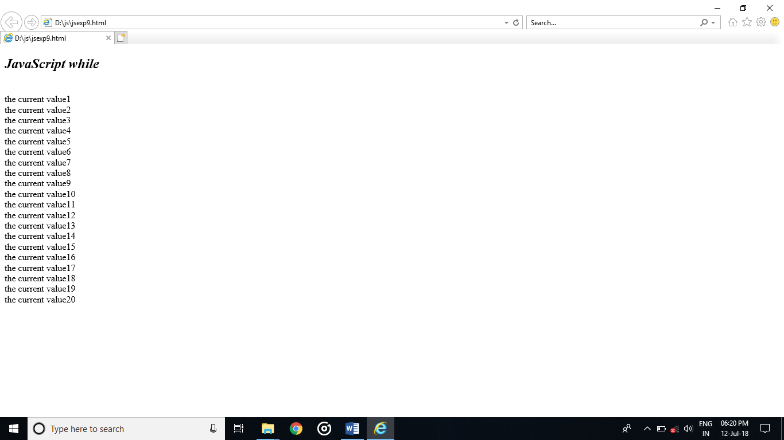

PROGRAM:  
<!DOCTYPE html>

<html>

<body>

<h2>JavaScript Loops</h2>

<p id="d"></p>

<script>

var a = [1,2,3,4,5];

var text = "";

var i;

for (i = 0; i < a.length; i++) {

text += a[i] + "<br>";

}

document.getElementById("d").innerHTML = text;

</script>

</body>

</html>

OUTPUT:  
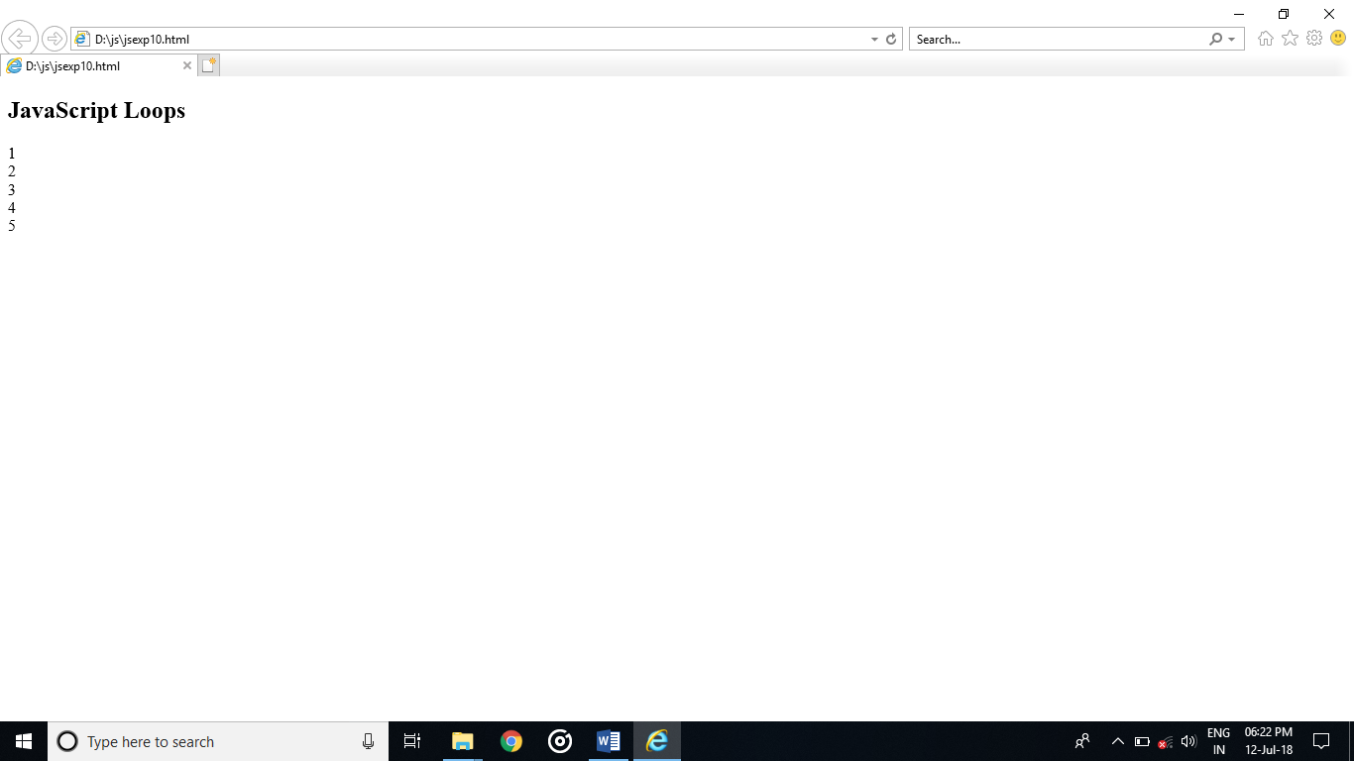

PROGRAM:  
<!DOCTYPE html>

<html>

<body>

<h2>JavaScript Arrays</h2>

<p id="d"></p>

<script>

var bike = ["Pulsar", "ktm", "r15","Royal Enfield"];

document.getElementById("d").innerHTML = bike;

</script>

</body>

</html>

OUTPUT:  
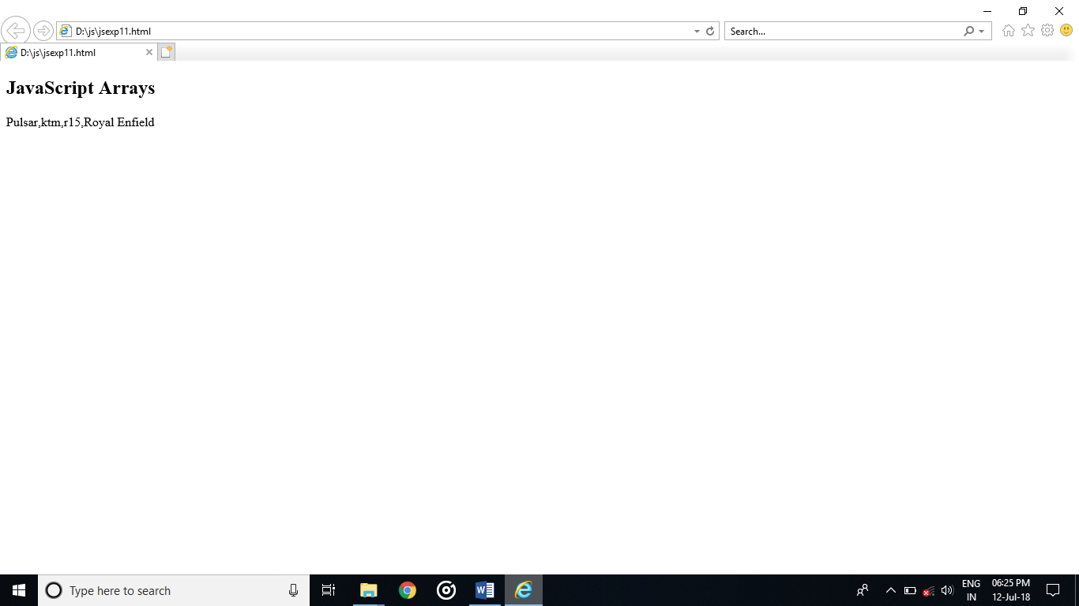

PROGRAM:  
<!DOCTYPE html>

<html>

<body>

<p id="d">Click for alert box.</p>

<button onclick="myFunction()">click</button>

<script>

function myFunction() {

alert("hiiiiiiiiiiiiiii");

}

</script>

</body>

</html>

OUTPUT:  
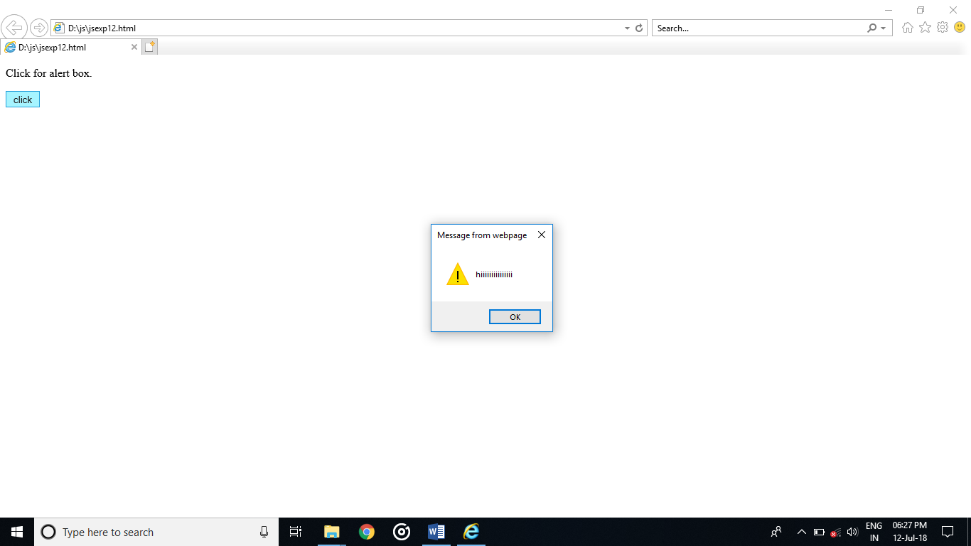

PROGRAM:  
<!DOCTYPE html>

<html>

<body>

<p>confirm box.</p>

<button onclick="myFunction()">click here</button>

<script>

function myFunction() {

confirm("booking confirmed");

}

</script>

</body>

</html>

OUTPUT:  
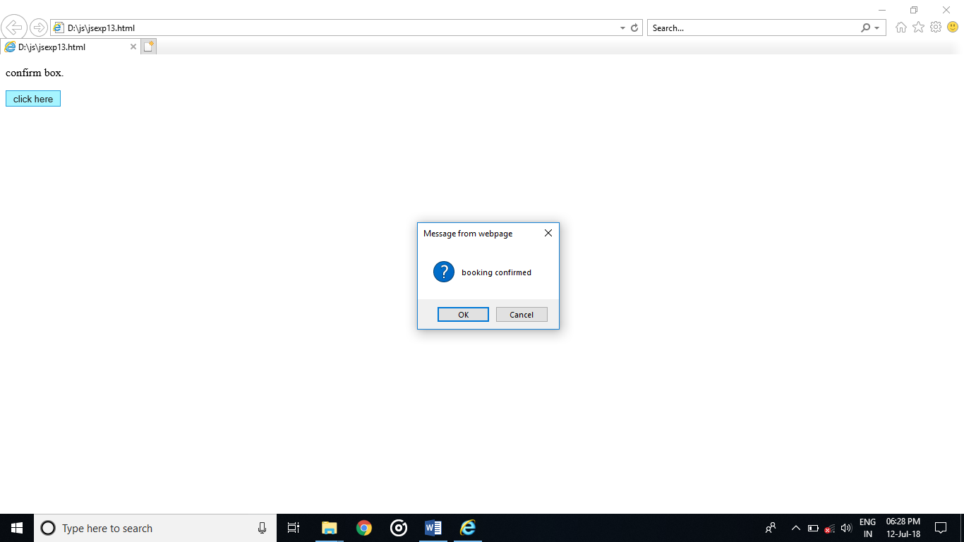

PROGRAM:  
<!DOCTYPE html>

<html>

<body>

<h2>JavaScript Prompt</h2>

<button onclick="myFunction()">click</button>

<p id="d"></p>

<script>

function myFunction() {

var text;

var person = prompt("Please enter your name:", "");

if (person == null || person == "") {

text = "Please enter your name";

} else {

text = "hiiii there " + person + "How are you???";

}

document.getElementById("d").innerHTML = text;

}

</script>

</body>

</html>

OUTPUT:  
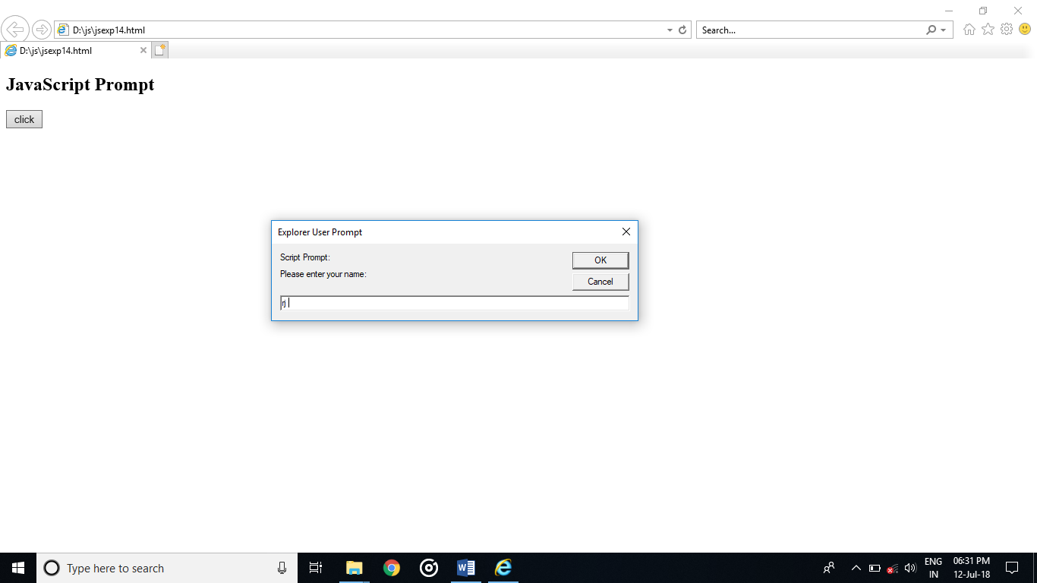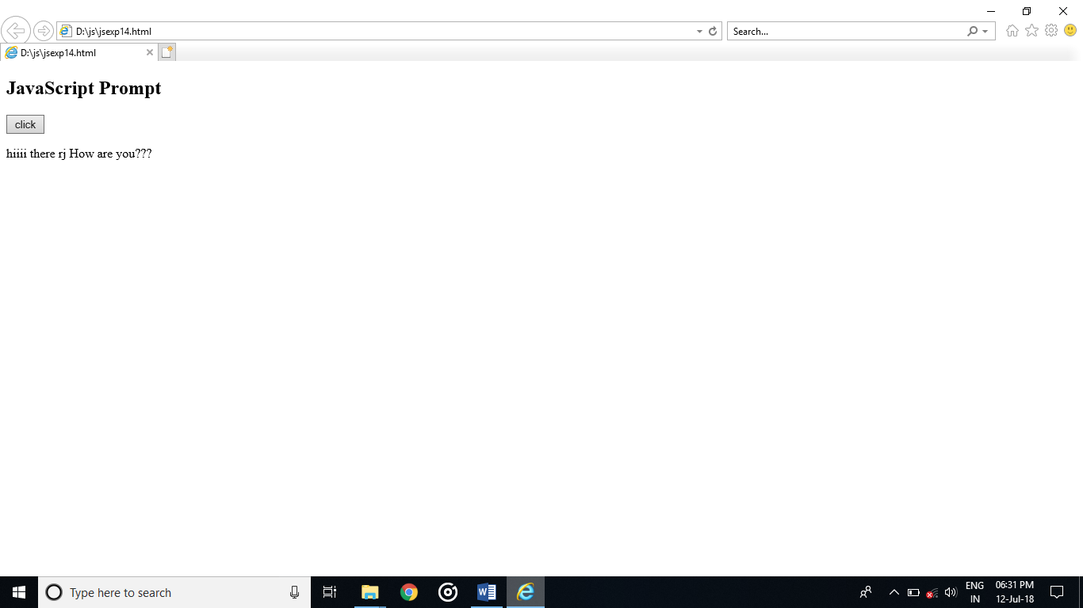

PROGRAM:

<!DOCTYPE html>

<html>

<body>

<p>print the current page.</p>

<button onclick="myFunction()">click to print</button>

<script>

function myFunction()

{

window.print();

}

</script>

</body>

</html>

OUTPUT:  
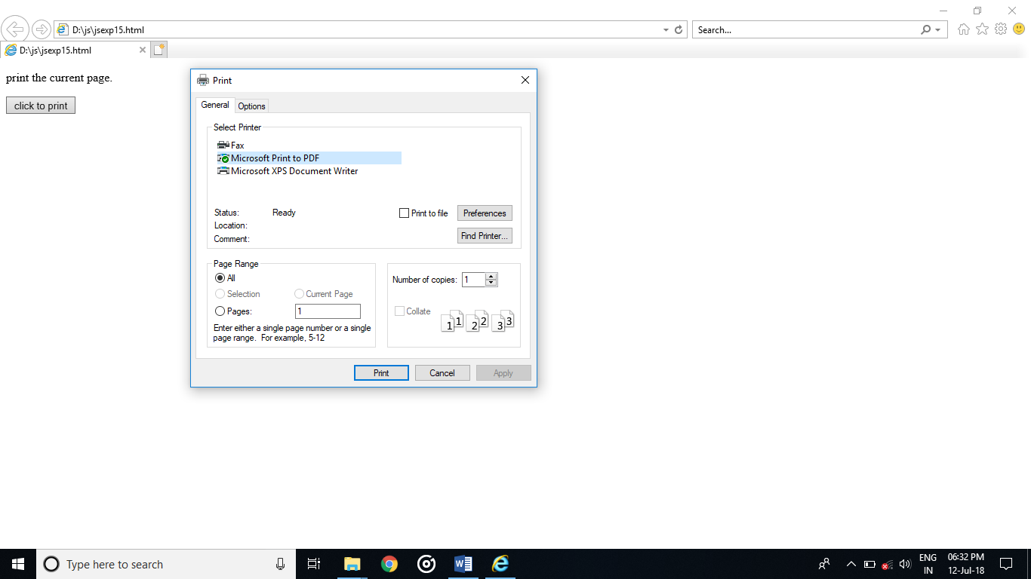

PROGRAM:

<!DOCTYPE html>

<html>

<body>

<input type="button" value="just click" onclick="newpg()">

<script>

function newpg() {

window.location.assign("https://www.gmail.com")

}

</script>

</body>

</html>

OUTPUT:  
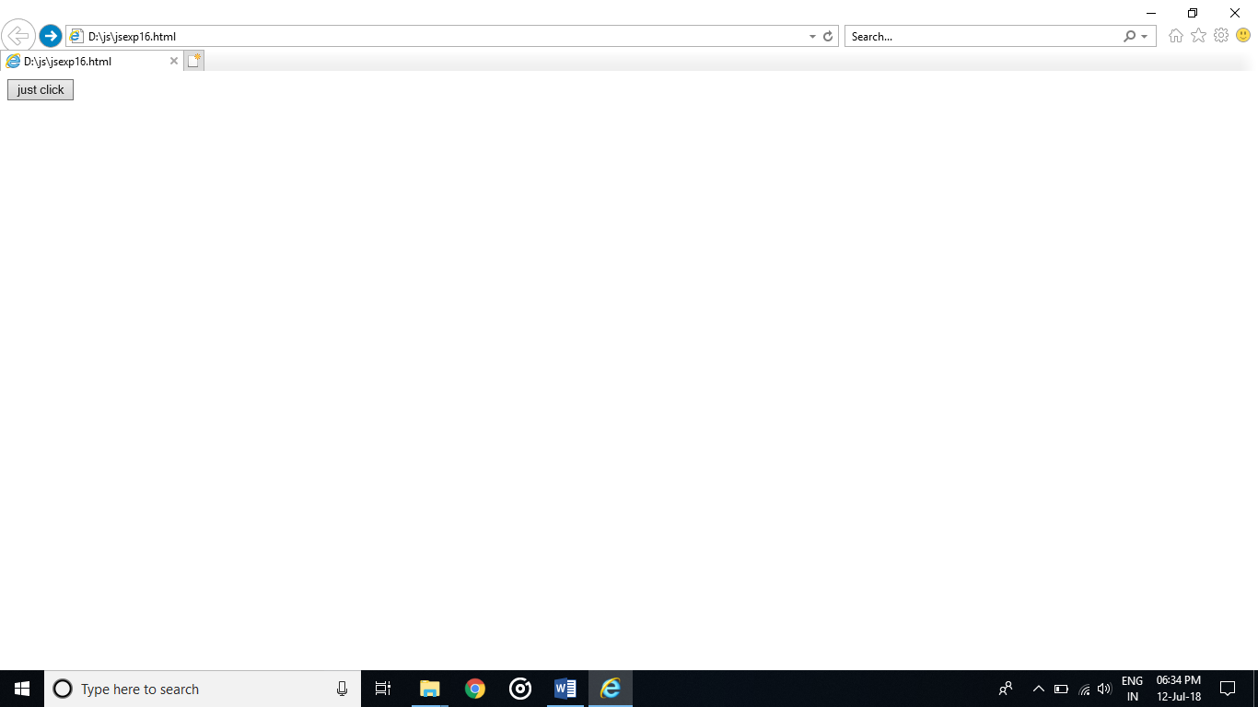

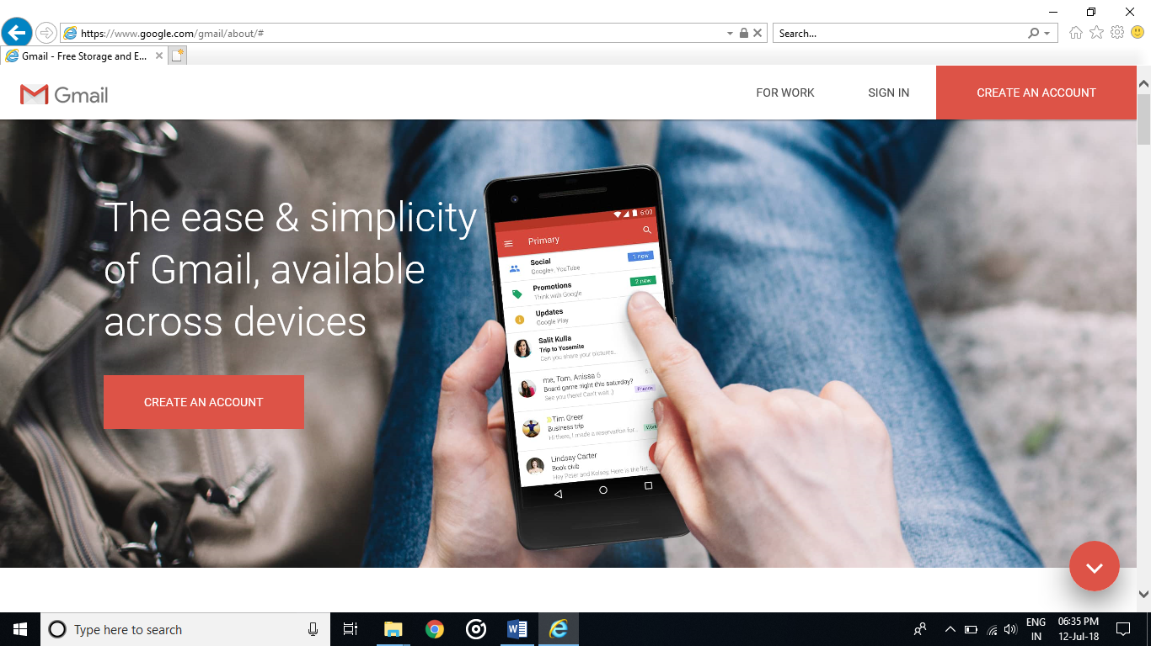

PROGRAM:  
<html>

<body>

<button onclick="popup()">click</button>

<script>

function popup()

{

alert("oiii");

}

</script>

</body>

</html>

OUTPUT:  
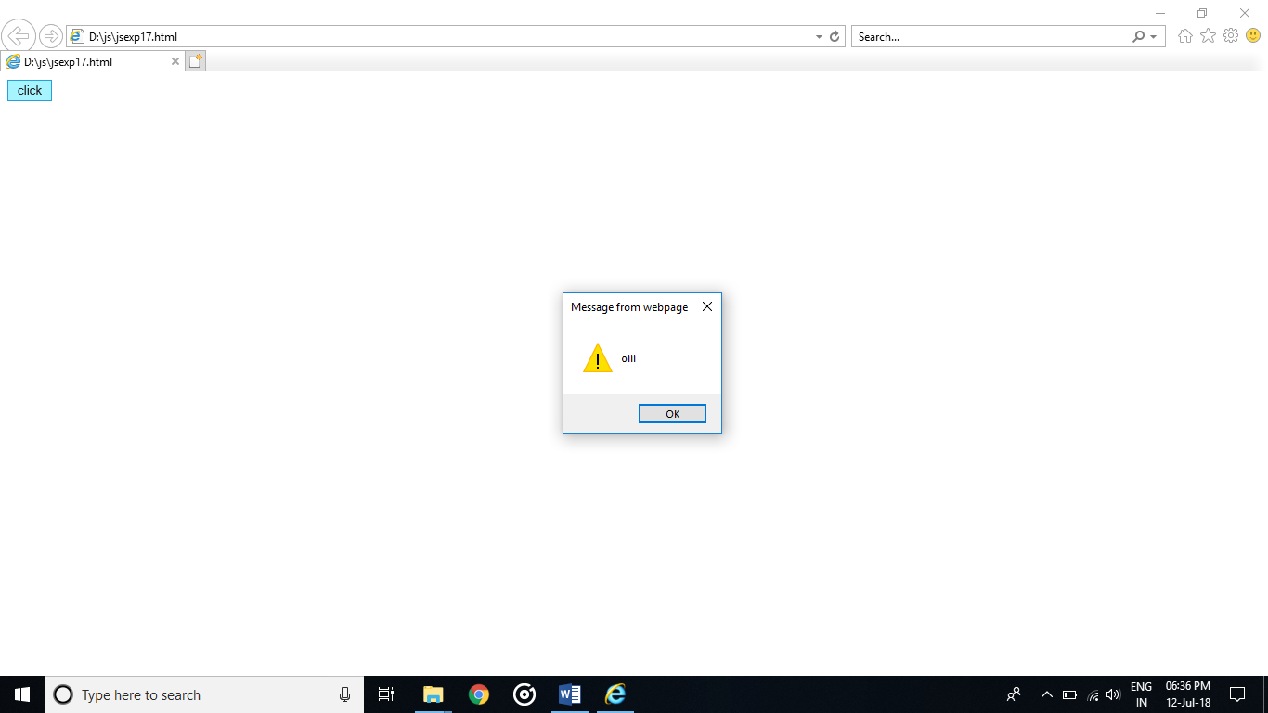

PROGRAM:  
<!DOCTYPE html>

<html>

<head>

<script>

function startTime() {

var today = new Date();

var h = today.getHours();

var m = today.getMinutes();

var s = today.getSeconds();

m = checkTime(m);

s = checkTime(s);

document.getElementById('txt').innerHTML = today

h + ":" + m + ":" + s;

var t = setTimeout(startTime, 500);

}

function checkTime(i) {

if (i < 10) {i = "0" + i}; // add zero in front of numbers < 10

return i;

}

</script>

</head>

<body onload="startTime()">

<div id="txt"></div>

</body>

</html>

OUTPUT:  
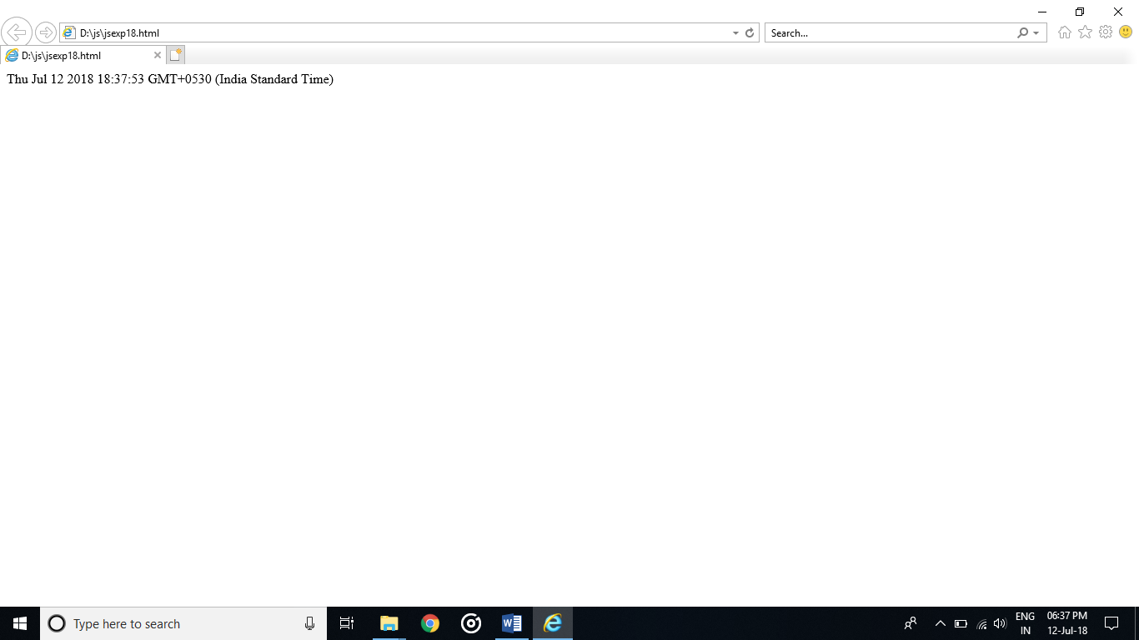

PROGRAM:  
<!--Html form for non-empty checking-->

<html>

<head>

<title>Empty form validation</title>

</head>

<body>

<h3><i>Enter Name</i></h3>

<form>

<input type="text" id="id">

<button onclick="valida()">Submit</button>

</form>

<script>

var n=document.getElementById("id").value;

function valida(){

if(name == ""){

alert("Value incorrect");}

else{alert("Value is taken");}

}

</script>

</body>

</html>

OUTPUT:  
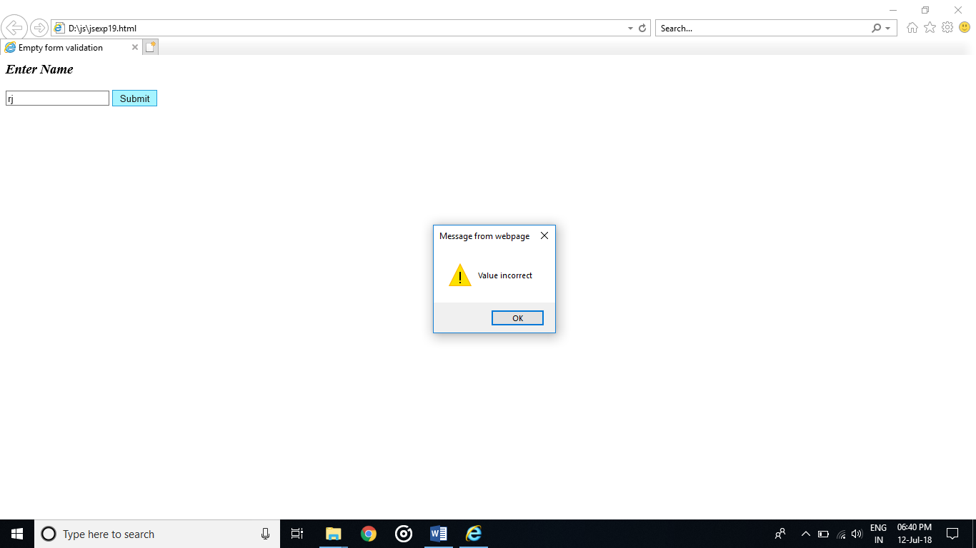

PROGRAM:

<!DOCTYPE html>

<html>

<body>

<p>enter the number</p>

<input id="numb">

<button type="button" onclick="myFunction()">Submit</button>

<p id="d"></p>

<script>

function myFunction() {

var x, text;

x = document.getElementById("numb").value;

if (isNaN(x)) {

text = "Input not valid";

} else {

text = "Input OK";

}

document.getElementById("d").innerHTML = text;

}

</script>

</body>

</html>

OUTPUT:  
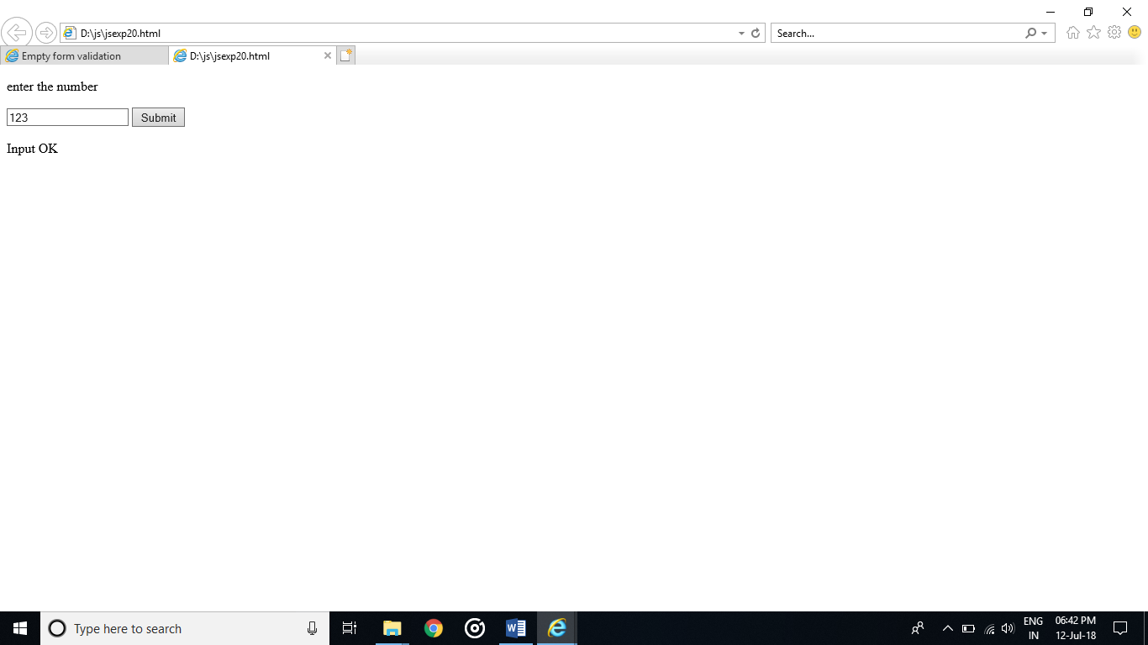

PROGRAM:  
<!--Html javascript code to validity check alphabet-->

<html>

<head>

<title>Alphabet Check</title>

</head>

<body>

<label for="number">Enter a Word</label>

<input id="word">

<button type="button" onclick="myFunction()">Submit</button>

<script>

function myFunction() {

var x, text;

// Get the value of the input field with id="number"

x = document.getElementById("word").value;

if (!x.match(/^[a-zA-Z]+$/)) {

text = "Input not valid";

} else {

text = "Input OK";

}

alert(text);

}

</script>

</body>

</html>

OUTPUT:  
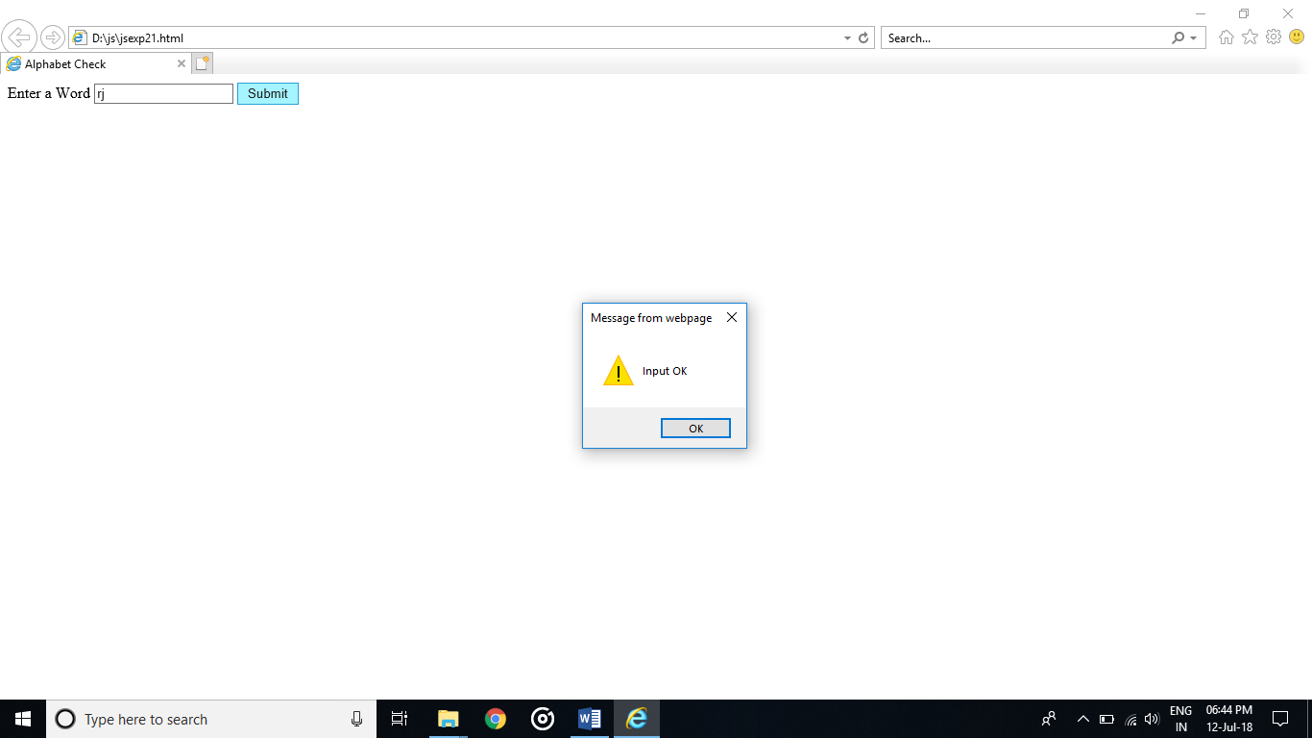

PROGRAM:  
<!--Html javascript code to check alphabet and number-->

<html>

<head>

<title>Alphabet Check</title>

</head>

<body>

<label for="number">Enter a value</label>

<input id="word">

<button type="button" onclick="myFunction()">Submit</button>

<script>

function myFunction() {

var x, text;

// Get the value of the input field with id="number"

x = document.getElementById("word").value;

if (!x.match(/^[a-zA-Z0-9]+$/)) {

text = "Input not valid";

} else {

text = "Input OK";

}

alert(text);

}

</script>

</body>

</html>

OUTPUT:  
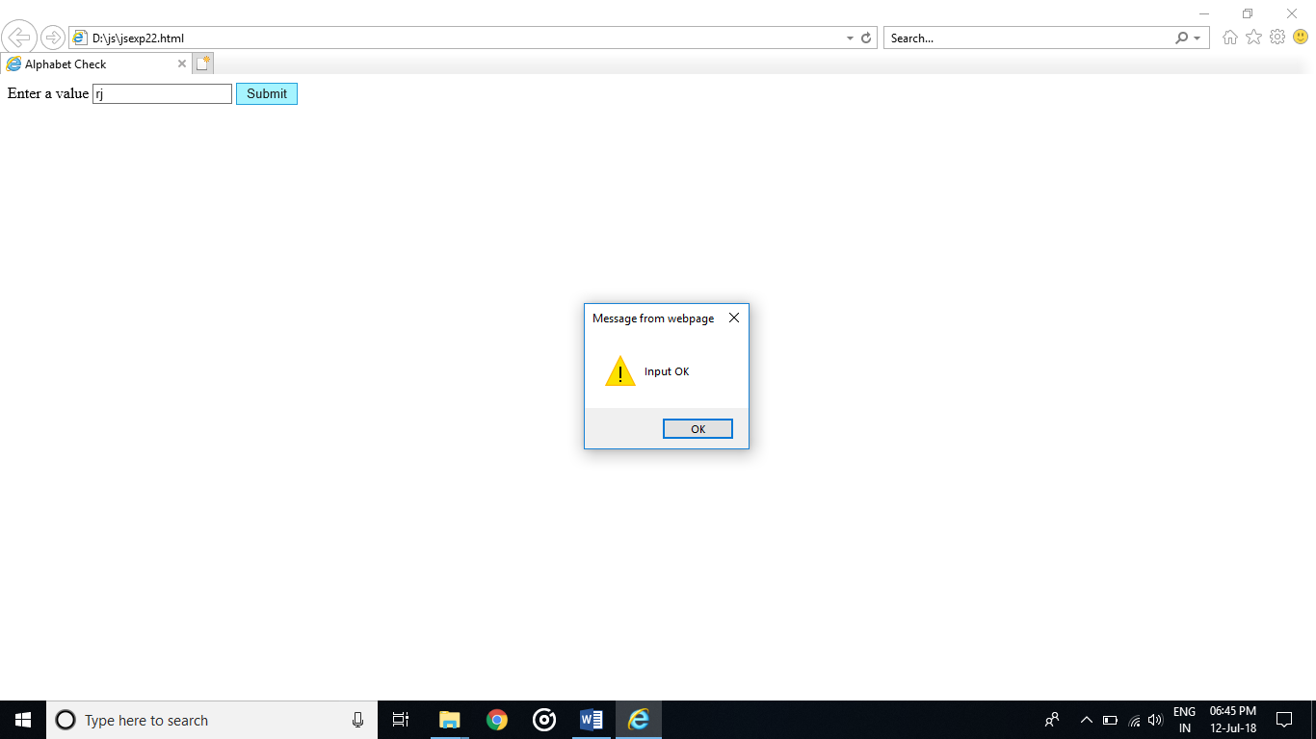

PROGRAM:  
<html>

<body>

mobile:<input type="text" maxlength=10></input>

<button onclick="mypopup()">click</button>

<script>

function mypopup()

{

alert("length restricted");

}

</script>

</body>

</html>

OUTPUT:  
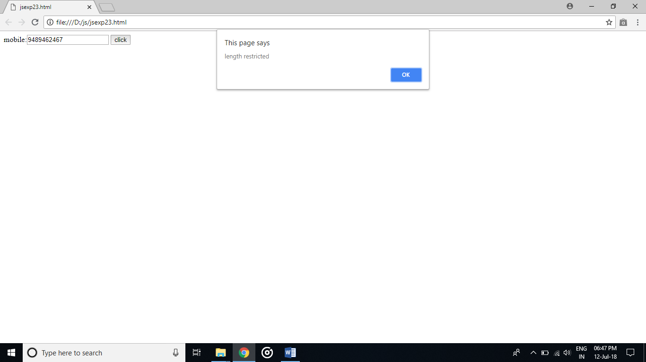

PROGRAM:  
<!DOCTYPE html>

<html>

<body>

<p>select:</p>

<form>

<select id="mySelect">

<option>IT</option>

<option>CSE</option>

<option>MECH</option>

<option>EEE</option>

<option>ECE</option>

<option>CIVIL</option>

</select>

</form><br>

<button onclick="myFunction()">submit</button>

<script>

function myFunction() {

alert("choice recognized");

}

</script>

</body>

</html>

OUTPUT:  
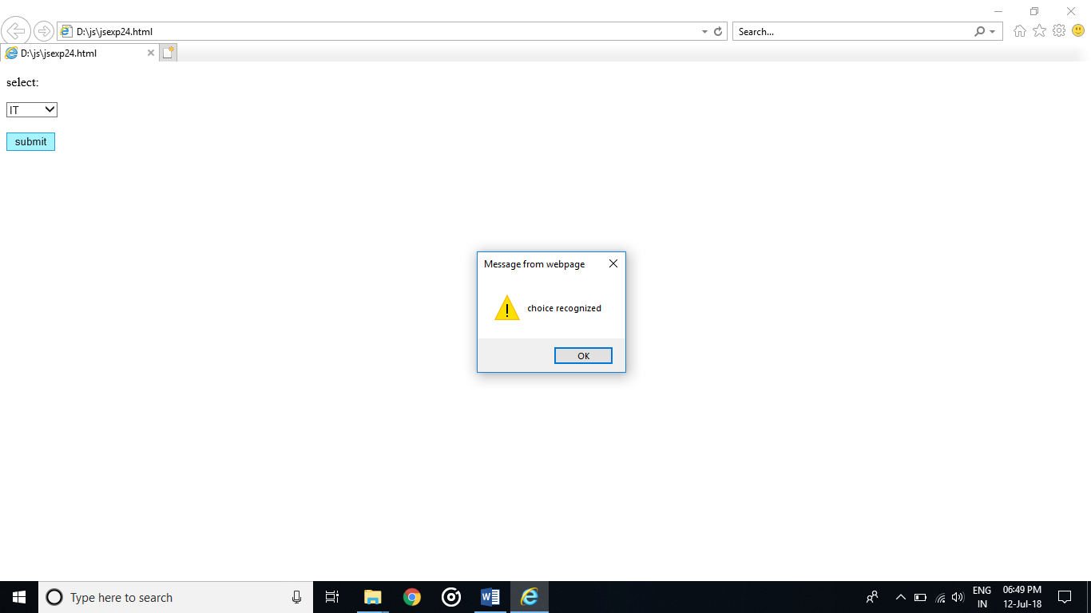

PROGRAM:  
<!DOCTYPE html>

<html>

<body>

<h2>JavaScript Email Validation</h2>

<input id="textEmail">

<button type="button" onclick="myFunction()">Submit</button>

<p id="demo"></p>

<script>

function myFunction() {

var email;

email = document.getElementById("textEmail").value;

var reg = /^([A-Za-z0-9_\-\.])+\@([A-Za-z0-9_\-\.])+\.([A-Za-z]{2,4})$/;

if (reg.test(textEmail.value) == false)

{

document.getElementById("demo").style.color = "red";

document.getElementById("demo").innerHTML ="Invalid EMail ->"+ email;

alert('Invalid Email Address ->'+email);

return false;

} else{

document.getElementById("demo").style.color = "DarkGreen";

document.getElementById("demo").innerHTML ="Valid Email ->"+email;

}

return true;

}

</script>

</body>

</html>

OUTPUT:  
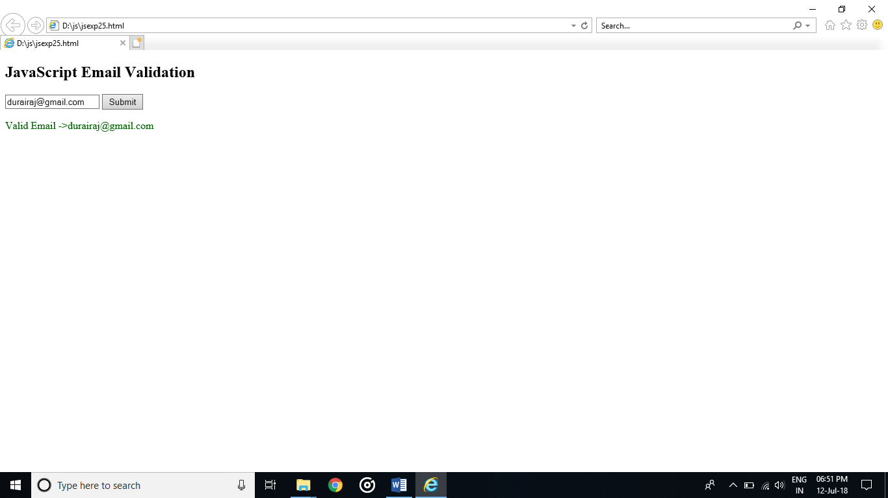

PROGRAM:  
<!--HTML javascript code to demonstrate form validation-->

<html>

<head>

<title>Form validation</title>

</head>

<body>

<form name="myForm" >

Name:<input type="text" name="name"><br><br>

Email: <input type="text" name="email"><br><br>

Address:<textarea rows="4" cols="50" name="comment" form="usrform">

</textarea>

</form>

<button onclick="valid()" >Register</button>

<script>

function valid(){

var x=document.forms["myForm"]["name"].value;

var y = document.forms["myForm"]["email"].value;

var atpos = x.indexOf("@");

var dotpos = x.lastIndexOf(".");

if (atpos<1 || dotpos<atpos+2 || dotpos+2>=x.length || x =="") {

alert("Invalid Input");}

else{

alert("Registred Successfully");}

}

</script>

</body>

</html>

OUTPUT:

