PROGRAM:

#FindingGreaterthan3Numbers.

a=int(input("EnterthevalueofA="))

b=int(input("EnterthevalueofB="))

c=int(input("EnterthevalueC="))

if(a>b)and(a>c):

print(a)

elif(b>c):

print(b)

else:

print(c)

OUTPUT:

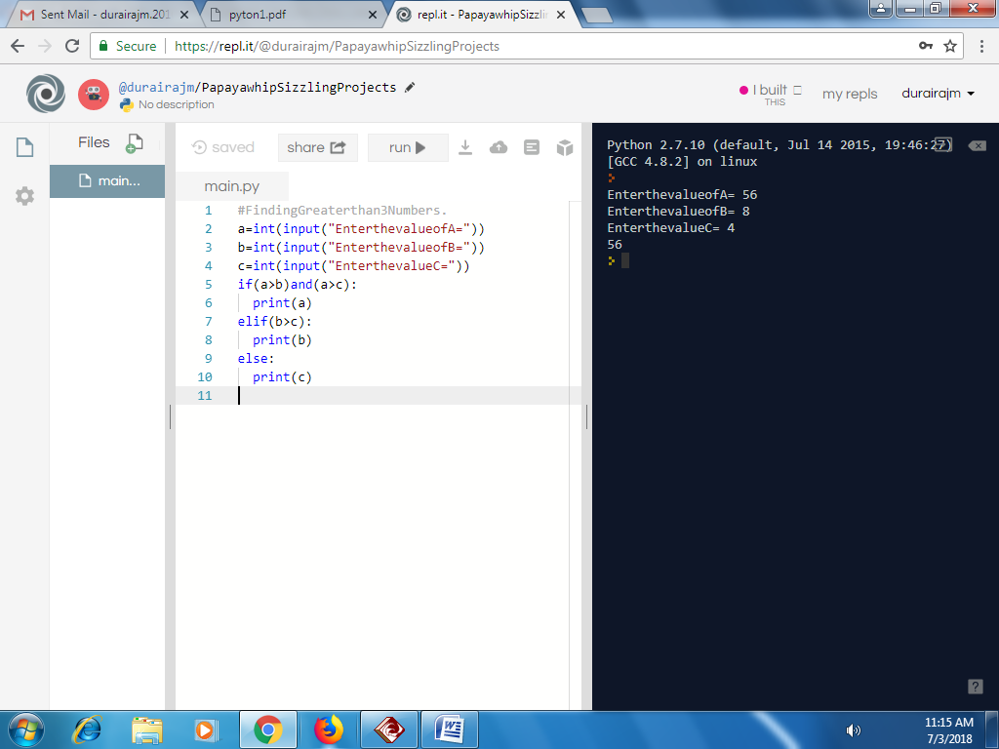

PROGRAM:

#AdditionofTwonumbers.

a=int(input("EnterthevalueofA="))

b=int(input("EnterthevalueofB="))

c=a+b

print(c)

OUTPUT:

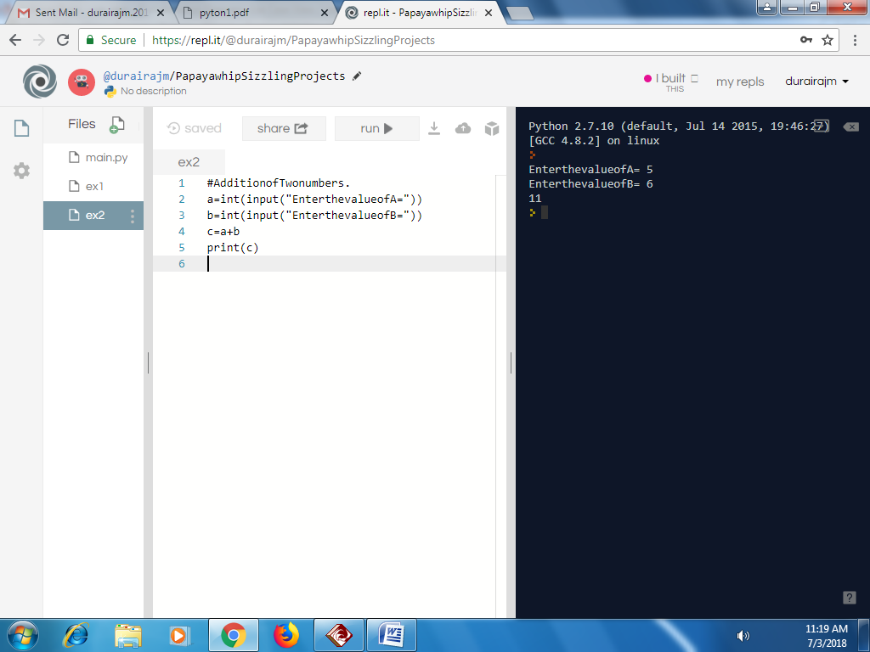

Program:

#Subtractionoftwonumbers

a=int(input("EnterthevalueofA="))

b=int(input("EnterthevalueofC="))

c=a-b

print(c)

OUTPUT:

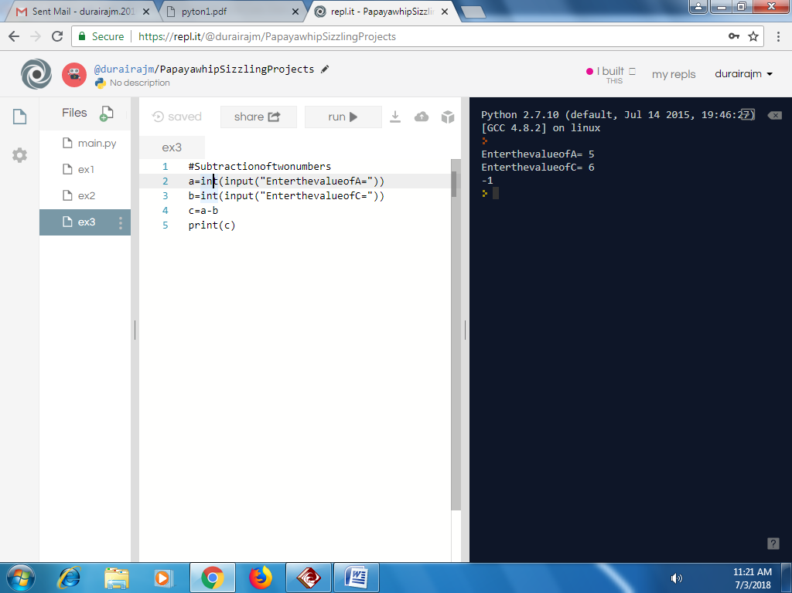

PROGRAM:

#MultiplicationofTwoNumbers.

a=int(input("EnterthevalueofA="))

b=int(input("EnterthevalueofB="))

c=a\*b

print(c)

OUTPUT:

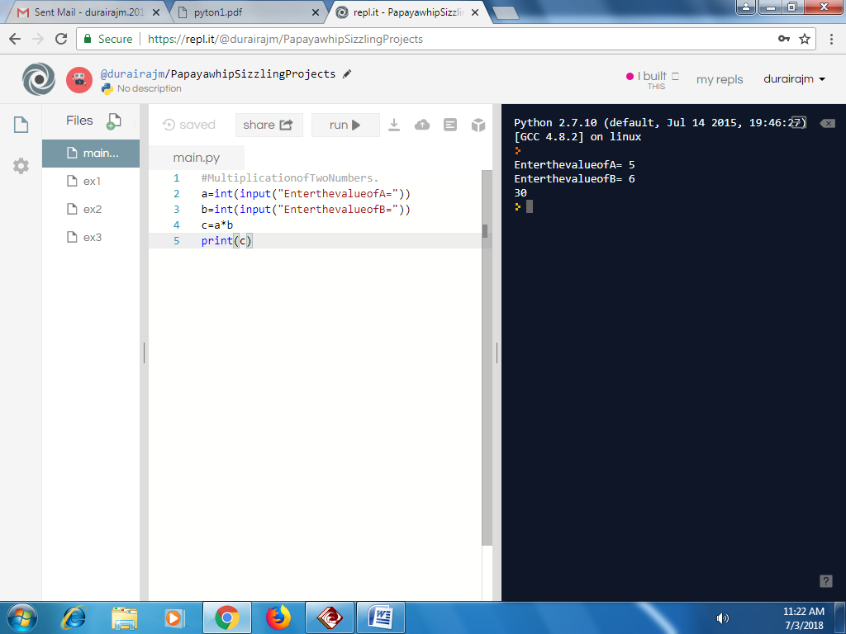

PROGRAM:

#Divisionoftwonumbers

a=int(input("EnterthevalueofA="))

b=int(input("EnterthevalueofB

c=a/b

print(c)

OUTPUT:

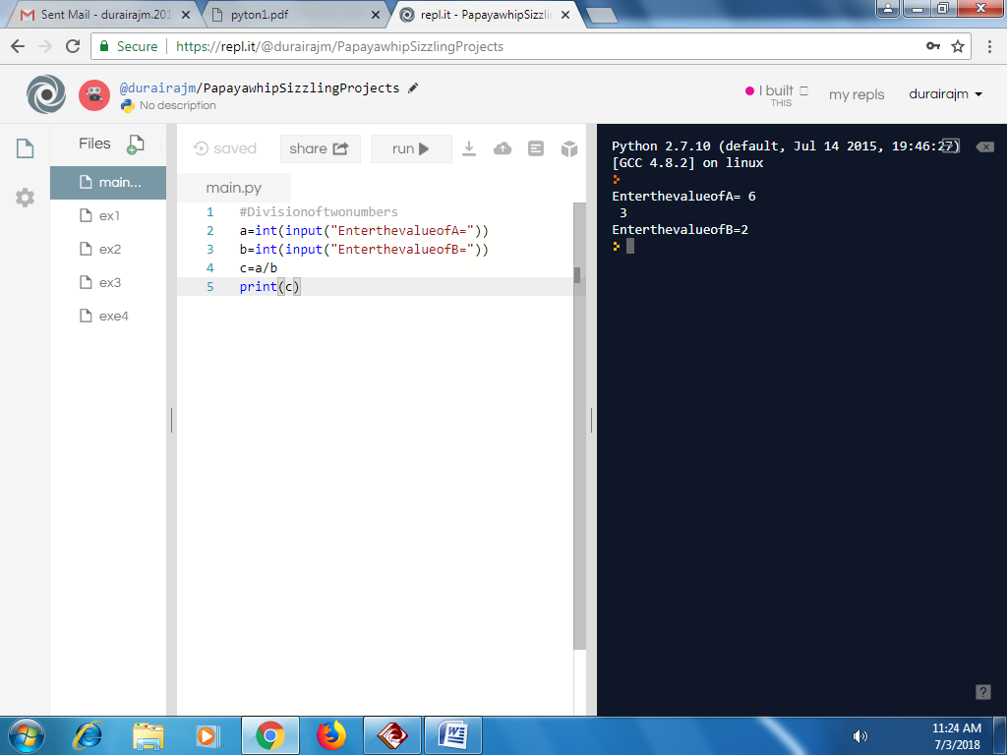

PROGRAM:

#Modulooftwonumbers

a=int(input("EnterthevalueofA="))

b=int(input("EnterthevalueofB="))

c=a%b

print(c)

OUTPUT:

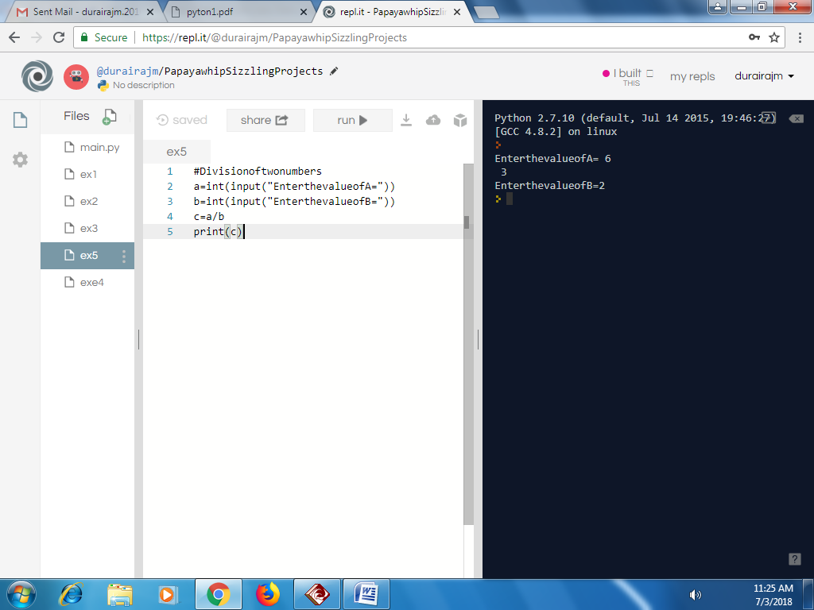

PROGRAM:

#Printingthehellopython

print("HelloPython\*\*\*\*\*")

OUTPUT:

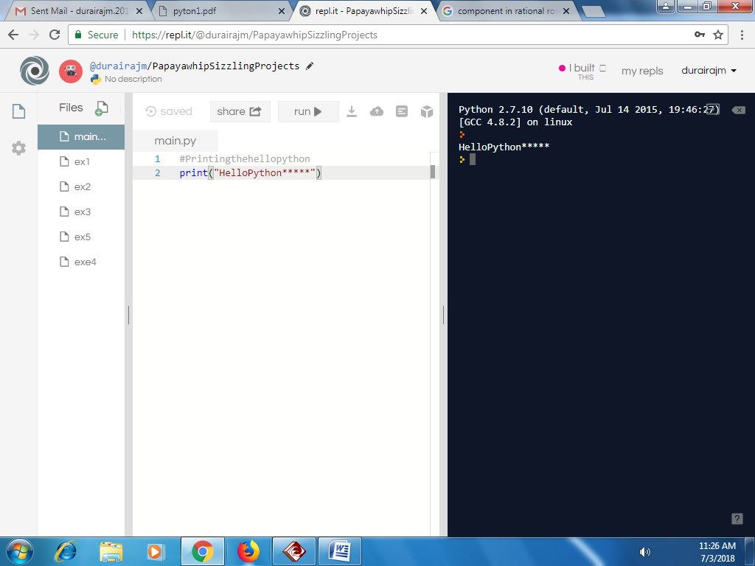

PROGRAM:

#Gettinginputandprinting

a=int(input("EnterthevalueofA="))

b=int(input("EnterthevalueofB="))

print("A=",a)

print("B=",b)

OUTPUT:

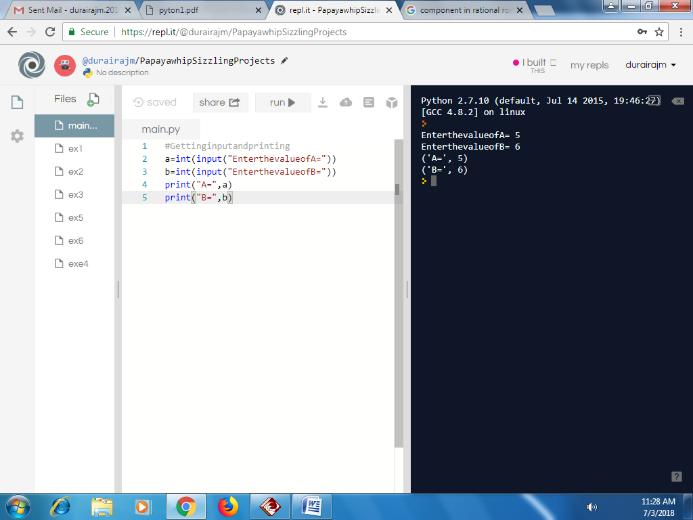

PROGRAM:

#FibbonacciSeries

n=int(input("Enterthevalue="))

a=0

b=1

i=2

print("FibbonacciSeriesuptorange=",n)

print(a)

print(b)

while(i<n):

c=a+b

print(c)

a=b

b=c

i=i+1

OUTPUT:  
