**Inferential Analysis**

* 1. Download the DatasetNaN values where replaced.

Data taken from the Preprocessed Placement Data

1.2 Replace the NaN value with the correct value

Replace it with 0.

Since the student is not placed, he cannot have any Salary. Hence ZERO is considered

* 1. How many of them are Not-placed ?

67 Students are Not-placed

1.5 What kind of relation between Salary and mba_p?

**variables VIF**

**0** mba_p 2.707661

**1** salary 2.707661

1.6 Which Specialization is getting the Minimum Salary?

Mkt&HR

1.7 How many of them are getting above 500000 salary?

42 are getting above Rs.500000

1.8 ANOVA between etest_p and mba_p

F_onewayResult(statistic=98.64487057324706, pvalue=4.672547689133573e-21)

p < 0.05. Hence there is significant difference between etest_p and mba_p

1.9 Test similarity between the degree_t(Sci&Tech) and specialisation(Mkt&HR) w.r.t the Salary at significance level of 5% (Make decision using Hypothesis Testing)

TtestResult(statistic=2.692041243555374, pvalue=0.007897969943471179, df=152.0)

0.7% - is a good probability. Hence, Sci&Tech and Mkt&HR have good Correlation with Salary

1.10 Convert Normal Distribution to Standard normal Distribution for Salary Column

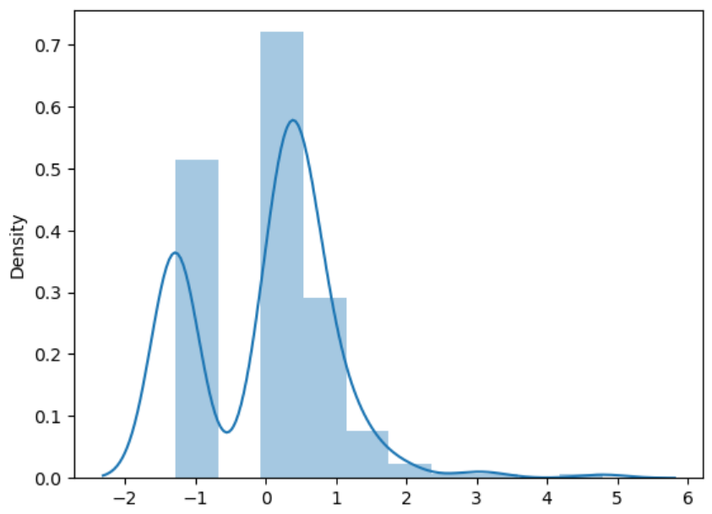

1.11 What is the Probability Density Function of the Salary range from 700000 to 900000?

Mean=198702.326, Standard Deviation=154780.927

The area between range(700000,900000):0.0005973310593974901

The Probability Density Function of the Salary range from 700000 to 900000 is: 0.000597

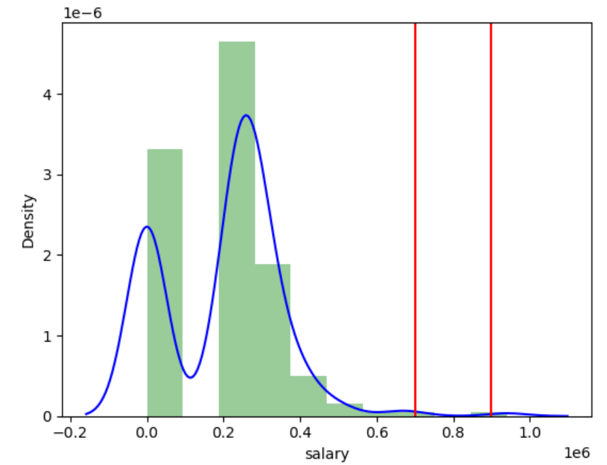

1.12 Test the similarity between the degree_t (Sci&Tech) with respect to etest_p and mba_p at significance level of 5% (Use Hypothesis Testing)

TtestResult(statistic=5.0049844583693615, pvalue=5.517920600505392e-06, df=58)

551% - is NOT a good probability

1.13 Which parameter is highly correlated with Salary?

etest_p

1.14 Plot any useful graph and explain it.

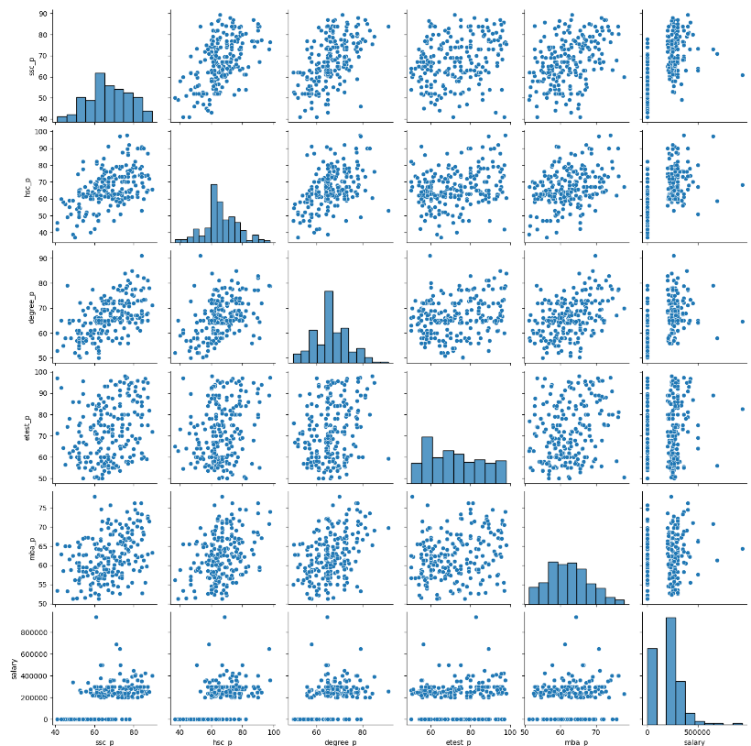

ssc_p and degree_p has good correlation