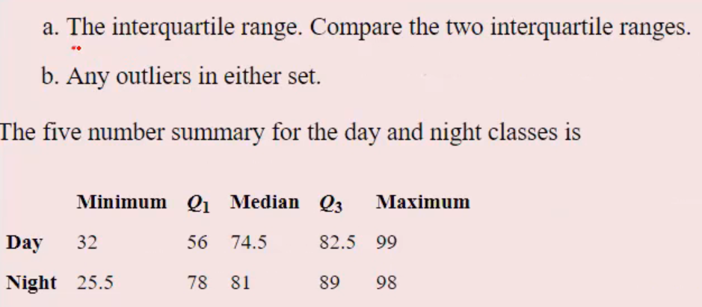

**Day:**

IQR = Q3-Q1= 82.5-56 = 26.5

Lesser Outlier = Q1 – 1.5xIQR

= 56-1.5x26.5

= 16.25

Greater Outlier = Q3 + 1.5xIQR

= 82.5+1.5x26.5

= 122.25

**Inference:**

**Min & Max values are Within Range**

**Night:**

IQR = Q3-Q1= 89-78 = 11

Lesser Outlier = Q1 – 1.5xIQR

= 78-1.5x11

= 61.5

Greater Outlier = Q3 + 1.5xIQR

= 89+1.5x11

= 105.5

**Inference:**

**Min value is in Lesser Outlier**

**Max value is Within Range**