1. Basic CSS Implementation Methods

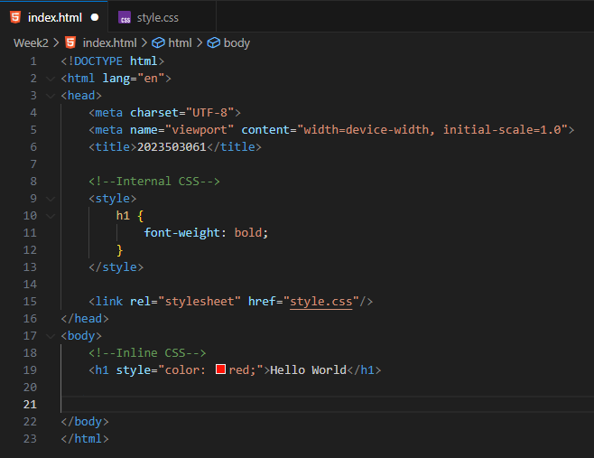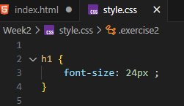

OUTPUT:

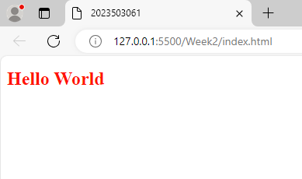

2. ID and Class Selectors

 <p id="ex2" class="exercise2">Welcome to the Audi Showroom! We provide you the best Audi cars at the mid range price. What is the reason for this?? You can have a doubt why we provide at low cost. Because we want middle class family should enjoy the luxurious car.</p>

#ex2 {

    background-color: blue;

    padding: 20px;

}

.exercise2 {

    color: white;

}

OUTPUT:

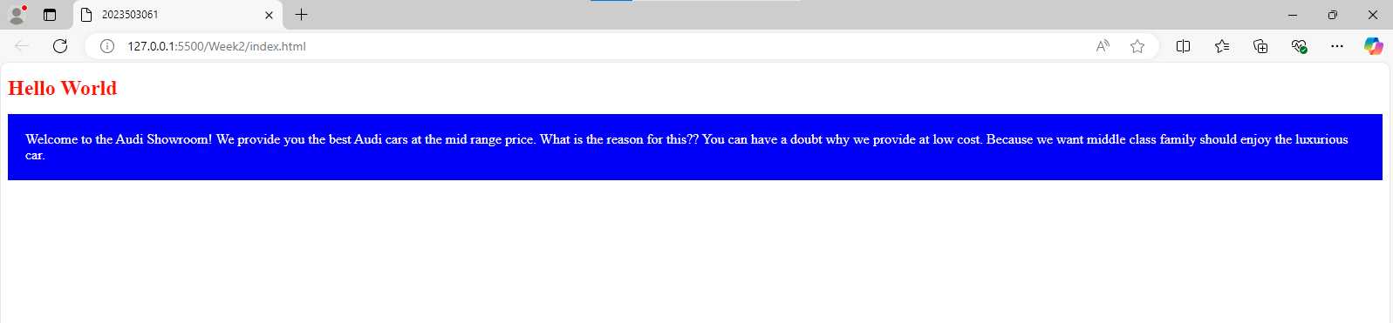

3. Font Properties

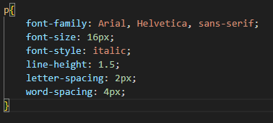

OUTPUT:

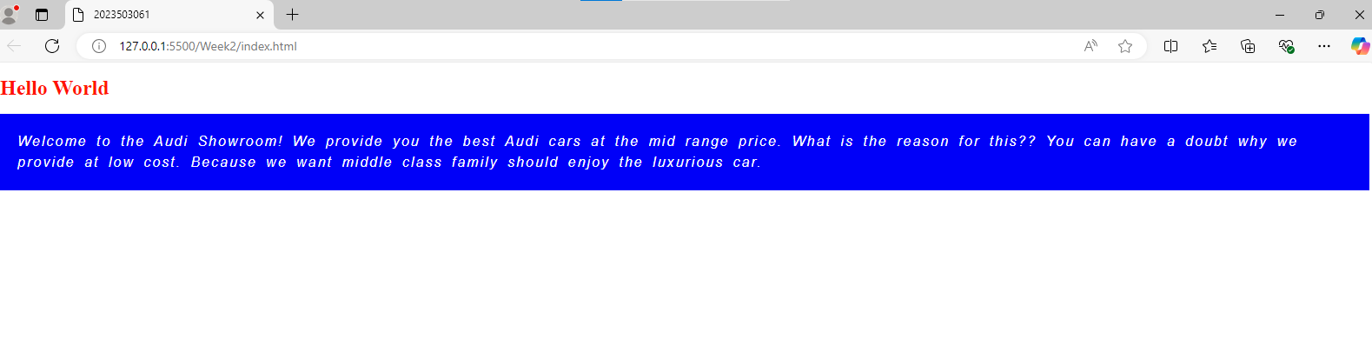

4. Text Properties

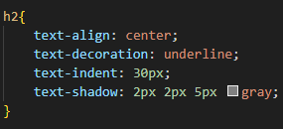

OUTPUT:

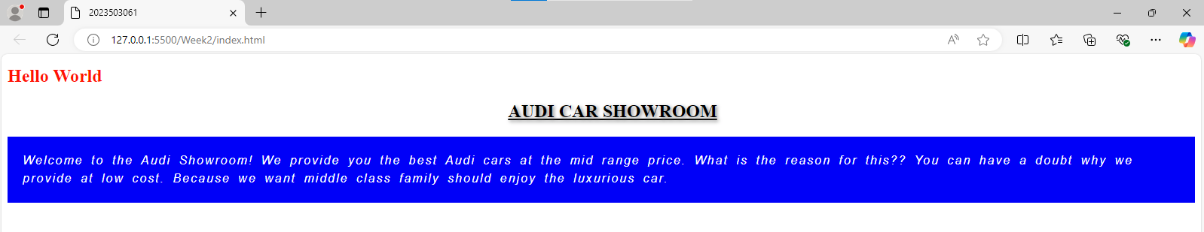

5. Border Properties

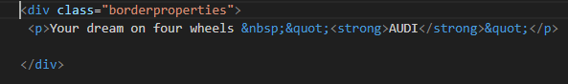

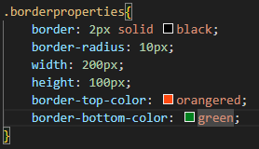

OUTPUT:

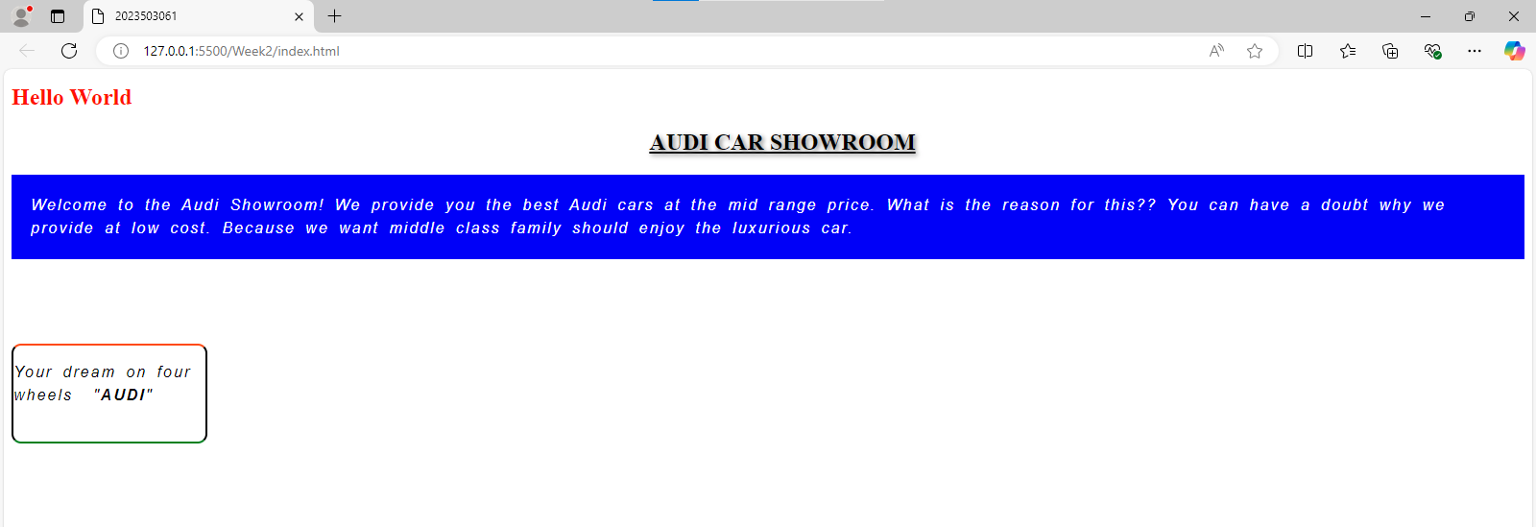

6. Box Shadow

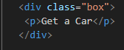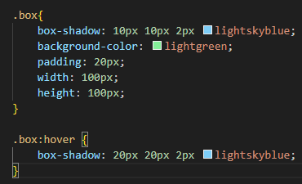

OUTPUT:

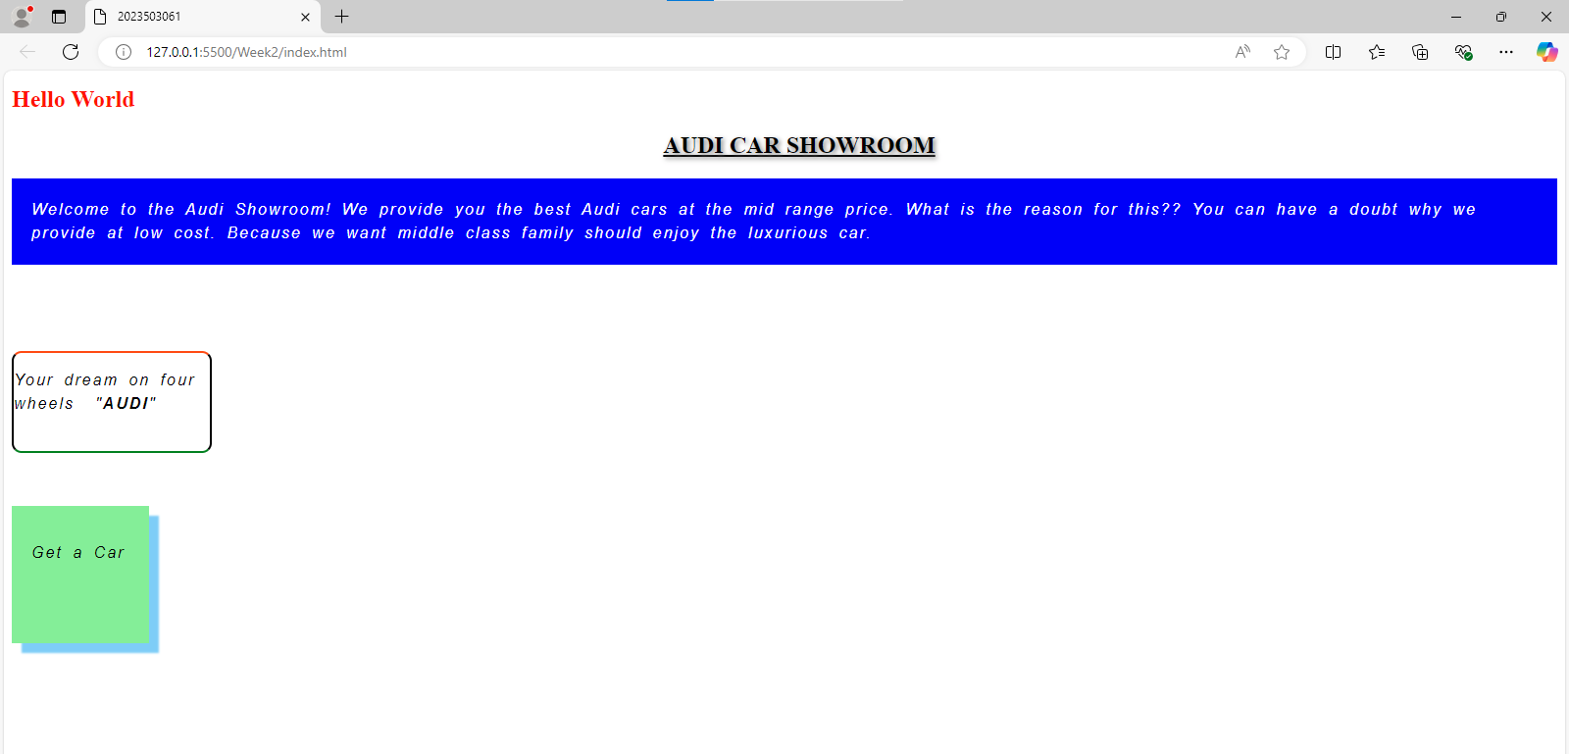

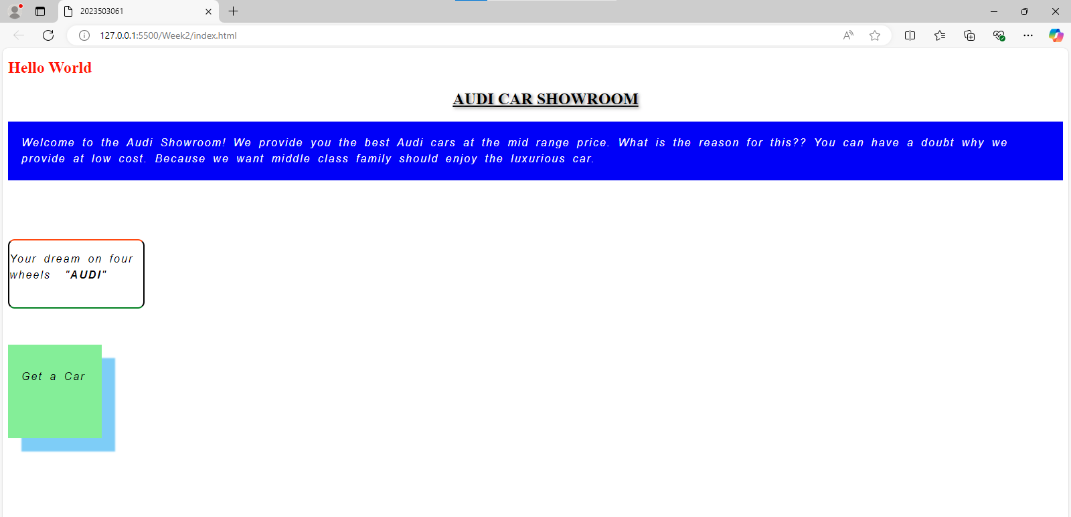

7. Margin and Padding

 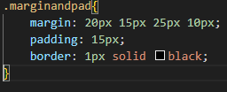

OUTPUT:

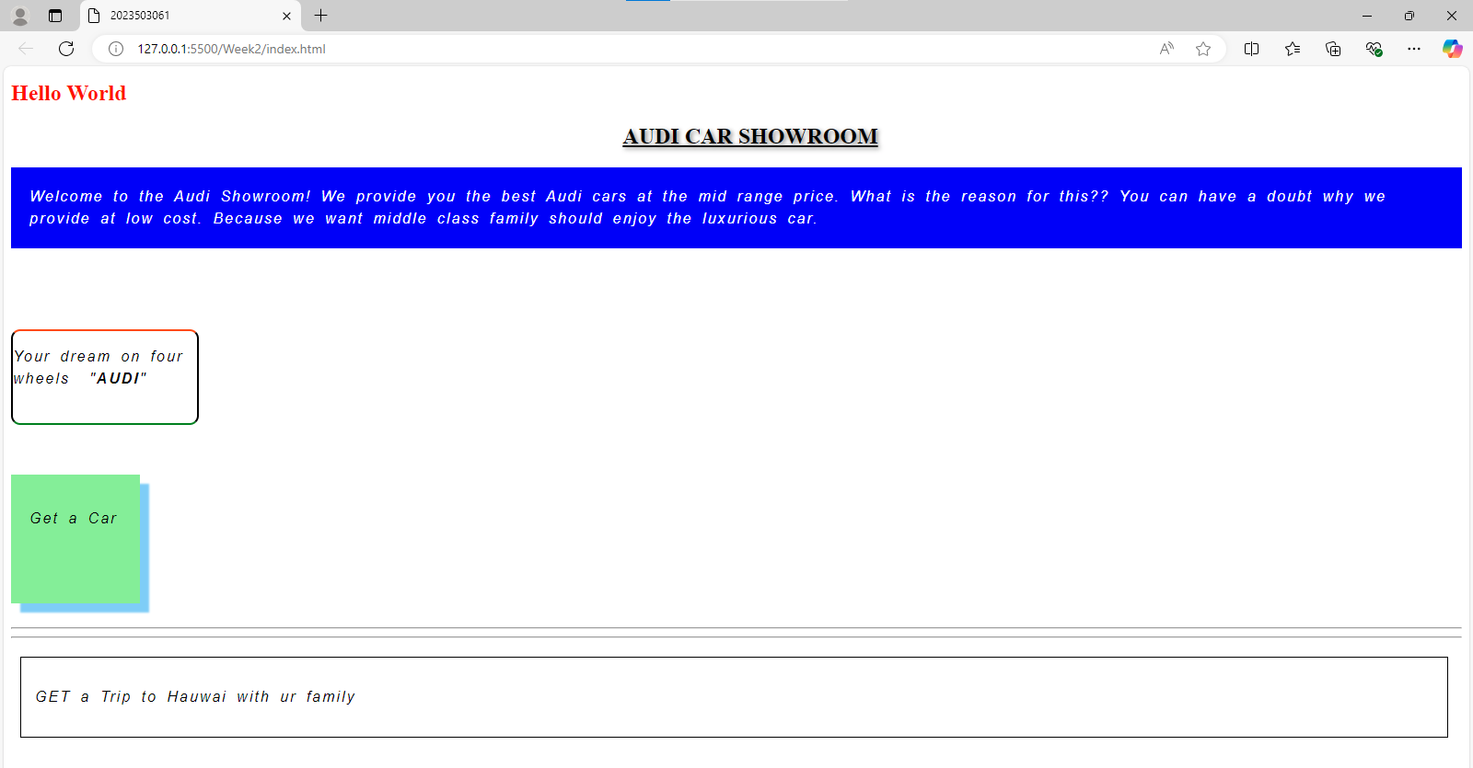

8. Float and Overflow

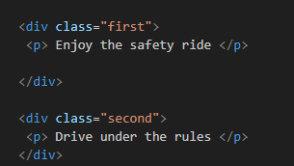 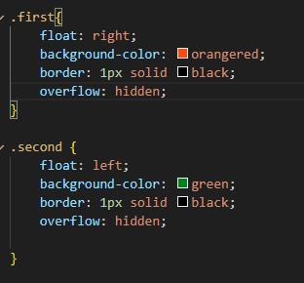 OUTPUT:

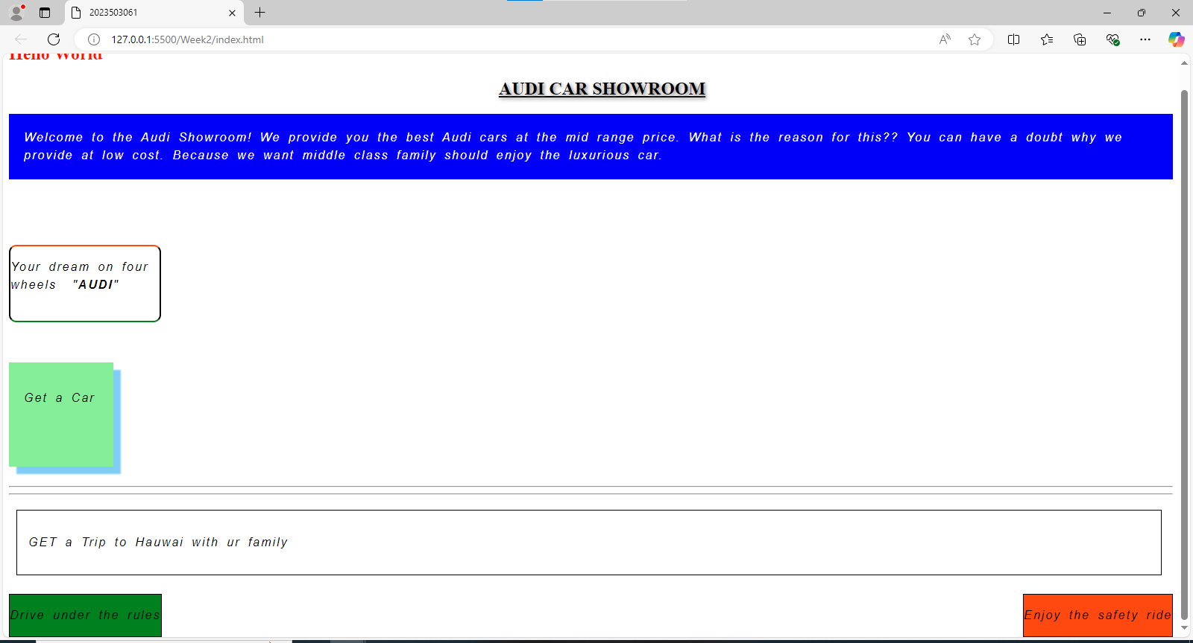

9. Display Properties

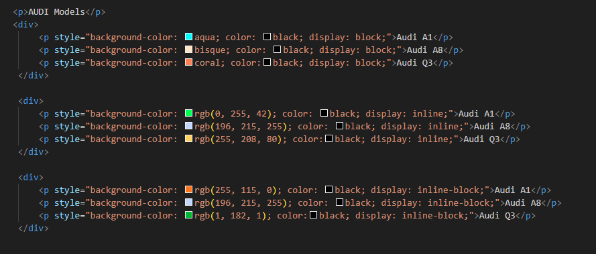

OUTPUT:

