Problem Statement

# Introduction

Varsity College lecturers find it difficult and tedious to record student attendance. Currently, a manual process is used whereby lecturers receive a register. This register contains the names and student numbers of all the students. Each student must sign their initials. The lecturers would like an app that can verify if a student is on campus.

# Program Specification

## App Description

This app should be able to retrieve the location of the student and check if it matches the campus address. If it does, the relevant data will be saved to a database. The data that will be saved will include: the student number, the date and time and the module code that the student attended. The students should be able to check in and check out. Check in will verify the students location. If the student is at the designated venue their student number, attendance time, date and module will be saved to an online database. Check out will then verify if they are at the location and then save their check out time from the lecture. Lastly, the lecturer should also be able to generate a report of the students who attendance a particular module. The student will also be able to view their attendance record on the application.

## Functionality

* Retrieve location using geocoder and Google api (Fused Location Provider)
* Show google Map and draw polylines tracking the students movements
* Saved data to an online database hosted on awards space
* Created a php scripts that communicates with android app and MYSQL database
* Made use of a JSON object to read the data from the MYSQL database
* Read from a text file
* Incorporated Geofencing into the project
* Display notifications to the user
* Incorporated Material Design into the application utilizing a Sliding Tab Layout
* Used Async task and Intent Service to reduce the work load on the Main UI thread
* Made use of share preferences to store data
* A website has been incorporated in the system. This allows lecturers to view reports. The data is retrieved from the online database
* Created store procedures in MYSQL

## 

## System Requirements

**Student Registration Start up Screen**

*This screen requires the student to enter in their basic details. These details include student number, student name and student course. This data will be saved to a shared preference and will later be sent to the database once the student has checked out. This screen will only appear and will never reappear unless the student uninstalls the app.*

***Student Main***

*This screen contains a sliding tab layout that contains 2 Fragments. The first Fragment (Check In) requires that the student first enter in the module that they are in. Provided that their location and wifi settings are on, they will be able to check in. A dialog box will be presented to prompt the user to turn on these settings. After clicking the red button, the location of the user is verified. Once a location has been found, the student can now close the app and return to it once the lecture has ended. Upon, closing the app, a notification will appear to remind the user to return to the app to check out. In addition, the app will also set a geofence after checking in. If the student leaves the geofence a notification will appear to notify the user to return to the lecture venue to check out. After checking out, the student’s details will get sent to the online database.*

*The Second Fragment (Report) contains a list view that contains the students information of the lectures he/she has attended. This allows the student to verify and view their attendance records.*

**Student Map**

*This screen contains a google map that locates the user. The map draws a poly line has the device moves.*

**Student Help**

*This displays a screen with information on how to use the application*

## Website/Backend

Web Site Link: http://duran.dx.am/attendanceRecord.php

The lecturer can also view a report of all the students’ attendance.

The lecturer can do the following on the website:

* Search for a particular students attendance records
* Search attendance for a module
* View all records

**Search Web Page**

*This presents the lecturer with search options. This includes: Student, Module or View all. Clicking on these options will redirect the lecturer to the designated web page.*

**Student Search Web Page**

*This presents the lecturer with a text field to enter in a student number. Clicking search will display a table with the student’s attendance record for all modules.*

**Module Search Web Page**

*This presents the lecturer with a text field to enter in a module code. Clicking search will display a table with all the attendance for the module code.*

**View All Attendance Web Page**

*This displays a list of all attendance for all modules and courses for every student*

# Screenshots

Registration Screen Registration Screen - Validation

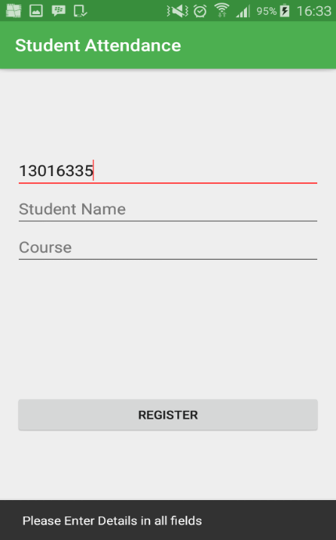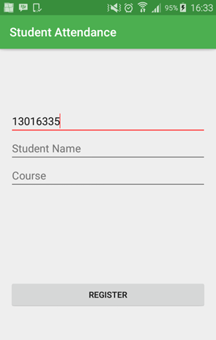

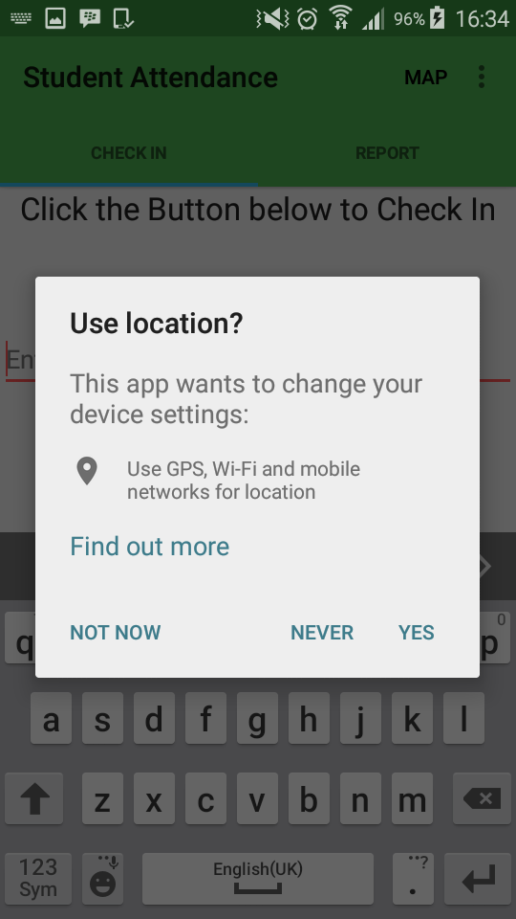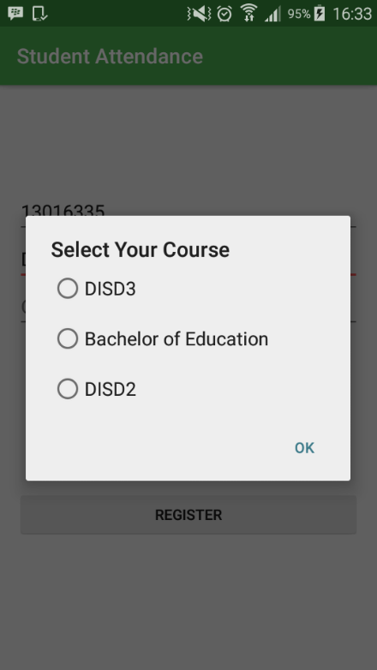Registration – Dialog to select course Check in Fragment – Dialog to turn on Location Settings

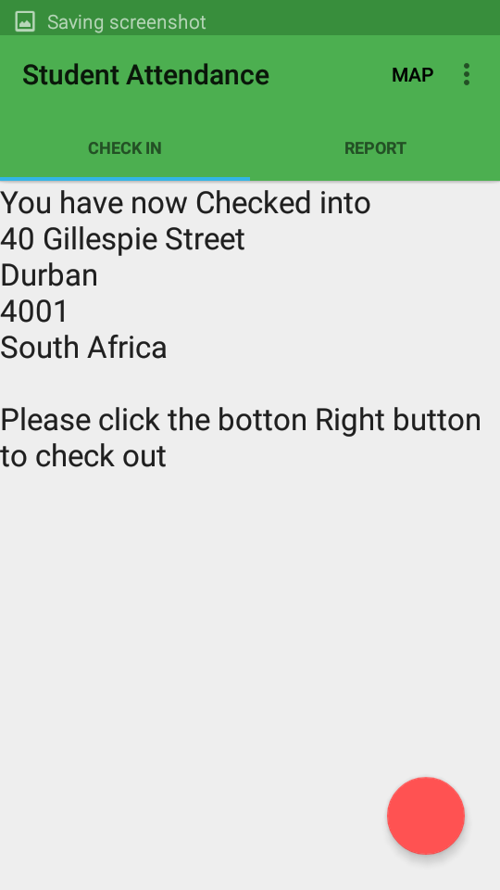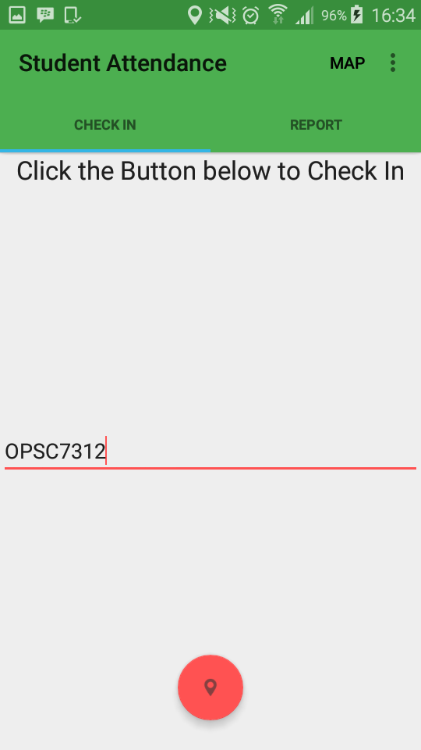Check in – Student Entering Module Check In – Student Has Checked in

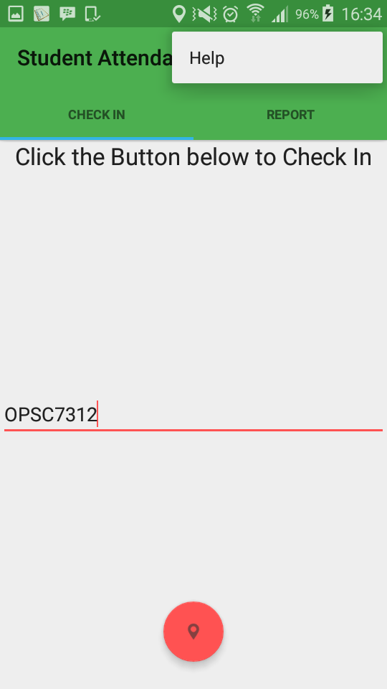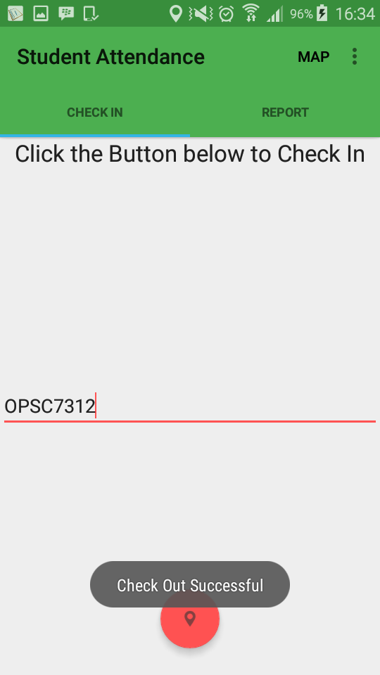Check in- Student has successfully checked out Check in – Help Option

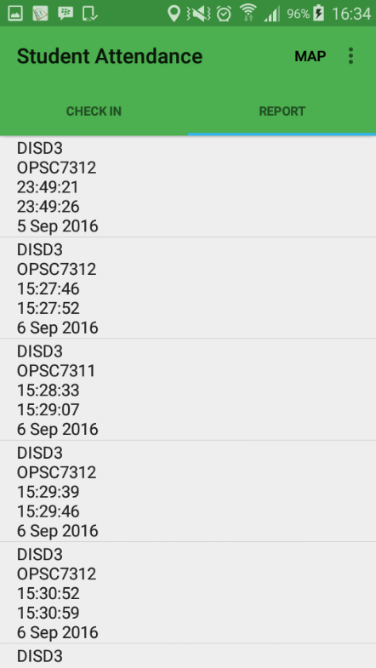Student Report – Shows Attendance Help Screen

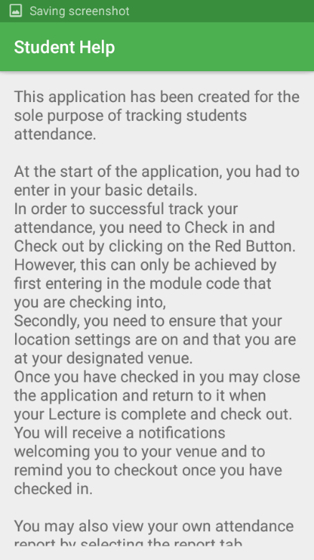

Student Map – Showing Location Student Map – Polyline drawn

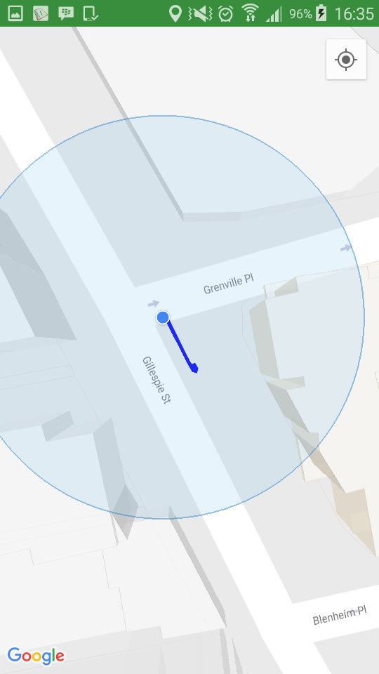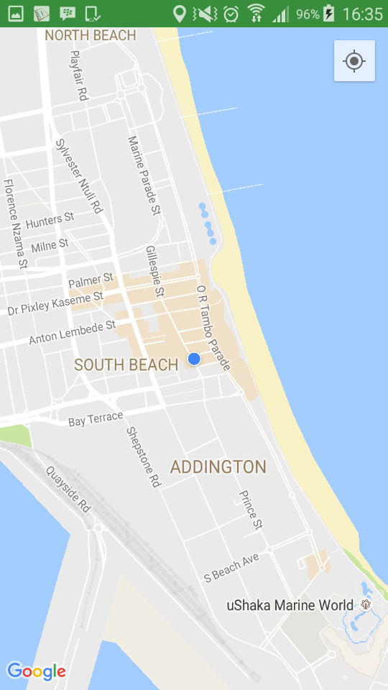

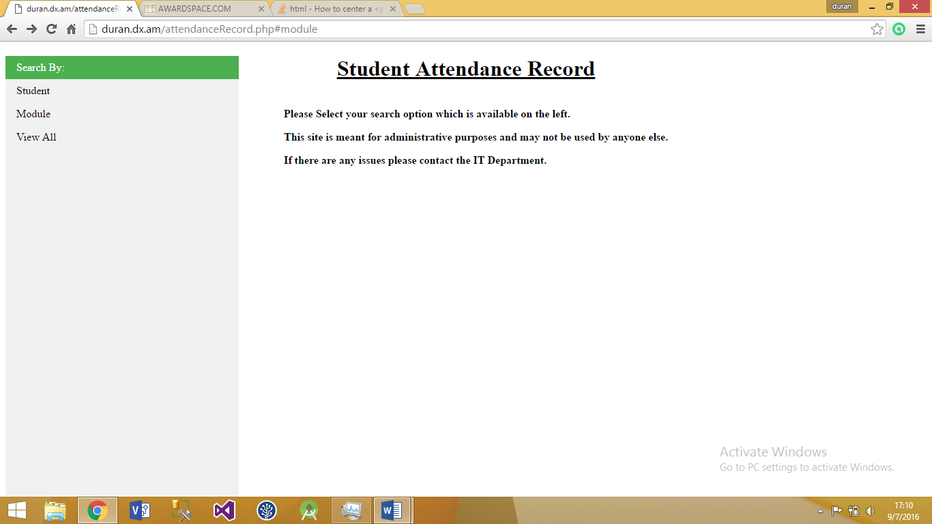Start Web page: Select Search option

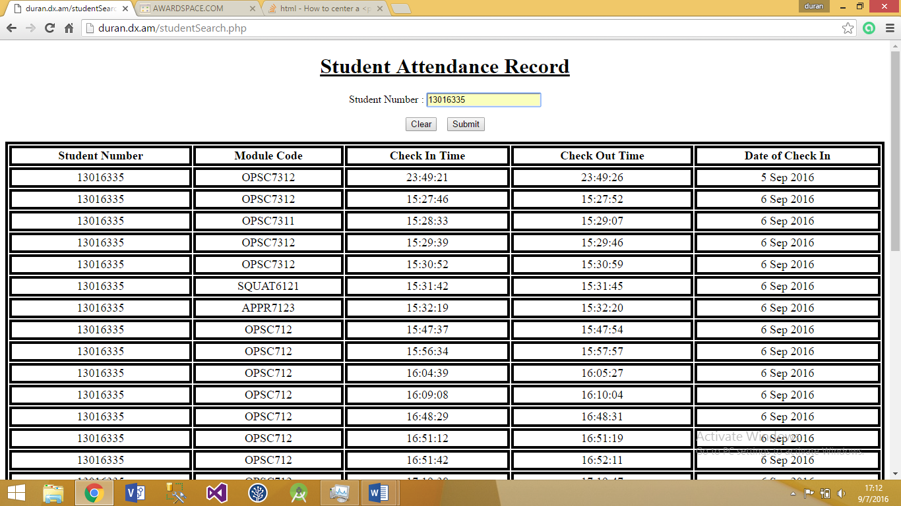Student Search: Student number entered and attendance report generated

Modu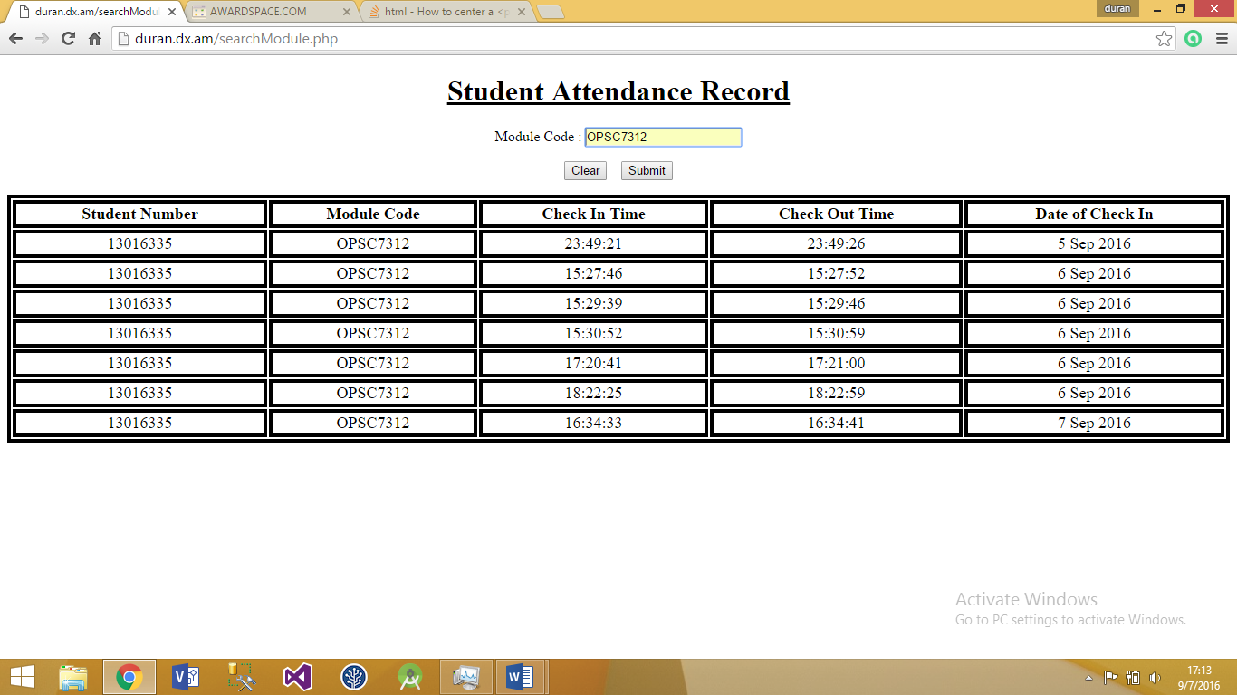le Search Page