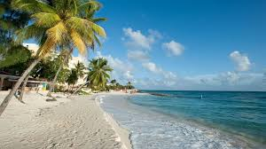**Project Proposal of SafeTravelBD**

***Submitted By:***

**Group 9 ( A1)**

**Rajesh Debnath**

**(Student ID: 1305017)**

**Mostofa Rafid Uddin**

**(Student ID: 1305039)**

Table of Contents

Scope and Motivation 3

Objective 3

Functionalities 4

User Interfaces 5

Tools and Technologies 11

Working Schedule 11

Afterwards 12

Scope and Motivation

The tourism sector in Bangladesh has obtained a marvelous growth in recent days. People are choosing travelling as one of the most common source of entertainment. When they get a vacation, they plan a tour – with families or friends or both. Again, most of the tourists are young (in most of the case university students) as usual. They try to celebrate the relief from the pressure of academics by making trips with friends to the most naturally attractive places in Bangladesh. Young minds are adventurous – they jump and swim in water streams, climb hills and does whatever the thrill let them do. But the sad part is often they harm themselves; sometimes with their lives. Many just blame the adventurous minds of the youth for it. But there is actually more reasons to observe –

1. There are many travel guide related applications that informs the tourists about the tourist spots of Bangladesh and the hotels available there, about the popular foods and products of that place etc. Recently there have been an app launched by the BD Police named ‘Hello Tourist BD’ [1]to help the tourists in security issues. But there is still no well enough reliable system that keeps track of the danger zones in the tourist areas in Bangladesh. So the tourists do not get a reliable source to know about them.
2. There is no database of the accidents that occurs in these tourist areas so that the tourism authority can do analysis with it and let the tourists know about it.
3. There is no way that a tourist can know about the environmental and geographical risks of a place that another tourist has faced before. There are some facebook groups like “BD Travellers” etc. but they don’t serve the purpose well.

So, we thought of an approach to solve these problems with a reliable and sound software system.

Objective

After analyzing the existing software systems in foreign countries regarding environmental and geographical safety in tourist spots and scrutinizing the context in our country, we have fixed some goals that we want to achieve :

1. To provide the tourists with information on the risky areas including hillside streams, oozy slopes in sea, quick sands, water streams with dangerous water animals etc.
2. To provide the tourists with tide chart of rivers/sea so that the tourists can know whether it will be okay for them to go in water. In many foreign countries there are apps for it like “My Tide Times”, “Tide”, “DGS Tides” etc. [2]
3. To provide the tourists with the pollution information of water streams in a tourist spot about if that stream’s water is safe to swim for the users. In New Zealand an application like this have launched recently.[3]
4. To make a platform for the tourists where they can share their bad experiences regarding these dangers while travelling and where other tourists and authorities can know about them.
5. To make a database of the accidents and deaths occurred in various tourist spots so that the tourism authority can use it later for research purposes.

Functionalities

We will provide functionalities to mainly two types of users.

1. Tourists
2. Tourism Authority

**Tourist Functionalities:**

Tourists will receive the following functionalities from the software :

**Create and Update Account :**

* Sign up with Facebook or Google account or by manually registering
* Update account information

**Experience Sharing :**

* Share their suffering stories with some categorized inputs (experience type, reason).
* Upload images or videos of the place where they faced problems with their stories. S
* Share their posted stories on our app to social medias like ‘Facebook’ with just one tap only.

**Search and Know about the Risky Areas :**

* Search for the tourist spots categorized with district and division and see the list of risky places on that spot.
* Know information about the risky places in the app.
* View the risky areas pointed in google maps.

**View User Stories about an spot :**

* Search for spots and view all the user stories in that spot.
* Mark those stories as important or report as fake. They will be submitted to the authority.

**View Additional Information about an spot :**

* Tide charts in river/sea
* Any weather danger forecast.(typically in sea areas)

**Authority Functionalities:**

Tourist authority is also a user. So, he/she will have all the functionalities of a tourist with some modification or extra features. We are enlisting here those modified or extra features only.

**Sign in and update information :**

* Sign in with an provided username and password
* Update information

**Watch Reports on a post and Delete it:**

* See the “report as inappropriate” reports on user stories.
* Delete the post accordingly or ignore the report

**Post about accidents and death incidents :**

* Post about death incidents or serious injuries of people in a tourist spot as a story
* No user will be able to report or mark admin stories.

User Interfaces

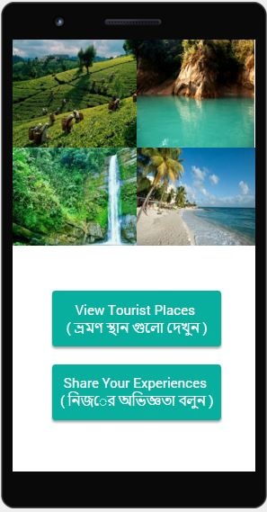

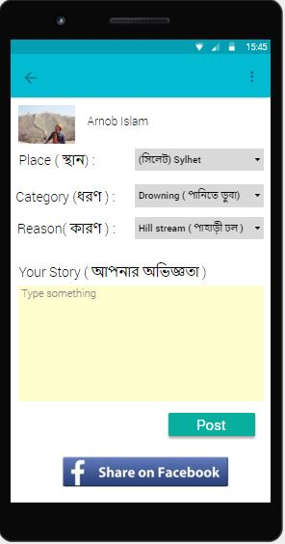

1. (ii)

Figure 1 : (i) Home page of the application

(ii) Share Story Page

:

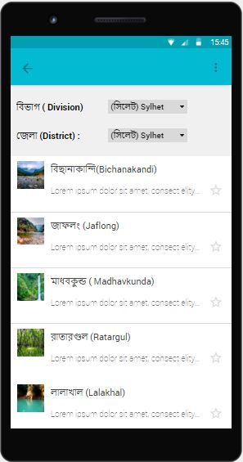

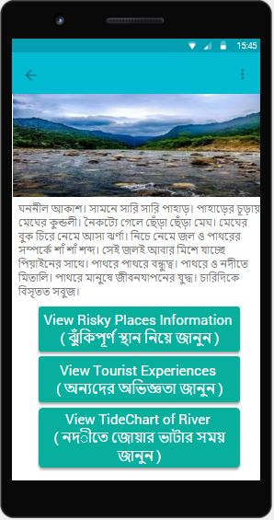

(i) (ii)

Figure 2: (i) Searching for Pages

(ii) Information about a place

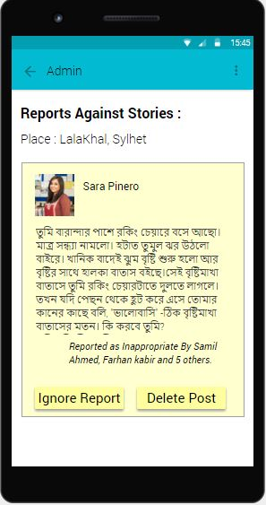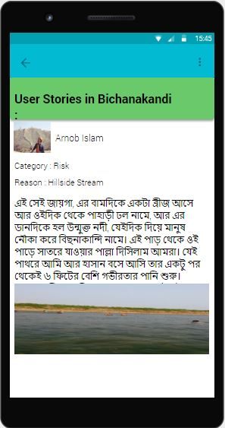

(i) (ii)

Figure 3: (i) User stories on a tourist site

(ii) Reported user story on admin side.

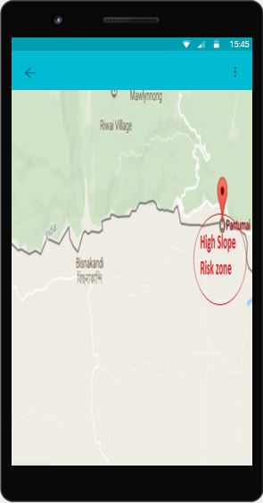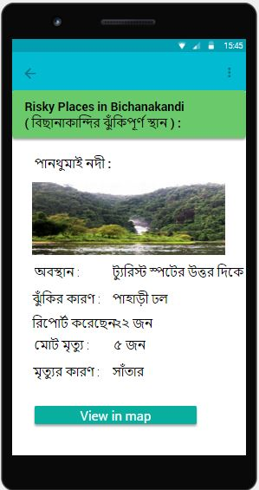

(i) (ii)

Figure 4: (i) Risky places in a tourists site

(ii) Viewing risky places in Google Maps

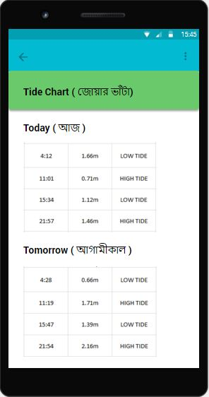

Figure 5: Tide chart Page

Tools and Technologies

We want to make this application a cross platform one. So we’ve decided to use the following technologies to use :

**Front End :**

We will use Ionic framework ( html5, css3, javascript) for front end. Our front end should be integrated with Google Maps API and Facebook API.

**Back End :**

For Back End, We’ve decided to use Django framework ( Python). In back end, we will have a mysql database in a running Apache Server.

**Communication between Both Ends :**

Communication between both ends will be done using Django REST API and JSON through Http requests.

Working Schedule

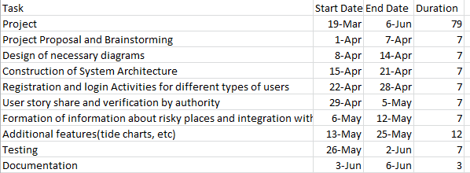

Figure 6: Project Schedule

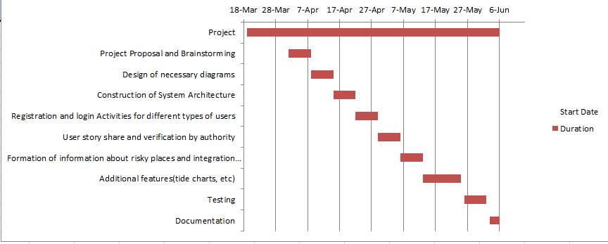

Figure 7: Gantt Chart

Afterwards

We are trying to initiate a software system in our country by analyzing the problem domain and existing systems. We hope this system in activation will help to reduce the deaths and accidents in tourism in Bangladesh and so, Bangladesh will obtain more reputation and recognition in her tourism sector.

1. https://play.google.com/store/apps/details?id=shuru.shakil.tourist.hello.hellotourist&hl=en
2. <https://play.google.com/store/search?q=tide%20apps&c=apps&hl=en>
3. <http://www.newshub.co.nz/home/new-zealand/2016/12/can-i-swim-here-the-app-designed-to-ensure-local-water-spots-are-safe.html>