Resources

**Compile Java Online** [www.tutorialspoint.com/compile_java_online.php](http://www.tutorialspoint.com/compile_java_online.php)

**jEdit** [www.jedit.org](http://www.jedit.org)

* click “download”
* click “Windows Installer” or “Mac OS X package”

**DrJava** [www.drjava.org](http://www.drjava.org/)

Top 10 Programming Languages in 2015

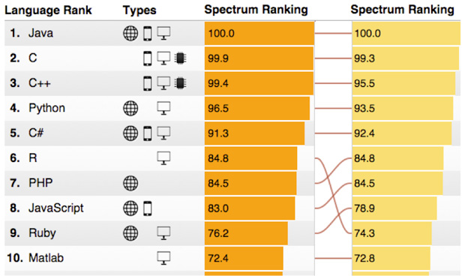

(<http://spectrum.ieee.org/computing/software/the-2015-top-ten-programming-languages>)

Arduino [www.arduino.cc](https://www.arduino.cc)

Raspberry Pi [www.raspberrypi.org](http://www.raspberrypi.org)