SRS Assignment

Project Name: Uni-Invest

# **Course Code:** CSE 3411/CSI 311 (A)

# **Course Name:** System Analysis and Design

**Section:** (A)

**Submitted To**

## Ajwad Akil

Lecturer

United International University

**Submitted By**

## 

Date of Submission: **31st December 2022**

**Introduction**

**1.1 Purpose**

This document aims to build an online money invest for all type of people. Through our system, they can know about our Businessman information and their profit ratio quickly and easily.Through this website will help all type of investor and all type of businessman get advice and information from experts in the industry.Busineesman found their fund for their business and Investor can find their best deal for their money invest. After graduation, if any student wants to apply to any company, through this website, he/she can find their jobs here.

**1.2 Document Conventions**

db - Database

**1.3 Intended Audience And Reading Suggestions**

The main objective of this system is to connect all type of investor and Businessman. This system will help fresh graduates to take job preparation and get advice from experts.

**1.4 Project Scope**

The main purpose of this project is to help all type of people .they can invest all type of amount and make profit here.Many businessman cannot find their fund because of many difficulties,in here they can get fund for their business.Fresh graduates to find jobs for the industry because here is a portal for for job seekers. Through this system, we want to build an investment area so that they can get money invest advice and information from the expert and they will able to know about invest money and found their best deal for both investor and businessman.

The system is based on a relational database with investor information,businessman information, online auto invest, expert advice,job seekers find their jobs and many other facilities. Above all, we will provide those features.

**1.5 References**

**2 Over All Description**

**2.1 Product Perspective**

Through our system users will get the following information:

* Investor Information

It includes the information of money invest and their profit ratio according to their invest.

* Businessman Information

It includes the information, and their profit ratio .

* Auto investment

It includes all information amount of money and organized by

* Investment advice

It includes investment suggested by expert

* Job Application

Users can apply for Jobs which are posted by companies.

**2.2 Product Features**

The major features of our system as shown below

Use Case Diagram

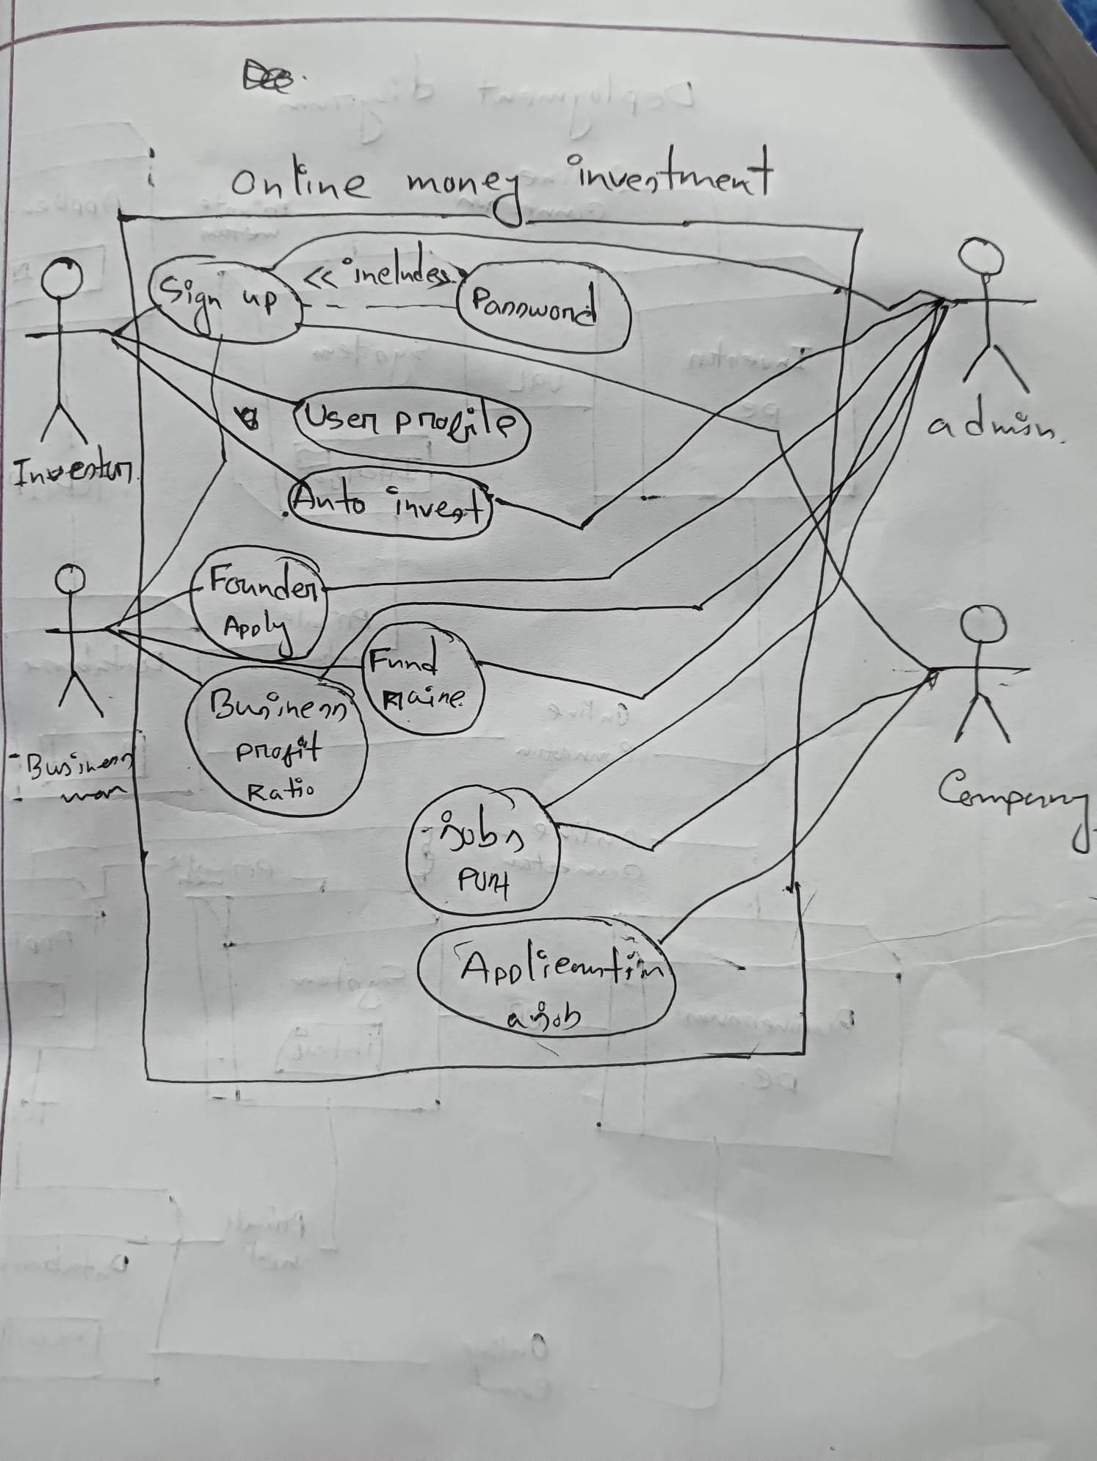

**2.3 User Class and Characteristics**

Users of this system should be able to find information related to their careers.

There are four kinds of users in this system Investor, Businessman, Admin and Organization company.

The Businessman should be able to do the following functions:

* Apply for funding
* Read all rules.
* Log in /log out

The Investor should be able to do the following functions:

* Apply for investment
* Log in/log out
* Read all rules.
* Apply for auto invest.
* Find expert advisor.
* Find Company Details.
* View Review of a company

The Admin should be able to do the following functions:

* View Investor,Businessman and companies.
* Set profit value.
* Post total amount of invest.
* Post update profit ratio.
* Post Jobs

The companies should be able to do the following functions:

* Post Job
* View Applicants

**2.4 Deployment diagram**

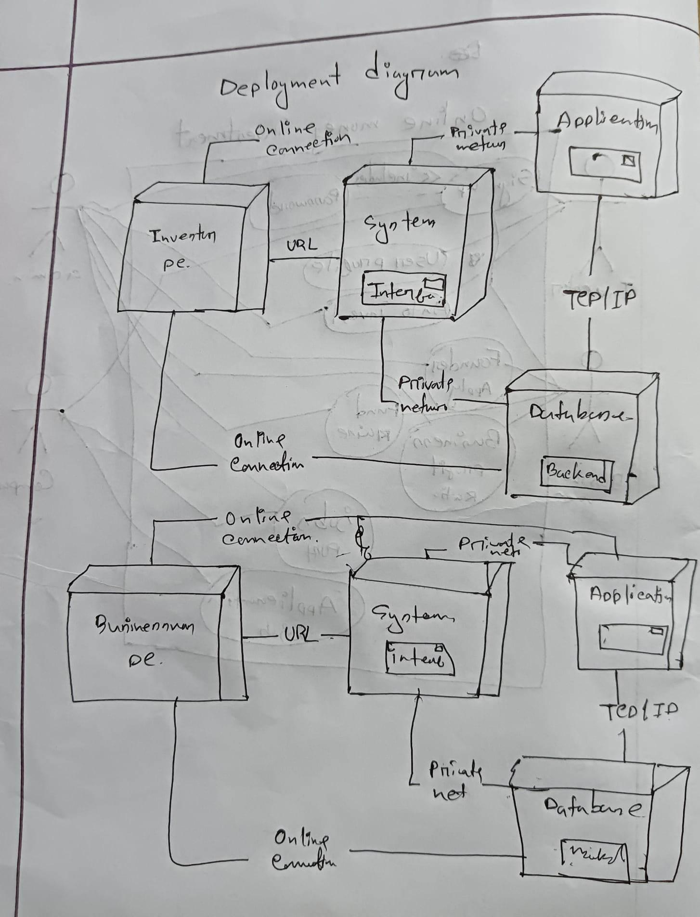

**2.4 Operating Environment**

Our system is based on the following tools and computer languages:

Front-End Tools and Technologies

* HTML
* CSS
* Bootstrap

Back-End Tools and Technologies

* PHP

Database

* MySQL

**2.5 User Environment**

HARDWARE REQUIREMENT

* Processor: Intel Pentium 4
* RAM: 512 MB RAM
* Monitor: 15” colour printer
* Processor speed: 1.7 GHZ

**2.6 Design and Implementation Constraints**

* Design database
* Implement the database at least using a centralized database management system
* SQL commands for the appropriate queries
* Design Front-end
* Connect with database
* Make the system responsive for all devices

**2.7 Assumption Dependencies**

Let us assume that this system is designed for students and it is used in the following application:

* An investor will log in to our system then he/she will create a profile with appropriate information. Then if he/she has any query about anything he/she can post in the forum section.
* A businessman will log in to our system then he/she will create a profile with appropriate information. Then if he/she has any query about anything he/she can post in the forum section.
* Admin will set all access and post all things.
* Organization will post jobs in this system so that job seekers can apply for those jobs directly through this system.

**3. SYSTEM FEATURES**

**Functional Requirements**

* The system will store the basic information types of Investor, businessman and companies.
* Admin can post live investment information, and the company can post job vacancies. Job seekers can find out suitable ones and apply.
* There will be an auto investment section where job interview-related blogs will be posted.

**4. EXTERNAL INTERFACE REQUIREMENTS**

**4.1 USER INTERFACES**

● Front-end: HTML, CSS, Bootstrap, JavaScript

● Back-end: MySQL, PHP

**4.2 HARDWARE INTERFACES**

● Windows.

● A browser which supports HTML, PHP, and Javascript.

**4.3 SOFTWARE INTERFACES**

| **Software** | **Description** |
| --- | --- |
| Operating System | We choose windows operating system to develop our project as it is more user friendly and has more user base. |
| PHP | We use PHP for our back-end development |
| CSS, Bootstrap | We use CSS, Bootstrap for the user Interface |
| Database | In our db we use MYSQL to store all kinds of data |
| Figma | Before start all, we made an user interface prototype using Figma |
| Jira | We assign individual’s work and we track the progress of the project here |
| GitKraken | We put and marge our work here |

**4.4 COMMUNICATION INTERFACES**

This project supports all types of web browsers. We are using simple verification to get into the system, and apply for jobs and etc.

**5. NONFUNCTIONAL REQUIREMENTS**

**5.1 SAFETY REQUIREMENTS**

There may have been some malfunction, disk crash, damage, or system failure of the system by which the database will be lost. So, we will have a backup center in the cloud where the database will be stored as a copy, so no data will be missing.

**5.2 SECURITY REQUIREMENTS**

Database storage is a requirement for security systems as well as many other applications. In the database, there will be a lot of sensitive information of the users. So, we will ensure the highest security for the system's database and vendors must be careful when selecting a database partner due to the particular requirements of the security.

**5.3 Figma design**

**5.3 Benchmark analysis**

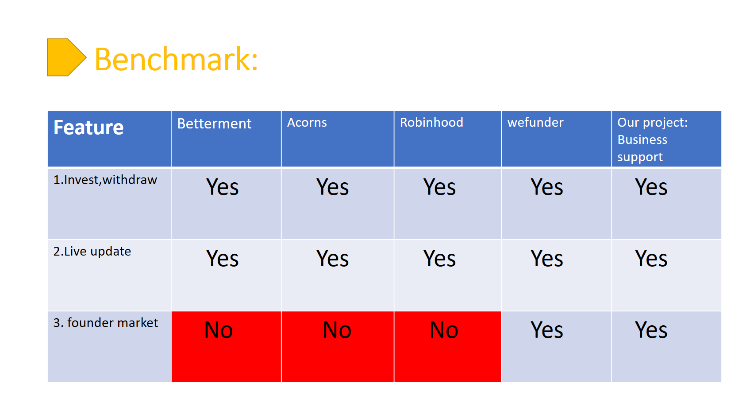

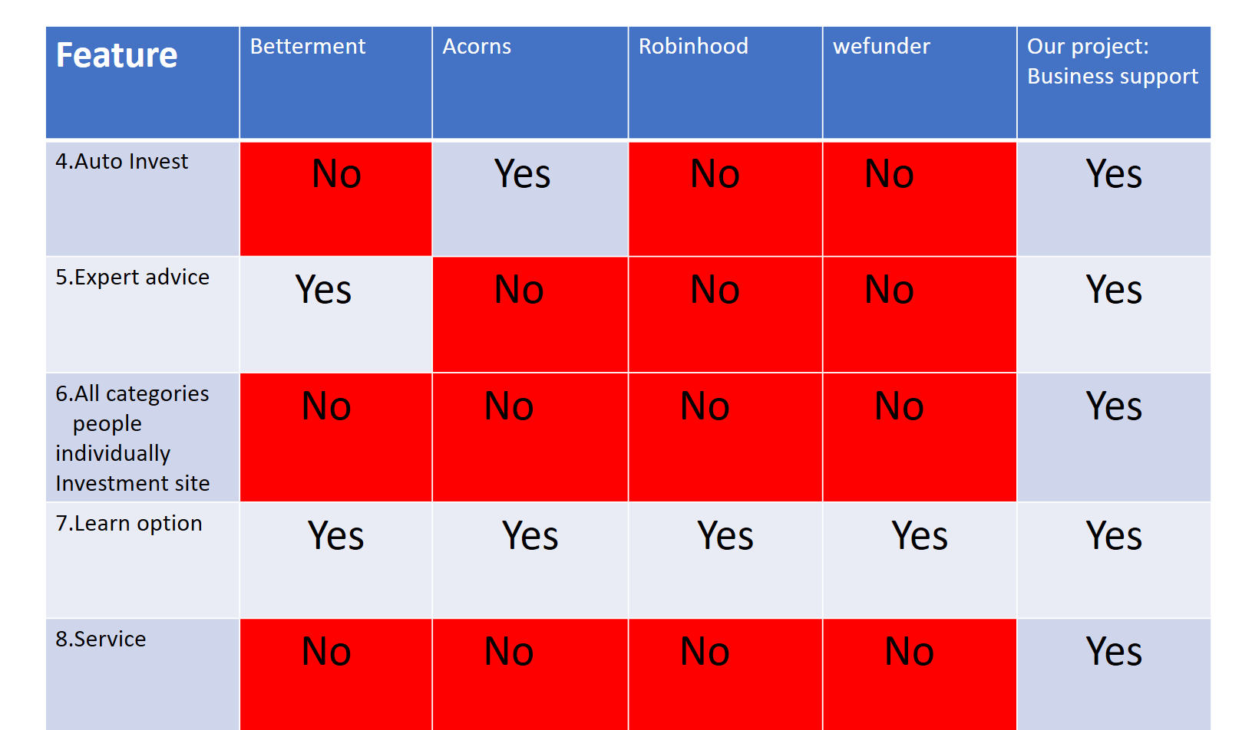

**Conclution:**

Investor are always looking for a reliable platform to invest money where they can get some advice or information related to their investment. This investment profitable or not that is a main concern for all of them.Businessman found their fund very easily and return ratio is very friendly amount.