UNIVERSIDAD NACIONAL EXPERIMENTAL POLITECNICA

“ANTONIO JOSE DE SUCRE”

VICE-RECTORADO DE PUERTO ORDAZ

DEPARTAMENTO DE ELECTRONICA

**MICROPROCESADORES II**

Laboratorio 1

|  |  |  |
| --- | --- | --- |
| Profesor: |  | Bachilleres: |
| Rafael Surga Luvo |  | Brito Eduardo C.I:24560857 |
|  |  | Duran Alejandro C.I: 25395510 |
|  |  | Zorrilla Paola C.I:24848197 |

Ciudad Guayana. Marzo, 2018

Esquemático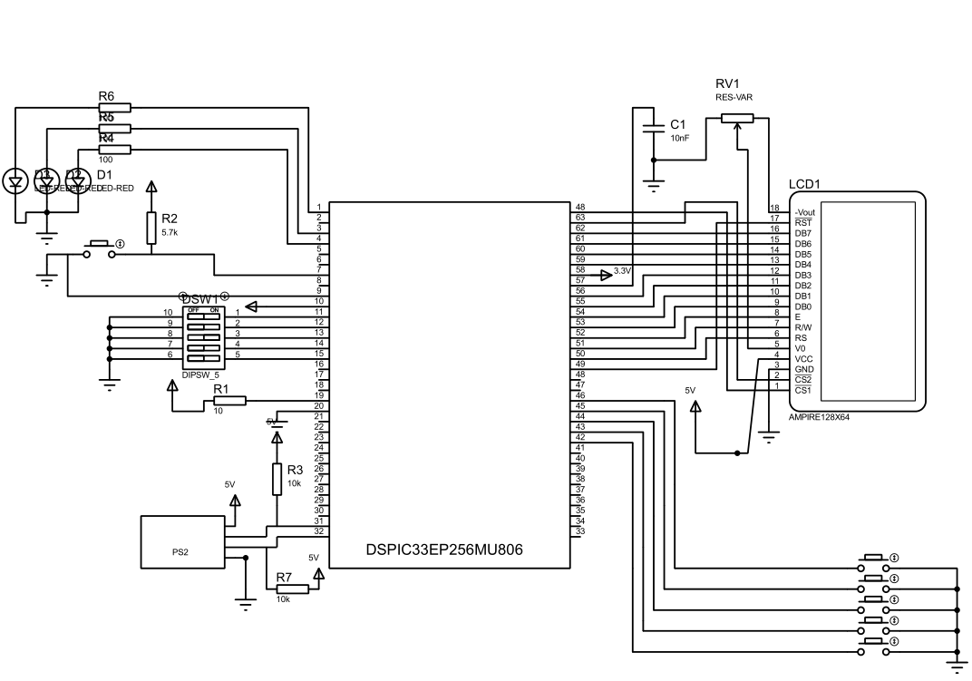

**CODIGO**

**LAB1.C**

#include "barras.h"

#include "sprites.h"

//~Constantes del dsPIC

//Variables de PS2

sbit PS2_Data at RF4_bit;

sbit PS2_Clock at RF5_bit;

sbit PS2_Data_Direction at TRISF4_bit;

sbit PS2_Clock_Direction at TRISF5_bit;

//Variables de GLCD

sbit GLCD_D7 at RE1_bit;

sbit GLCD_D6 at RE0_bit;

sbit GLCD_D5 at RF1_bit;

sbit GLCD_D4 at RF0_bit;

sbit GLCD_D3 at RD7_bit;

sbit GLCD_D2 at RD6_bit;

sbit GLCD_D1 at RD5_bit;

sbit GLCD_D0 at RD4_bit;

sbit GLCD_D7_Direction at TRISE1_bit;

sbit GLCD_D6_Direction at TRISE0_bit;

sbit GLCD_D5_Direction at TRISF1_bit;

sbit GLCD_D4_Direction at TRISF0_bit;

sbit GLCD_D3_Direction at TRISD7_bit;

sbit GLCD_D2_Direction at TRISD6_bit;

sbit GLCD_D1_Direction at TRISD5_bit;

sbit GLCD_D0_Direction at TRISD4_bit;

sbit GLCD_CS1 at LATE3_bit;

sbit GLCD_CS2 at LATE2_bit;

sbit GLCD_RS at LATD1_bit;

sbit GLCD_RW at LATD2_bit;

sbit GLCD_EN at LATD3_bit;

sbit GLCD_RST at LATE4_bit;

sbit GLCD_CS1_Direction at TRISE3_bit;

sbit GLCD_CS2_Direction at TRISE2_bit;

sbit GLCD_RS_Direction at TRISD1_bit;

sbit GLCD_RW_Direction at TRISD2_bit;

sbit GLCD_EN_Direction at TRISD3_bit;

sbit GLCD_RST_Direction at TRISE4_bit;

//Constantes del sistema

//Constantes de las ubicaciones de los pines

const int BTN_PPS_LOCATIONS[5]={-1,37,36,35,34};//5 posiciones para las 4 Ubicaciones de los botones de Interrupciion del ejercicio 1

// el 0 nunca se usa porque INT0 esta fijo en el pin 46 RP64. RB2-5

const int DIP_PPS_LOCATIONS[5]={32,33,38,39,40};//5 posiciones para 5 Dipswitches RPI32,33,38,39,40 Y RB0,1,6,7,8

const int KEYBOARD_PPS_LOCATIONS[2]={100,101};//RF4,RF5

//const int LED_PPS_LOCATIONS[3]={85,87,118};//3 posiciones para 3 LEDS de salida RE5,RE7,RG6

//Variables de trabajo

int counters[5]={0,0,0,0,0};

int valores_cn[4]={0,0,0,0};

unsigned short keydata = 0, special = 0, down = 0,casoQactivo=0;

//~~~~~~~~~~~~~~~~Declaraciones de Funciones~~~~~~~~~~~~~~~~~~~~~~~~~~~~~~~~~~

void InterrAdapter(int Ix);

void bar_drawer(unsigned short x_left,unsigned short contador_barra);

int DrawableBars(int real_number_of_bars);

//Interrupciones

void INT0() org 0x14{

InterrAdapter(0);

delay_ms(600);

IFS0bits.INT0IF=0;

}

void INT1() org 0x3C{

InterrAdapter(1);

delay_ms(600);

IFS1bits.INT1IF=0;

}

void INT2() org 0x4E{

InterrAdapter(2);

delay_ms(600);

IFS1bits.INT2IF=0;

}

void INT3() org 0x7E{

InterrAdapter(3);

delay_ms(600);

IFS3bits.INT3IF=0;

}

void INT4() org 0x80{

InterrAdapter(4);

delay_ms(600);

IFS3bits.INT4IF=0;

}

void INT_CN() org 0x3A{

IFS1bits.CNIF = 0;

if(PORTBbits.RB5 ==1){

valores_cn[0]=1;

valores_cn[1]=0;

valores_cn[2]=0;

valores_cn[3]=0;

}else if(PORTBbits.RB4==1){

valores_cn[0]=0;

valores_cn[1]=1;

valores_cn[2]=0;

valores_cn[3]=0;

}else if(PORTBbits.RB3==1){

valores_cn[0]=0;

valores_cn[1]=0;

valores_cn[2]=1;

valores_cn[3]=0;

}else if(PORTBbits.RB2==1){

valores_cn[0]=0;

valores_cn[1]=0;

valores_cn[2]=0;

valores_cn[3]=1;

}

if(PORTBbits.RB1==1){

RCONbits.SWDTEN=1;

Glcd_Write_TEXT("INT WDT",0,0,1);

}

delay_ms(1000);

Glcd_Fill(0);

}

void InterrAdapter(int Ix){

if(casoQactivo==1){

counters[Ix]++;

barra(Ix,counters[Ix]);

}

}

//~~~~~~~~~~~~~~~~~~~~~~Configuraciones Iniciales~~~~~~~~~~~~~~~~~~~~~~~~~~

void config_IO(){

ANSELB=0;

ANSELC=0;

ANSELD=0;

ANSELE=0;

ANSELG=0; //ANA//logiCO SON B Y F

TRISB=0xffff;

TRISDbits.TRISD0=1;

TRISDbits.TRISD11=1;

TRISDbits.TRISD10=1;

TRISDbits.TRISD9=1;

TRISE=0;

TRISG=0;

//Entrada Botones y Dipswitches

//Las entradas del teclado y las salidas de la pantalla son manejadas por las librerias;

}

void config_LCD(){

Glcd_Init();

Glcd_Set_Font(font5x7 , 5, 7, 32);

Glcd_Fill(0);

}

void config_CN(){//CNENx, CNPUx,CNIEx

CNENBbits.CNIEB5=1;CNENBbits.CNIEB4=1; CNENBbits.CNIEB3=1;

CNENBbits.CNIEB2=1;CNENBbits.CNIEB1=1;

CNPUBbits.CNPUB5=1;//CNPU RB1-rb5, rpi33-37

CNPUBbits.CNPUB4=1;CNPUBbits.CNPUB3=1;

CNPUBbits.CNPUB2=1;CNPUBbits.CNPUB1=1;

IPC4bits.CNIP=7;//Prioridad

IFS1bits.CNIF=0; IEC1bits.CNIE=1;//Resset Interrupcion

}

void config_INT(){

SRbits.IPL =0;// iNTERRUPCION DE CPU ES DE NIVEL 0

INTCON1bits.NSTDIS =0;// INTERRUPCION ANIDADAS ACTIVADAS

INTCON2bits.GIE=1; //interrupciones habilitadas

CORCONbits.IPL3 = 0; // El nivel del cpu es de nivel 0, las interrupciones por perifericos habilitadas

//------------------------- habilitacion de interrupcion

IEC0bits.INT0IE=1; //HABILITA INTERRUPCION POR INT0

IEC1bits.INT1IE=1; //HABILITA

IEC1bits.INT2IE=1; IEC3bits.INT3IE=1; IEC3bits.INT4IE=1;

//prioridad int

// Banderas de Interrupcion post Reset (Limpieza)

IFS0bits.INT0IF=0; //interrupcion de INT0 ACTIVADA

IFS1bits.INT2IF =0; // interrupcion de INT1 ACTIVADA

IFS1bits.INT2IF =0 ; // INTERRIPCION DE INT2 ACTVADA

IFS3bits.INT3IF =0; //INTERRUPCION DE INT3 ACTIVADA

IFS3bits.INT4IF =0; // INTERRUPCION DE INT4 ACTIVADA

//Prioridad de Interrupciones

counters[0]=0; counters[1]=0; counters[2]=0;

counters[3]=0; counters[4]=0;

//--------------------interrupcion flanco positivo

INTCON2bits.INT0EP=0; INTCON2bits.INT1EP=0;

INTCON2bits.INT2EP=0; INTCON2bits.INT3EP=0;

INTCON2bits.INT4EP =0;

//PPS para los pines de Interrupcion

RPINR0bits.INT1R=75; RPINR1bits.INT2R=74;

RPINR1bits.INT3R=73; RPINR2bits.INT4R=72;

}

void disable_INT(){

IPC0bits.INT0IP= 0; IPC5BITS.INT1IP=0;

IPC7bits.INT2IP =0; IPC13bits.INT3IP=0;

IPC13bits.INT4IP=0;

counters[0]=0; counters[1]=0;

counters[2]=0; counters[3]=0;

counters[4]=0;

casoQactivo=0;

}

//~~Casos~~~~~~~~~~~~~~~~~~~~~~~~

void casoQ(){

IPC0bits.INT0IP= 6; IPC5BITS.INT1IP=5;

IPC7bits.INT2IP =4; IPC13bits.INT3IP=3;

IPC13bits.INT4IP=2; Glcd_Fill(0);

casoQactivo=1;

do{

down=0;special=0;keydata=0;

Ps2_Key_Read(&keydata, &special, &down);

}while(keydata!=34 && !down & !special);

disable_INT();

Glcd_Fill(0);

disable_INT();

}

void casoW(){

valores_cn[0]=0; valores_cn[1]=0;

valores_cn[2]=0; valores_cn[3]=0;

Glcd_Fill(0) ;

Glcd_Write_TEXT("Caso 2",0,0,1);

delay_ms(1000);

do{

Glcd_Fill(0);

down=0;special=0;keydata=0;

if(valores_cn[0]==1){

animate_charmander_5s();

}

else if(valores_cn[1]==1){

animate_kirby_5s(0,0);

}

else if(valores_cn[2]==1){

animate_shell_5s(0,0);

}

else if(valores_cn[3]==1){

animate_bullet_5s()

}

Ps2_Key_Read(&keydata, &special, &down);

}while(keydata!=34 && !down & !special);

}

void casoE(){

Glcd_Fill(0);

Glcd_Write_TEXT("Caso E",60,0,1);

do{

down=0;

special=0;

if (RCONbits.WDTO==1){

Glcd_Write_TEXT("WDT",0,1,1);

RCONbits.WDTO=0;

PORTEbits.RE5=1;

animate_dog_20s();

}else if(RCONbits.EXTR==1){

Glcd_Write_TEXT("MCLR",0,2,1);

RCONbits.EXTR=0;

RCONbits.POR=0;

PORTEbits.RE7=1;

animate_blooper_20s();

continue;

}else if (RCONbits.POR==1){

Glcd_Write_TEXT("POR",0,3,1);

RCONbits.POR=0;

PORTGbits.RG6=1;

animate_charmander_20s();

break;

}

Ps2_Key_Read(&keydata, &special, &down);

}while(keydata!=34&&!down&&!special);

LATEbits.LATE5=0;

LATEbits.LATE7=0;

LATGbits.LATG6=0;

// PORTGbits.RG6=0;

// PORTEbits.RE7=0;

// PORTEbits.RE5=0;

}

void main(){

config_IO(); config_LCD();

config_INT(); config_CN();

animate_charmander_5s();

PS2_Config(); Glcd_Fill(0);

while(1){

Glcd_Write_TEXT("Laboratorio 1",31,0,1);

Glcd_Write_TEXT("'Q' para Caso Q",0,1,1);

Glcd_Write_TEXT("'W' para Caso W",0,2,1);

Glcd_Write_TEXT("'E' para Caso E",0,3,1);

Glcd_Write_TEXT("'R' para WDT ",0,4,1);

if(Ps2_Key_Read(&keydata, &special, &down)){

if(down &&!special){

switch(keydata){

case 'q':

case 'Q':

Glcd_Write_TEXT("Caso Q",60,0,1);

casoQ();

break;

case 'w':

case 'W':

Glcd_Write_TEXT("Caso W",60,0,1);

casoW();

Glcd_Fill(0);

break;

case 'e':

case 'E':

Glcd_Fill(0);

Glcd_Write_TEXT("Ultimo Reset",60,0,1);

casoE();

Glcd_Fill(0);

break;

default:

Glcd_Fill(0);

Glcd_Write_TEXT("Erroneo ",60,0,1);

delay_ms(2000);

break;

}

}

}

}

}

**BARRAS.H**

const int BAR_HEIGHT=2;

const int BAR_WIDTH=20;

const int WHITE=0;

const int BLACK=1;

const int MAX_BAR_HEIGHT=BAR_HEIGHT*25;

unsigned short BARS_H_LOCATIONS[5]={4,29,54,79,104};

char txt[5];

unsigned short x_left,x_right,y_top,y_bottom,count,contador_reset,Ix;

int quotient;

void bar_drawer(unsigned short x_left,unsigned short contador_barra);

int DrawableBars(int real_number_of_bars);

void box(int x_left,int count);

void barra(int INTx,int contador_barra) {

// void Glcd_Box(unsigned short x_upper_left, unsigned short y_upper_left, unsigned short x_bottom_right, unsigned short y_bottom_right, unsigned short color);

box(BARS_H_LOCATIONS[INTx],contador_barra);

ShortToStr(contador_barra,txt);

// txt=Ltrim(txt);

Glcd_Write_Text(txt,BARS_H_LOCATIONS[INTx],0,1);

}

void box(int x_left,int count){

y_top=64-DrawableBars(count)*2;

y_bottom=y_top+2;

x_right=x_left+20;

contador_reset=DrawableBars(count);

if(count>1){

if (contador_reset==1){

Glcd_Box(x_left,7,x_right,64,0);

// Glcd_Box(x_left,64,x_right,62, 1);

} else {

Glcd_Box(x_left,y_top,x_right,y_bottom, 1);}

}else {

Glcd_Box(x_left,y_top,x_right,y_bottom, 1);

}

}

int DrawableBars(int real_number_of_bars){

//Funcion para devolver el numero necesario de barras a formar si el contador>25 dentro de un rango de [0-25].

//Ejemplo 80-->5

if(real_number_of_bars>25){

quotient=real_number_of_bars/25;

quotient=floor(quotient);

return real_number_of_bars-25*quotient;

}else{

return real_number_of_bars;

}

}

**SPRITES.H**

void animate_charmander_5s(){

Glcd_Image(charmander_1);

delay_ms(2500);

Glcd_Image(charmander_2);

delay_ms(2500);

}

void animate_charmander_20s(){

animate_charmander_5s();

animate_charmander_5s();

animate_charmander_5s();

animate_charmander_5s();

}

void animate_bullet_5s(){

Glcd_PartialImage(100,23,18,18,18,18,bullet); delay_ms(830);Glcd_Fill(0);

Glcd_PartialImage(80,23,18,18,18,18,bullet); delay_ms(830);Glcd_Fill(0);

Glcd_PartialImage(60,23,18,18,18,18,bullet); delay_ms(830);Glcd_Fill(0);

Glcd_PartialImage(40,23,18,18,18,18,bullet); delay_ms(830);Glcd_Fill(0);

Glcd_PartialImage(20,23,18,18,18,18,bullet); delay_ms(830);Glcd_Fill(0);

Glcd_PartialImage(0,23,18,18,18,18,bullet); delay_ms(830);Glcd_Fill(0);

}

void animate_shell(unsigned int x_left, unsigned int y_top,code const far char * image){

Glcd_PartialImage(x_left,y_top,16,16,16,16,image);

}

void animate_shell_5s(unsigned int x_left, unsigned int y_top){

Glcd_Fill(0);

animate_shell(x_left,y_top,shell_1);

delay_ms(1667);

animate_shell(x_left,y_top,shell_2);

delay_ms(1667);

animate_shell(x_left,y_top,shell_1);

delay_ms(1667);

}

void animate_dog(unsigned int x_left, unsigned int y_top,code const far char * image){

Glcd_PartialImage(x_left,y_top,31,40,31,40,image);

}

void animate_dog_5s(unsigned int x_left, unsigned int y_top){

Glcd_Fill(0);

Glcd_Write_TEXT("WDT",60,0,1);

// animate_shell(x_left,y_top,shell_1);

animate_dog(x_left,y_top,dog_1);

delay_ms(1667);

animate_dog(x_left,y_top,dog_2);

delay_ms(1667);

animate_dog(x_left,y_top,dog_3);

delay_ms(1667);

}

void animate_dog_20s(){

animate_dog_5s(48,12);animate_dog_5s(48,12);animate_dog_5s(48,12);animate_dog_5s(48,12);

}

void animate_kirby(unsigned int x_left, unsigned int y_top,code const far char * image){

Glcd_PartialImage(x_left,y_top,21,19,21,19,image);

}

void animate_kirby_5s(int x_left,int y_top){

Glcd_Fill(0);

animate_kirby(x_left,y_top,kirby_1);delay_ms(833);

animate_kirby(x_left,y_top,kirby_2) ;delay_ms(833);

animate_kirby(x_left,y_top,kirby_3) ;delay_ms(833);

animate_kirby(x_left,y_top,kirby_4) ;delay_ms(833);

animate_kirby(x_left,y_top,kirby_5) ;delay_ms(833);

animate_kirby(x_left,y_top,kirby_6);delay_ms(833);

}

void animate_blooper(unsigned int x_left, unsigned int y_top,code const far char * blooper){

Glcd_PartialImage(x_left,y_top,35,34,35,34,blooper);

}

void animate_blooper_5s(int x_left,int y_top){

Glcd_Fill(1);

Glcd_Write_TEXT("MCLR",60,0,0);

animate_blooper(x_left,y_top,blooper_1);

delay_ms(1000);

animate_blooper(x_left,y_top,blooper_2);

delay_ms(1000);

animate_blooper(x_left,y_top,blooper_1);

delay_ms(1000);

animate_blooper(x_left,y_top,blooper_2);

delay_ms(1000);

}

void animate_blooper_20s(){

animate_blooper_5s(46,15);

animate_blooper_5s(46,15);

animate_blooper_5s(46,15);

animate_blooper_5s(46,15);

}