SUMMARY OF APPLICATION NUMBERS GRAPHICAL REPORT TEMPLATE

Admission System uses awesome graphical report generation module which can generate different types of the various reports, represented as a separate chart or a set of various charts.

One of them is Summary of Application Numbers Graphical Report.

**SUMMARY OF APPLICATION NUMBERS GRAPHICAL REPORT**

Summary of Application Numbers Graphical Report should be represented as a set of various charts, which aggregates data obtained from the Summary of Application Numbers (Numerical) Report.

There are two various charts should be represented in this set:

The first chart shows the summary of application numbers aggregated by the total number of applications, which have registration for particular course.

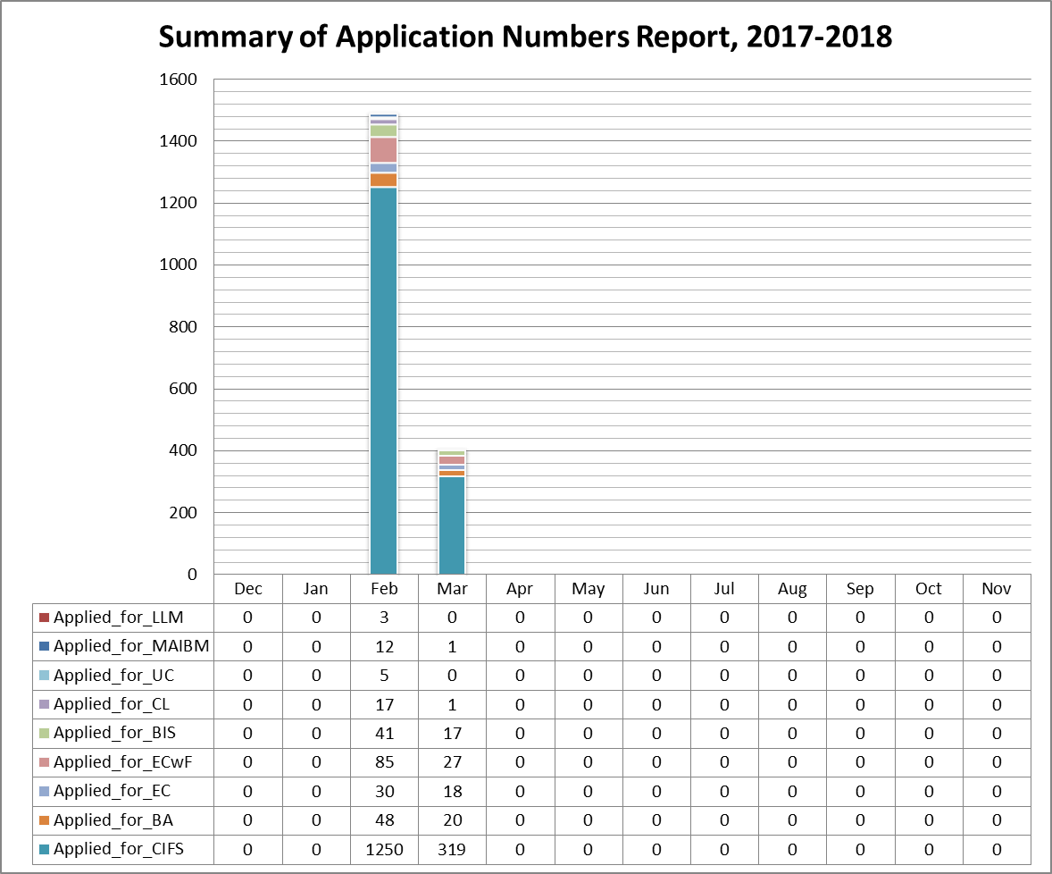

This chart should be also supplemented by a table of detailed data obtained from the main report.

The second chart shows the summary of application numbers aggregated by the total number of submitted applications and the total number of applications, which do not have registration to the math entrance exam.

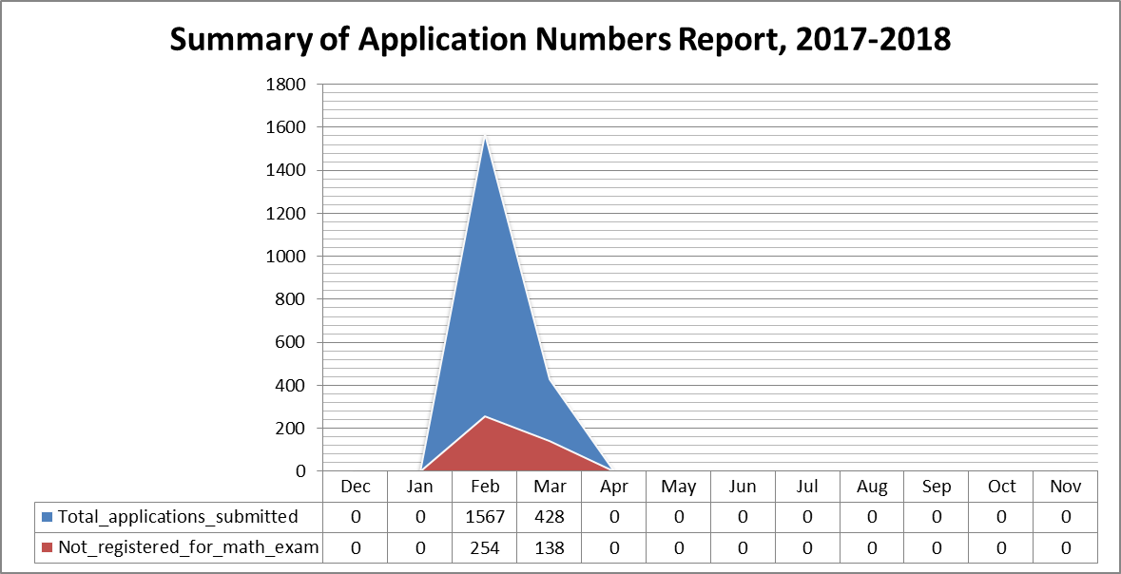

This chart should be also supplemented by a table of detailed data obtained from the main report.

These charts should be able to be exported as image in BMP, JPG or PNG formats in order to be imported as image to any documents or copied into the memory.