PROGRAMME: BSSE/BSCS/BIT
YEAR/SEM: YEAR 2 SEM 1
COURSE CODE: BIT2115
PROBLEM NAME: EXPLICIT & IMPLICIT DATA CONVERSION

STUDENT DETAILS:
NAME OF STUDENT | Dureti Edao Obse
REG NUMBER | 25/1707/BSCS-S

Table of Contents

List of Figures
Figure 1:Class Main showing project structure 3
Figure 2:Class Output after running the program 4

Section 1
Logic Building & Programming
Lines of code & explanations
Line Number | Explanation
1 | Imports the Scanner class so the program can read the user's input from the keyboard.
2 | Declares the class SavingsInterestCalculator.
3 | The main method, where the program starts running.
4 | Creates a Scanner object (sc) that reads what the user types.
5 | Displays a prompt asking the user to enter the deposit, the interest rate and the number of years.
6 | Reads the deposit as a whole number (int), the rate as a decimal (double) and the years as a whole number (int).
7 | IMPLICIT (automatic) conversion: the int deposit is widened to a double. This is safe because a double can hold every int value, so no data is lost.
8 | Calculates the interest (deposit x rate / 100 x years), which produces a decimal value, and then the total (deposit + interest).
9 | Prints the summary report for management. Math.round() rounds the interest and the total to whole numbers for accounting purposes.
10 | Shows the int deposit and its double form (for example 1000 -> 1000.0), demonstrating that automatic conversion loses nothing.
11 | EXPLICIT (manual) conversion: (int) interest casts the double to an int. The decimal part is chopped off, not rounded, so it is compared with the exact value to show the loss.
12 | Casts the rate to an int. Decimals are lost, so a manual cast is needed and accuracy is affected.
13 | Recalculates the interest using the cut-down rate, which gives a different (wrong) amount. This shows how data accuracy is affected during conversion. 100.0 keeps the division in decimals.
14 | Closes the main method.
15 | Closes the class.

Detailed Screenshots and caption descriptions
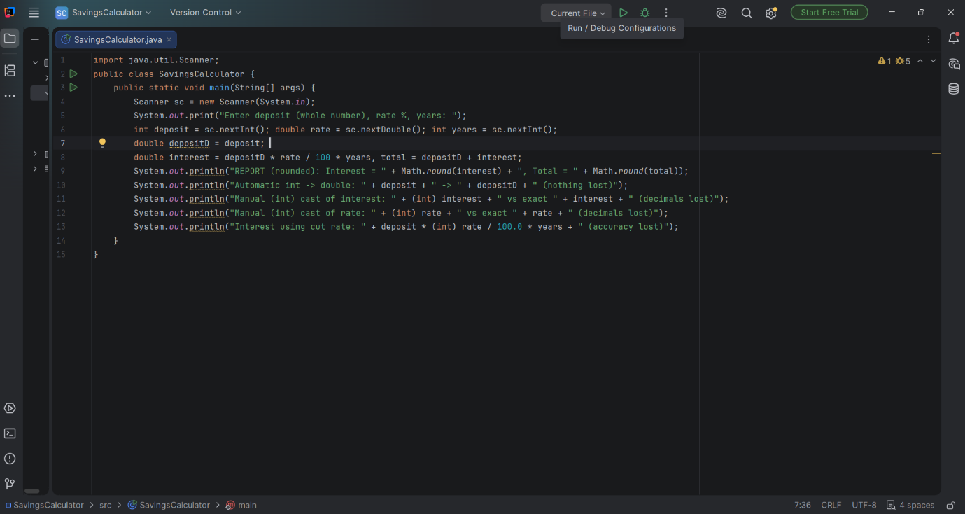
Figure 1:Class Main showing project structure

Output and caption descriptions
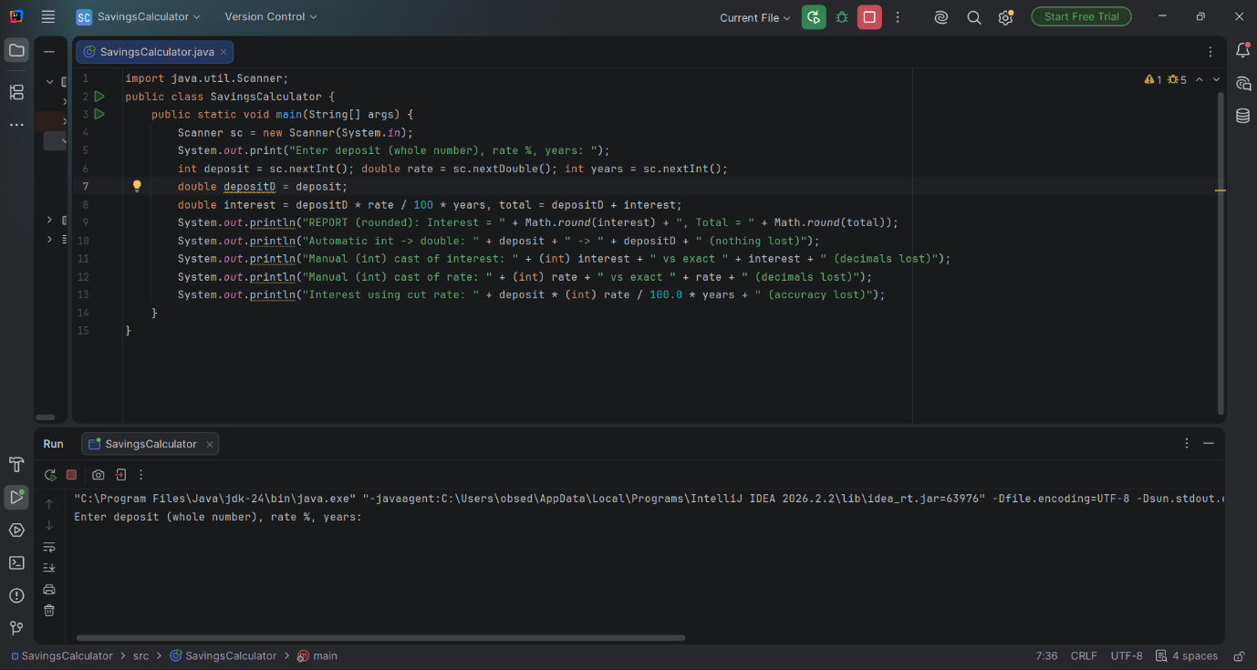
Figure 2: Output after running the program

Output Explanation
When the program is executed, it displays the following, in order:
1. It asks the user to enter the deposit (whole number), the interest rate and the number of years.
2. The report line shows the interest and total rounded to whole numbers with Math.round(), as required for accounting.
3. The automatic conversion line shows the int deposit becoming a double. This is safe because nothing is lost.
4. The manual cast of the interest to int cuts off the decimals, so it differs from the exact value.
5. The manual cast of the rate to int also loses its decimals.
6. The last line shows the interest recalculated with the cut rate, which is wrong, so accuracy is lost.
Conclusion: widening (int to double) is safe and automatic, while narrowing (double to int) needs a manual cast and loses accuracy.

Section 2
Version Control
Repository Overview
Repository Name
Repository URL
Branches

Commit #1 On Branch #1

Commit Summary
Commit Name
Commit ID
Commit Description
Branch Affected

Section 3
What Have You Learned From The Task?

Skill Set | Description
Implicit conversion | Understood that Java automatically converts a smaller data type to a larger one, such as int to double, and that this is safe because no data is lost.
Explicit conversion (type casting) | Learned to use casts such as (int) to convert a larger type to a smaller one, and saw that decimals are chopped off, which reduces accuracy.
Rounding and reading input | Used Math.round() to produce rounded figures for reports and Scanner to accept user input in a Java program.

