PROGRAMME: BSSE/BSCS/BIT
YEAR/SEM: YEAR 2 SEM 1
COURSE CODE: BIT2115
PROBLEM NAME: JAVA ACCESS MODIFIERS

STUDENT DETAILS:
NAME OF STUDENT | Dureti Edao Obse
REG NUMBER | 25/1707/BSCS-S

Table of Contents

List of Figures
Figure 1:Class Main showing project structure 4
Figure 2:Output after running the program 5

Section 1
Logic Building & Programming
Lines of code & explanations
Line Number | Explanation
Patient.java: 1 | Places the class in the package hospital.records, which holds the patient data classes.
Patient.java: 3 | Declares the public class Patient. It is public so classes in other packages (reception, doctors) can use it.
Patient.java: 4-5 | name and appointmentDate are private: the data is hidden and can only be read through the public getters, so no other class can change it directly.
Patient.java: 6 | diagnosis is private because it is sensitive medical information. Only code inside Patient can touch it directly.
Patient.java: 8-10 | Public constructor that sets name, appointment date and diagnosis when a patient object is created.
Patient.java: 11-12 | getName() and getAppointmentDate() are public: receptionists (and anyone) may view these basic details, but they are read-only.
Patient.java: 13-14 | getDiagnosis() and setDiagnosis() are protected: only subclasses (such as MedicalFile used by doctors) and the same package can view or update the diagnosis. Receptionists cannot.
MedicalFile.java: 1 | Places the class in a different package, hospital.medical, to separate medical staff code from patient records.
MedicalFile.java: 3 | Imports Patient from the hospital.records package so it can be extended.
MedicalFile.java: 5 | MedicalFile extends Patient. Inheritance is what allows it to use the protected methods from another package.
MedicalFile.java: 6 | Public constructor that passes the patient details up to the Patient class using super().
MedicalFile.java: 7-8 | viewDiagnosis() and updateDiagnosis() are public methods for doctors. They call the protected getDiagnosis() and setDiagnosis(), so doctors can view and update medical information.
FinancialRecord.java: 1 | Places the class in the hospital.admin package (the administration department).
FinancialRecord.java: 3 | The class has no modifier, so it is package-private: only classes inside hospital.admin can see or create it. This keeps financial records within administration.
FinancialRecord.java: 4-6 | The amountBilled field, the constructor and balanceDue() are also package-private, so they cannot be accessed from doctors' or receptionists' code. balanceDue() returns the amount billed minus the amount paid.
Administration.java: 1, 3 | Puts the class in hospital.admin and makes it public, so it is the only door to the financial data for outside code.
Administration.java: 4-6 | showBalance() is public. It creates a FinancialRecord (allowed, same package) and prints the balance due, without exposing the record itself.
HospitalSystem.java: 1-5 | Declares the package hospital and imports the Administration, MedicalFile and Patient classes from their packages.
HospitalSystem.java: 7-8 | The public class HospitalSystem and its main method, where the program starts.
HospitalSystem.java: 9 | Creates a MedicalFile object (the doctor's view of the patient) with a name, appointment date and diagnosis.
HospitalSystem.java: 10-11 | The receptionist is given only the Patient type, so the receptionist can view only the name and appointment date through the public getters.
HospitalSystem.java: 12-13 | Commented lines that show what would NOT compile: getDiagnosis() is protected and diagnosis is private, so a receptionist cannot access them.
HospitalSystem.java: 14-16 | The doctor views the diagnosis and then updates it using the public methods of MedicalFile, and prints both results.
HospitalSystem.java: 17 | Administration shows the balance due (500000 billed, 200000 paid). Only Administration can work with the financial record.
HospitalSystem.java: 18 | Commented line showing that new FinancialRecord(...) would not compile from here because the class is package-private.
HospitalSystem.java: 19-20 | Closes the main method and the class.

Detailed Screenshots and caption descriptions
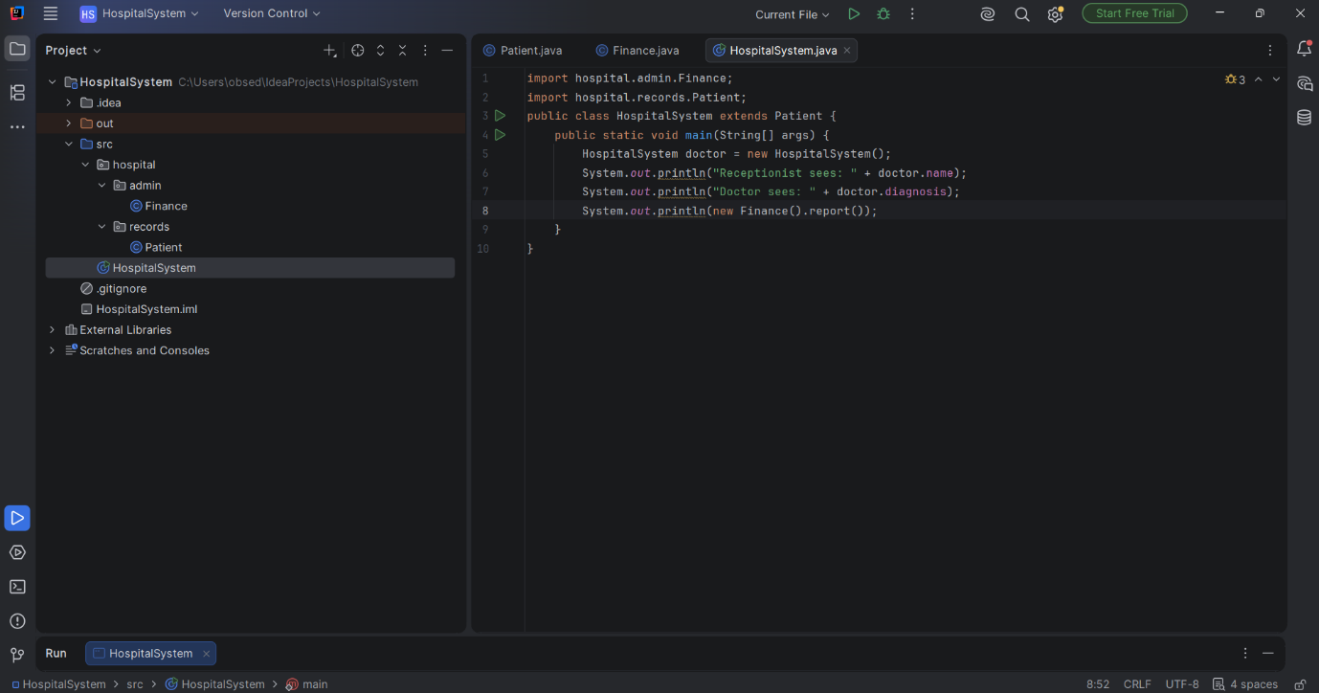
Figure 1:Class Main showing project structure

Output and caption descriptions
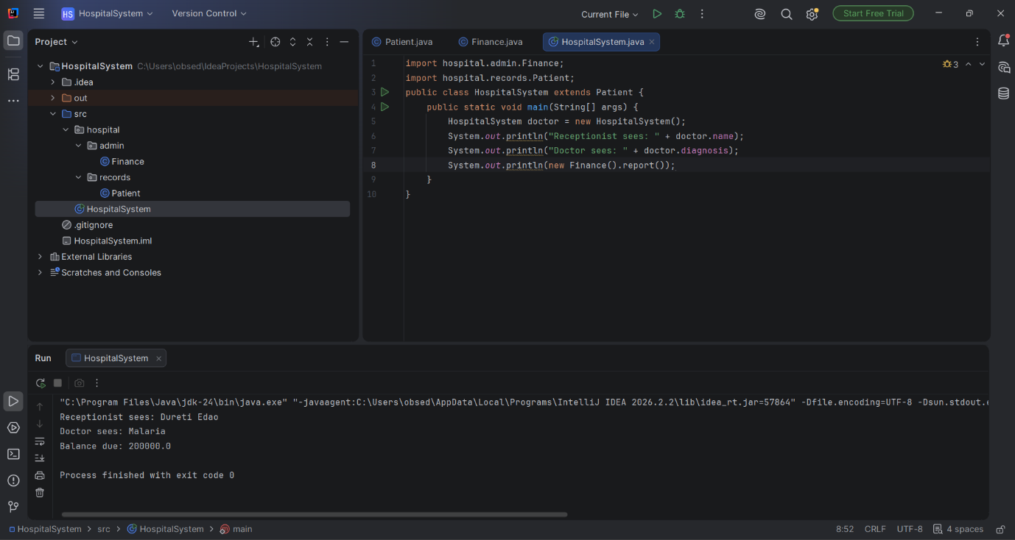
Figure 2: Output after running the program

Output Explanation
When the program is executed, it displays the following four lines:
1. Receptionist sees: Jane Akello, 2026-10-05. The receptionist can view only the basic details, through public methods.
2. Doctor views diagnosis: Malaria. The doctor reads the medical information through the public method of MedicalFile, which uses the protected getDiagnosis().
3. Doctor updated diagnosis: Malaria - treatment started. The doctor changes the private diagnosis through the protected setDiagnosis(), and the new value is shown.
4. Administration: Jane Akello balance due = 300000.0. Only the administration package can use the package-private FinancialRecord to work out the balance (500000 billed minus 200000 paid).
Conclusion: private hides the data, public gives controlled access, protected limits access to subclasses, and package-private keeps financial records inside the administration package. Trying to access hidden members from the wrong class causes a compile error.

Section 2
Version Control
Repository Overview
Repository Name
Repository URL
Branches

Commit #1 On Branch #1
[Insert your GitHub Desktop commit screenshot here]
Figure 3: Commit 1 on Branch 1

Commit Summary
Commit Name
Commit ID
Commit Description
Branch Affected

Section 3
What Have You Learned From The Task?

Skill Set | Description
Access modifiers | Learned how private, protected, public and package-private (default) control who can see and change variables, methods and classes.
Packages and inheritance | Organised classes into packages (records, medical, admin) and used inheritance so a subclass in another package can use protected methods.
Data security and encapsulation | Understood how to protect sensitive data such as diagnoses and financial records by hiding it and exposing only what each role needs.

