**The solar based automatic wireless charging hub**

**Abstract:**

Our project, focuses on developing a cutting-edge automatic wireless charging system powered by renewable solar energy. This system eliminates the need for manual handling, as the entire charging process is automated, making it more convenient for users. The integration of an RFID module secure identification and communication with the vehicle during charging, allowing for efficient and seamless power transfer.

Designed with user convenience in mind, this wireless charging solution provides a hassle-free experience, enabling drivers to charge their electric vehicles effortlessly. By harnessing solar energy, the system operates 24 hours a day, reducing dependency on traditional charging stations and promoting sustainable energy usage.

This project not only enhances user convenience but also contributes to environmental sustainability by relying on solar power, making it a practical and eco-friendly alternative to conventional energy sources.

Output :

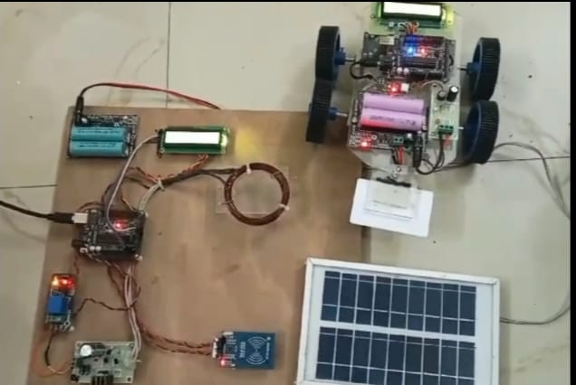

Figure:1.1

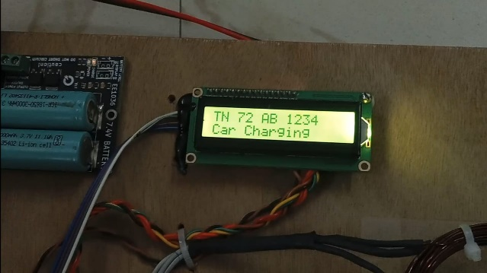

Figure:1.2

Submitted by:

Durgadevi R

Kalavathy S

Mohammed Mydeen S

Mohammed Ithris Nooruthen I

Arumugagobal M