Oil Price Forecasting Using Time Series and Deep Learning Methods
Name: Durga Prasad Rao Mannem
Student ID: 23072455
Git URL: https://github.com/Durga-DS1566/Time-Series-Modelling.git
1. Introduction
Forecasting oil prices is an important task for governments, investors, and energy companies because oil prices directly affect economic stability, energy markets, and global trade. Oil prices are influenced by multiple factors including geopolitical events, supply and demand dynamics, economic growth, and financial speculation. Because of this complexity, oil price data typically shows strong time-dependent patterns and volatility.
Machine learning and statistical time-series models provide powerful tools to analyse historical price movements and generate forecasts of future prices. Accurate forecasting helps stakeholders make informed decisions regarding investment strategies, energy policy, and risk management.
This report investigates oil price forecasting using two different modelling approaches:
- ARIMA (AutoRegressive Integrated Moving Average) – a classical statistical time-series model.
- LSTM (Long Short-Term Memory) – a deep learning model capable of learning complex temporal relationships.
The objective of this analysis is to compare these two methods in terms of their ability to model historical oil prices and generate accurate forecasts. The models are evaluated using prediction accuracy metrics and visual comparisons of forecast performance.
2. Dataset Description and Exploratory Analysis
The dataset used in this analysis contains historical daily oil prices measured in US dollars. The data consists of two main variables:
- Date – the date of the observation
- Price (USD) – daily oil price
Before modelling, the dataset was pre-processed by converting the date column to a time format and sorting the observations chronologically. The date column was then set as the index to allow proper time-series analysis.
2.1 Time Series Visualization
The first step in the analysis involved visualizing the time series of oil prices.
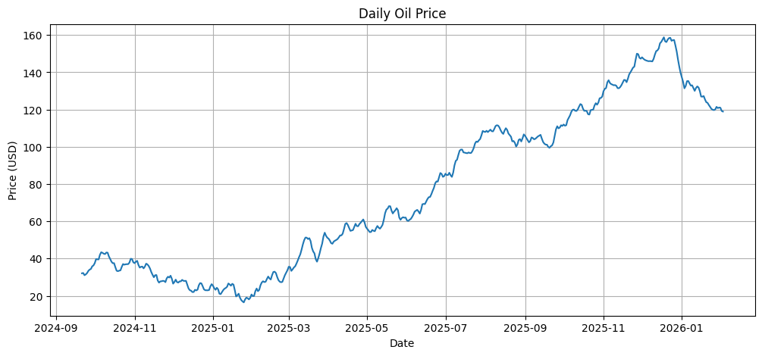
Figure 1: Oil price time series plot
From the plot, several characteristics can be observed:
- Oil prices exhibit strong temporal dependence, meaning current prices are influenced by past prices.
- There are periods of rapid increase and decrease, indicating volatility.
- The series appears to have long-term trends, suggesting it may not be stationary.
Stationarity is a key requirement for many time-series models, particularly ARIMA, and therefore must be tested before modelling.
2.2 Distribution Analysis
To better understand the statistical properties of the data, the distribution of oil prices was examined using a histogram and boxplot.
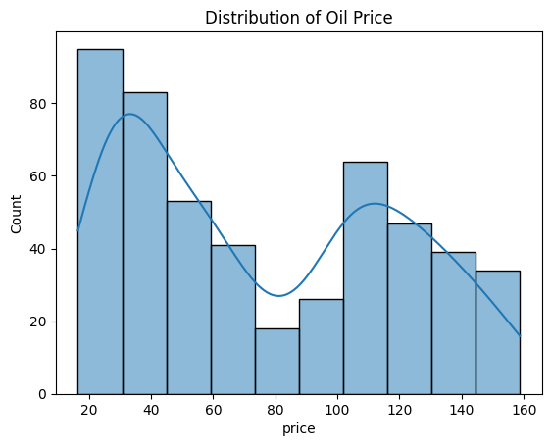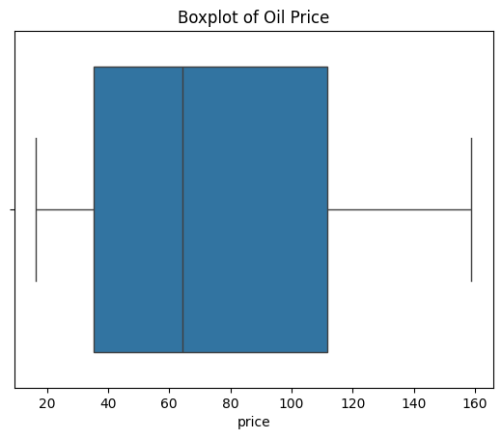
Figure 2: Histogram of oil prices Insert Figure 3: Boxplot of oil prices
The histogram shows that oil prices are moderately skewed, while the boxplot highlights the presence of potential outliers. These characteristics are common in financial and commodity price data.

3. Stationarity Analysis
Time series models such as ARIMA require the data to be stationary, meaning that its statistical properties (mean and variance) remain constant over time.
To test for stationarity, the Augmented Dickey–Fuller (ADF) test was applied.
The ADF test evaluates the null hypothesis that the series contains a unit root, which indicates non-stationarity.
The results from the test are shown below:
ADF Statistic: -4.541
p-value: 0.000165
Since the p-value is less than 0.05, the null hypothesis can be rejected, suggesting that the series is stationary.
However, financial time series often require differencing to stabilize the mean before modelling.
To explore this further, first and second differences of the series were computed.
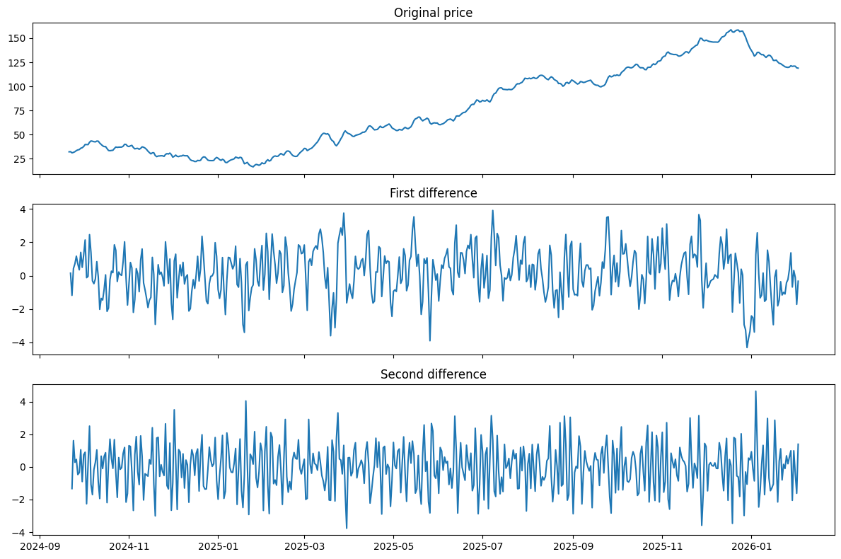
Figure 4: Original series, first difference, and second difference plots
The differenced series appear more stable around a constant mean, indicating that differencing helps remove trend components.
4. ARIMA Model
4.1 Method Overview
The ARIMA model is a widely used statistical approach for time-series forecasting. It combines three key components:
- Autoregressive (AR) – uses past values to predict future values.
- Integrated (I) – applies differencing to achieve stationarity.
- Moving Average (MA) – models the relationship between observations and past forecast errors.
Rather than simply applying a predefined ARIMA model, the model parameters were selected by evaluating different combinations of p, d, and q values using the Akaike Information Criterion (AIC). The AIC measures the trade-off between model complexity and goodness of fit, where lower values indicate a better model.
4.2 Model Selection
A grid search was performed across multiple parameter combinations.
The best model identified during this process was:
ARIMA (2,2,7)
with an AIC value of approximately 1429.
This indicates that the model provides a good balance between complexity and fit.
4.3 Model Evaluation
The dataset was split into:
- Training set: 80% of the data (400 observations)
- Test set: 20% of the data (100 observations)
This allows evaluation of the model on unseen data.
The ARIMA model produced a Root Mean Squared Error (RMSE) of:
RMSE = 14.78
RMSE measures the average difference between predicted and actual values. Lower values indicate better prediction accuracy.
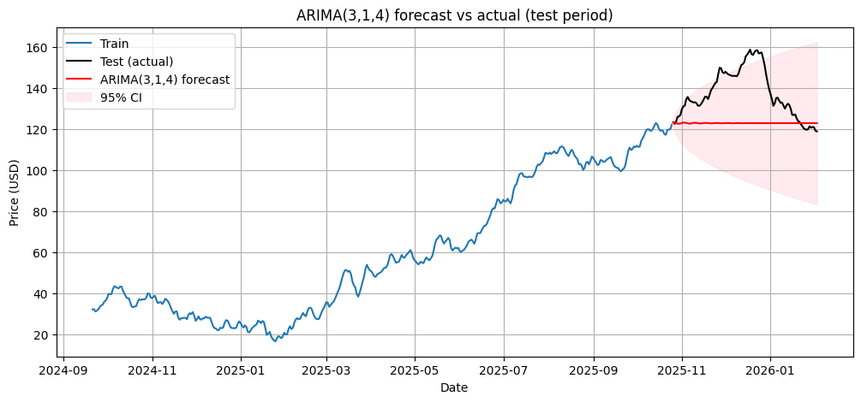
Figure 5: ARIMA forecast vs actual values
From the figure, it can be observed that the ARIMA model captures the overall trend of oil prices reasonably well. However, it struggles to accurately predict sudden fluctuations or sharp price movements.
5. LSTM Model
5.1 Method Overview
Long Short-Term Memory (LSTM) networks are a type of recurrent neural network (RNN) designed specifically for sequential data.
Unlike traditional models, LSTM networks are capable of learning long-term dependencies within time series. This makes them particularly useful for financial and commodity forecasting where complex nonlinear relationships may exist.
The LSTM model was trained using sequences of 30 previous observations to predict the next oil price value.
Before training, the data was normalized using Min-Max scaling, which improves neural network performance by ensuring all input values fall within a consistent range.
5.2 Model Training
The LSTM architecture consisted of:
- One LSTM layer with 50 neurons
- One dense output layer
- Adam optimizer
- Mean squared error loss function
The model was trained for 50 epochs with a batch size of 16.
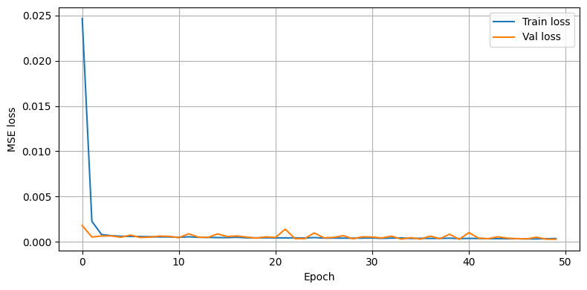
Figure 6: Training and validation loss plot
The loss curve shows that both training and validation loss decrease steadily, suggesting the model successfully learned patterns in the data without severe overfitting.
5.3 Model Performance
After training, the LSTM model was evaluated using the test dataset.
The resulting performance metric was:
LSTM RMSE = 18.10
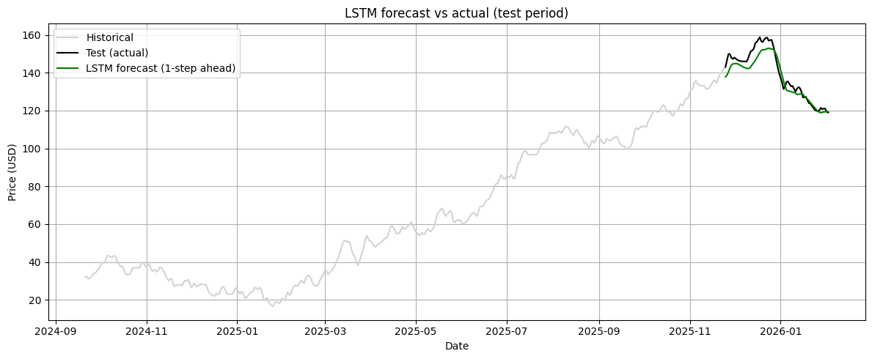
Figure 7: LSTM forecast vs actual values
The LSTM model captures general patterns in the data but produces slightly larger prediction errors compared with ARIMA.
6. Forecasting Future Oil Prices
Both models were used to generate forecasts for approximately 24 months into the future.
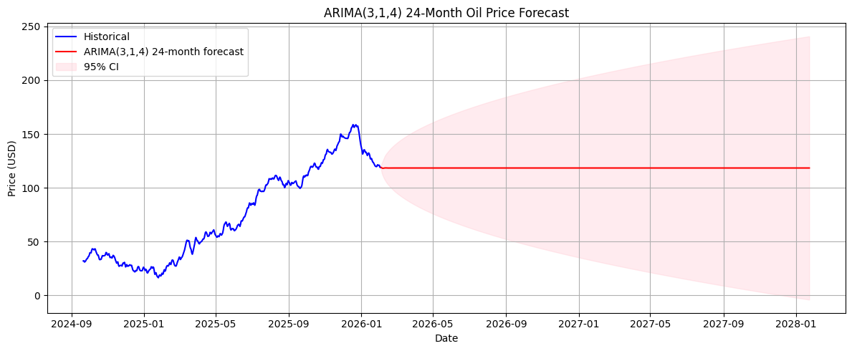
Figure 8: ARIMA 24-month forecast
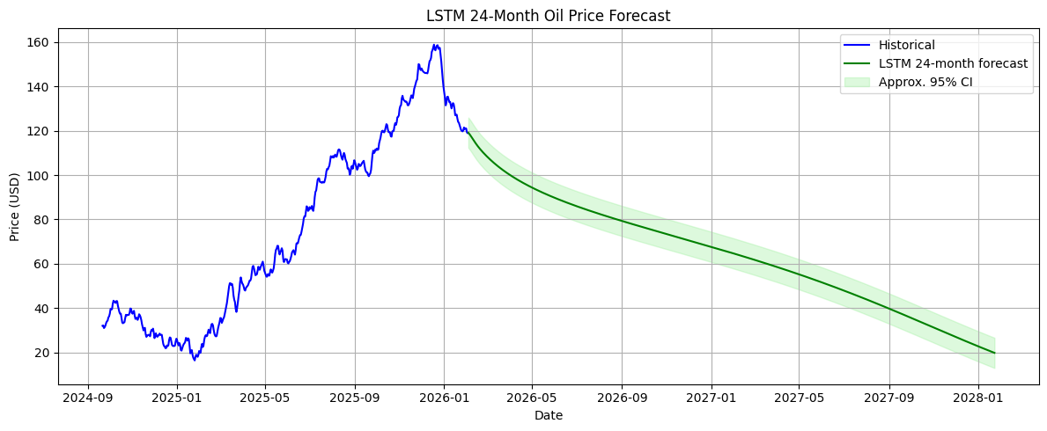
Insert Figure 9: LSTM 24-month forecast
The ARIMA forecast produces a relatively stable prediction with confidence intervals that gradually widen over time, reflecting increasing uncertainty.
The LSTM model generates forecasts that reflect learned patterns from the historical data but also display wider uncertainty bands.
These forecasts should be interpreted cautiously, as oil prices are influenced by unpredictable external factors such as geopolitical events and global economic conditions.
7. Comparison of ARIMA and LSTM
The two models demonstrate different strengths and limitations.
Model | RMSE | Strengths | Limitations
ARIMA | 14.78 | Good for linear trends and stable time series | Struggles with nonlinear patterns
LSTM | 18.10 | Can capture complex temporal patterns | Requires more data and tuning
In this analysis, ARIMA achieved a lower RMSE, indicating better predictive accuracy for the given dataset.
This suggests that the oil price series in this dataset may be sufficiently explained by linear relationships captured by ARIMA. While LSTM has the potential to model nonlinear patterns, its performance may depend on larger datasets or more extensive tuning of hyperparameters.
8. Conclusion
This study investigated oil price forecasting using two different modelling approaches: ARIMA and LSTM.
The analysis began with exploratory data analysis and stationarity testing using the Augmented Dickey-Fuller test. The results indicated that the series could be effectively modelled using time-series methods.
Two models were implemented and evaluated:
- ARIMA, a classical statistical forecasting method
- LSTM, a deep learning approach designed for sequential data
The evaluation results showed that the ARIMA model outperformed the LSTM model, achieving a lower RMSE value and producing forecasts that more closely matched the observed test data.
This suggests that for this dataset, traditional time-series methods remain highly effective. However, LSTM models may still offer advantages in scenarios involving larger datasets or more complex nonlinear patterns.
Future work could improve forecasting performance by incorporating additional variables such as global demand indicators, geopolitical risk factors, or macroeconomic variables.

9. References
Box, G., Jenkins, G., Reinsel, G., & Ljung, G. (2015). Time Series Analysis: Forecasting and Control. Wiley.
Hochreiter, S., & Schmidhuber, J. (1997). Long short-term memory. Neural Computation, 9(8), 1735–1780.
Hyndman, R., & Athanasopoulos, G. (2021). Forecasting: Principles and Practice. OTexts.
Zhang, G., Patuwo, B., & Hu, M. (1998). Forecasting with artificial neural networks. International Journal of Forecasting, 14(1), 35-62.

