Sreyas Institute of Engineering Technology

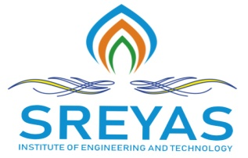
An Autonomous Institution
Approved by AICTE, Affiliated to JNTUH
Accredited by NAAC-A Grade, NBA (CSE, ECE & ME) & ISO 9001:2015 Certified

DEPARTMENT OF COMPUTER SCIENCE AND ENGINEERING

III CSE – IOMP 2025-2026

Date:
To
The HOD,
CSE Department,
Sreyas Institute of Engineering and Technology.

Subject – Regarding interaction of all batch members with Major Project Internal Guide.
We, the members of Batch B14 from III CSE – B section, have interacted with our Major Project Internal Guide on a regular basis and discussed the Major Project Review, also verified with the status of Major Project.
After verification, our guide has approved the review PPT of the Project.
Hereby, we are informed to proceed for presentation of Major Project Review-III to the respective Guides.
TITLE OF THE PROJECT –AI – BASED ONLINE EXAM MALPRACTICE DETECTION SYSTEM
DOMAIN OF THEPROJECT –AI – BASED ONLINE EXAM MALPRACTICE DETECTION SYSTEM
Batch Members –
ROLL NUMBER OF THE STUDENT | NAME OF THE STUDENT
23VE1A05B6 | PAGADALA DURGA
23VE1A05A0 | KONGARA SWAPNA
23VE1A0571 | ARAKATLA DIVYA
23VE1A0590 | GUGULOTHU ANIL

INTERNAL GUIDE

PROJECT COORDINATOR HOD, CSE

