Integrate the Jira with existing codebase
Before making changes
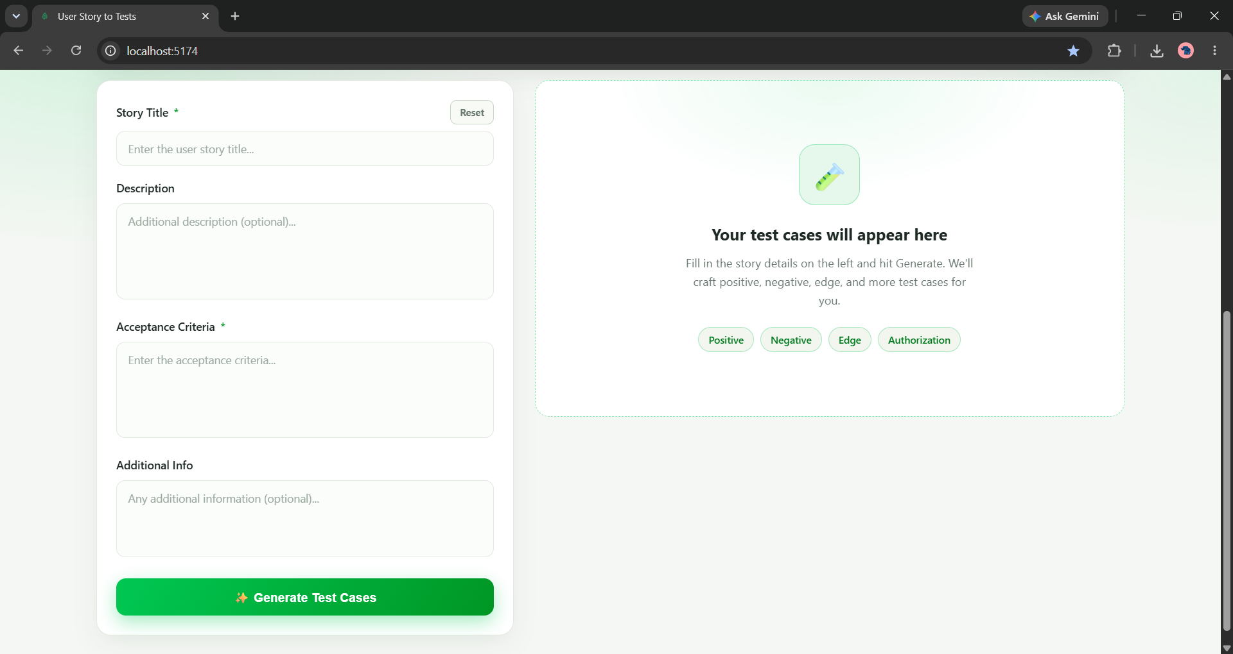
Sample prompt for Jira integration: - Front end: Need to add "Connect Jira" button to establish the connection
- Base URL
- Email id
- Jira API key
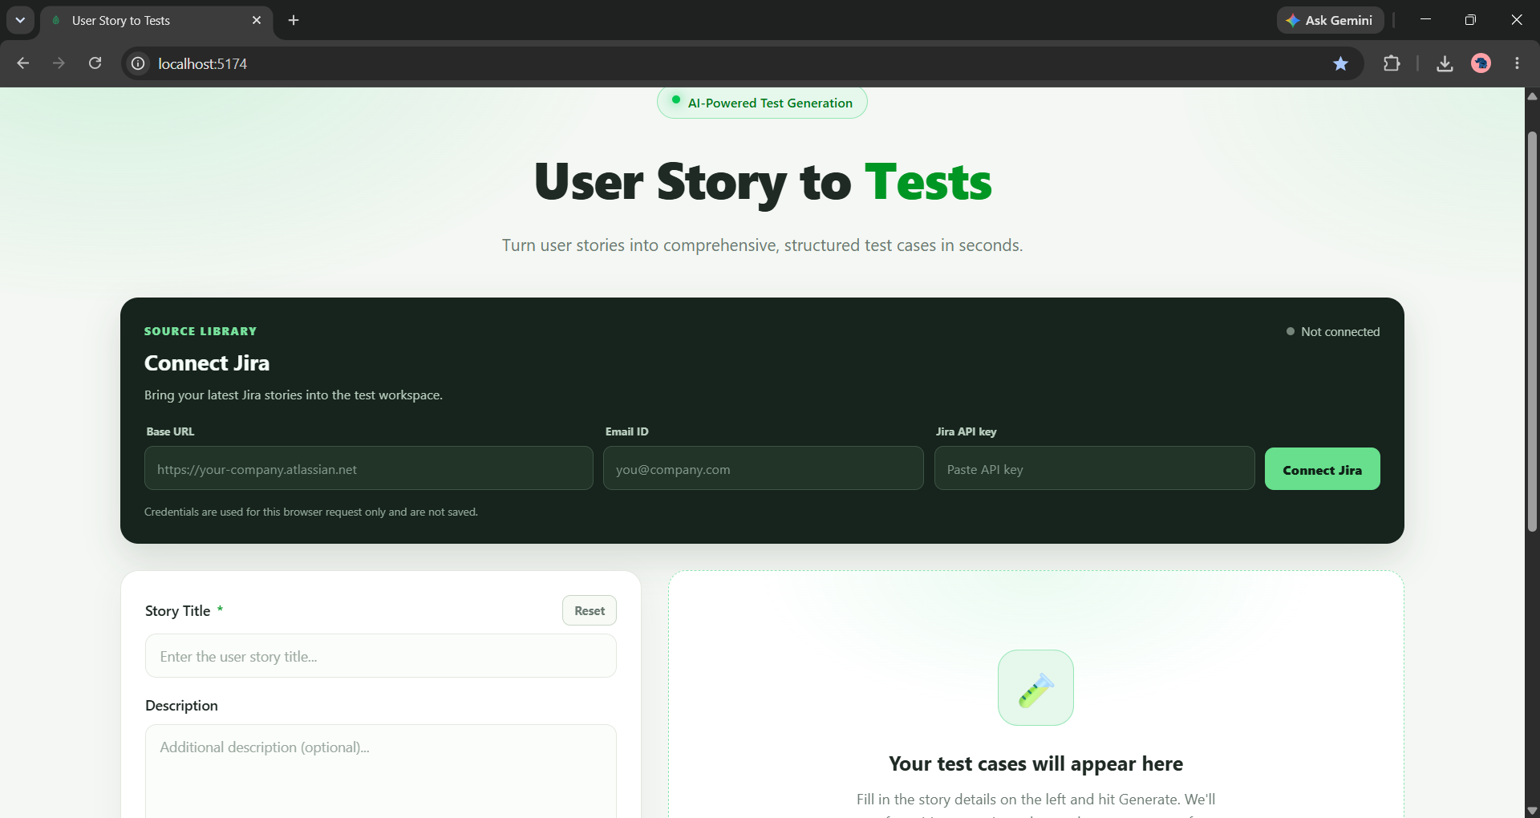

Connect Jira button is established. Passing Base URL, Email Id and Jira API Key 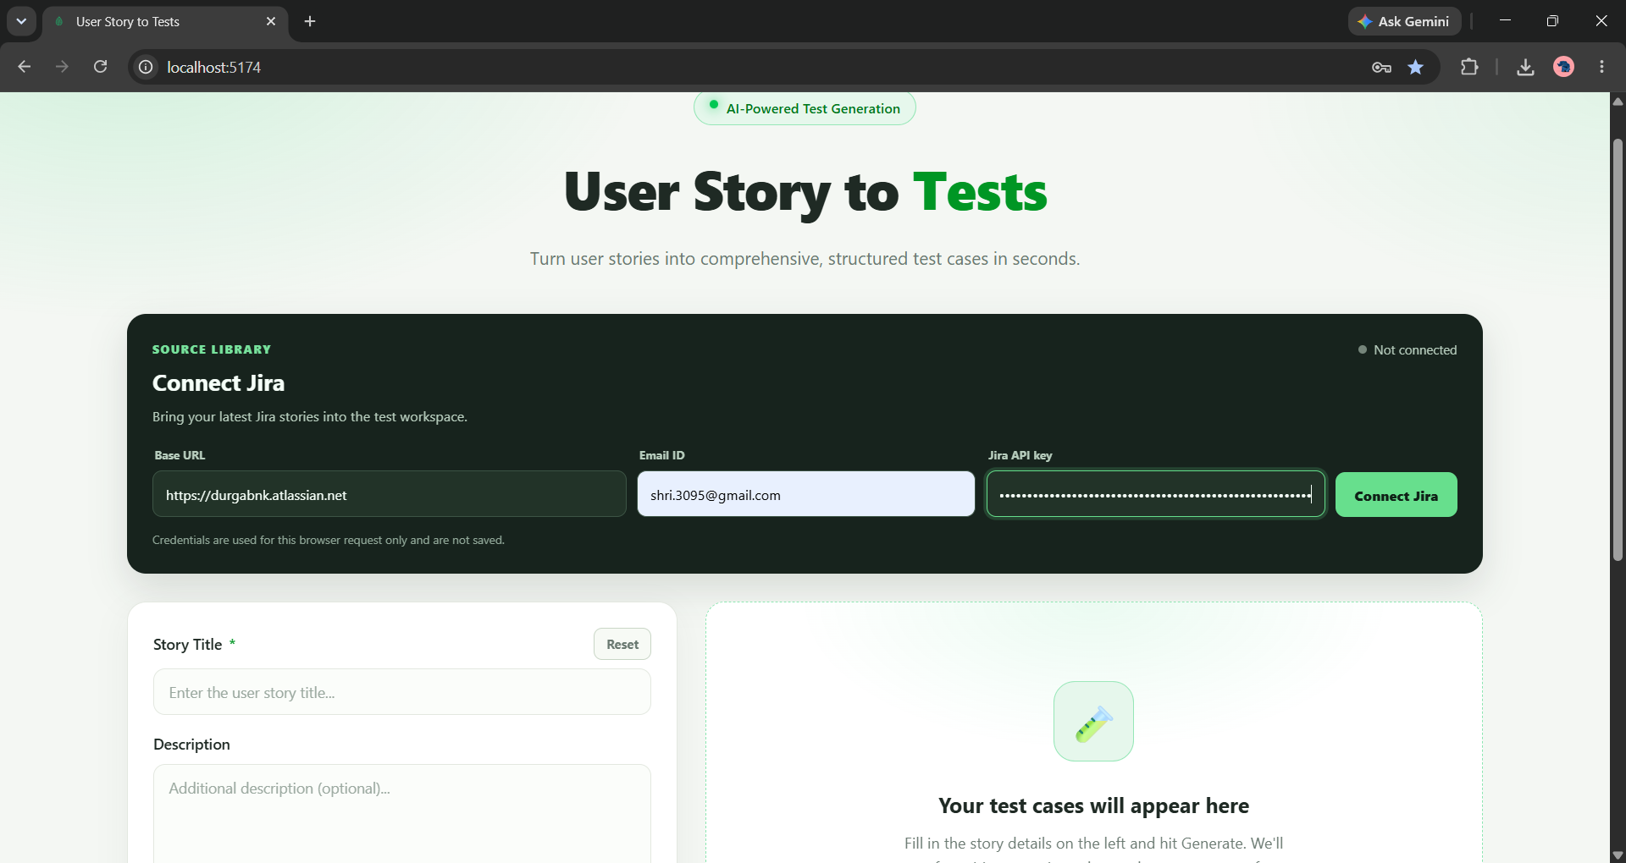

- Once the jira is connected userstories should be populated in the UI screen.
- After Implementing the UI changes, ensure that the "Connect Jira" button is functional and triggers the connection process. Upon successful connection, fetch the user stories from Jira and display them in a structured format within the UI. > Working as expected
