Classroom activity 09/26

* Add a radio button for **Accept Link** and another radio button for **File Upload**.
* If **Accept Link** is selected, display and populate the input box for entering the link.

Added URL in place of Accept Link
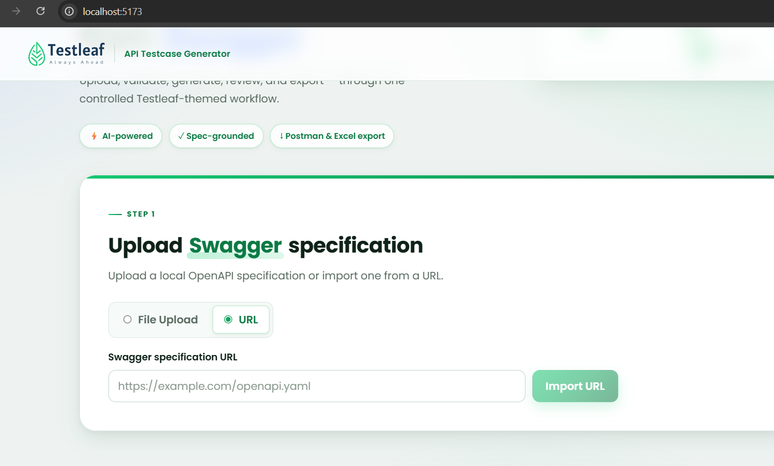

If **File Upload** is selected, display the file upload option.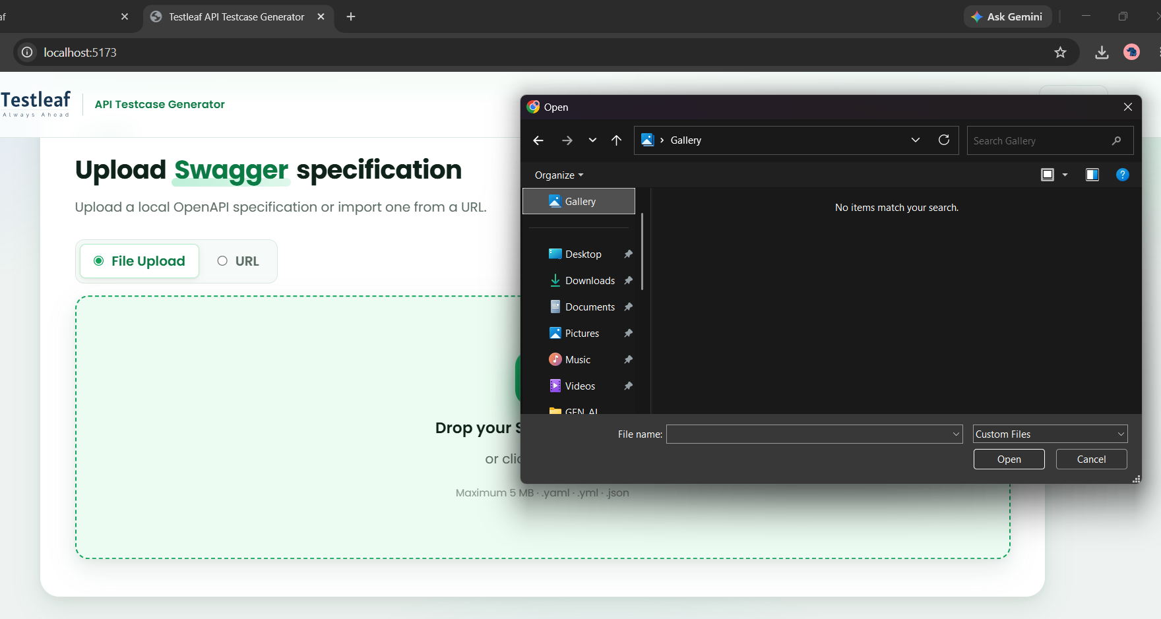
Pass URL: https://petstore.swagger.io/v2/swagger.json
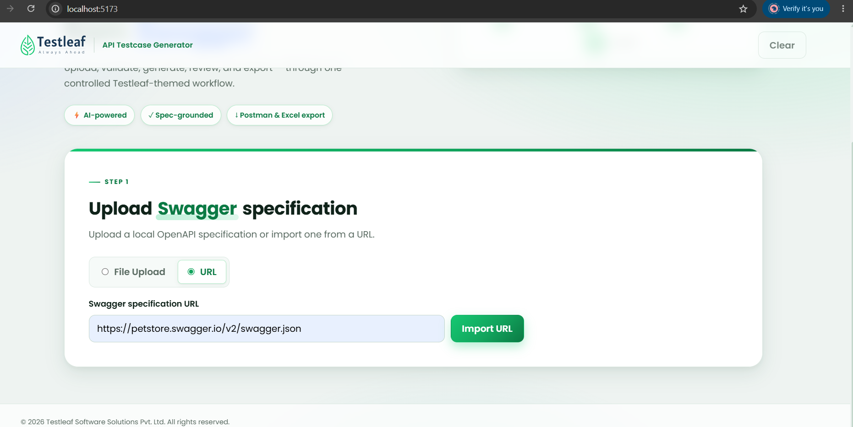
Proceed with Import URL: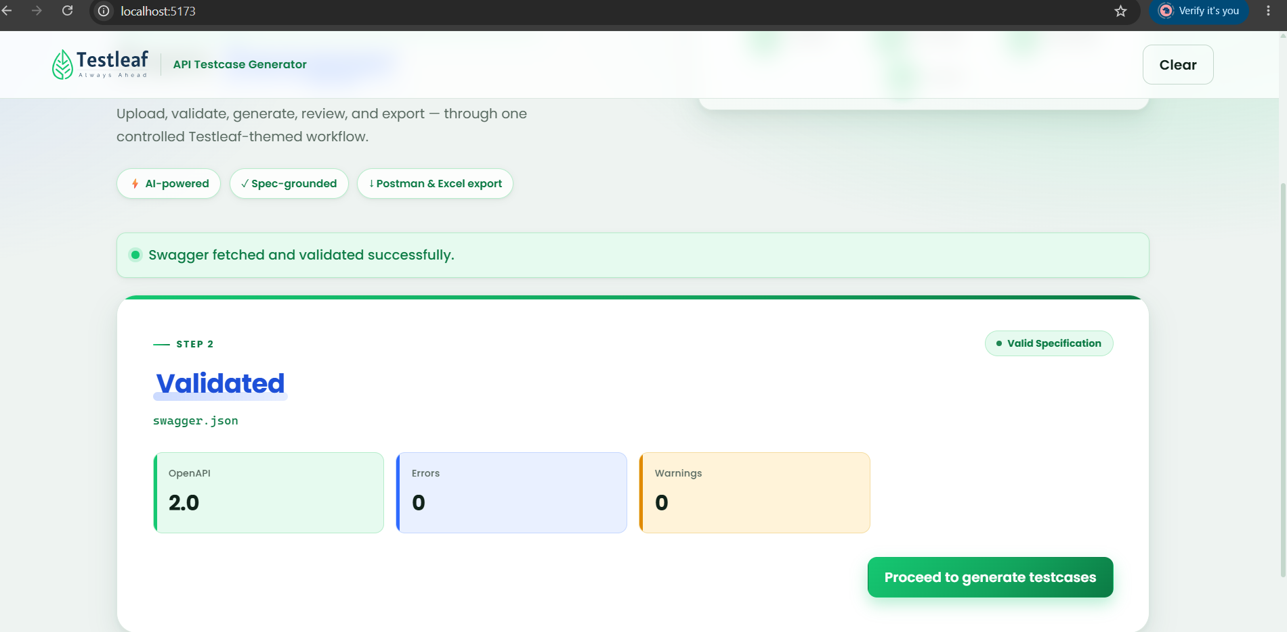
Prceed to generate test cases
