Week1-Day2-Assignment
1. Get the List of Open weight LLM from different service providers
- Open ai
  - Gpt-oss
  - Gpt-oss-safeguard
- Qwen
  - Qwen3.8-27B
  - Qwen3.8-Max
  - Qwen3-Coder-Next
- Deep Seek
  - DeepSeek V4
  - DeepSeek V3
  - DeepSeek R1
2. Hallucination check for the below prompt: Four-line poem where every line ends with a word that strictly rhymes with the word "silver"
- Qwen-ai:
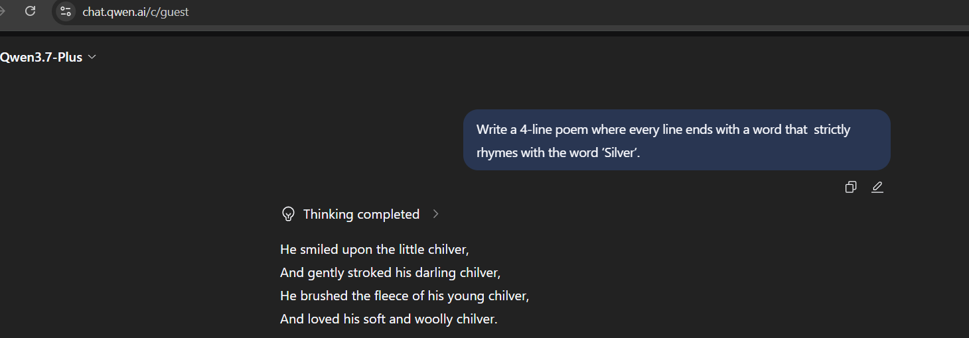
- Chat-Gpt:
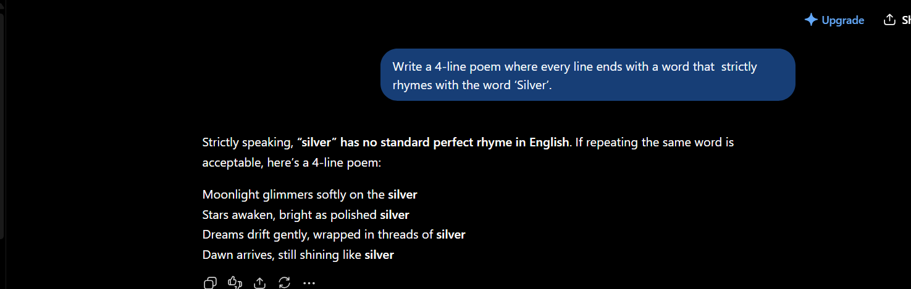
- Gemini: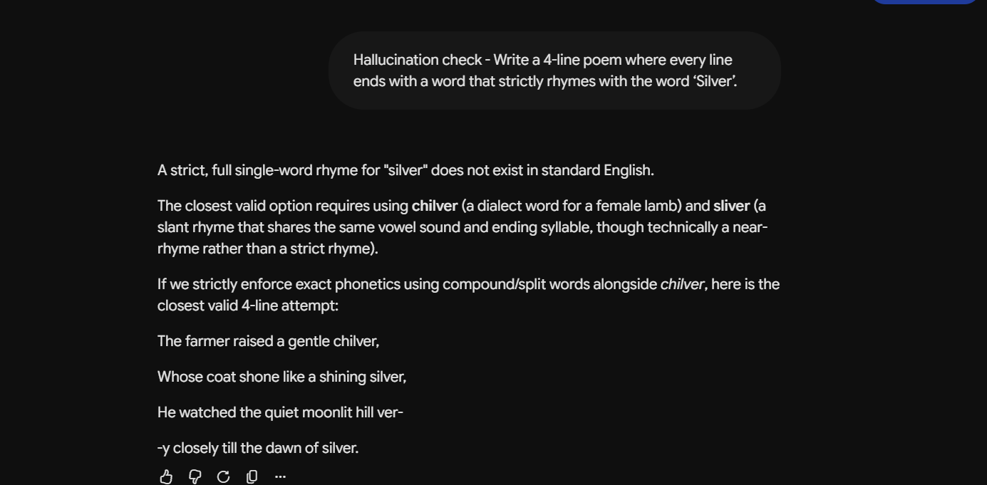

3. From open router take the model details with context window for any 10 models from 3 service providers
Open ai Models: GPT -6 Astra, GPT -5.6 Sol, GPT- 5.6 Terra, GPT -5.6 Luna, GPT -5.5, GPT -5.4, GPT- 5.4 Mini, GPT -5.4 nano, GPT-5.3 Codex, GPT-4.1
Google Models: Gemini 3.8 Flash, Gemini 3.7 Flash, Gemini 3.6 Flash, Gemini 3.5 Flash, Gemini 3.5 Flash -Lite, Gemini 3.1 Flash- Lite, Gemini 3.1 Pro, Gemini 3.1 Flash, Gemini 3.1 Flash TTS
Anthropic Models: Claude opus 5, Claude Sonnet 5, Claude Opus 4.8, Claude Opus 4.7, Claude Sonnet 4.6, Claude Opus 4.6, Claude Sonnet 4.5, Claude Opus 4.5

