Name:-Pruthviraj k
Data mining and visualization lab -02
Use the data sources, like ARFF, XML ARFF files. Do the following
i) a. Classify , Invoke MultiLayerPerception
b. Build neural network GUI as below
ii) Beginning the process of editing the network to add a second hidden layer
iii) The finished network with two hidden layers
iv) Apply Lazy classifier, multi instance classifier
v) Apply any MetaLearning Algorithm
vi) Optimize base classifier’s performance
vii) Use clustering algorithm such as Cobweb, and Hierarchical Cluster
viii) Select attribute by specifying an evaluator and a search method
ix) Insert 30 more records in this file. Perform clustering on this new dataset. Identify optimum number of clusters. After identification of optimum number of clusters, prepare clustering on this number.
x) Perform data analysis on the result obtained and prepare an analysis report for the same
xi) Apply Apriori, Interpret the results.
xii) Apply Association rules and interpret the results.
xiii) Apply Association mining with the Apriori alforithm and find the best rules with threshold value of support of 50% and confidence of 70%
xiv) Interpret the results obtained at Summary. Analyse Precision, Recall, F Score values.
xv) Install R package at Weka environment and install rpart package. Implement decision tree.

1.a. Classify , Invoke MultiLayerPerception

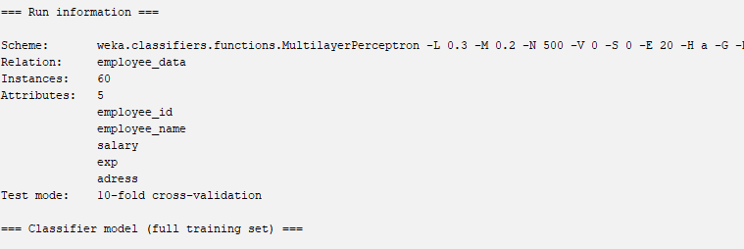

1.b.. Build neural network GUI as below

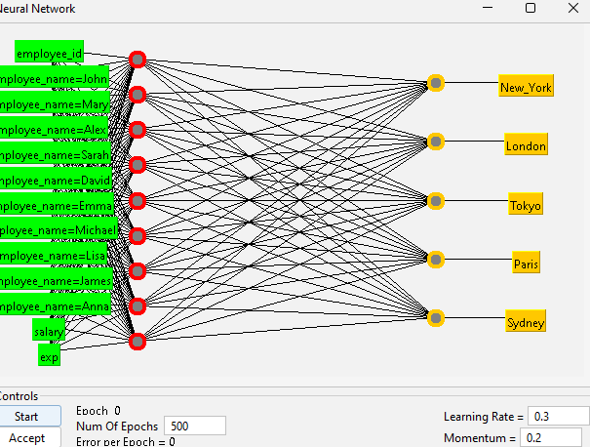

2. Beginning the process of editing the network to add a second hidden layer

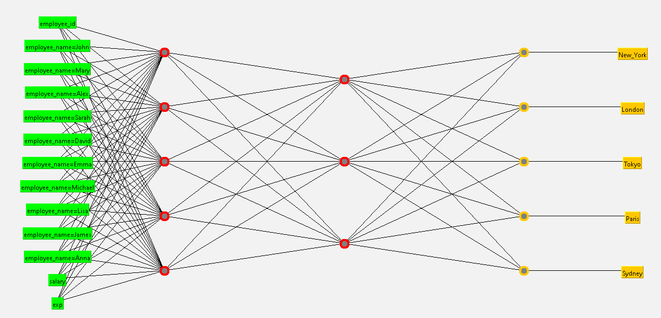

3.verified.
4. Apply Lazy classifier, multi instance classifier
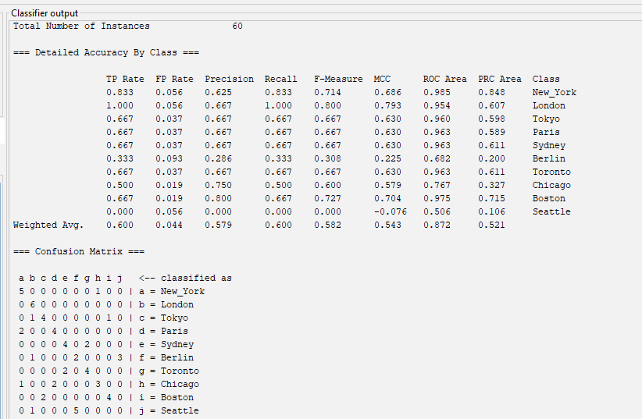

5. Apply any MetaLearning Algorithm
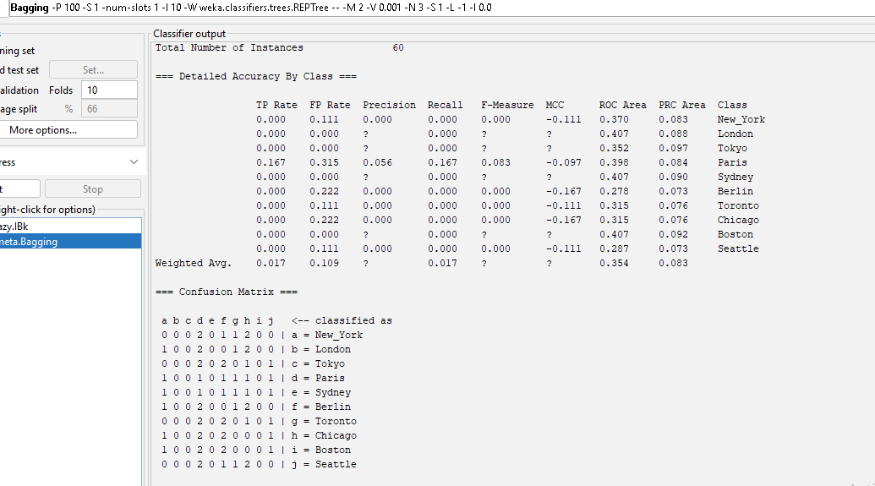

6. Optimize base classifier’s performance
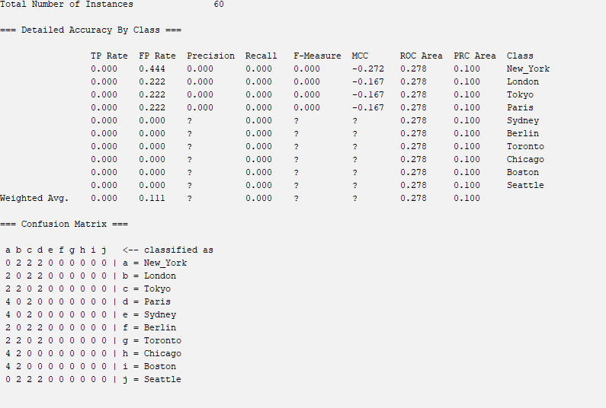

7.Use clustering algorithm such as Cobweb, and Hierarchical Cluster 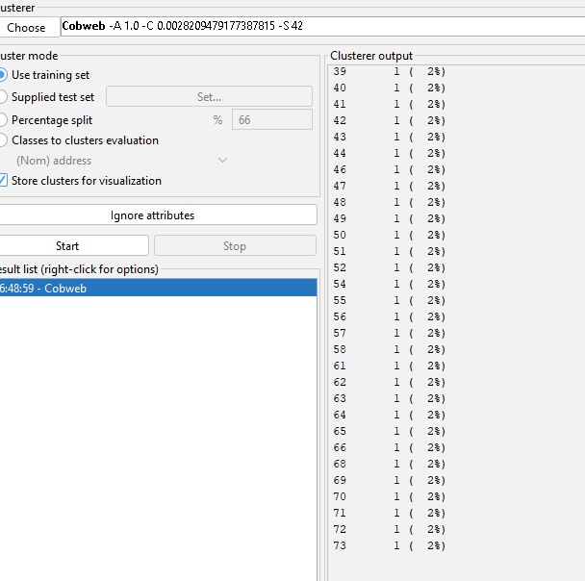
8. Select attribute by specifying an evaluator and a search method
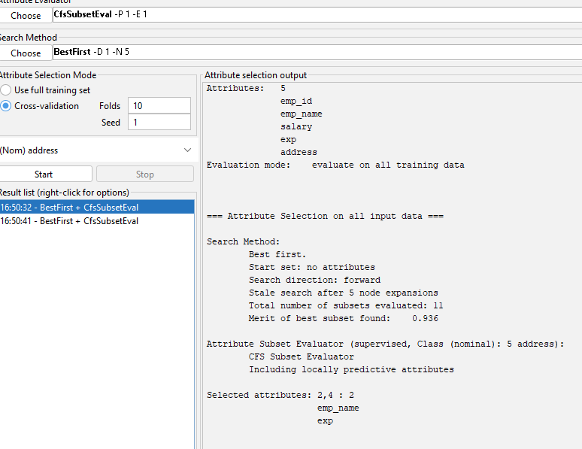

9. Insert 30 more records in this file. Perform clustering on this new dataset. Identify optimum number of clusters. After identification of optimum number of clusters, prepare clustering on this number.

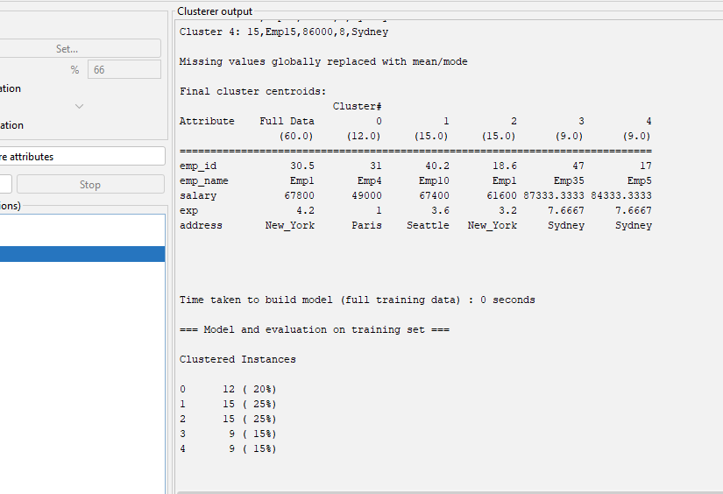

10. Perform data analysis on the result obtained and prepare an analysis report for the same

