Phase 4: Theme & Branding Setup

Prepared by: Sugrivu Durga Bhavani

Phase 4 focuses on establishing the theme and branding of the Salesforce Experience Cloud site. This step ensures the portal or website reflects the organization’s identity through consistent colors, logos, fonts, and layouts. It also involves setting up responsive design elements to provide an engaging experience across devices.

# Step 1: Can I change the name on a Booking?

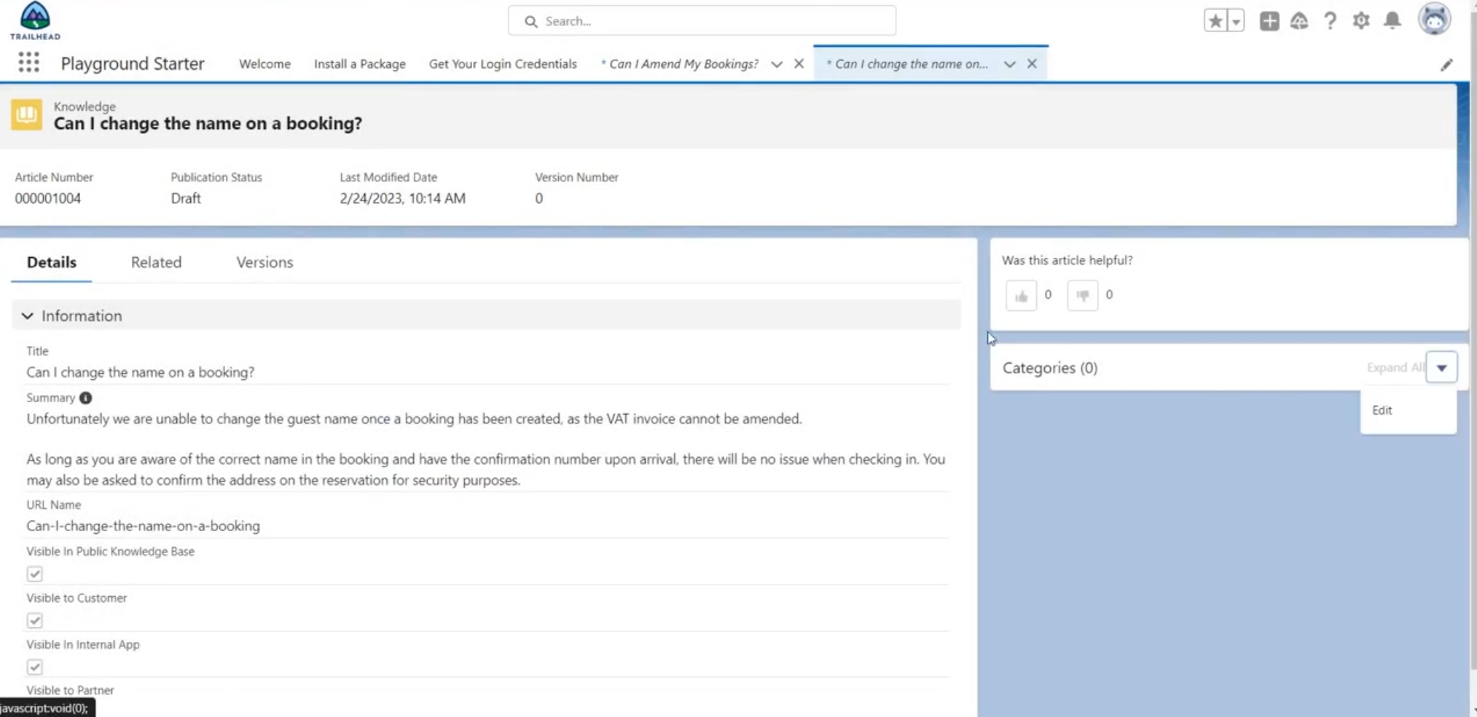

# Step 2: Can I Chat to someone in Customer Services?

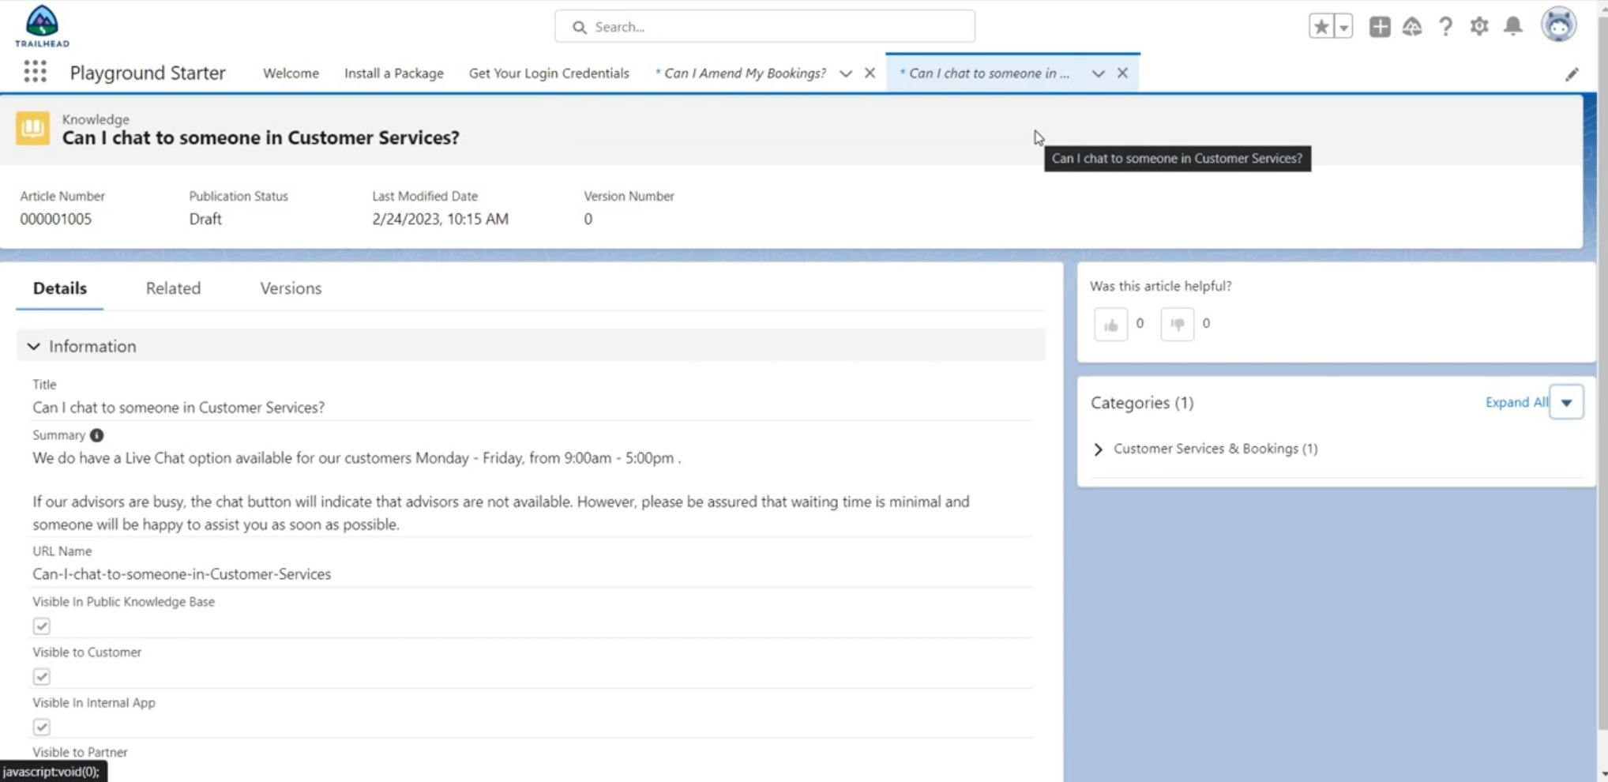

# Step 3: Cancel a Booking?

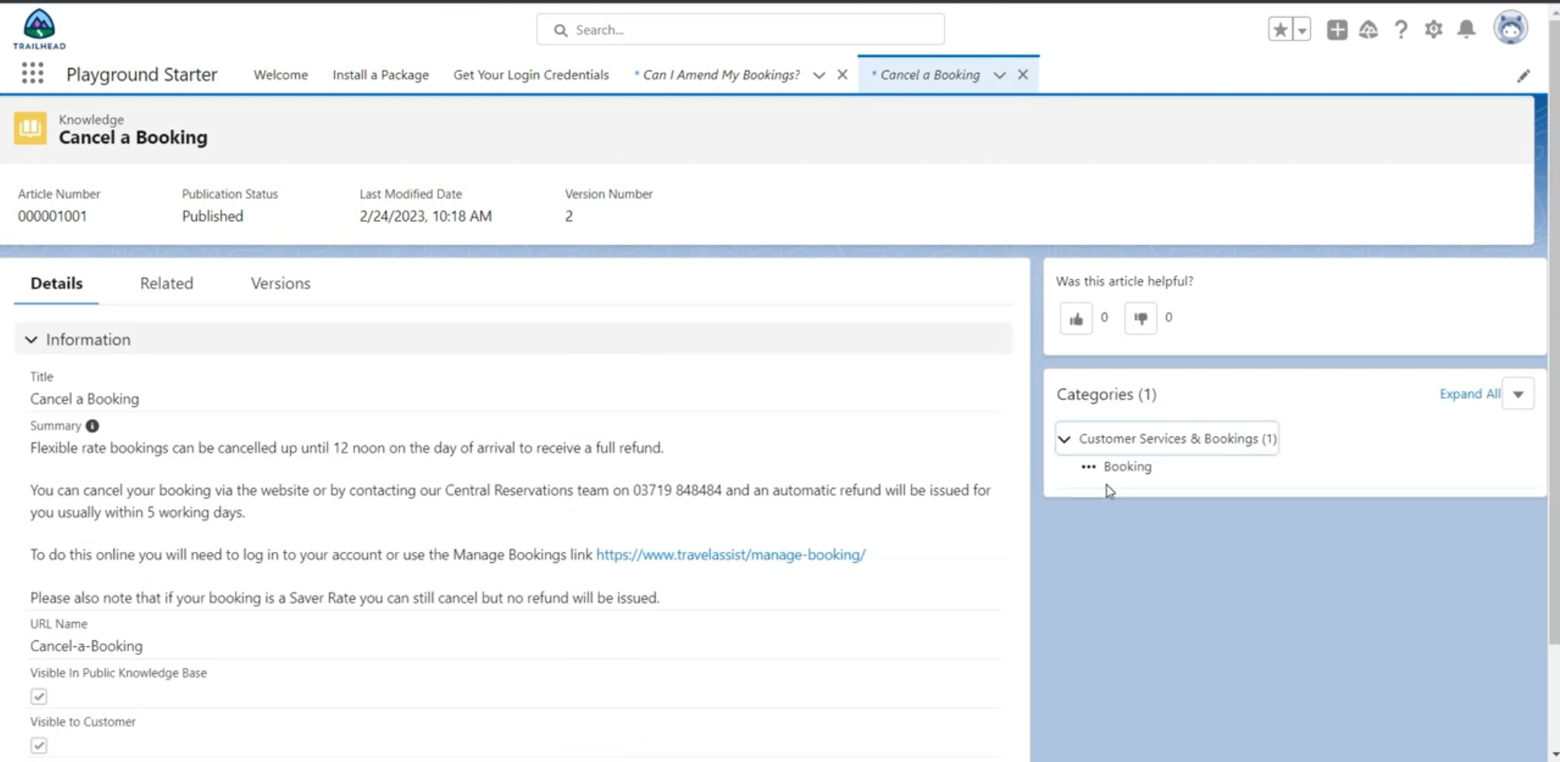

# Step 4: Profile -> System Administrator

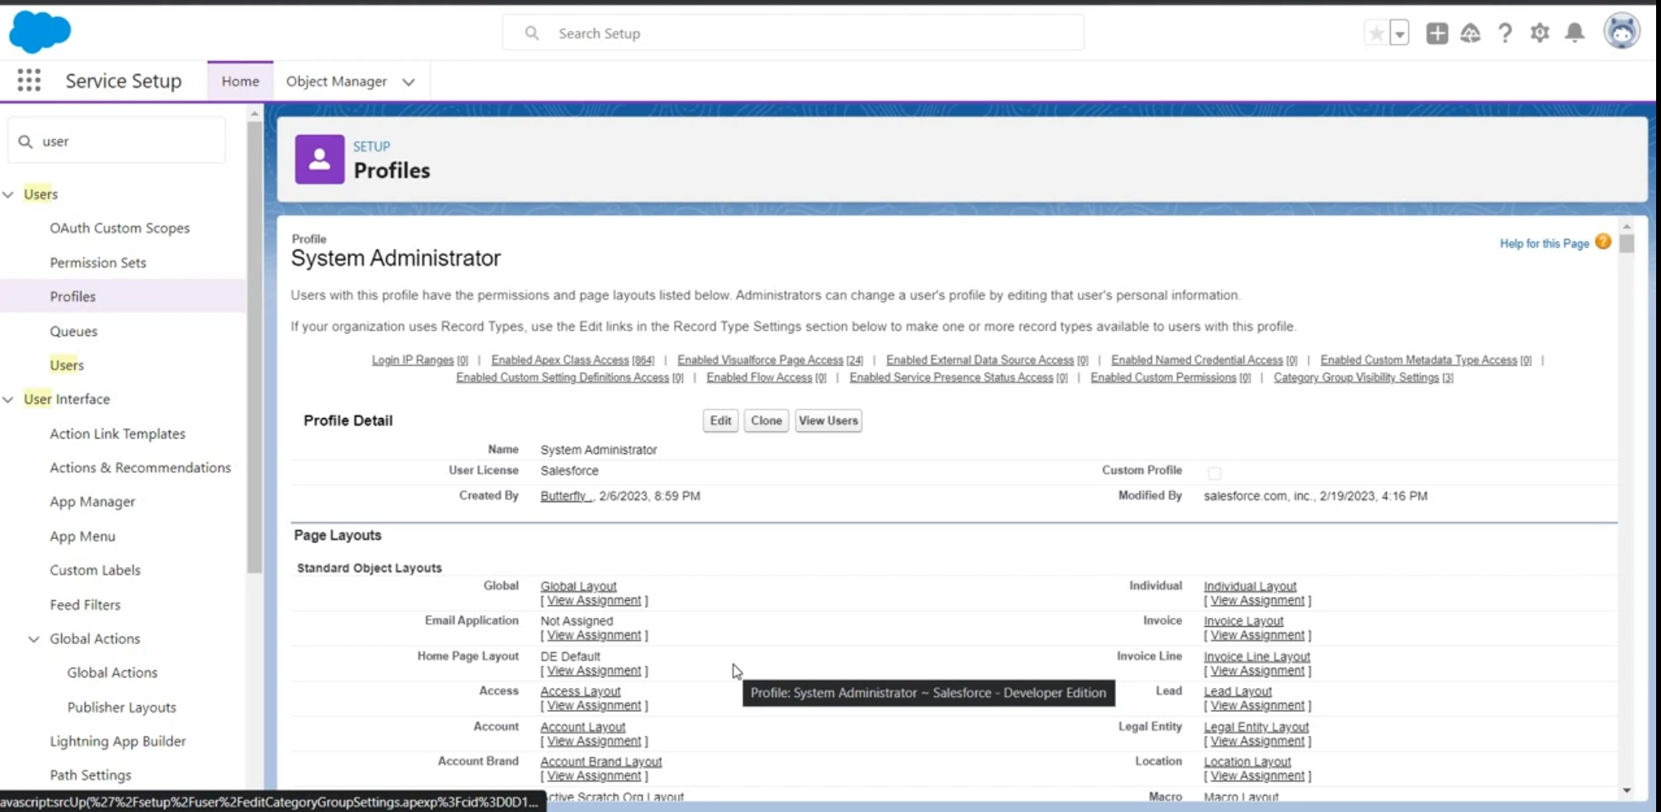

# Step 5: Community website Page

