Phase 5: Page & Navigation Construction

Prepared by: Sugrivu Durga Bhavani

Phase 5 focuses on building the structure of the Salesforce Experience Cloud site through page creation and navigation setup. This ensures users can seamlessly move across different areas of the site while maintaining consistency and usability. Proper planning of navigation and page layouts improves user experience and accessibility.

# Step 1: Content management Edits

# Step 2: Adding Rules for invoice

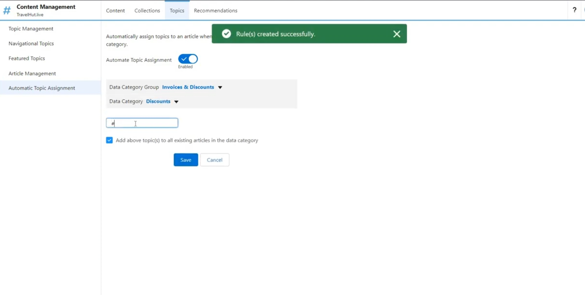

# Step 3: Adding Topics to Article Management

# Step 4: setup -> Adding members to Administration

