Phase 8: Content & Data Integration

Prepared by: Sugrivu Durga Bhavani

Phase 8 focuses on integrating content and Salesforce data into the Experience Cloud site. This phase ensures that static and dynamic content, as well as CRM data, is presented effectively to users. Content and data integration is vital for providing meaningful, interactive, and personalized user experiences.

# Step 1: Editing Case List

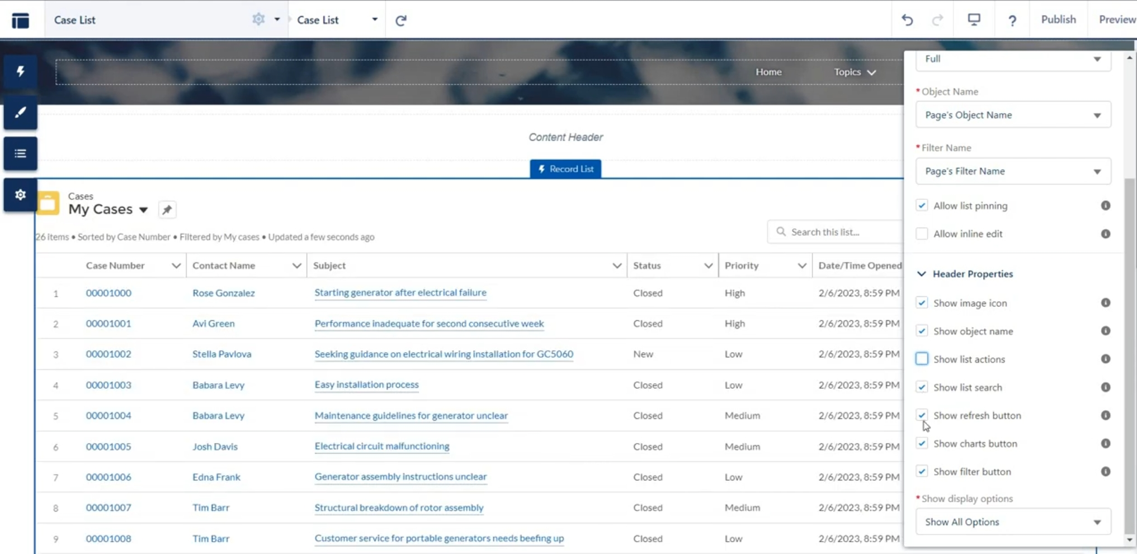

# Step 2: Creating New Page Layout

# Step 3: Adding Changes To Page Layout

# 

# Step 4: Getting Contact for John Depp

# Step 5: Refund Not Updated

# 