**Report**

# Q. 1) Find all the unique 'Wind Speed' values in the data.

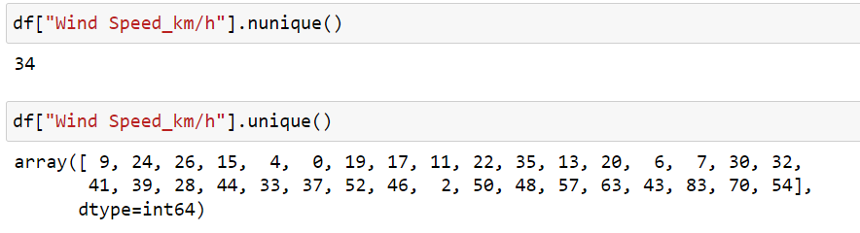

Explanation:-

A unique key is a set of one or more than one fields/columns of a table that uniquely identify a record in a database table.

**Q. 2) Find the number of times when the 'Weather is exactly Clear'.**

### 

Explanation:-

### *Here, the code represents the number of occurences of weather condition*

### *when “weather is exactly Clear”.*

**Q. 3) Find the number of times when the 'Wind Speed was exactly 4 km/h'**

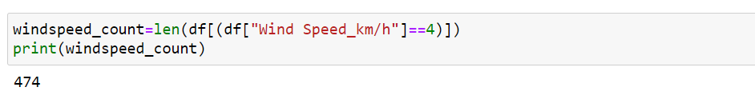

Explanation:-

### This code tells to select rows when the wind speed is 4 km/h and then

### counts the number of such rows, storing the count in the variable windspeed count.

# Q. 4) Find out all the Null Values in the data.

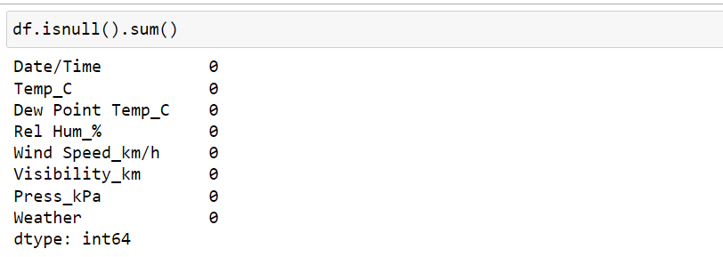

Explanation:-

The isnull() function in Python is used to detect missing or null values in a Pandas Data Frame.

# Q. 5) Rename the column name 'Weather' of the data frame to 'Weather Condition'

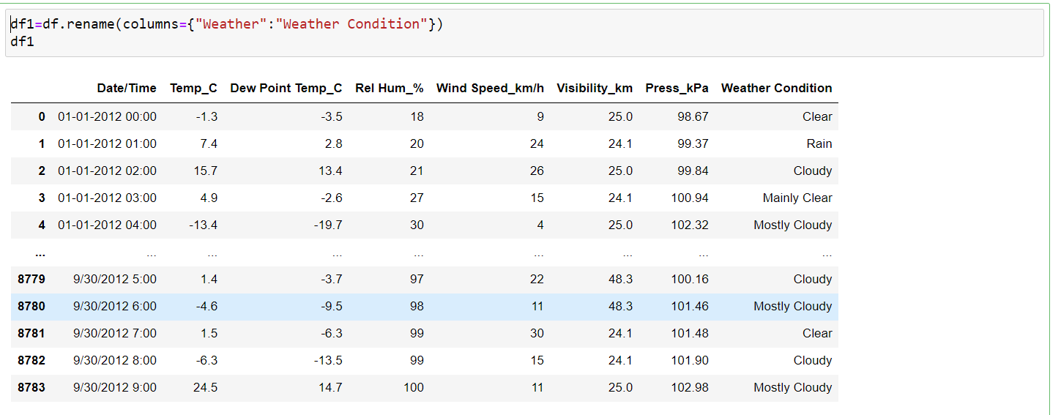

Explanation:-

One way of renaming the columns in a Pandas Dataframe is by using the rename() function. This method is quite useful when we need to rename some selected columns because we need to specify information only for the columns which are to be renamed.

# Q. 6) What is the mean 'Visibility' ?

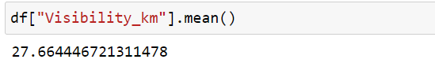

Explanation:-

It computes the average visibility in kilometeres based on values present in the visibility column

**Q. 7) What is the Standard Deviation of 'Pressure' in this data?**

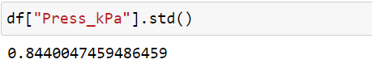

Explanation:-

In above code , it tells about the standard deviation of atmospheric pressure values in “pressure” column

# Q. 8) What is the Variance of 'Relative Humidity' in this data ?

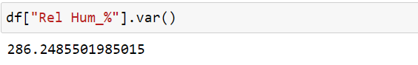

Explanation:-

 Variance Function in python pandas is used to calculate variance of a given set of numbers, Variance of a data frame, Variance of column or column wise variance in pandas python and Variance of rows or row wise variance in pandas python.

# Q. 9) Find all instances when 'Snow' was recorded

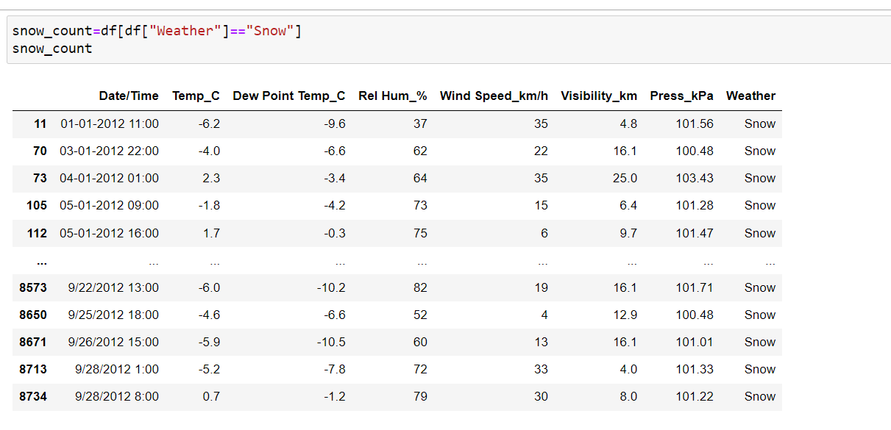

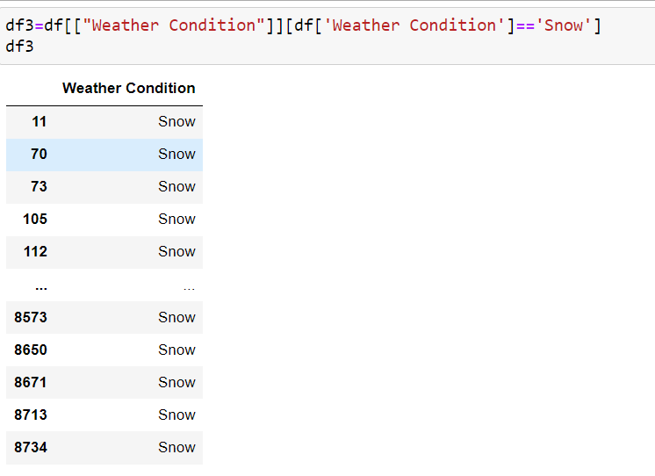

Explanation:-

### In above it computes to find all rows where snow was recorded in weather column.

# Q. 10) Find all instances when 'Wind Speed is above 24' and 'Visibility is 25'.

# 

# 

Explanation:-

# The resulting data frame contains only the rows where the windspeed is greater than 24 km/h and visibility is 25km

# Q. 11) What is the Mean value of each column against each 'Weather Condition ?[¶](http://localhost:8888/notebooks/weather%20task.ipynb#Q.-11)-What-is-the-Mean-value-of-each-column-against-each-'Weather-Condition-?)

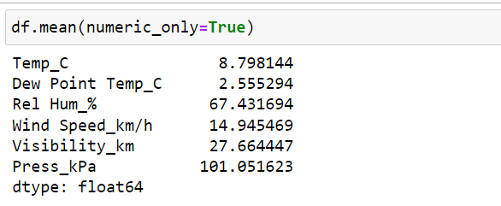

Explanation:-

To calculate mean of a Pandas Data Frame, you can use pandas. Data Frame.mean() method. Using mean() method, you can calculate mean along an axis, or the complete Data Frame

# Q. 12) What is the Minimum & Maximum value of each column against each 'Weather Condition ?

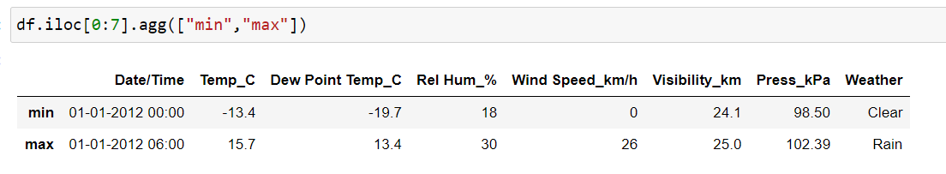

Explanation:-

**max () and.min () functions allow us to find the smallest and largest numbers in a column**.

**Q. 13) Show all the Records where Weather Condition is Fog.**

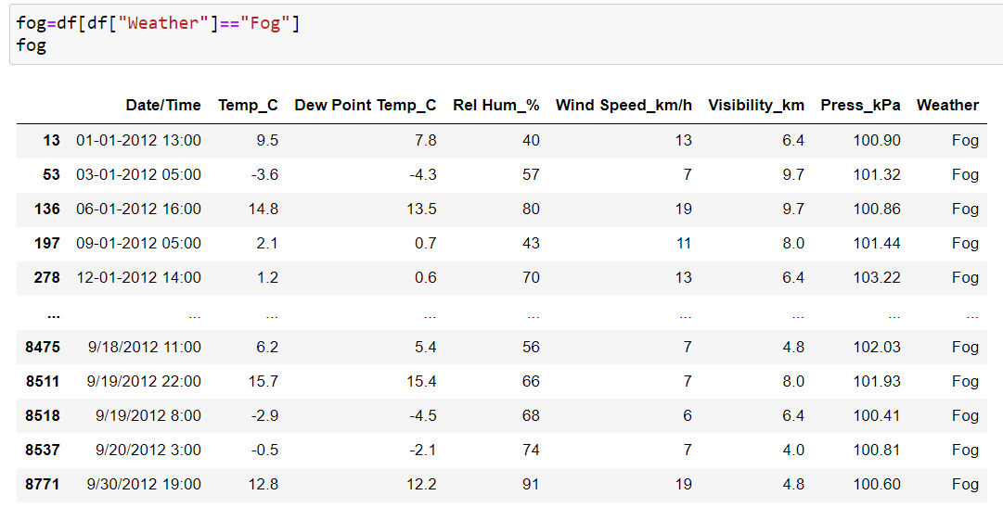

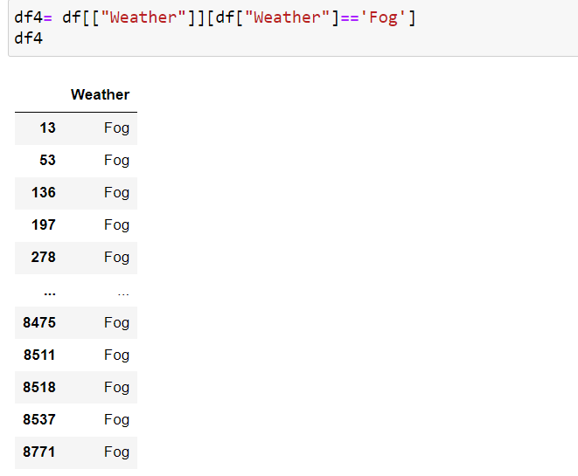

Explanation:-

It computes a data frame that contains only the rows from the “weather” column where the weather condition is fog and only weather column where fog is record.

# Q. 14) Find all instances when 'Weather is Clear' or 'Visibility is above 40'.

# 

# 

Explanation:-

### The resulting data frame contains only the rows where the weather condition is “Clear” or the visibility is greater than 40 km

### It represents a data frame that contains only 2 columns from the weather and visibility_ km columns where the weather condition is “Clear” or the visibility is greater than 40 km.

### 15. Find all instances when :

#### **A. 'Weather is Clear' and 'Relative Humidity is greater than 50'**

#### **or**

#### **B. 'Visibility is above 40'**

### 

### 

Explanation:-

It computes data frame containing only the rows from the "Weather", " Rel Hum_%", and "Visibility_ km" columns where either the weather is 'Clear' and relative humidity is greater than 50% or visibility is greater than 40 km And it represents a data frame containing only the rows where either the weather condition is “ Clear ” and relative humidity is greater than 50% or the visibility is greater than 40km.