Day-2 : 11/16/2021 Training
Team :
1. Bhargav Mandadi
2. Durga Phukan
3. Amit yadav
4. Pritam patra
5. Ankit rawat

Entity Rationship Diagram :

An Entity Relationship (ER) Diagram is a type of flowchart that illustrates how “entities” such as people, objects or concepts relate to each other within a system.

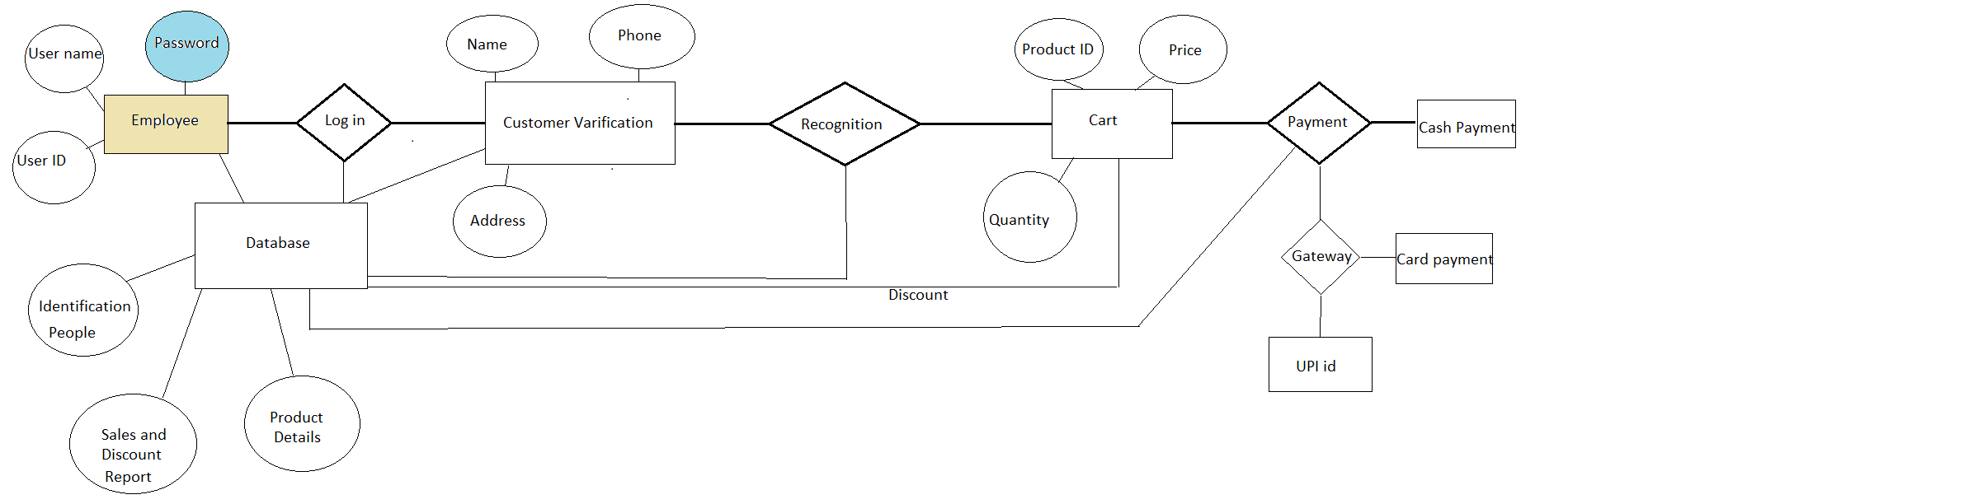

Data Flow Diagram :

A data flow diagram (DFD) illustrates how data is processed by a system in terms of inputs and outputs. As its name indicates its focus is on the flow of information, where data comes from, where it goes and how it gets stored.

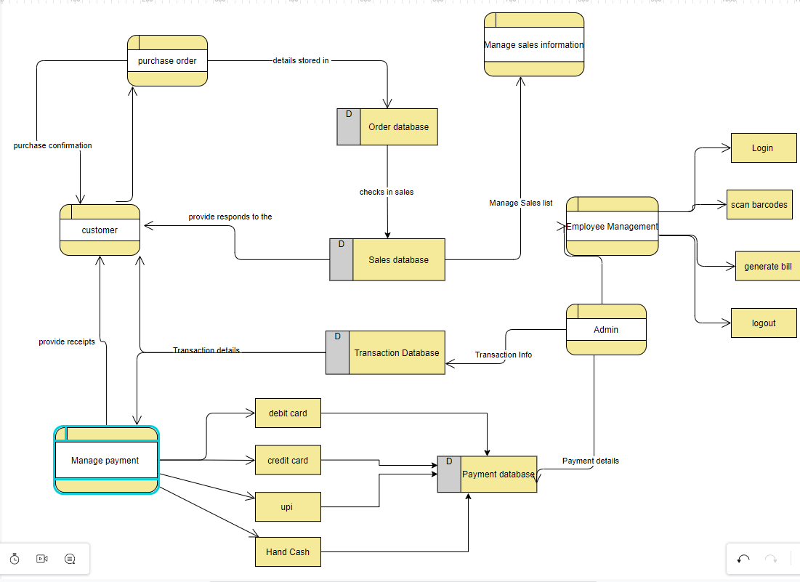

Activity Diagram:

An activity diagram shows business and software processes as a progression of actions. These actions can be carried out by people, software components or computers. Activity diagrams are used to describe business processes and use cases as well as to document the implementation of system processes.

