WEEK-2

**JUnit Testing Exercises**

**Exercise 1: Setting Up JUnit**

Scenario:

You need to set up JUnit in your Java project to start writing unit tests.

Steps:

1. Create a new Java project in your IDE (e.g., IntelliJ IDEA, Eclipse).

2. Add JUnit dependency to your project. If you are using Maven, add the following to your pom.xml:

<dependency>

<groupId>junit</groupId>

<artifactId>junit</artifactId>

<version>4.13.2</version>

<scope>test</scope>

</dependency>

3. Create a new test class in your project.

**CODE**

**junitdemo Example**

Pom.xml

<project xmlns="http://maven.apache.org/POM/4.0.0"

xmlns:xsi="http://www.w3.org/2001/XMLSchema-instance"

xsi:schemaLocation="http://maven.apache.org/POM/4.0.0 http://maven.apache.org/xsd/maven-4.0.0.xsd">

<modelVersion>4.0.0</modelVersion>

<groupId>com.example</groupId>

<artifactId>junitdemo</artifactId>

<version>0.0.1-SNAPSHOT</version>

<dependencies>

<dependency>

<groupId>junit</groupId>

<artifactId>junit</artifactId>

<version>4.13.2</version>

<scope>test</scope>

</dependency>

</dependencies>

</project>

**Calculator.java**

package com.example;

public class Calculator {

public int add(int a, int b) {

return a + b;

}

}

**CalculatorTest.java**

package com.example;

import static org.junit.Assert.*;

import org.junit.Test;

public class CalculatorTest {

@Test

public void testAdd() {

Calculator calc = new Calculator();

assertEquals(5, calc.add(2, 3));

}

}**OUTPUT**

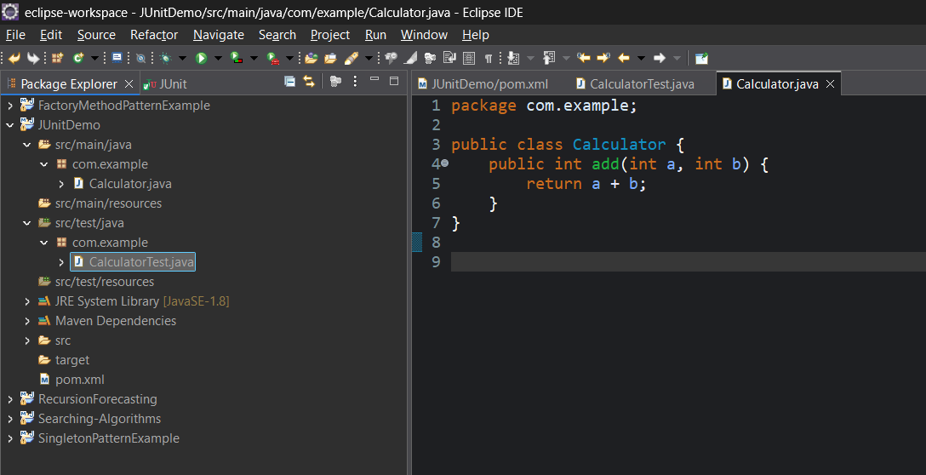

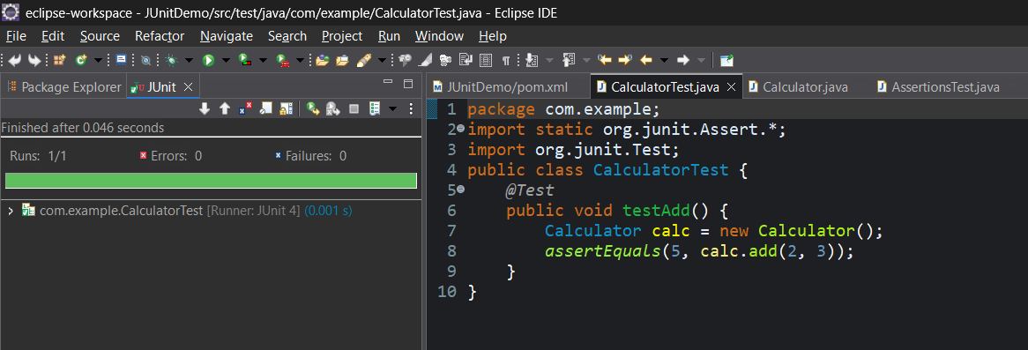

**Exercise 3: Assertions in JUnit**

Scenario:

You need to use different assertions in JUnit to validate your test results.

Steps:

1. Write tests using various JUnit assertions.
2. Solution Code:

public class AssertionsTest {

@Test

public void testAssertions() {

// Assert equals

assertEquals(5, 2 + 3);

// Assert true

assertTrue(5 > 3);

// Assert false

assertFalse(5 < 3);

// Assert null

assertNull(null);

// Assert not null

assertNotNull(new Object());

}

}

**CODE**

**AssertionsTest.java**

package com.example;

import static org.junit.Assert.*;

import org.junit.Test;

public class AssertionsTest {

@Test

public void testAssertions() {

// Assert equals

assertEquals(5, 2 + 3);

// Assert true

assertTrue(5 > 3);

// Assert false

assertFalse(5 < 3);

// Assert null

assertNull(null);

// Assert not null

assertNotNull(new Object());

}

}

**OUTPUT**

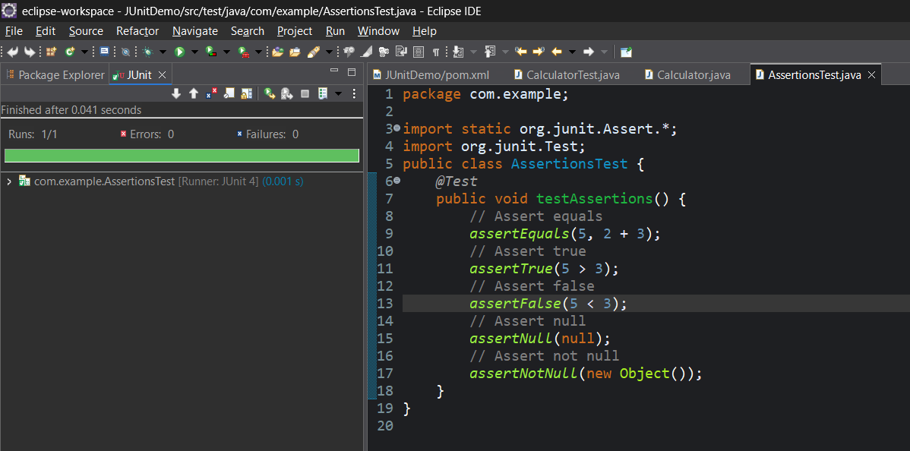

**Exercise 4:** **Arrange-Act-Assert (AAA) Pattern, Test Fixtures, Setup and Teardown Methods in JUnit**

Scenario:

You need to organize your tests using the Arrange-Act-Assert (AAA) pattern and use setup and teardown methods.

Steps:

1. Write tests using the AAA pattern.

2. Use @Before and @After annotations for setup and teardown methods.

**CODE**

**Calculator.java**

package com.example;

public class Calculator {

public int add(int a, int b) { return a + b; }

public int subtract(int a, int b) { return a - b; }

public int multiply(int a, int b) { return a * b; }

public int divide(int a, int b) {

if (b == 0) throw new IllegalArgumentException("Division by zero");

return a / b;

}

}

**CalculatorTest.java**

package com.example;

import static org.junit.Assert.*;

import org.junit.Before;

import org.junit.After;

import org.junit.Test;

public class CalculatorTest {

private Calculator calculator;

// Setup method

*@Before*

public void setUp() {

calculator = new Calculator();

System.***out***.println("Setup before test");

}

// Teardown method

*@After*

public void tearDown() {

calculator = null;

System.***out***.println("Cleanup after test");

}

*@Test*

public void testAdd() {

int result = calculator.add(2, 3);

*assertEquals*(5, result);

}

*@Test*

public void testSubtract() {

int result = calculator.subtract(10, 4);

*assertEquals*(6, result);

}

*@Test*

public void testMultiply() {

int result = calculator.multiply(3, 4);

*assertEquals*(12, result);

}

*@Test*

public void testDivide() {

int result = calculator.divide(12, 3);

*assertEquals*(4, result);

}

}

**OUTPUT**

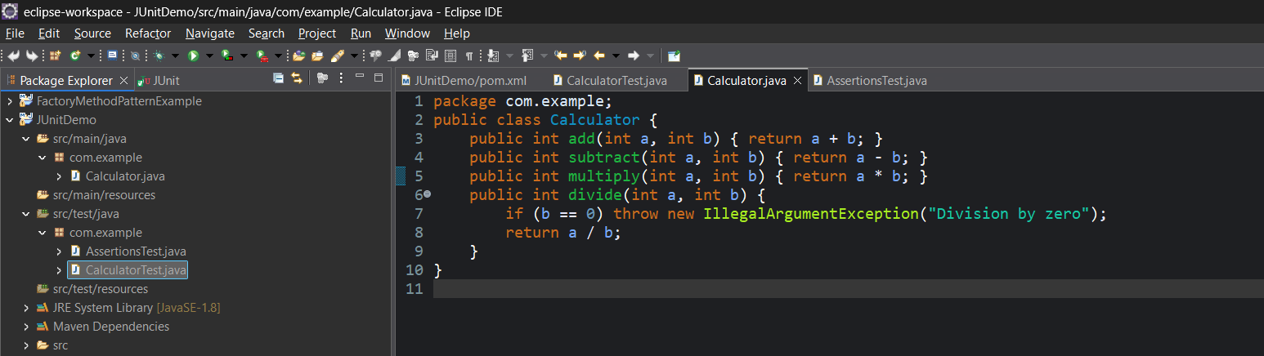

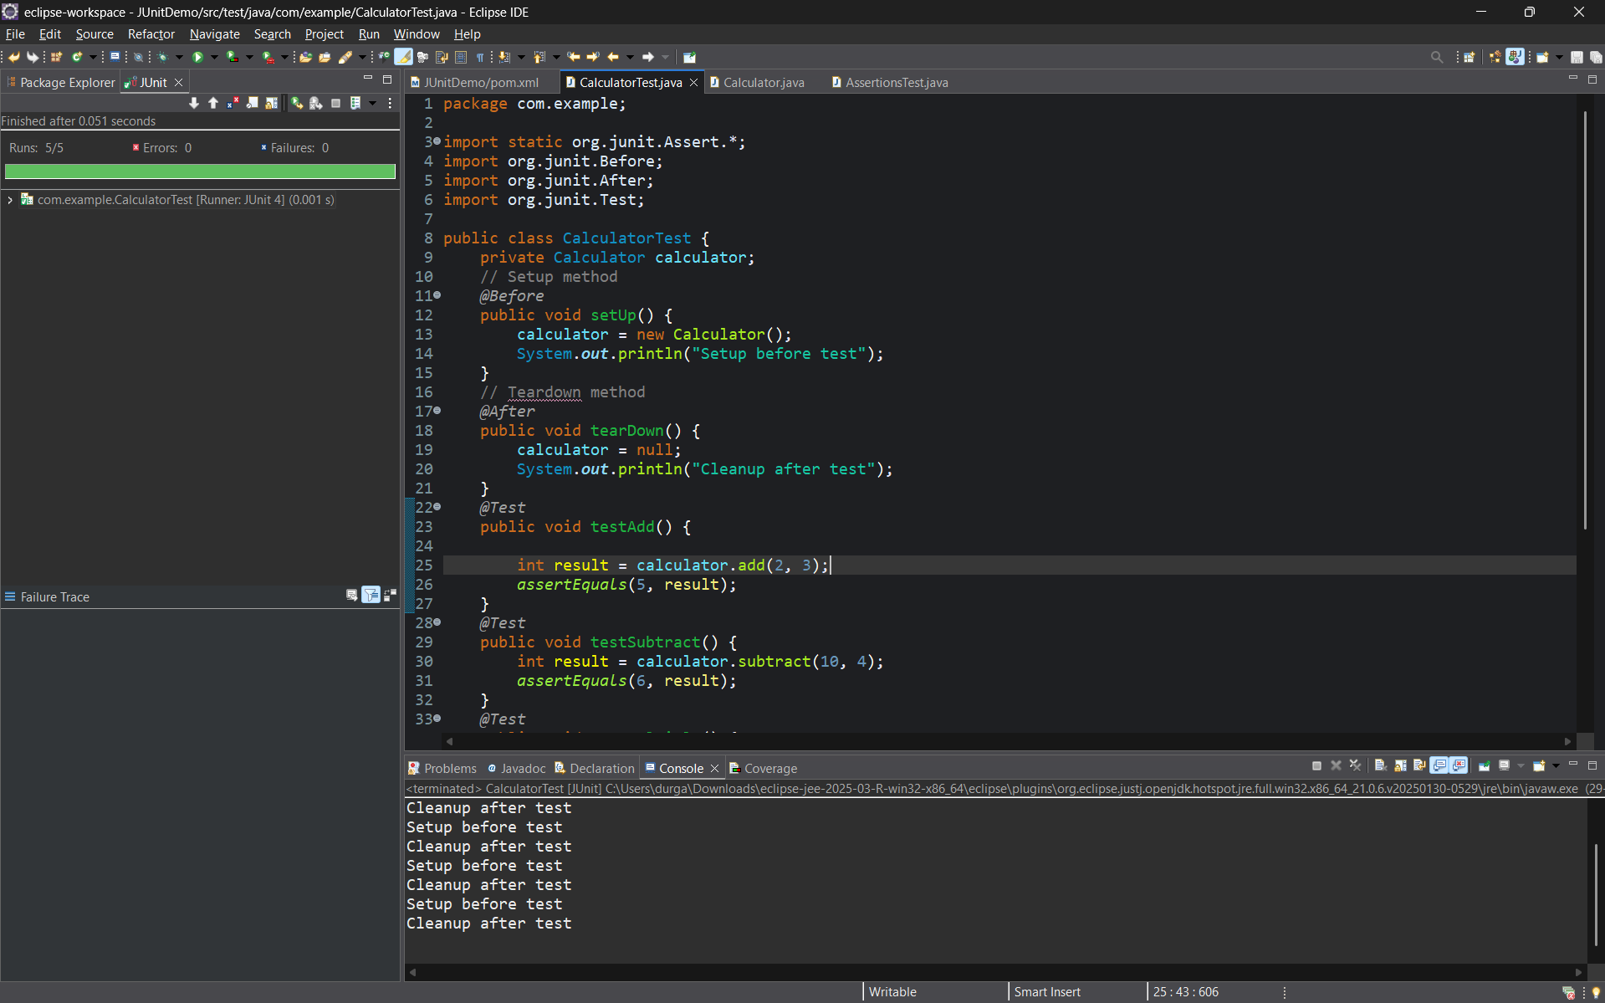

**MOCKITO EXERCISES**

**Exercise 1: Mocking and Stubbing**

Scenario: You need to test a service that depends on an external API. Use Mockito to mock the external API and stub its methods.

Steps:

1. Create a mock object for the external API.

2. Stub the methods to return predefined values.

3. Write a test case that uses the mock object.

Solution Code:

import static org.mockito.Mockito.*;

import org.junit.jupiter.api.Test;

import org.mockito.Mockito;

public class MyServiceTest {

@Test

public void testExternalApi() {

ExternalApi mockApi = Mockito.mock(ExternalApi.class); when(mockApi.getData()).thenReturn("Mock Data");

MyService service = new MyService(mockApi);

String result = service.fetchData();

assertEquals("Mock Data", result);

}

}

**CODE**

pom.xml

<project xmlns="http://maven.apache.org/POM/4.0.0"

xmlns:xsi="http://www.w3.org/2001/XMLSchema-instance"

xsi:schemaLocation="http://maven.apache.org/POM/4.0.0 http://maven.apache.org/xsd/maven-4.0.0.xsd">

<modelVersion>4.0.0</modelVersion>

<groupId>com.example</groupId>

<artifactId>mockitodemo</artifactId>

<version>0.0.1-SNAPSHOT</version>

<dependencies>

<dependency>

<groupId>org.junit.jupiter</groupId>

<artifactId>junit-jupiter</artifactId>

<version>5.9.3</version>

<scope>test</scope>

</dependency>

<dependency>

<groupId>org.mockito</groupId>

<artifactId>mockito-core</artifactId>

<version>5.11.0</version>

<scope>test</scope>

</dependency>

</dependencies>

<build>

<plugins>

<plugin>

<groupId>org.apache.maven.plugins</groupId>

<artifactId>maven-surefire-plugin</artifactId>

<version>3.1.2</version>

</plugin>

</plugins>

</build>

</project>

**ExternalApi.java**

package com.example;

public interface ExternalApi {

String getData();

}

**MyService.java**

package com.example;

public class MyService {

private ExternalApi api;

public MyService(ExternalApi api) {

this.api = api;

}

public String fetchData() {

return api.getData();

}

}

**MyServiceTest.java**

package com.example;

import static org.junit.jupiter.api.Assertions.*assertEquals*;

import static org.mockito.Mockito.*;

import org.junit.jupiter.api.Test;

public class MyServiceTest {

*@Test*

public void testExternalApi() {

ExternalApi mockApi = *mock*(ExternalApi.class);

*when*(mockApi.getData()).thenReturn("Mock Data");

MyService service = new MyService(mockApi);

String result = service.fetchData();

*assertEquals*("Mock Data", result);

}

}

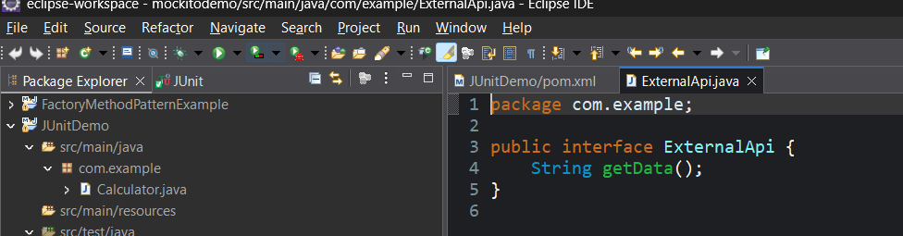OUTPUT

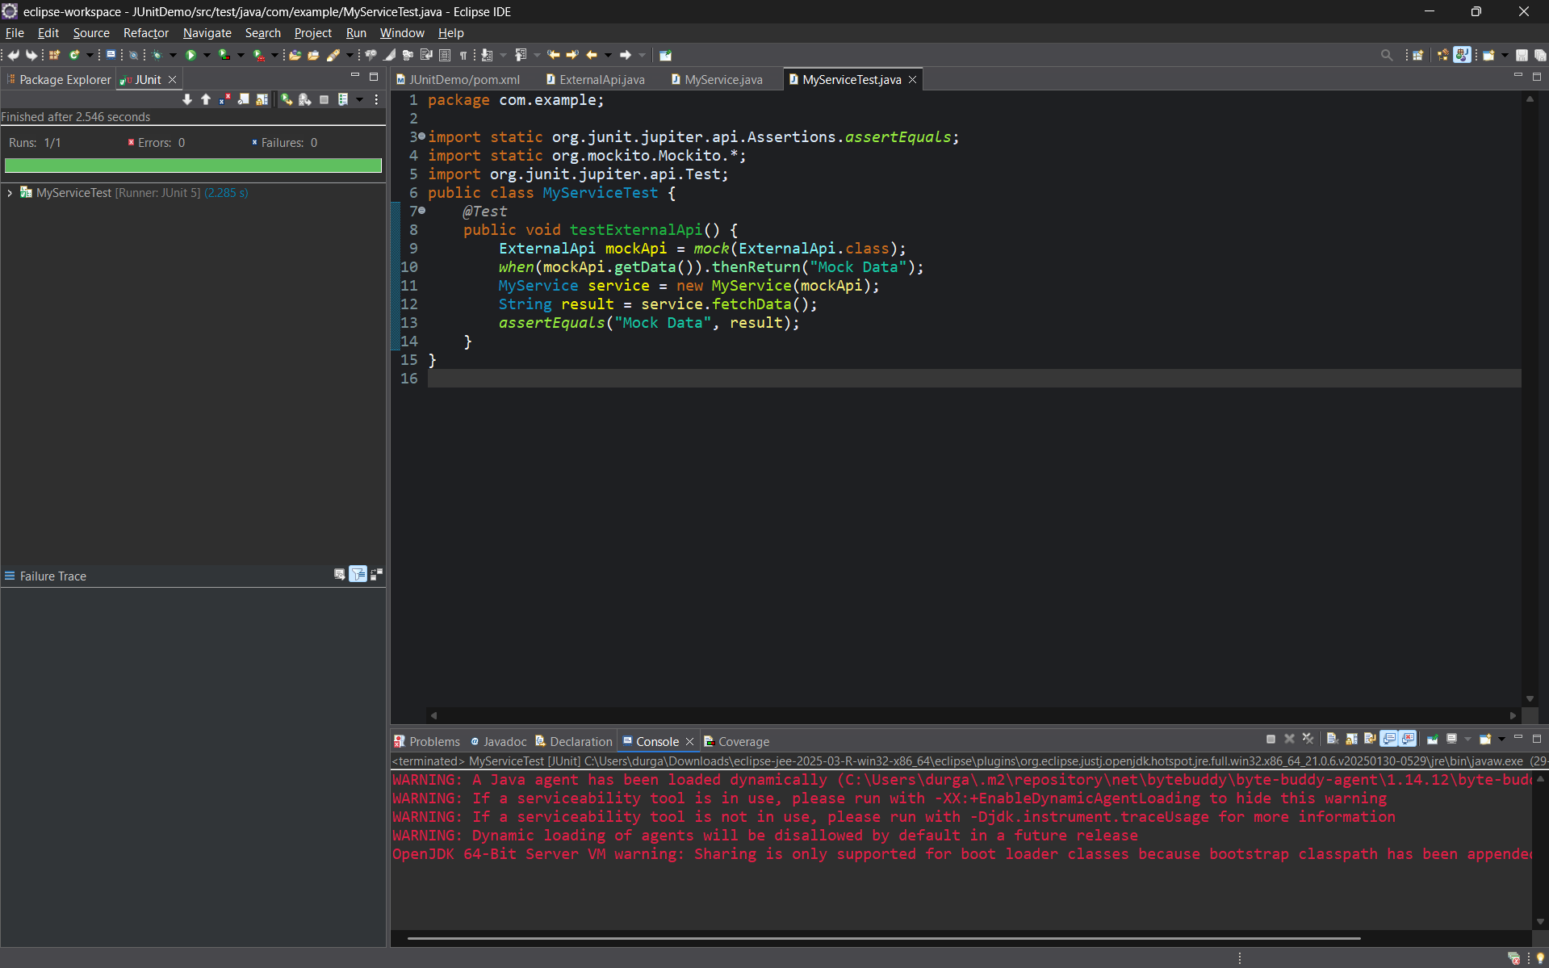

**Exercise 2: Verifying Interactions**

Scenario:

You need to ensure that a method is called with specific arguments.

Steps:

1. Create a mock object.

2. Call the method with specific arguments.

3. Verify the interaction.

Solution Code:

import static org.mockito.Mockito.*;

import org.junit.jupiter.api.Test;

import org.mockito.Mockito;

public class MyServiceTest {

@Test

public void testVerifyInteraction() {

ExternalApi mockApi = Mockito.mock(ExternalApi.class);

MyService service = new MyService(mockApi);

service.fetchData();

verify(mockApi).getData();

}

}

**CODE**

**ExternalApi.java**

public interface ExternalApi {

void getData();

}

**MyService.java**

public class MyService {

private ExternalApi api;

public MyService(ExternalApi api) {

this.api = api;

}

public void fetchData() {

api.getData();

}

}

**MyServiceTest.java**

import static org.mockito.Mockito.*;

import org.junit.jupiter.api.Test;

public class MyServiceTest {

@Test

public void testVerifyInteraction() {

ExternalApi mockApi = Mockito.mock(ExternalApi.class);

MyService service = new MyService(mockApi);

service.fetchData();

verify(mockApi).getData();

}}

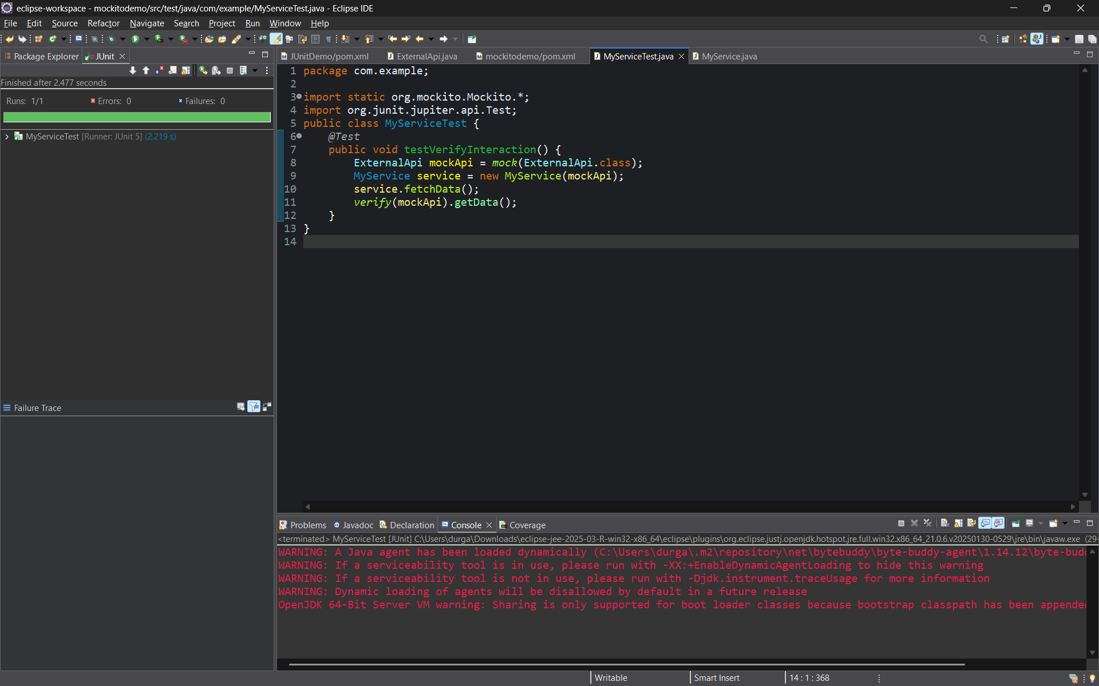 **OUTPUT**.