LABEL ANAYA
PHASE 1 — CUSTOMER WEBSITE DESIGN SPECIFICATION
Desktop and mobile reference mockups | Handoff for ChatGPT and Codex
Status: Design references approved in conversation; implementation not yet started.

Purpose and scope
This document is the visual and functional handoff for the Label Anaya Phase 1 customer-facing boutique website. The attached mockups are design references, not production-ready screenshots or pixel-perfect specifications. Build a responsive implementation that preserves their hierarchy, palette, typography, content and interactions while fitting real device widths.

Phase 1 includes
- Homepage with Shop by Category and Shop All navigation
- Category listing pages
- Product detail pages
- Shopping cart
- Customer login / sign-up
- Checkout and payment
- Order confirmation

Explicitly postponed
Admin dashboard UI, custom tailoring, video measurement appointments, Anaya Originals, Trending Styles, favorites, Instagram auto-DM, advanced filters and sorting.

Global visual design
- Palette: warm ivory/cream backgrounds, deep olive-green announcement strip and primary buttons, dark charcoal/brown text, muted botanical details.
- Brand: LABEL ANAYA wordmark with delicate botanical sprig. Use actual approved logo asset when provided; mockup logo is a visual reference.
- Desktop header: announcement bar, brand at left, Home and Shop All dropdown, search/cart/account at right.
- Mobile header: compact Made to Order strip, hamburger menu, brand and utility icons. Keep icon and logo sizes practical for 320–430 px viewports.
- Typography: elegant serif for brand and major headings, readable supporting text. Consistent spacing and accessible contrast.
- Responsive: mobile-first; desktop category grid 4 columns and mobile 2 columns. Preserve functionality on tablet and narrow screens.
- Product photos: actual licensed Label Anaya assets will replace generated reference imagery. Do not assume mockup photos are final catalog files.

Implementation guardrails for Codex
- Use one coherent component system and reusable product/category templates; do not create seven unrelated hardcoded pages.
- Do not invent extra sections, promotions, filters, shipping policies, discounts or business rules not approved.
- All prices and product information come from the database; sample mockup values are placeholders.
- Browsing and cart use do not require login; checkout does. Admin access is separately role-protected when built.
- Keep server-only credentials private. Verify payment server-side and authorize all order reads.
- Use semantic HTML, keyboard-accessible controls, responsive images, form validation, and mobile performance checks.
- Provide desktop and mobile previews for each page and compare against its paired reference images.

Recommended technical direction (planning, not design)
Next.js App Router + TypeScript + Tailwind CSS; Supabase PostgreSQL/Auth/Storage; Razorpay; Vercel. Future admin routes may live under /admin but the admin interface is not part of this design handoff.

01 — Homepage
Route: /
Goal: Introduce Label Anaya and direct customers to shop.

Behavior and acceptance notes
- Desktop: olive announcement strip, botanical LABEL ANAYA logo, Home and Shop All dropdown, search/cart/account icons, left-aligned Collection 01 headline and CTA, Anaya hero photograph on right, Shop by Category section.
- Mobile: compact announcement strip, hamburger navigation, logo and utility icons; stacked hero and category content sized for narrow screens.
- CTA opens category shopping; category cards link to their respective category routes.

Desktop design reference
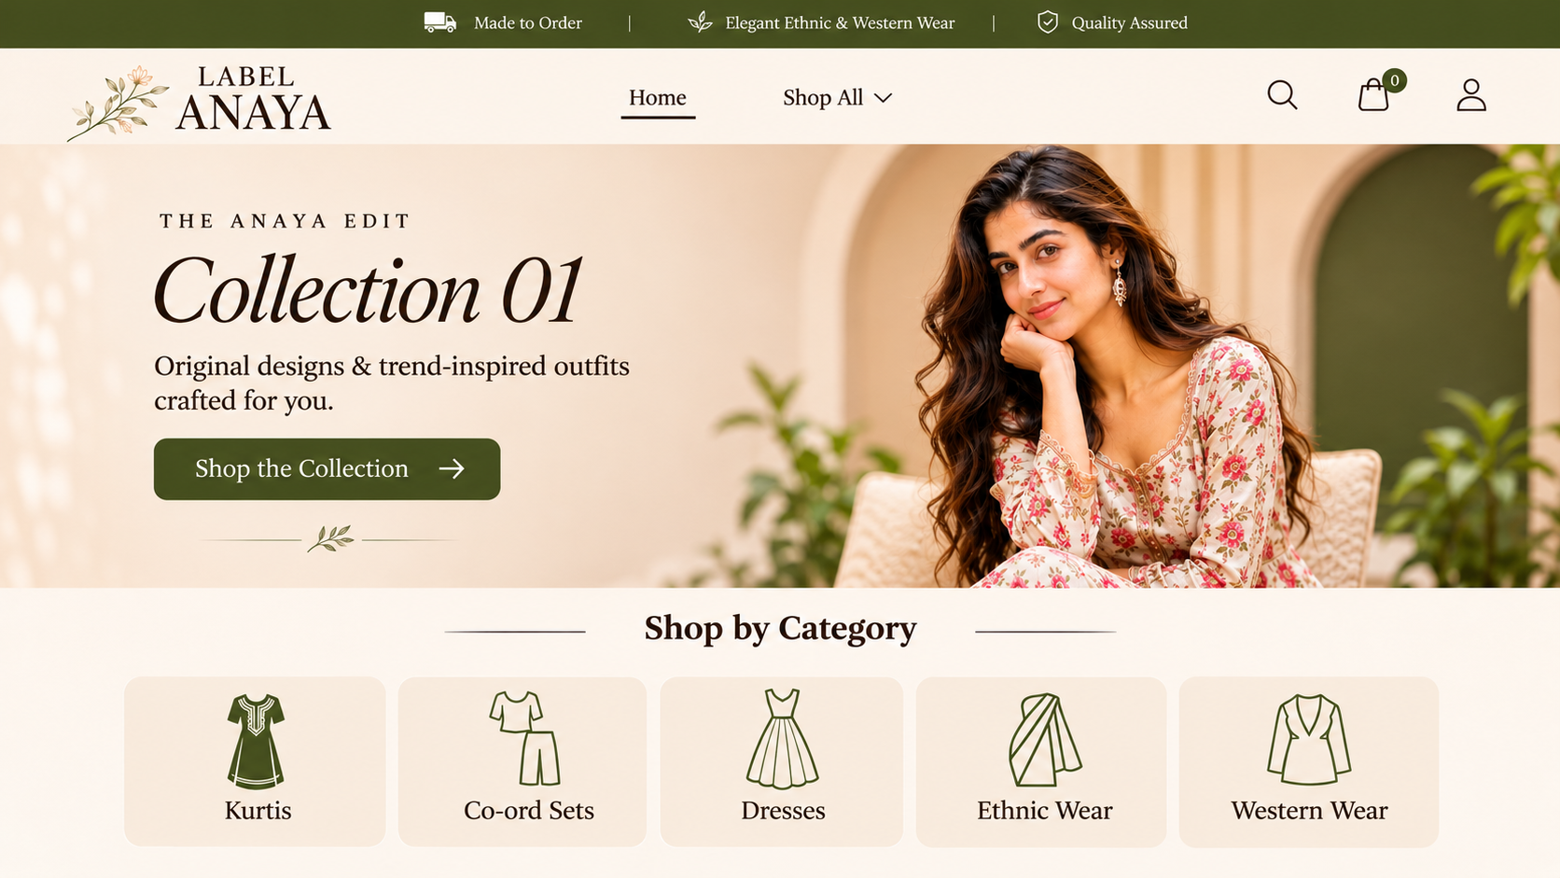

01 — Homepage — Mobile

Mobile design reference
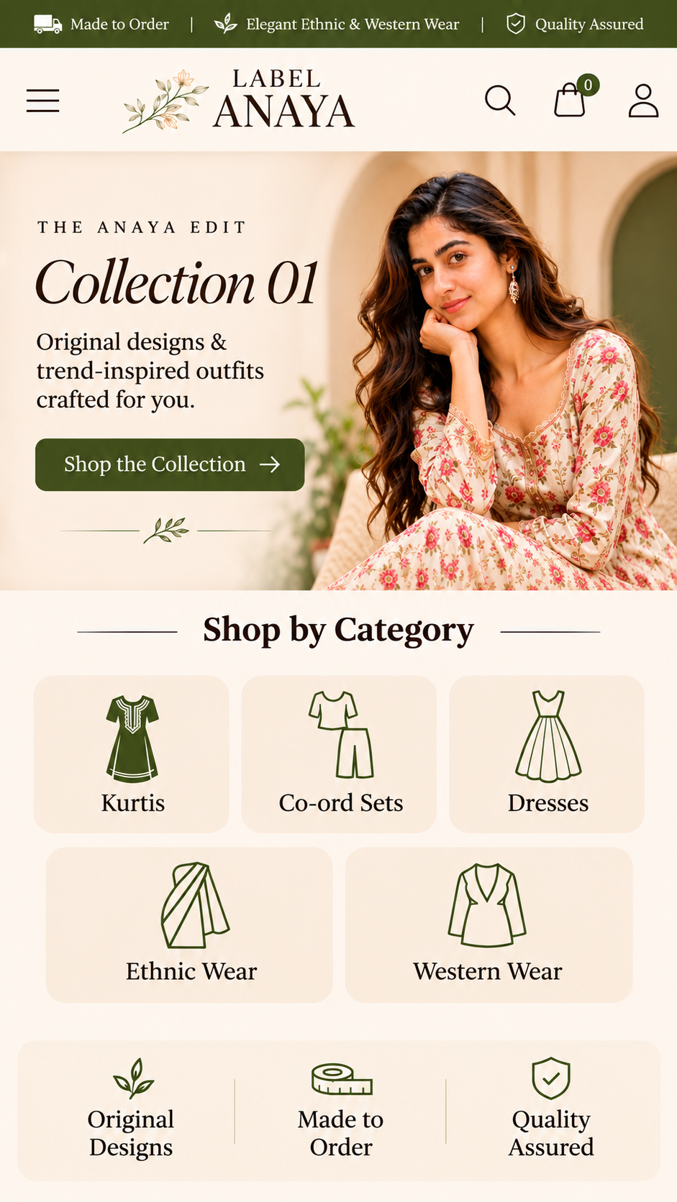
Mobile implementation must retain the same content and interactions while using appropriate responsive spacing, touch targets and text sizes.

02 — Kurtis Category / Shop Grid
Route: /shop/kurtis
Goal: Let customers browse products within a category.

Behavior and acceptance notes
- Desktop: four-column product grid; mobile: two-column grid. Reuse the same layout for other categories.
- Example products: Sage A-Line Kurti Set ₹1,699; Burgundy Straight Kurti Set ₹1,599; Navy Embroidered Kurti Set ₹1,699; Off-White Floral Kurti Set ₹1,699.
- Each product card links to its detail page. No filters, sorting or category hero in Phase 1.

Desktop design reference
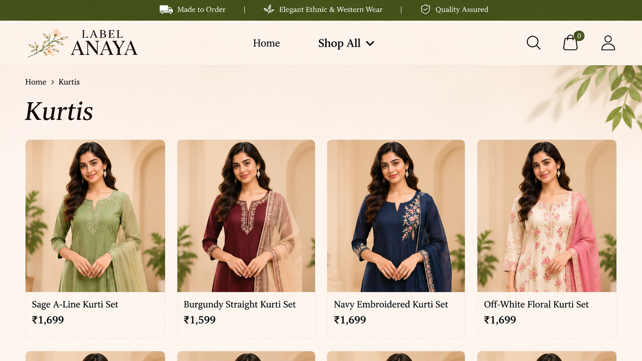

02 — Kurtis Category / Shop Grid — Mobile

Mobile design reference
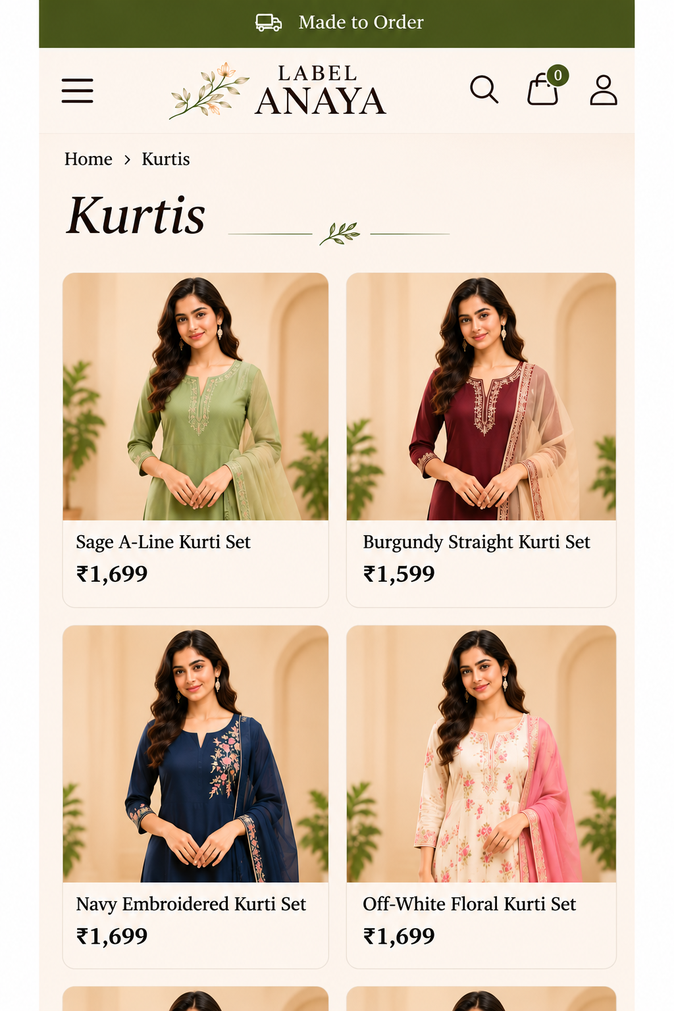
Mobile implementation must retain the same content and interactions while using appropriate responsive spacing, touch targets and text sizes.

03 — Product Details
Route: /products/[slug]
Goal: Help customers choose a size and add a product to their cart.

Behavior and acceptance notes
- Gallery of product photos, product name, price, description, size selection (S/M/L/XL as available), quantity controls and Add to Cart.
- Example: Sage A-Line Kurti Set, ₹1,699, size S, quantity 1.
- Require a valid size and quantity before adding to cart; show out-of-stock/unavailable options appropriately.

Desktop design reference
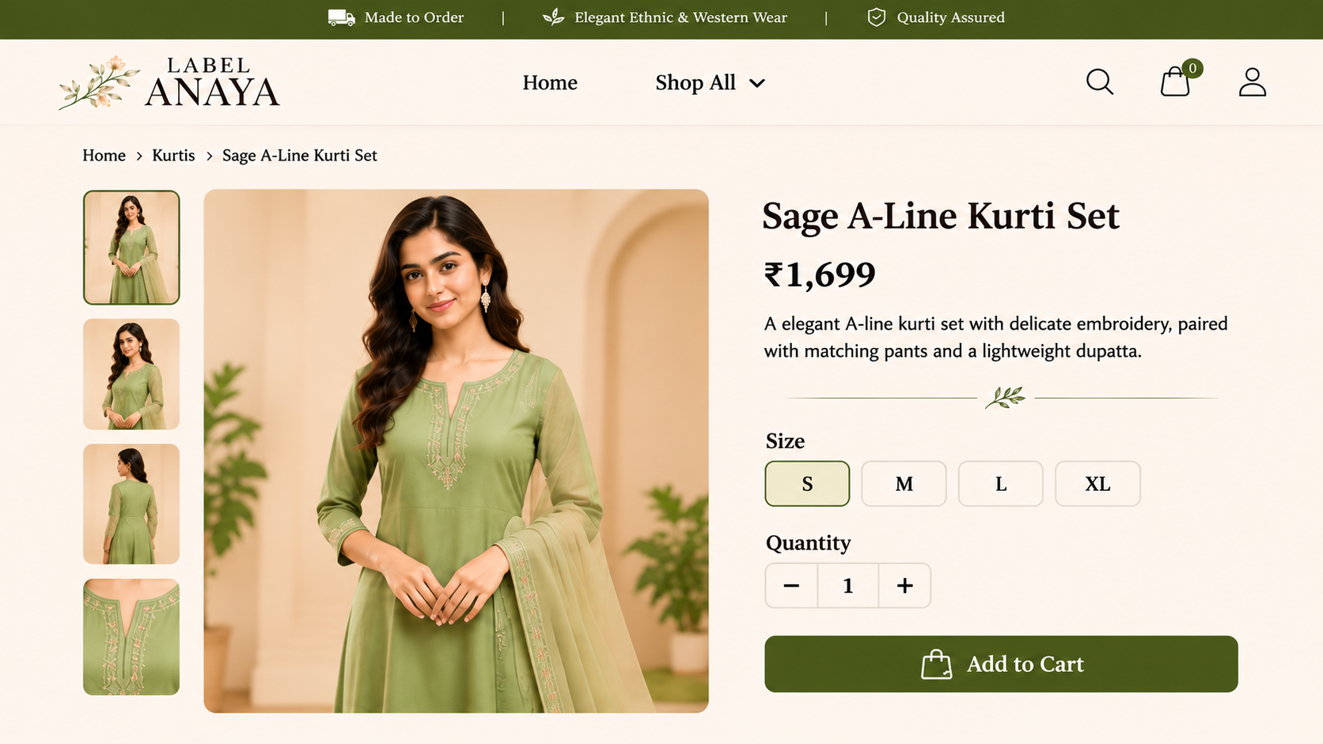

03 — Product Details — Mobile

Mobile design reference
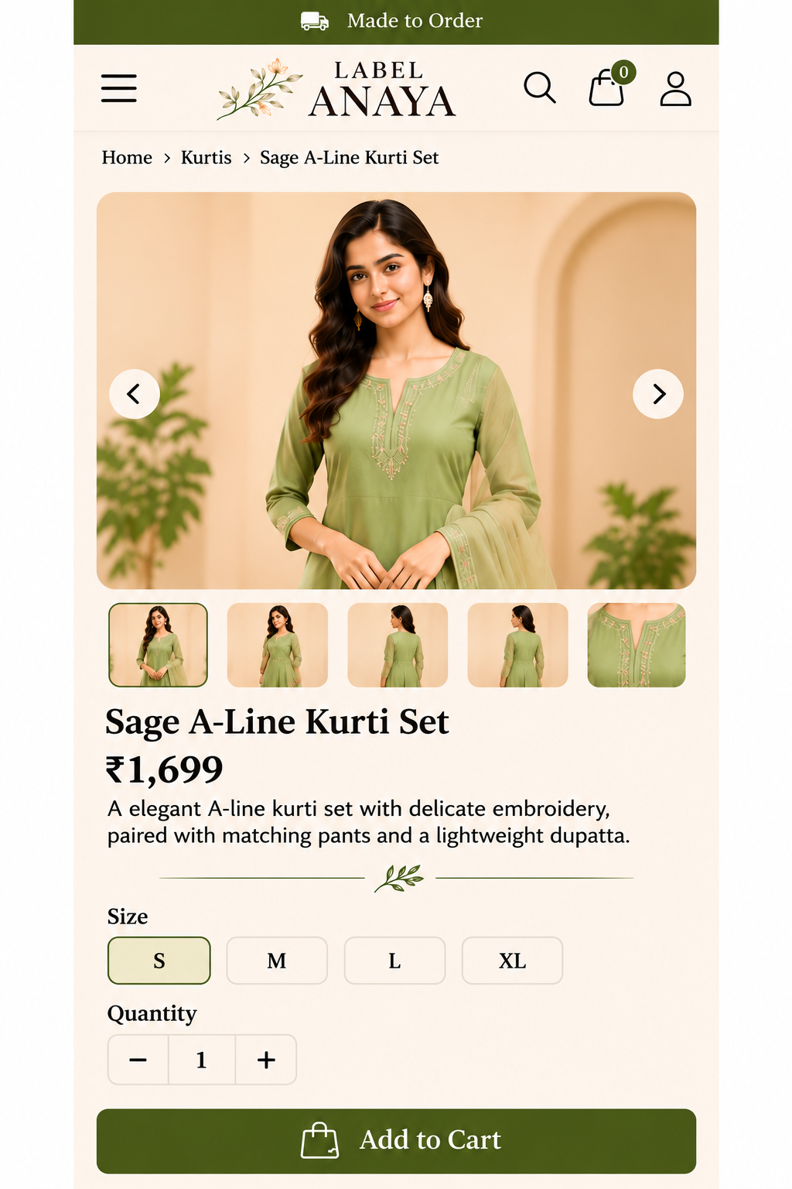
Mobile implementation must retain the same content and interactions while using appropriate responsive spacing, touch targets and text sizes.

04 — Shopping Cart
Route: /cart
Goal: Review selected items and proceed to checkout.

Behavior and acceptance notes
- Show product thumbnail, name, selected size, unit price, quantity controls, remove action and order summary.
- Illustrative example: one Sage A-Line Kurti Set at ₹1,699, shipping ₹0; final shipping is calculated at checkout.
- Cart persists across refreshes; guests may add items but must log in before checkout.

Desktop design reference
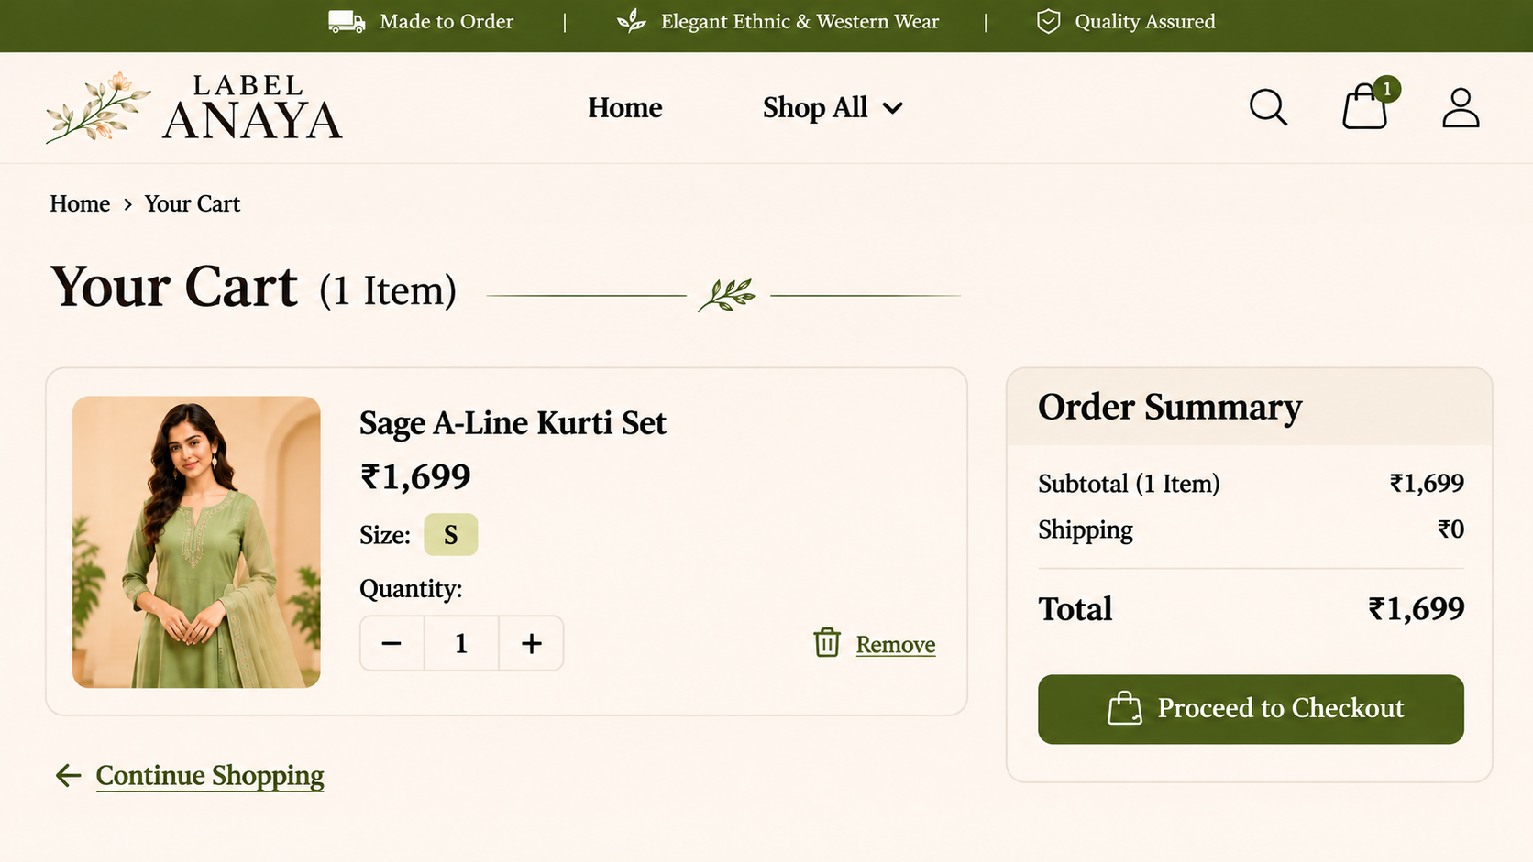

04 — Shopping Cart — Mobile

Mobile design reference
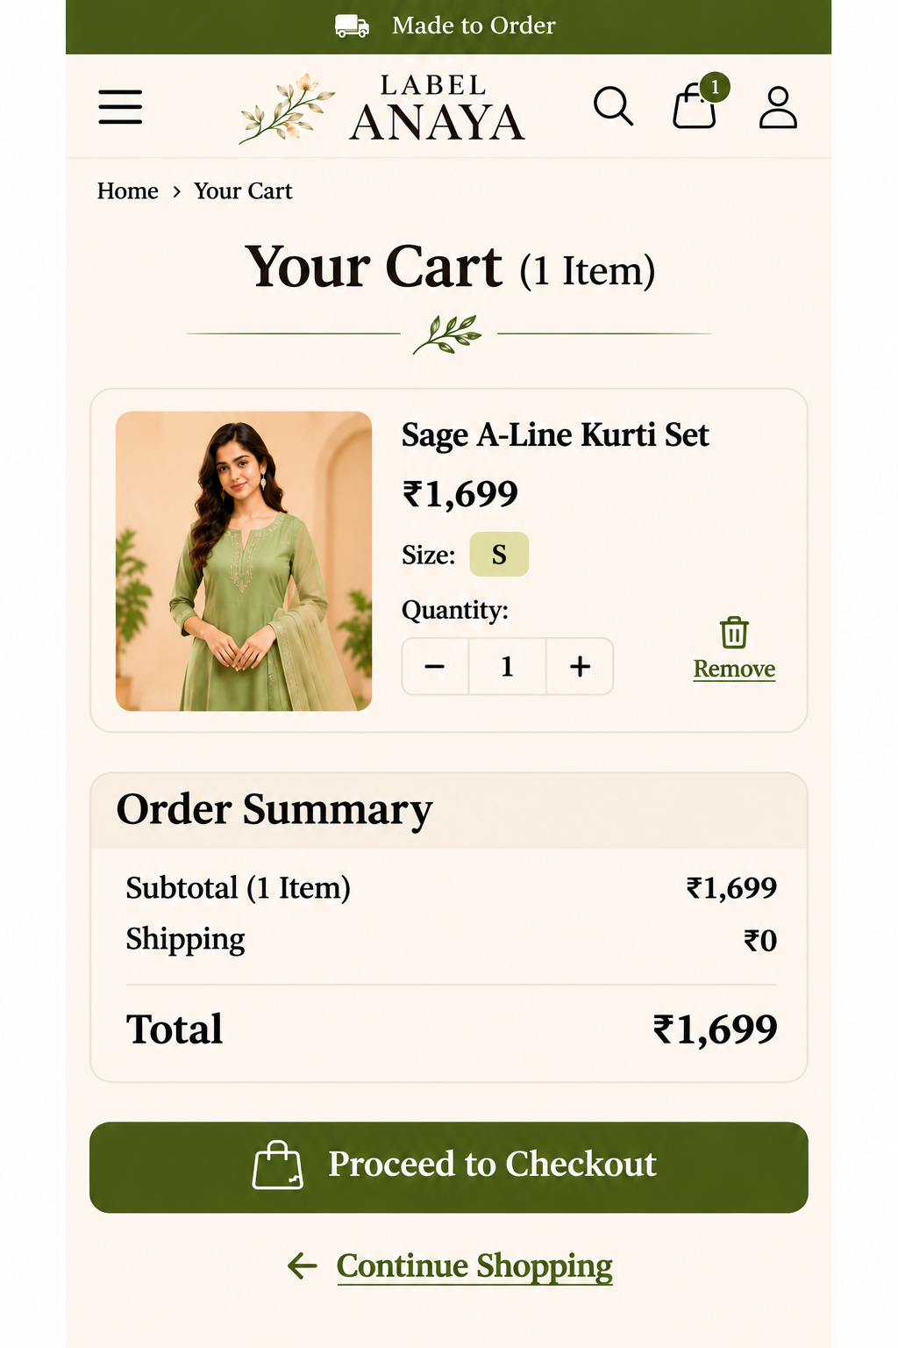
Mobile implementation must retain the same content and interactions while using appropriate responsive spacing, touch targets and text sizes.

05 — Login / Sign Up
Route: /login
Goal: Authenticate customers before checkout.

Behavior and acceptance notes
- Support email/password and Google sign-in. No guest checkout.
- After login, return the customer to their intended checkout destination.
- Provide clear error, loading and password-reset states; do not expose admin access through customer navigation.

Desktop design reference
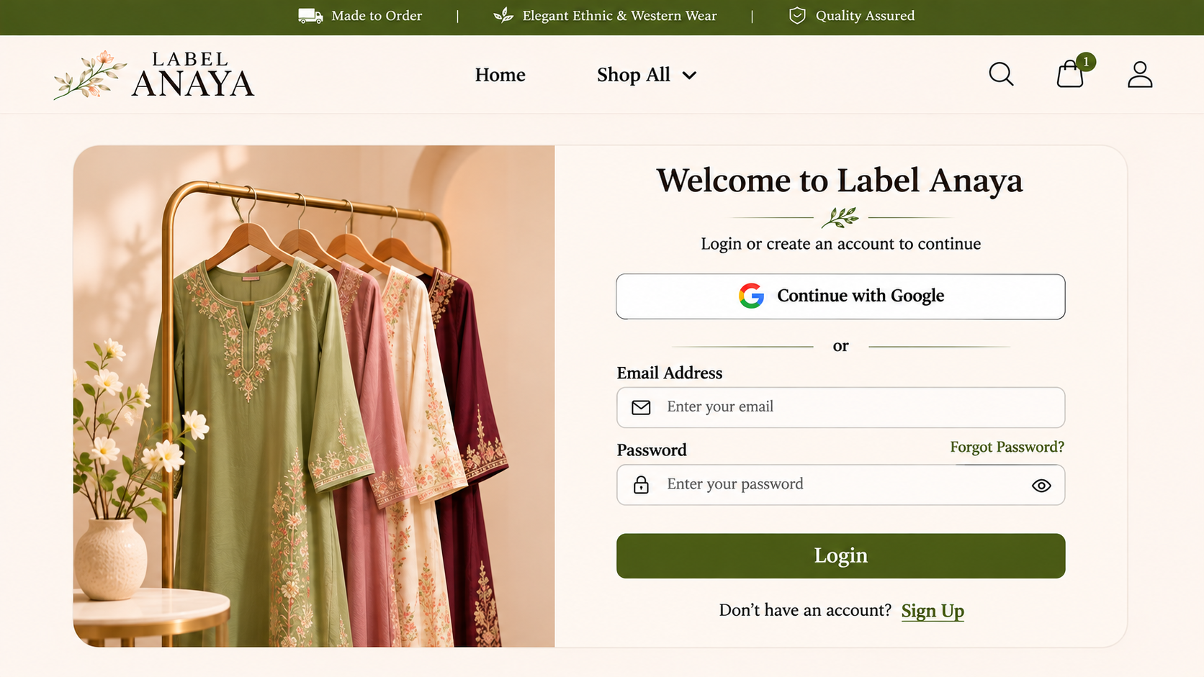

05 — Login / Sign Up — Mobile

Mobile design reference
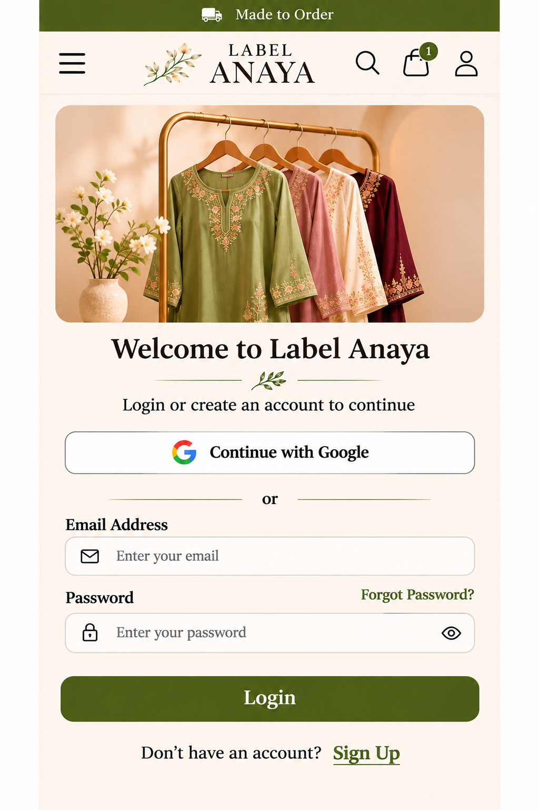
Mobile implementation must retain the same content and interactions while using appropriate responsive spacing, touch targets and text sizes.

06 — Checkout
Route: /checkout
Goal: Collect delivery details and take payment securely.

Behavior and acceptance notes
- Delivery address form, order summary and Razorpay Pay Now action.
- Server validates prices, availability and total; Razorpay order is created on the server; credentials never appear in client code.
- Verify payment server-side and handle pending/failed payment states before marking the order paid.

Desktop design reference
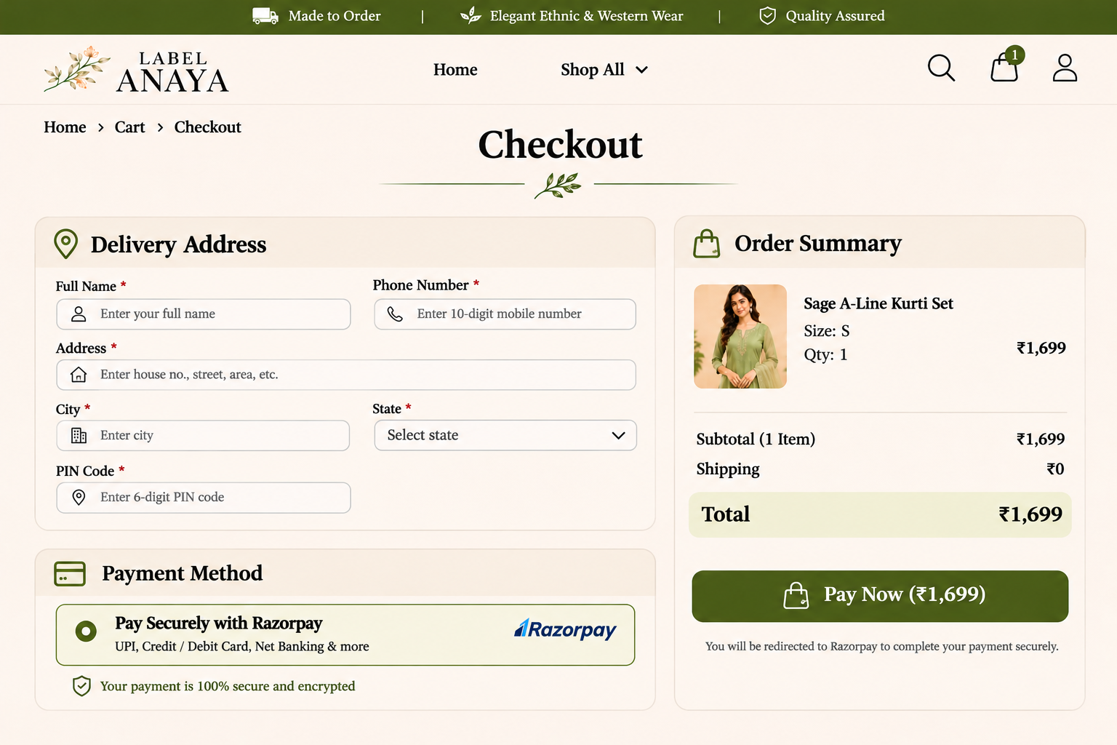

06 — Checkout — Mobile

Mobile design reference
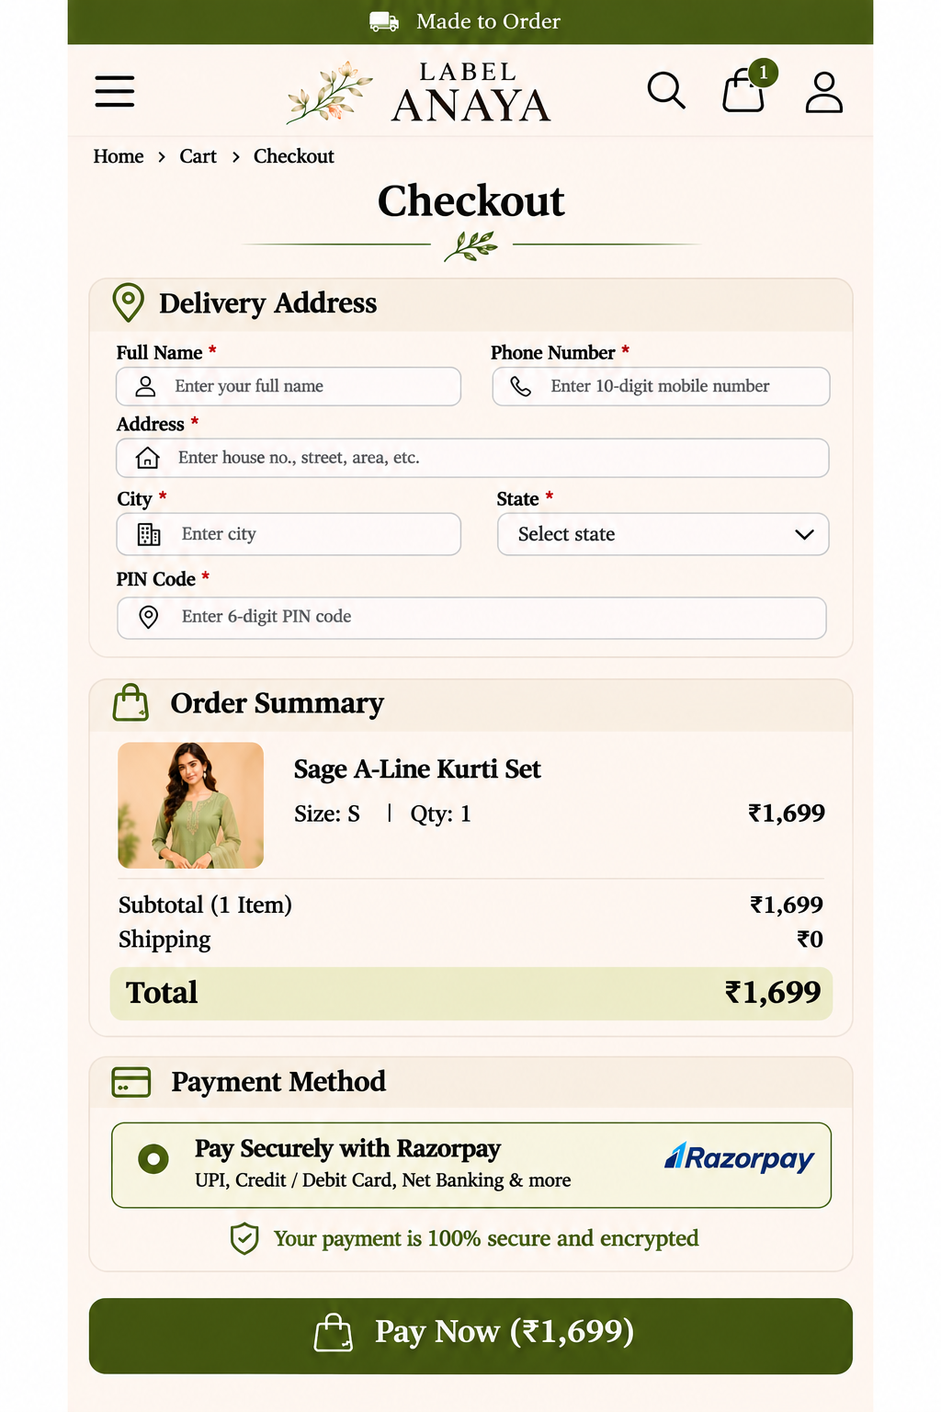
Mobile implementation must retain the same content and interactions while using appropriate responsive spacing, touch targets and text sizes.

07 — Order Confirmation
Route: /orders/[id]/confirmation
Goal: Confirm an authenticated customer's successfully paid order.

Behavior and acceptance notes
- Success icon and heading, order number, purchased item with size/quantity, subtotal, shipping, total paid, delivery address and Continue Shopping.
- Order number LA25984 and all personal/address details in the mockups are illustrative only; do not hardcode them or reuse any displayed personal name.
- Only display a confirmed order belonging to the signed-in customer, after server-side payment verification.

Desktop design reference
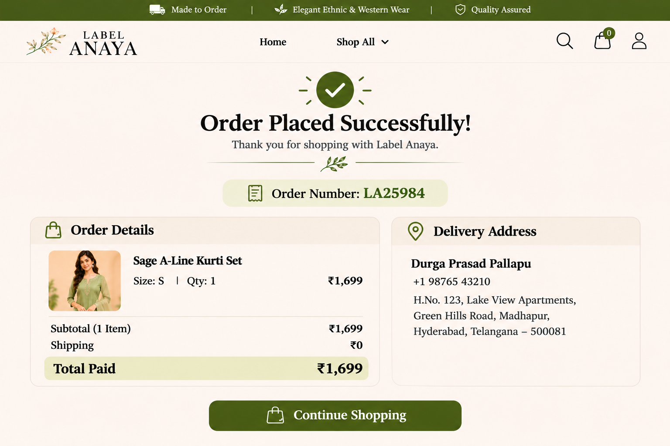

07 — Order Confirmation — Mobile

Mobile design reference
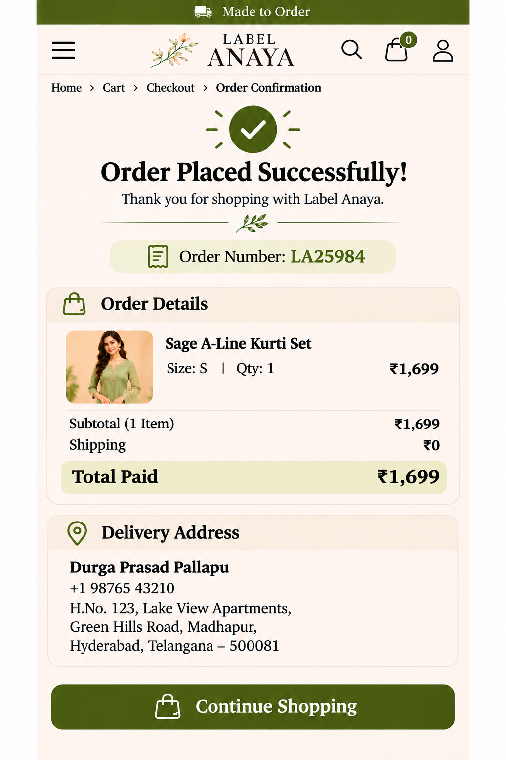
Mobile implementation must retain the same content and interactions while using appropriate responsive spacing, touch targets and text sizes.

Navigation and state transitions
- Homepage → Shop All dropdown → Category → Product Details → Add to Cart → Cart → Checkout.
- If signed out at checkout: Login / Sign Up → return to Checkout.
- Checkout → Razorpay payment → verified success → Order Confirmation.
- Payment failed/pending → do not show a successful order confirmation.
- Order confirmation → Continue Shopping → storefront.

Data and content needed before production
- Final brand logo and Anaya hero image in appropriate dimensions.
- Product catalog: names, descriptions, categories, prices, size variants, availability, photographs and SKUs.
- Shipping policy, serviceable locations, charges, returns/cancellations and contact information.
- Google OAuth and Supabase project configuration; Razorpay merchant onboarding and test credentials.
- Production domain and legal/privacy/customer-support pages (not included among the seven visual page types).

Important mockup limitations
Generated images can contain unrealistic dimensions, decorative flourishes or sample personal details. The mockups establish intended visual direction, not authoritative customer data, actual payment records, legally required copy or exact production measurements. In particular, do not copy any displayed name, phone number or address from the confirmation image into the website.

Suggested Codex instruction
Implement Label Anaya Phase 1 using this document as the design and behavior specification. Build one responsive customer website with reusable components. Match each desktop/mobile pair as closely as practical, do not add out-of-scope features, use sample catalog data only until real assets are provided, and run build/tests before reporting completion. Ask for missing business rules instead of inventing them.

