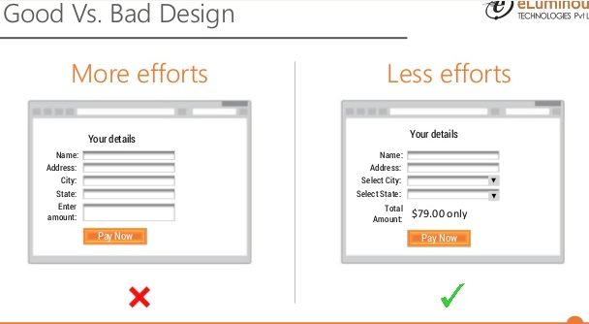

The above design need more efforts like we need to enter all the fields but in the other design we can simply select dropdown.

file:///C:/Users/1892807/Downloads/EventsSpec_v2.0.pdf