**Project:Marketing Analysis**

**1. Load data and create Spark data frame**

Output:

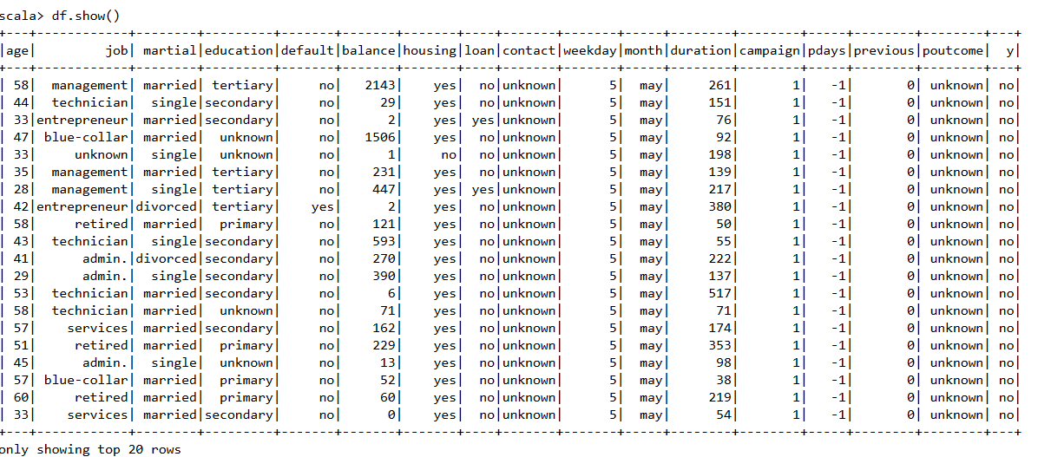

**2. Marketing success rate.**

Output:

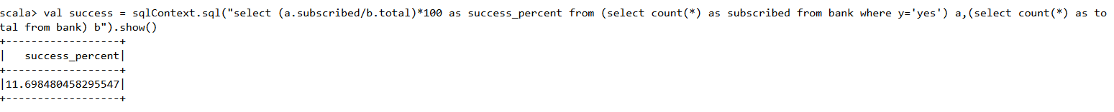

**2a Give marketing failure rate**

Output:



**3. Maximum, Mean, and Minimum age of average targeted customer**

Output:

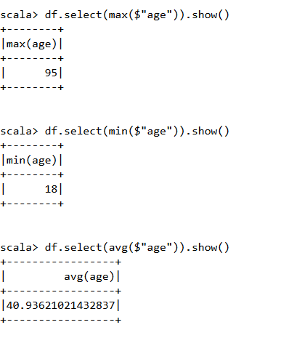

**4. Check quality of customers by checking average balance, median balance of customers**

Output:

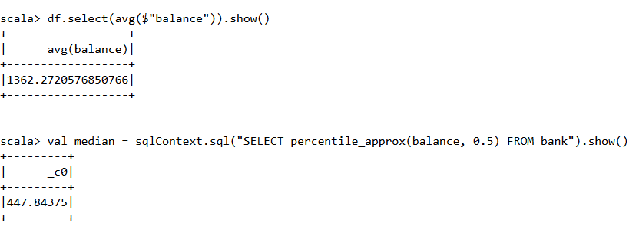

**5. Check if age matters in marketing subscription for deposit**

Output:

We can see age truly matters from screen shot below. The age group between 30 and 36 who go for subscription for a term deposit most.

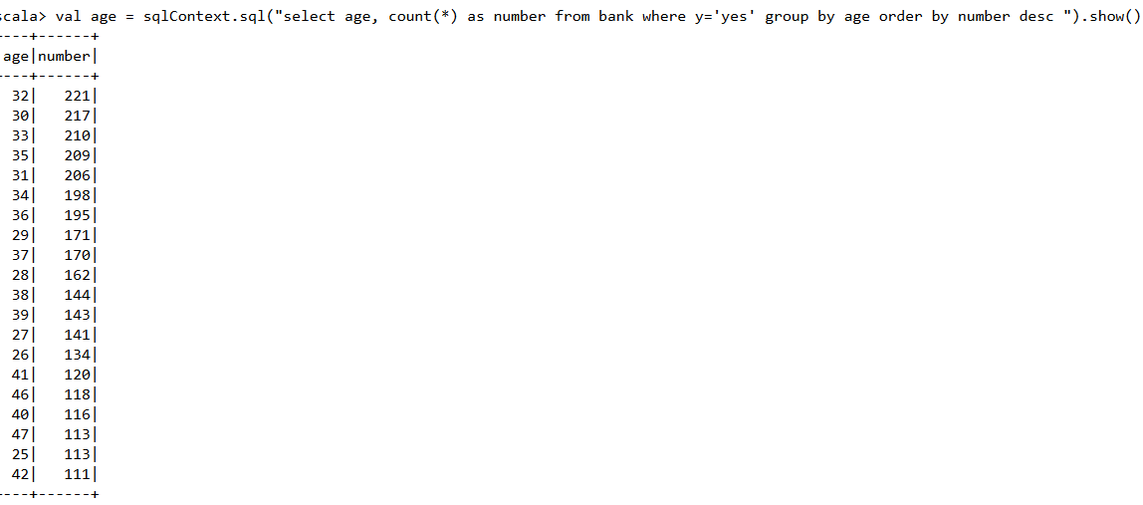

**6. Check if marital status mattered for subscription to deposit.**

Output:

We can see marital status mattersfrom screenshot below .The married couples who go for the subscriptions the most

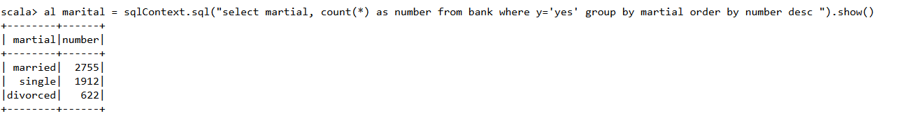

**7.** **Check if age and marital status together mattered for subscription to deposit scheme**

Output:

Age and marital status together matters for subscription **a**s per the screen shot below. Single people between the age 26-32 shows most subscriptions

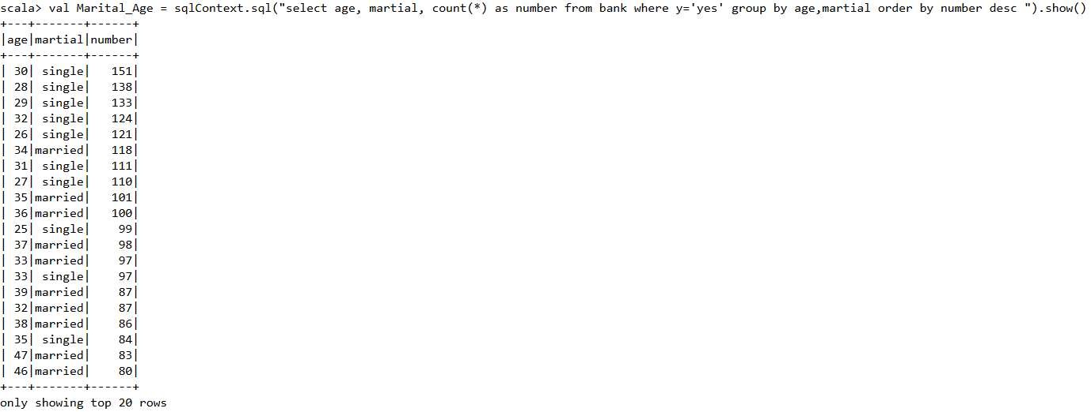

**8. Do feature engineering for column—age and find right age effect on campaign**

Output:

From the screen shot below, Middle-Age (age between 33 and 55) group who should be the targeted customers as they subscribe the most

