SWIFTSHIP TRACKER
Salesforce Implementation Documentation
Parcel Booking, Tracking & Delivery Management using Salesforce CRM, Flows and Agentforce AI

Project | SwiftShip Tracker (Salesforce)
Document Type | Project Implementation & Documentation
Institution | Anjalai Ammal Mahalingam Engineering College
Team ID | 2026-6814
Submission Date | 03/10/2026
Team Members
Name | Register No. | Mail ID
S. DurgaSri | 820423205029 | durgasrisoundarrajan@gmail.com
B. Hasben Farhana | 820423205034 | hasbeenfn@gmail.com
B. Afrana Renose | 820423205004 | 2kfrana@gmail.com
K. Aisath Delisha | 820423205006 | delishakader@gmail.com

Table of Contents
1. Introduction 2
1.1 User Story 2
1.2 Project Overview 2
1.3 Purpose 2
2. Ideation Phase 3
2.1 Problem Statement 3
2.2 Empathy Map Canvas 3
2.3 Brainstorming & Idea Prioritization 4
3. Requirement Analysis Phase 6
3.1 Customer Journey Map 6
3.2 Solution Requirements 6
3.3 Data Flow Diagram 8
3.4 Technology Stack 9
4. Project Design Phase 10
4.1 Problem–Solution Fit 10
4.2 Proposed Solution 10
4.3 Solution Architecture 11
5. Project Planning & Scheduling 12
5.1 Project Planning 12
5.2 Product Backlog, Sprint Schedule and Estimation 12
5.3 Project Tracker, Velocity & Burndown 13
6. Project Development Phase 14
Phase 1: Requirement Analysis & Planning 14
Phase 2: Salesforce Development – Backend & Configurations 16
Phase 3: UI/UX Development & Customization 33
Phase 4: Data Migration, Testing & Security 41
Phase 5: Deployment, Documentation & Maintenance 44
7. Functional & Performance Testing 45
8. Advantages & Disadvantages 46
8.1 Advantages 46
8.2 Disadvantages 46
9. Conclusion 47
10. Future Scope 48
11. Appendix 49

1. Introduction

1.1 User Story
The SwiftShip Tracker is designed to provide a centralized Salesforce-based parcel management solution that enables customers to book parcels, track delivery status, and manage shipments through an intuitive interface and conversational AI support. The system manages Parcel, Delivery, Sender, and Receiver information using Salesforce custom objects and relationships. Flows automate parcel operations and notifications, while Agentforce AI and Prompt Builder enable customers to retrieve parcel information and interact with the system conversationally. Delivery agents can update parcel status in real time, while Experience Cloud, security controls, reports, and dashboards provide secure customer access and operational visibility.

1.2 Project Overview
The SwiftShip Tracker is a Salesforce CRM solution developed to simplify parcel booking, shipment tracking, and delivery management. It supports the complete parcel lifecycle from booking and dispatch through tracking and delivery confirmation. Customers can access shipment information, while delivery agents can update parcel details and delivery status.

1.3 Purpose
The purpose of SwiftShip Tracker is to:
- Centralize parcel and delivery information.
- Simplify parcel booking and tracking.
- Provide real-time shipment visibility.
- Automate delivery updates and customer notifications.
- Enable conversational parcel tracking using Agentforce AI and Prompt Builder.
- Improve agent efficiency through Salesforce Flows and dashboards.
- Provide secure, role-based access to customers, agents, support staff, and administrators.

2. Ideation Phase

2.1 Problem Statement
The Customer Problem Statement template below captures the main problems faced by each user type.
PS | I am (Customer) | I'm trying to | But | Because | Which makes me feel
PS-1 | Customer / Sender | book a parcel easily | booking requires support assistance or multiple applications | parcel operations are not centralized | frustrated
PS-2 | Customer / Sender | track my parcel | I do not have a simple real-time tracking experience | shipment information is difficult to access | confused
PS-3 | Delivery Agent | update parcel status | status updates require manual handling | there is a need for centralized operational tracking | concerned
PS-4 | Customer | receive delivery updates | notifications may not be available at every delivery stage | communication needs to be automated | uncertain
PS-5 | Admin | monitor parcel operations | parcel flow and delivery performance are difficult to monitor | operational data needs centralized reporting | concerned

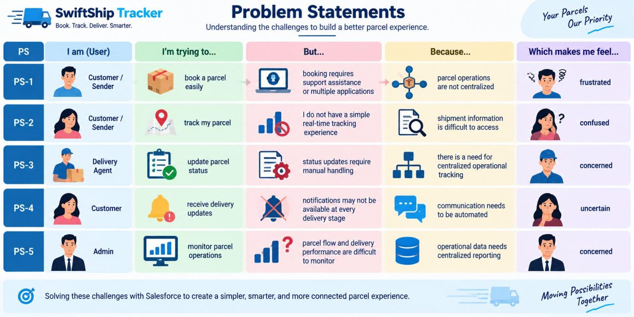
Figure 1: Customer problem statement canvas

2.2 Empathy Map Canvas
User Persona: Customer / Sender
- Think & Feel: Wants a simple way to book and track parcels without repeatedly contacting support.
- Hear: Receives delivery information and status updates from the parcel service.
- See: Parcel details, tracking status, estimated delivery date, and delivery information.
- Say & Do: Books parcels, checks tracking information, and asks for delivery updates.
- Pain: Delays, confusion, lack of easy tracking, and dependence on support or multiple apps.
- Gain: Real-time visibility, self-service tracking, convenient booking, and timely notifications.
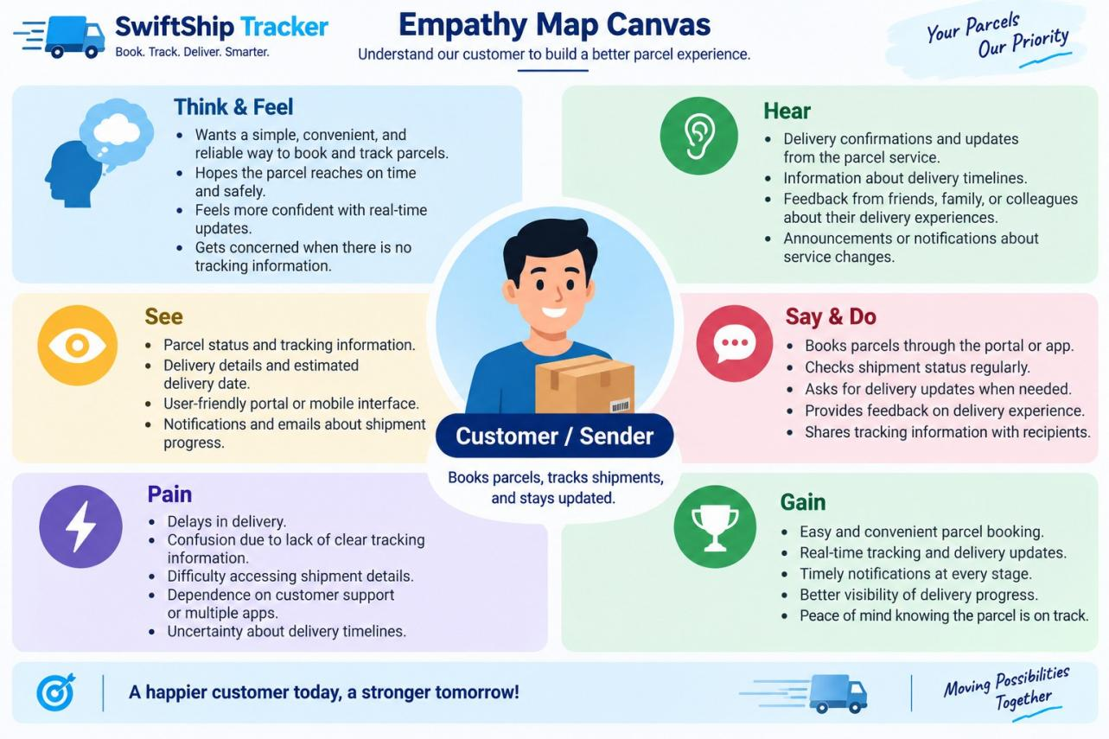
Figure 2: Empathy map canvas

2.3 Brainstorming & Idea Prioritization

Ideas Considered
- Manual registers
- Spreadsheet tracking
- Standalone parcel portal
- Salesforce CRM with Agentforce AI

Final Selection
Salesforce CRM was selected because it offers:
- Centralized parcel management
- Automation through Flows
- Real-time tracking visibility
- Conversational AI assistance
- Secure role-based access
- Reports and dashboards
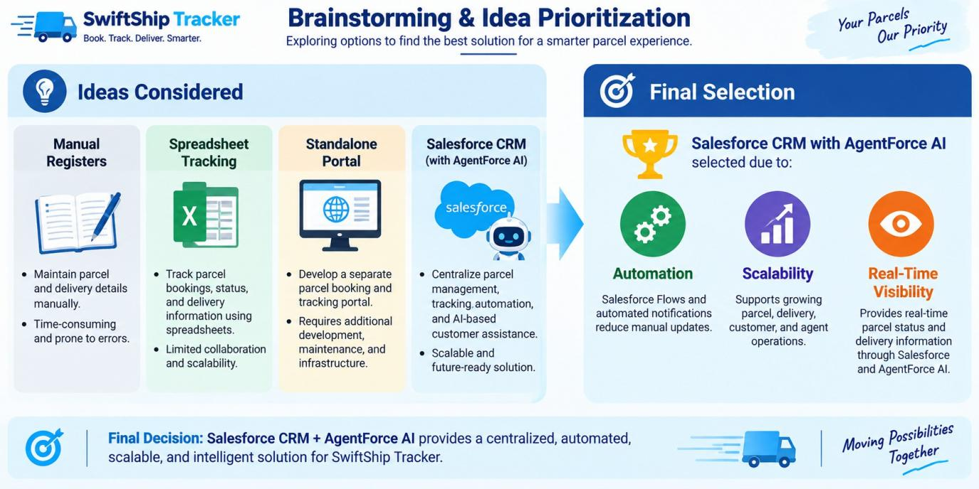
Figure 3: Brainstorming and idea prioritization

3. Requirement Analysis Phase

3.1 Customer Journey Map
The customer journey passes through the following stages:
- Parcel Booking
- Parcel Record Creation
- Dispatch & Shipment
- In-Transit Tracking
- Out for Delivery
- Delivery Confirmation
- Customer Notification
- Feedback / Support
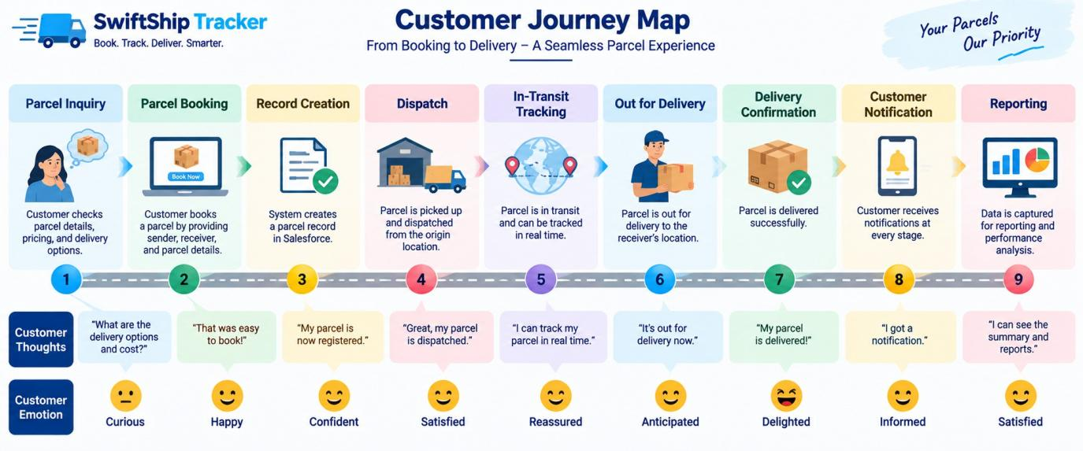
Figure 4: Customer journey map

3.2 Solution Requirements

Functional Requirements
FR No | Requirement
FR-1 | Parcel booking and record creation
FR-2 | Parcel status tracking
FR-3 | Weight management
FR-4 | Estimated delivery date management
FR-5 | Sender information management
FR-6 | Receiver information management
FR-7 | Delivery and current-location tracking
FR-8 | Agent parcel status updates
FR-9 | Automated customer notifications
FR-10 | AI-powered parcel tracking
FR-11 | Reports and dashboards
FR-12 | Customer access through Experience Cloud

Non-Functional Requirements
NFR | Description
Usability | Intuitive Salesforce and customer-facing interface
Security | Role-based and field-level access control
Reliability | Accurate parcel status and delivery information
Performance | Timely Flow and Agentforce responses
Availability | Salesforce cloud-based access
Scalability | Supports growing parcel and delivery operations
Data Integrity | Controlled access and relationship-based parcel data
Maintainability | Flows, prompts, topics, and configurations can be updated

3.3 Data Flow Diagram
The end-to-end flow of parcel data through the system is shown below.
Customer / Sender
▼
Parcel Booking
▼
Parcel Record
▼
Sender + Receiver Information
▼
Delivery Record
▼
Parcel Status Update
▼
Current Location & Estimated Delivery
▼
Automated Notifications
▼
Customer Tracking / Agentforce AI
▼
Reports & Dashboards

AI Tracking Flow
Customer Query
▼
Agentforce AI
▼
Prompt Builder – Retrieve Parcel Details
▼
Parcel Record
▼
Status / Weight / Estimated Delivery
▼
Conversational Response

The Prompt Builder implementation retrieves Parcel ID, Status, Weight, and Estimated Delivery Date information for tracking responses.
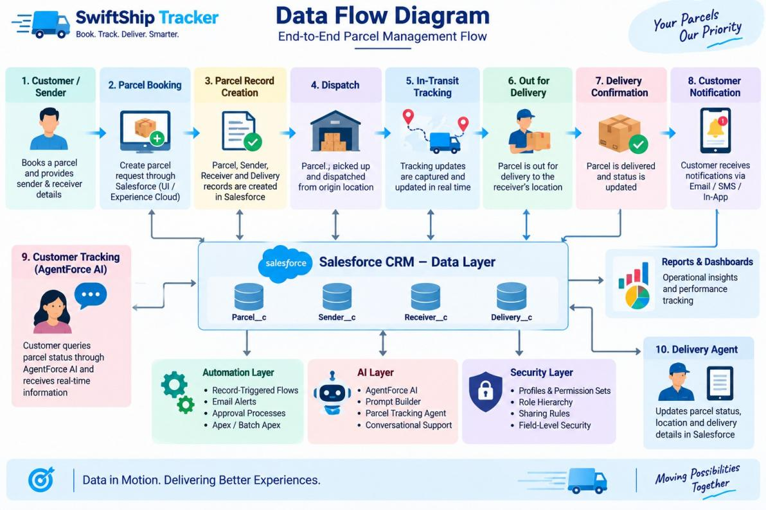
Figure 5: Data flow diagram

3.4 Technology Stack
Layer | Technology
Platform | Salesforce Developer Edition
UI | Lightning App Page, Lightning Record Pages, Experience Cloud
Database | Salesforce Custom & Standard Objects
Business Logic | Salesforce Flows, Apex Classes
Automation | Record-Triggered Flows, Auto-Launched Flows, Scheduled Flows
AI | Agentforce AI, Prompt Builder
Notifications | Email Alerts & Email Templates
Processing | Batch Apex
Security | Profiles, Permission Sets, Role Hierarchy, Field-Level Security, Sharing Rules
Reporting | Reports & Dashboards

4. Project Design Phase

4.1 Problem–Solution Fit
Problem | Solution | Benefit
Parcel booking is difficult | Salesforce Parcel management | Centralized booking
Tracking requires support | Agentforce AI + Prompt Builder | Self-service tracking
Manual status updates | Salesforce Flows | Automated processes
Delivery communication gaps | Email Alerts | Timely notifications
Scattered shipment information | Parcel, Delivery, Sender & Receiver objects | Structured data
Difficult operational monitoring | Reports & Dashboards | Better visibility
Different users need different access | Profiles, Roles & Permission Sets | Secure access

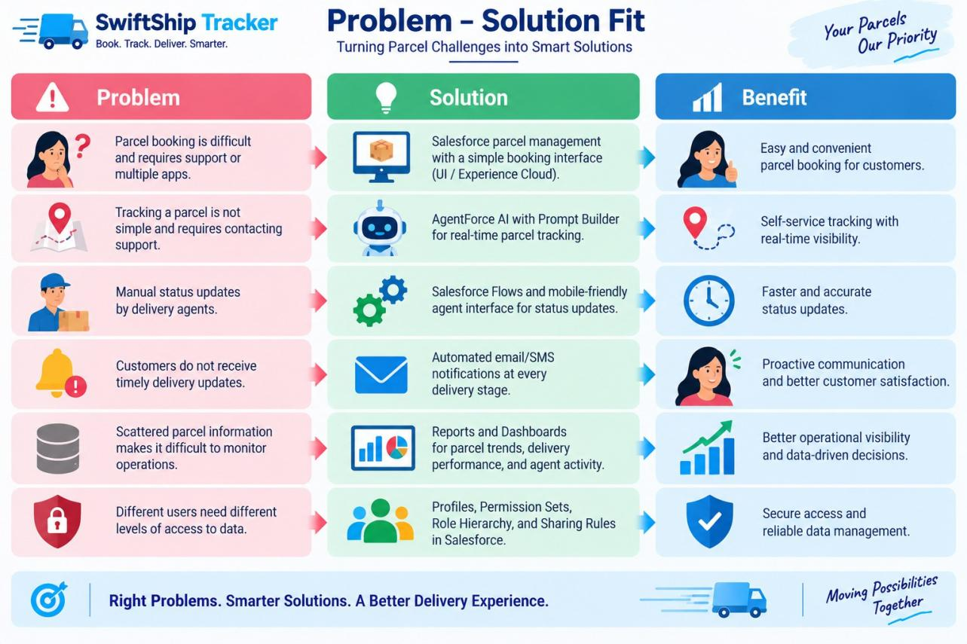
Figure 6: Problem–solution fit canvas

4.2 Proposed Solution
Parameter | Description
Problem | Difficult and inefficient parcel booking and tracking
Solution | Salesforce-based Parcel Management System
Innovation | Agentforce AI + Prompt Builder for conversational self-service tracking and automated Salesforce Flows
Impact | Centralized booking, real-time tracking visibility, timely notifications, and efficient delivery management
Business Model | Parcel, customer, delivery-agent, support, and administrator operations
Scalability | Supports growing parcel operations, Experience Cloud, and integration with external logistics systems

4.3 Solution Architecture
The solution is organized in layers, from the users down to reporting:
- Users: Customer, Delivery Agent, Support Staff, Admin
- Interface: Salesforce Lightning / Experience Cloud
- Data Layer: Parcel, Delivery, Sender, Receiver
- Automation Layer: Flows, Approval Processes, Apex Classes, Batch Apex, Email Alerts
- AI Layer: Agentforce AI, Prompt Builder, Parcel Tracking Agent
- Security Layer: Profiles, Roles, Permission Sets, Sharing Rules, Field-Level Security
- Insights: Reports & Dashboards providing parcel tracking and operational insights
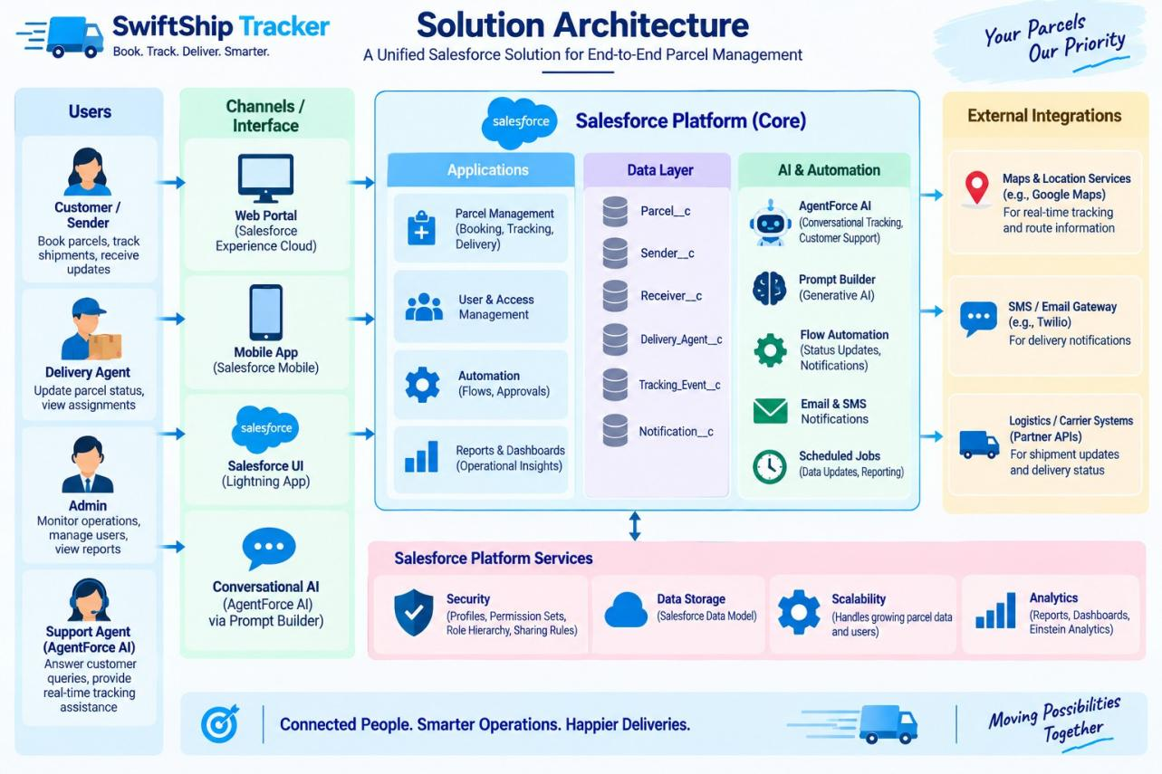
Figure 7: Solution architecture

5. Project Planning & Scheduling

5.1 Project Planning
- Agile methodology
- Epics → Stories → Story Points
- Sprint-based execution
- Velocity calculation used for estimation

5.2 Product Backlog, Sprint Schedule and Estimation
Sprint | Functional Requirement (Epic) | User Story No. | User Story / Task | Story Points | Priority | Team Member
Sprint-1 | Developer Setup | USN-1 | As a system administrator, I want to create and configure the Salesforce environment so that I can build the SwiftShip Tracker parcel management system. | 3 | High | Member 1
Sprint-2 | Data Modeling | USN-2 | As an admin, I want to create Parcel, Delivery, Sender, and Receiver objects with proper relationships so that parcel and delivery data is stored and managed systematically. | 5 | High | Member 2
Sprint-2 | Data Modeling | USN-3 | As a staff member, I want dedicated tabs and a Lightning App for SwiftShip modules so that I can easily navigate and manage parcel and delivery operations. | 5 | High | Member 3
Sprint-3 | Automation | USN-4 | As a system, I want to validate parcel details, mandatory fields, and booking inputs so that invalid or incomplete parcel records are prevented. | 3 | High | Member 4
Sprint-3 | Automation | USN-5 | As a delivery coordinator, I want automated Flows to update parcel status and delivery information so that parcel processing requires minimal manual effort. | 3 | High | Member 4
Sprint-4 | Apex | USN-6 | As a system, I want Apex triggers and classes to automatically perform critical parcel and delivery actions so that important processes are handled accurately. | 5 | High | Member 1
Sprint-4 | Apex | USN-7 | As an operations manager, I want Batch Apex jobs to process and update parcel or delivery records automatically so that operational data remains accurate and up to date. | 5 | High | Member 2
Sprint-5 | Reports | USN-8 | As a manager, I want reports showing parcel status, delivery performance, and operational metrics so that I can monitor SwiftShip operations and make informed decisions. | 4 | High | Member 3
Sprint-6 | Dashboards & AI | USN-9 | As a manager, I want dashboards showing parcel status, delivery performance, and key metrics, while Agentforce provides AI-powered tracking assistance, so that I can monitor operations efficiently. | 4 | Medium | Member 4

5.3 Project Tracker, Velocity & Burndown
Sprint | Total Story Points | Duration | Sprint Start Date | Sprint End Date (Planned) | Story Points Completed | Sprint Release Date (Actual)
Sprint-1 | 20 | 6 Days | 24 Oct 2022 | 29 Oct 2022 | 20 | 29 Oct 2022
Sprint-2 | 20 | 6 Days | 31 Oct 2022 | 05 Nov 2022
Sprint-3 | 20 | 6 Days | 07 Nov 2022 | 12 Nov 2022
Sprint-4 | 20 | 6 Days | 14 Nov 2022 | 19 Nov 2022
Sprint-5 | 20 | 6 Days | 21 Nov 2022 | 26 Nov 2022
Sprint-6 | 20 | 6 Days | 28 Nov 2022 | 03 Dec 2022

6. Project Development Phase

Phase 1: Requirement Analysis & Planning
Objective: Customers often face delays and confusion while booking, tracking, and managing parcel deliveries because they need to call support or use multiple apps. A conversational AI agent can simplify this by allowing customers to book parcels, get live tracking, and manage deliveries in one place.
Key requirements:
- Requirement gathering from end users and delivery agents.
- Defining system scope and user personas (Customer, Agent, Admin).
- Designing the data model with relationships between Parcel, Sender, Receiver, and Delivery.
- Identifying use cases such as parcel booking, tracking, and delivery update automation.
- Selecting tools: Salesforce Flows, Prompt Builder, and Agentforce AI.

Project Scope & Objectives
- Build a scalable CRM solution for parcel delivery businesses to manage customer bookings, shipments, and delivery operations efficiently.
- Support the end-to-end parcel lifecycle: parcel booking → dispatch → tracking → delivery confirmation.
- Include data model design, automation (Flows, Apex, Email Alerts), AI-powered Prompt Builder, and reporting dashboards.
- Provide role-based access for admins, delivery agents, and customers through Salesforce profiles, permission sets, and Experience Cloud.
- Ensure real-time parcel visibility for customers and simplified operational tracking for agents through AI-integrated conversational support.
Objectives summary:
- Streamline parcel operations by automating booking, tracking, and delivery notifications to reduce manual updates.
- Improve customer satisfaction with transparent, real-time shipment status and self-service tracking.
- Enhance agent efficiency through centralized dashboards and guided Flows for quick status updates.
- Enable business insights with reports and dashboards showing parcel trends, delivery performance, and agent activity.
- Ensure security and reliability through role hierarchies, sharing rules, and audit-based data access.

Gathering & Analysing User Needs
Users involved:
- Customers / Senders – book parcels, track deliveries, and receive real-time updates through the portal or AI agent.
- Delivery Agents – manage assigned parcels, update delivery status, and ensure timely handover.
- Customer Support Team – handle delivery-related issues and respond to customer queries.
- Admin Team – configure the Salesforce environment, manage roles and security, and monitor performance.
- System Integrator / Developer – implement automation, AI agent setup, and backend integrations.
Key functional needs:
- Seamless parcel booking and tracking for customers through an Experience Site or agent assistance.
- Real-time agent updates of parcel status (Booked → In Transit → Out for Delivery → Delivered).
- Automated notifications and email alerts to customers at every delivery stage.
- Sender and Receiver management with address, contact, and email fields.
- AI agent integration (via Prompt Builder) for parcel status queries and automated assistance.
- Reports and dashboards to monitor parcel flow, delivery performance, and agent activity.
- Role-based access through profiles and permission sets.
Tools used:
- Salesforce Developer Org – configuration, development, and testing.
- Prompt Builder (Agentforce AI) – parcel tracking prompts and responses.
- Salesforce Flow Builder – booking, tracking, and delivery update automation.
- Google Sheets / Docs – initial data planning, requirement documentation, and system mapping.

Key Salesforce Features & Tools
Area | Planned Features
Custom Objects | Parcel__c, Delivery__c, Sender__c, Receiver__c
Standard Objects | Account, Contact, Case, Task, EmailMessage, User
Automation | Record-Triggered Flows, Auto-Launched Flows, Approval Processes, Scheduled Flows
Apex | Apex Classes for automated parcel operations (e.g., Lead-to-Parcel mapping, delivery notifications); Batch Apex for periodic updates or notifications
UI | Lightning App Page (SwiftShip Tracker App), Dynamic Forms for Parcel Details, Lightning Record Pages, Experience Cloud for customer access
Agentforce AI & Prompt Builder | AI agent trained to fetch parcel data by Parcel ID and respond to tracking or delivery status queries
Email Services | Custom Email Alerts and Templates for booking confirmations, delivery updates, and completion acknowledgments
Security | Profiles, Permission Sets, Role Hierarchies, Field-Level Security, and Sharing Rules for Admin, Agent, and Customer roles

Data Model & Security Model
Object | Purpose and Relationships
Parcel__c | Stores Parcel ID, Status, Weight, and Estimated Delivery Date. Linked to Sender__c and Receiver__c, and connected with Delivery__c to track real-time location and status.
Delivery__c | Stores current location, estimated delivery date, and the linked parcel. Used by agents to update and monitor delivery status. Connected with Sender__c and Parcel__c.
Sender__c | Captures sender address, contact number, and email. Linked to multiple parcels to track sender history; used for booking confirmations and delivery update emails.
Receiver__c | Stores receiver address, contact, and email. Linked to Sender__c and Parcel__c to associate both ends of the shipment; used for delivery reference and email notifications.

Security model design
- Role Hierarchy: Administrator → Delivery Manager → Agent → Customer
- Admin Profile: Full access to all objects and records.
- Delivery Agent Profile: Read/Edit access to Parcel, Delivery, Sender, and Receiver objects.
- Customer Profile: Read-only access to their own parcel details via Experience Cloud.
- Support Staff Profile: Access to Cases and Parcel details for issue resolution.
- Permission Sets: Grant additional privileges (e.g., "Update Delivery Status", "Access Agent Console").
- Record-Level Security: Sharing rules on Parcel__c and Delivery__c allow controlled access for agents and managers; customers see only records linked to their own Sender or Receiver details.
- Field-Level Security: Sensitive fields such as Sender Email, Receiver Contact, and Location Coordinates are restricted to Admin and Agent profiles.

Phase 2: Salesforce Development – Backend & Configurations
This phase focused on developing the core logic of SwiftShip Tracker. Custom objects were created for Parcel, Sender, Receiver, and Delivery with relationships. Automations were built using Flows for parcel status updates and approval processes.

Milestone 1 – Salesforce Developer Account
Salesforce is a customer success platform designed to help organizations sell, service, market, analyse, and connect with their customers. A free Developer Edition org was created to build and test this project.
Creating a developer org
- Go to https://developer.salesforce.com/signup.
- On the sign-up form, enter your First name, Last name, Email, Job Title (Developer), Company (College Name), and Country (India), then click Sign me up.
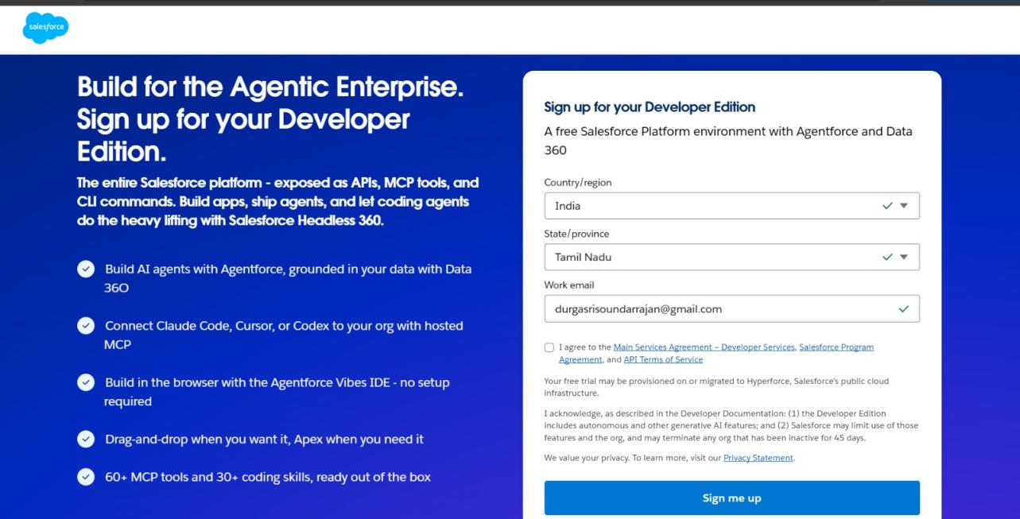
Figure 8: Salesforce Developer Edition sign-up form
- Open the inbox of the email used to sign up and click Verify Account. The email may take 10–30 minutes, and sometimes up to 2 hours.
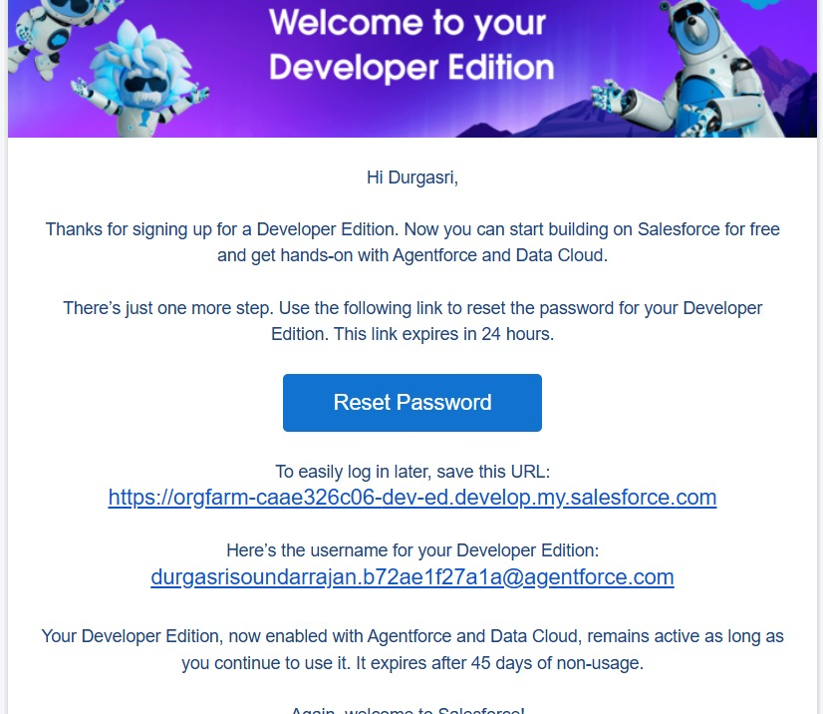
Figure 9: Account verification email
- Set a password, answer a security question, and click Change Password.
- You will be redirected to your Salesforce Setup page.
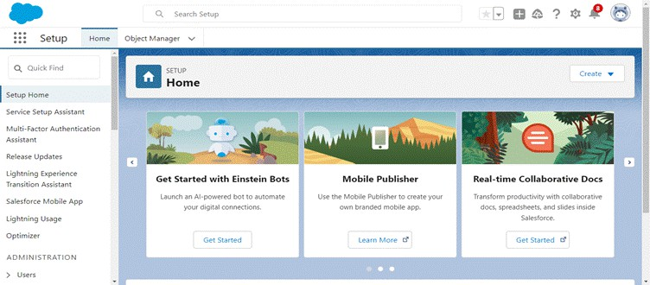
Figure 10: Salesforce Setup home page

Milestone 2 – Object Creation
Four custom objects were created: Parcel, Delivery, Sender, and Receiver. The same steps apply to each object; only the label values change.
- From the Setup page, click Object Manager.
- Click Create → Custom Object.
- Enter the Label, Plural Label, and Record Name (see table below); set the Record Name data type to Text.
- Select Allow Reports, Allow Search, and Track Field History.
- Click Save (or Save & New for the next object).
Object | Label | Plural Label | Record Name
Parcel | Parcel | Parcels | Parcel Name
Delivery | Delivery | Deliveries | DeliveryName
Sender | Sender | Sender's | SenderName
Receiver | Receiver | Receiver's | ReceiverName

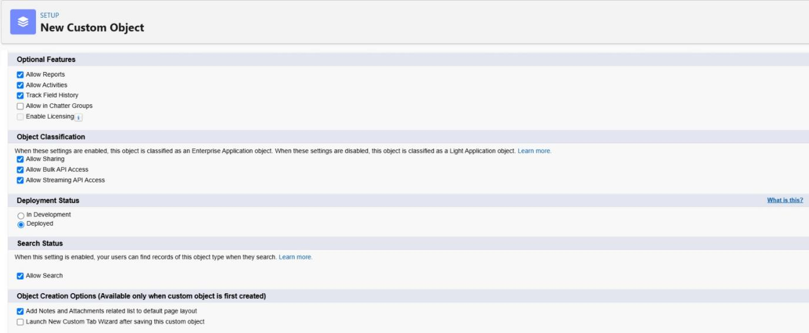
Figure 11: New custom object form (Parcel)
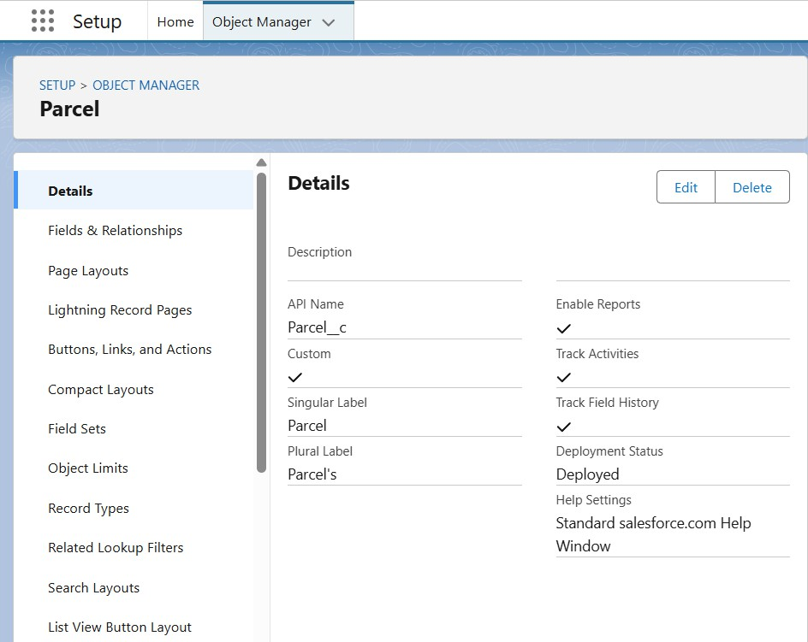
Figure 12: Parcel object created
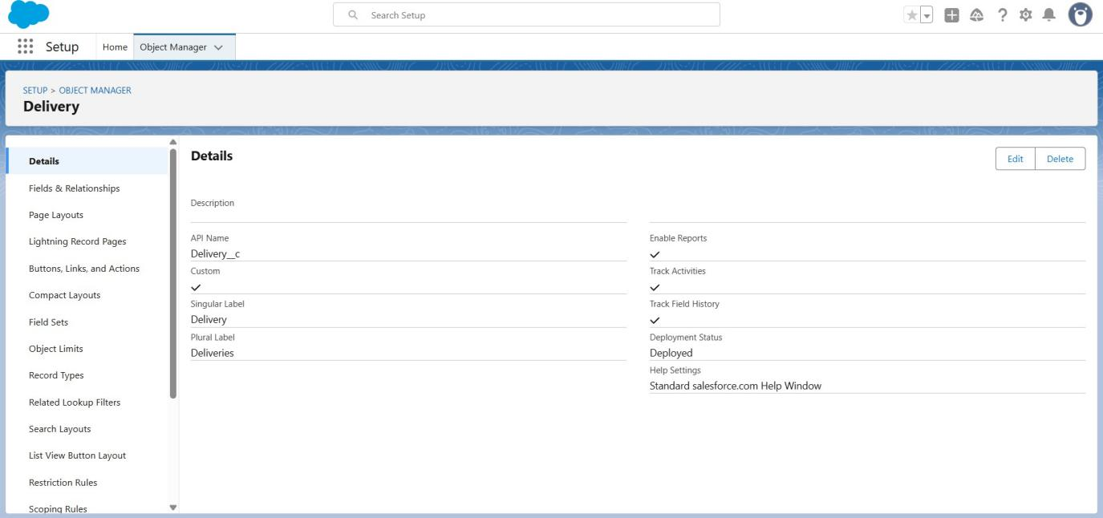
Figure 13: Delivery object created
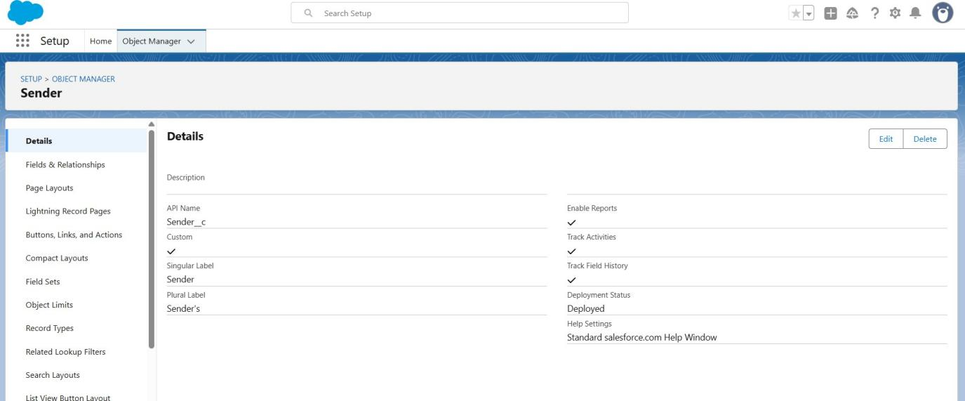
Figure 14: Sender object created

Milestone 3 – Tabs
A custom tab was created for each object so that records can be accessed from the navigation bar.
- Go to Setup and type Tabs in the Quick Find box, then click Tabs.
- Under Custom Object Tabs, click New.
- Select the object (Parcel, Delivery, Sender, or Receiver) and choose a Tab Style.
- Click Next, keep the Add to Profiles settings as default, and click Next.
- On the Add to Custom Apps page, uncheck Include Tab.
- Ensure Append tab to the user's existing personal customizations is checked.
- Click Save, and repeat for each remaining object.
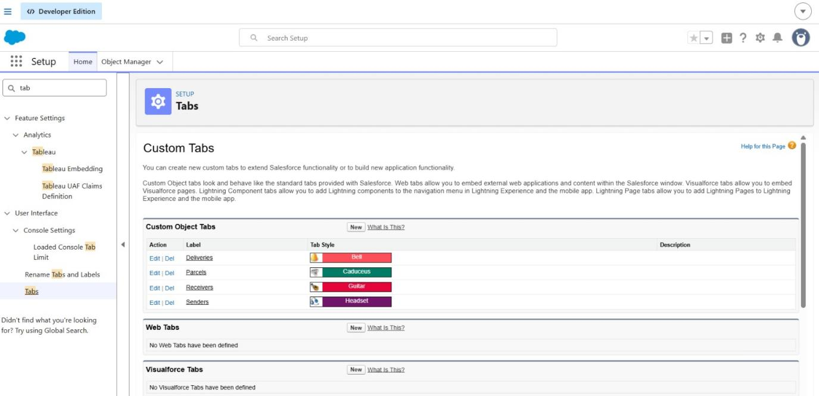
Figure 15: Creating the Parcel tab
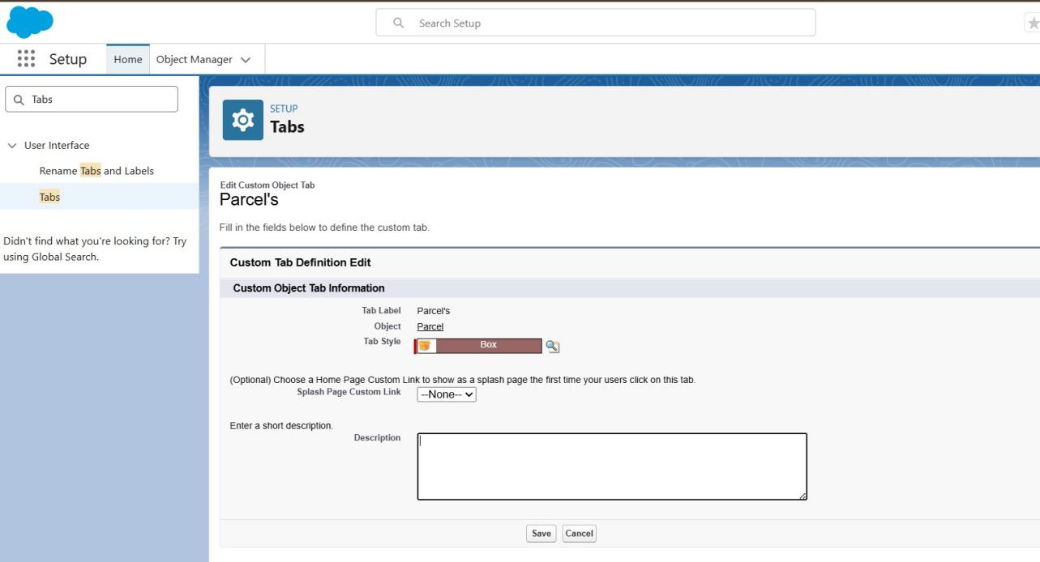
Figure 16: Parcel tab created
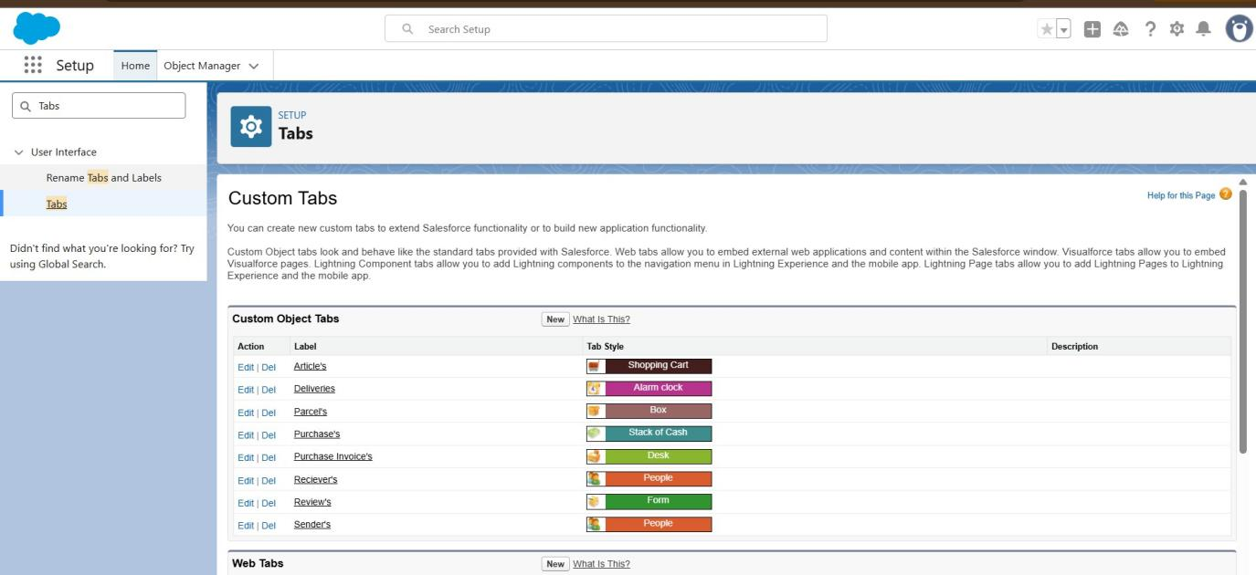
Figure 17: Tabs created for Delivery, Sender, and Receiver

Milestone 4 – Fields & Relationships
Fields and relationships were created for each custom object. Open Object Manager, select the object, go to Fields & Relationships, and click New.
Parcel object
- Parcel ID – Data type: Auto Number, format P-{000}.
- Status, Weight, Estimated Delivery, and Sender – created the same way as listed in the figure below.
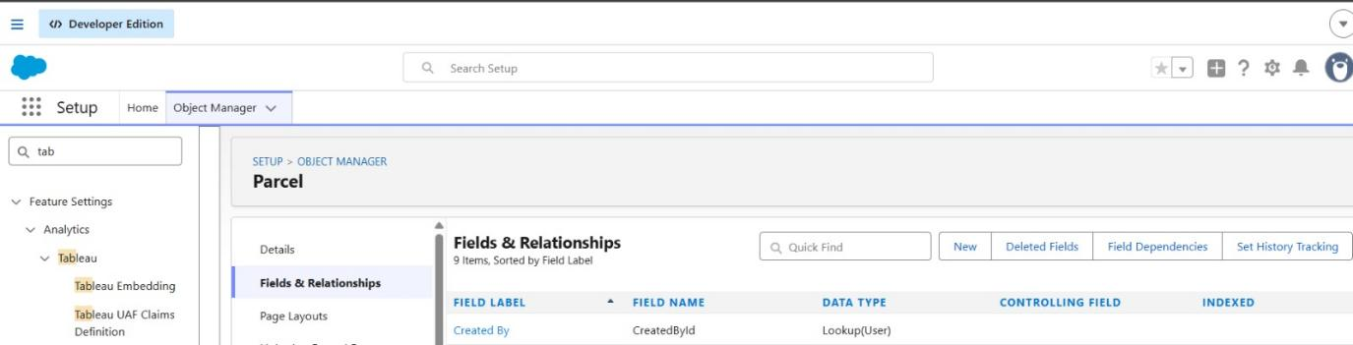
Figure 18: Creating the Parcel ID field
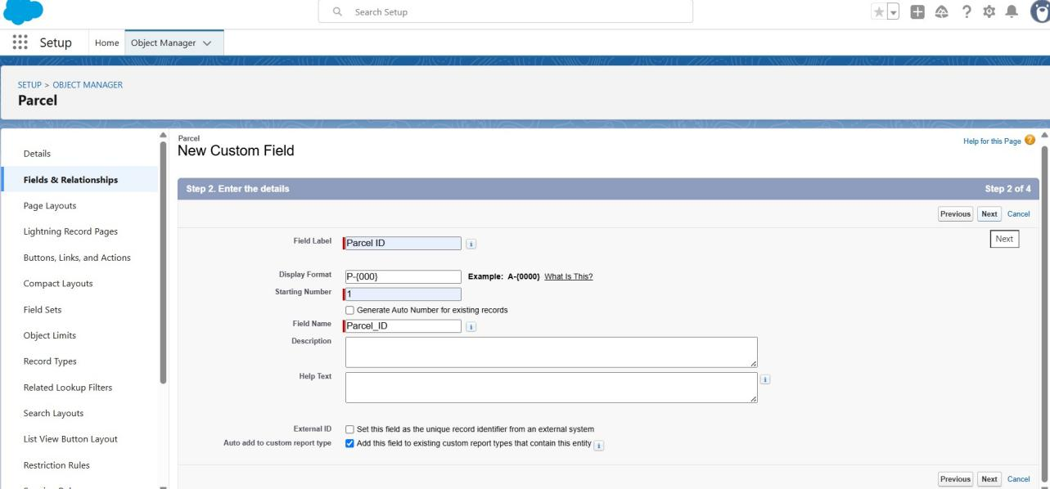
Figure 19: Parcel ID auto-number configuration
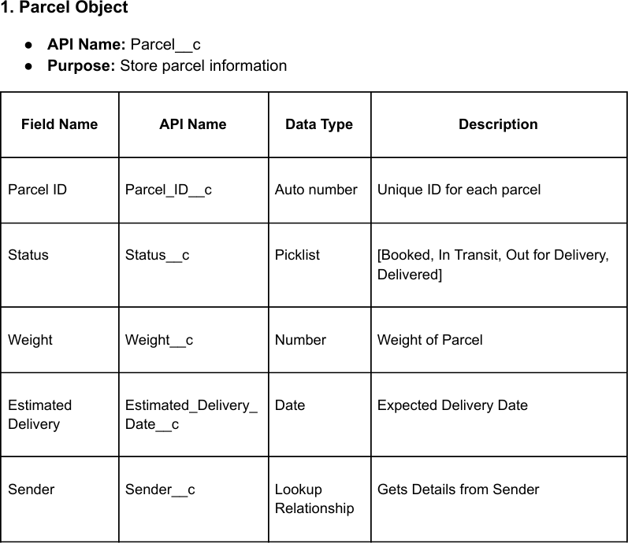
Figure 20: Parcel object fields
Delivery object
- Current Location – Data type: Geolocation.
- Estimated Delivery, Sender, and Parcel – created as shown below.
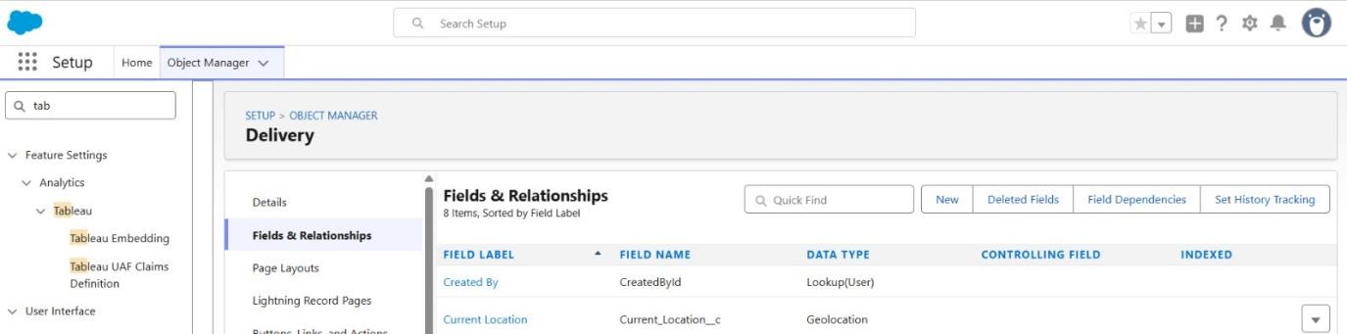
Figure 21: Creating the Delivery fields
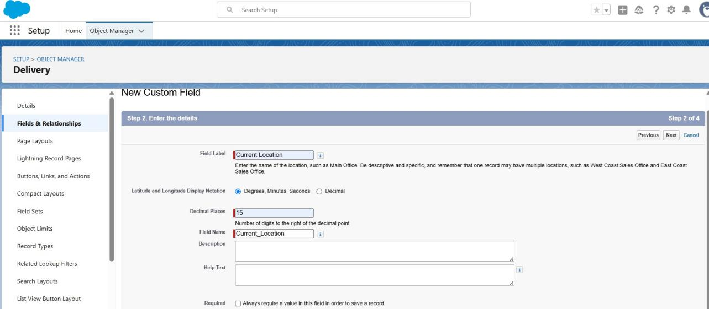
Figure 22: Current Location (Geolocation) field
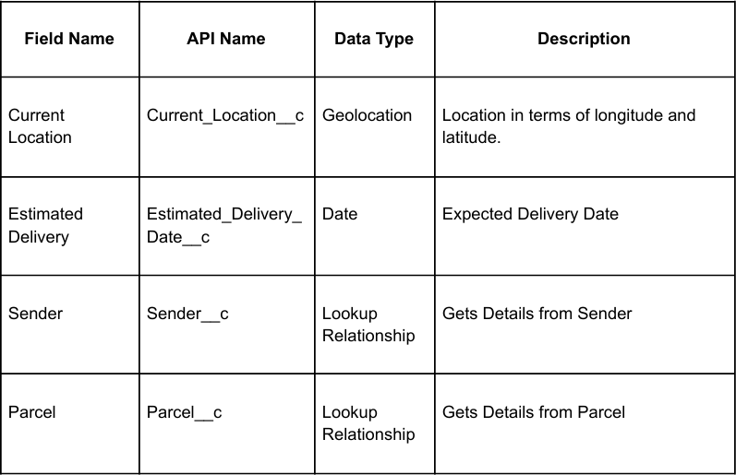
Figure 23: Delivery object fields
Sender object
- Sender Address – Data type: Geolocation.
- Sender Contact and Sender Email – created as shown below.
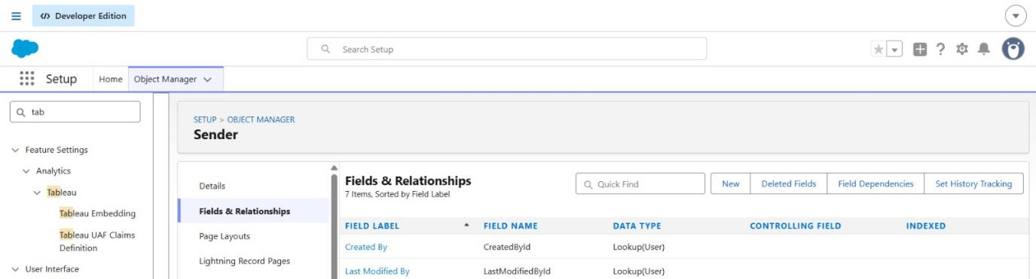
Figure 24: Creating the Sender fields
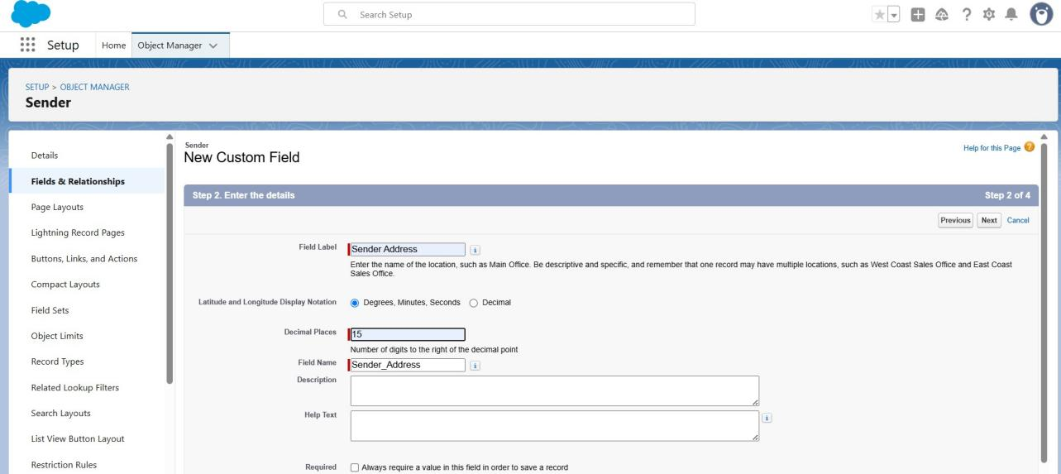
Figure 25: Sender Address (Geolocation) field
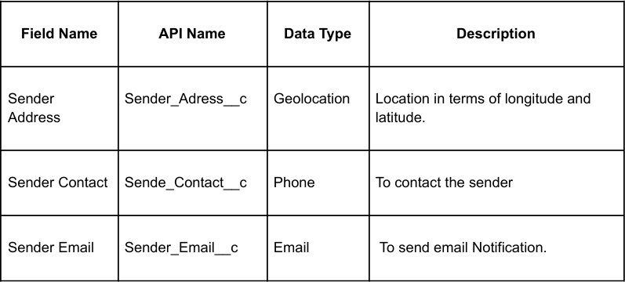
Figure 26: Sender object fields
Receiver object
- Receiver's Address – Data type: Geolocation.
- Receiver Contact, Receiver Email, Sender, and Parcel – created as shown below.
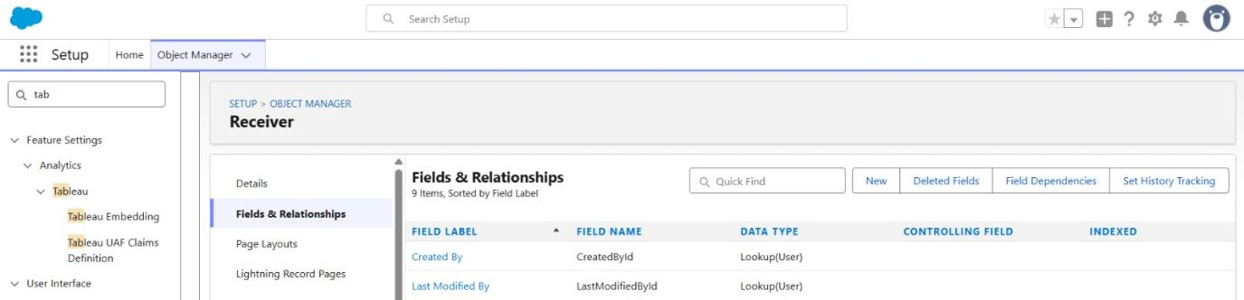
Figure 27: Creating the Receiver fields
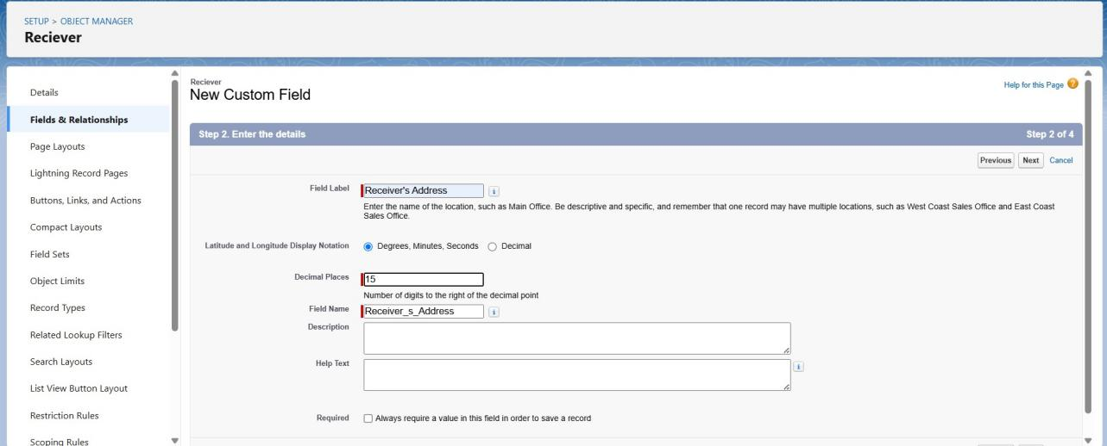
Figure 28: Receiver's Address (Geolocation) field
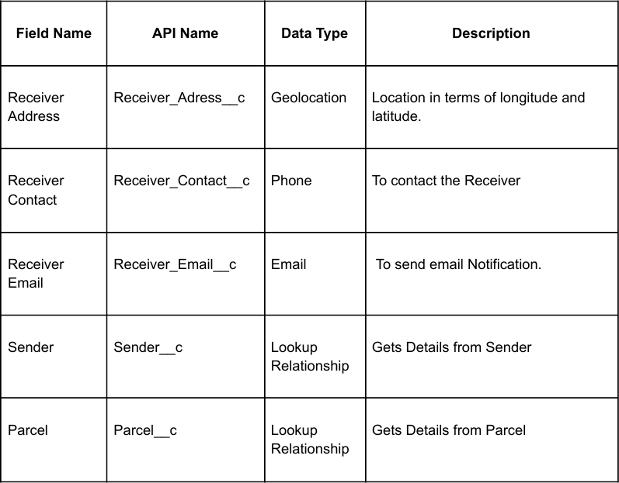
Figure 29: Receiver object fields

Milestone 5 – Prompt Builder
A prompt template was designed so that the Agentforce agent can retrieve parcel details by Parcel ID.
- In Setup, type Prompt Templates in the Quick Find box (or open Agent Builder → Prompt Templates).
- Click New Prompt Template and choose the Record Summary type.
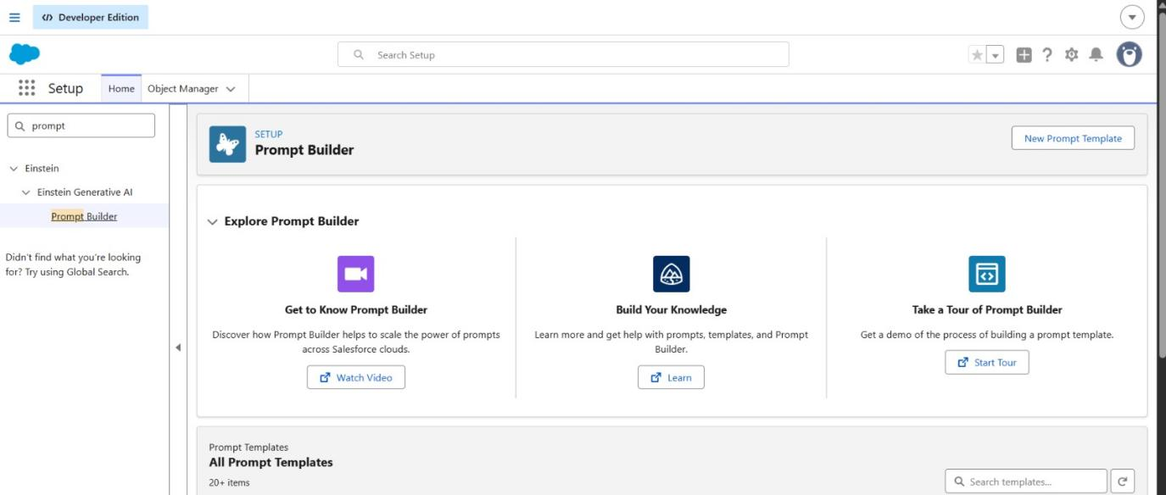
Figure 30: Creating a new prompt template
- Enter the details – Label: Retrieve Parcel Details; API Name: Retrieve_Parcel_Details; Description: Retrieves parcel details where Parcel_ID matches the user input.
- In the Prompt Template text area, enter the content shown below.
Prompt template content
Retrieve details from Parcel__c where Parcel_ID__c matches user input. Return response in this format:
📦 Parcel Tracking Update
Parcel Name: {!$Input:Parcel__c.Name}
Parcel ID: {!$Input:Parcel__c.Parcel_ID__c}
Status: {!$Input:Parcel__c.Status__c}
Weight: {!$Input:Parcel__c.Weight__c}
Estimated Delivery Date: {!$Input:Parcel__c.Estimated_Delivery_Date__c}

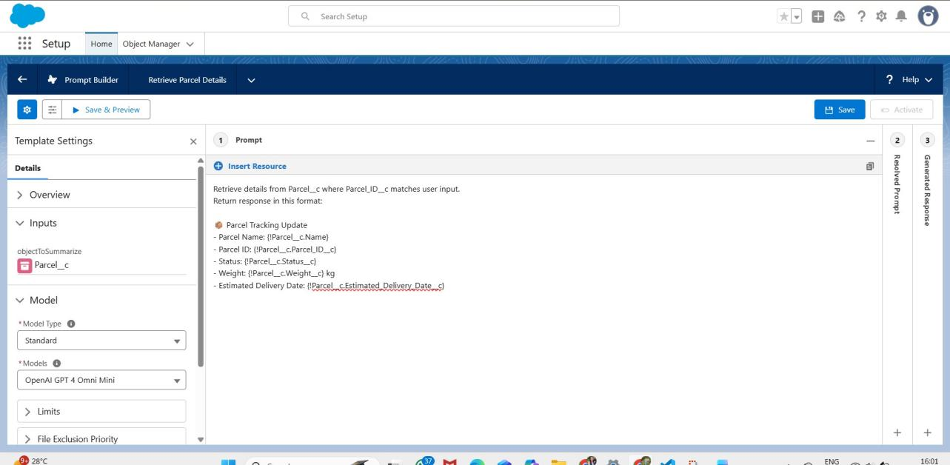
Figure 31: Prompt template content
- Scroll to Resources and click Insert Resource → Object, then select Parcel__c.
- Add the fields Name, Parcel_ID__c, Status__c, Weight__c, and Estimated_Delivery_Date__c.
- Click Save, then click Activate to make the template available to the agent or flow.
Testing the prompt
- Open the Agent preview.
- Type: "Track parcel P-12345".
- The agent should return the details from the Parcel record.
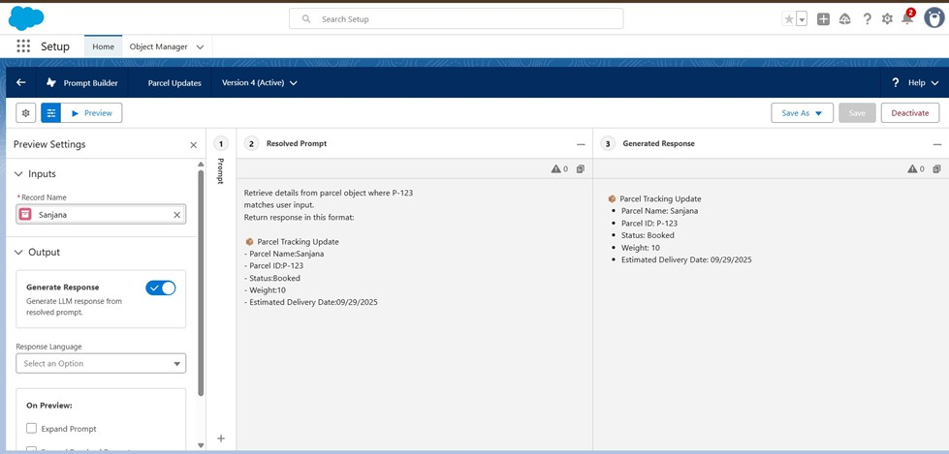
Figure 32: Prompt test in agent preview

Milestone 6 – Flows
An auto-launched flow was created to capture the parcel details and return them to the agent. Go to Setup → Flows → New Flow.
- Choose Auto-Launched Flow (No Trigger) and click Create.
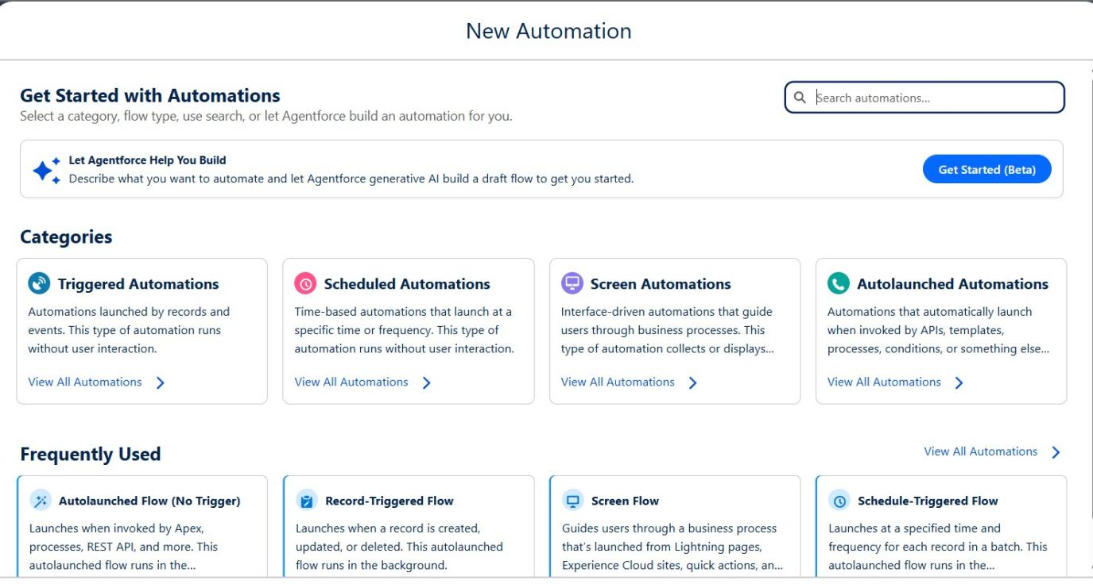
Figure 33: Creating an auto-launched flow
- Add input and output variables: click New Resource → Variable. Create a Text variable "ids" (Available for Input) and a Text variable "Output" (Available for Output).
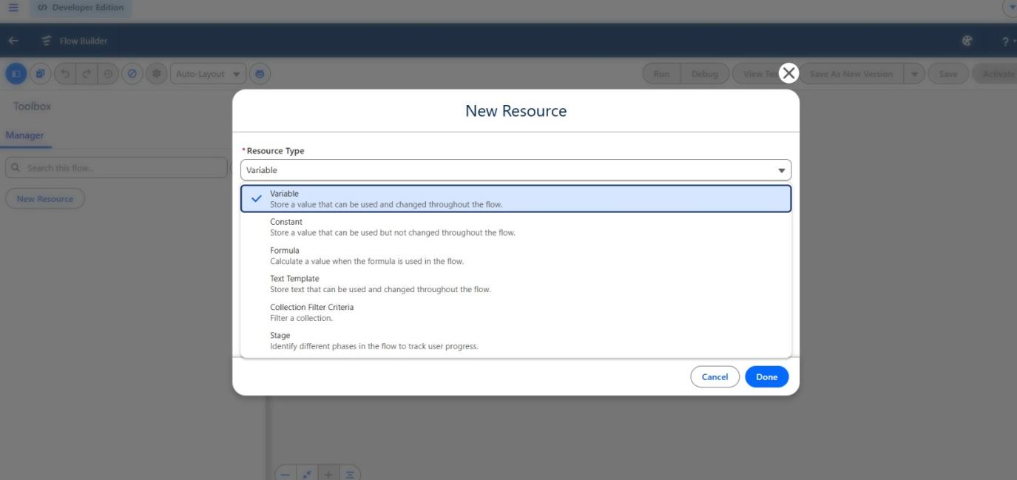
Figure 34: Creating flow variables
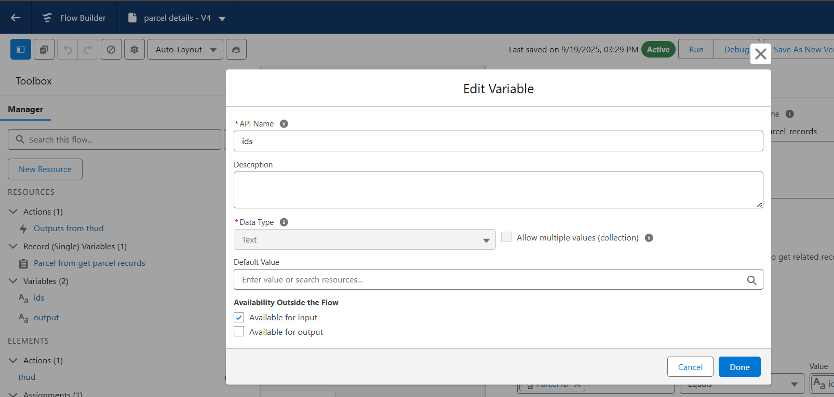
Figure 35: Input variable configuration
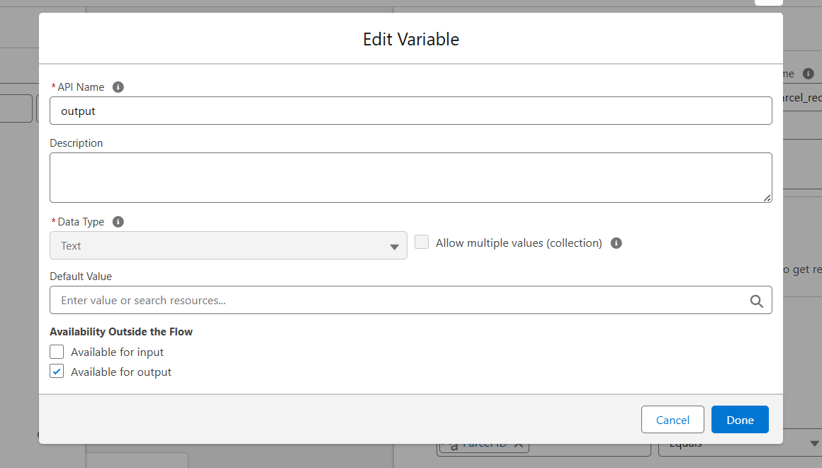
Figure 36: Flow variables created
- Add an element: Get Records. Label: Get Parcel Records. Object: Parcel; Condition: Parcel_ID__c Equals ids.
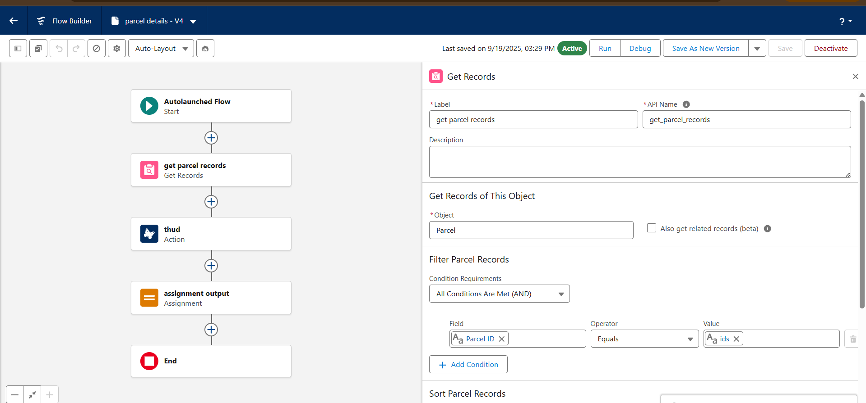
Figure 37: Get Records element
- Add an Action element: select "Retrieve Parcel Details" (the prompt template). Label: Parcel Updates. Object to Summarize: Parcel from Get Parcel Records.
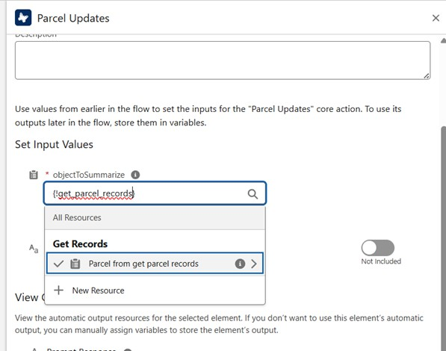
Figure 38: Prompt template action in the flow
- Add an Assignment element. Label: Assignment Outputs. Variable: Output; Operator: Equals; Value: Prompt Response from the Action.
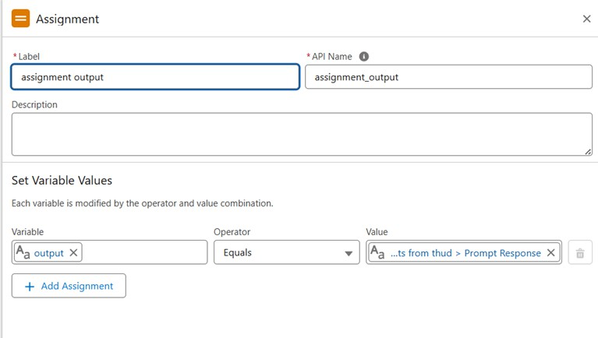
Figure 39: Assignment element
- Connect Start → Get Records → Action → Assignment → End.
- Save the flow with the name "Parcel Details" and activate it.
- Return to the Flows list, open the drop-down for the new flow, and click Edit Access.
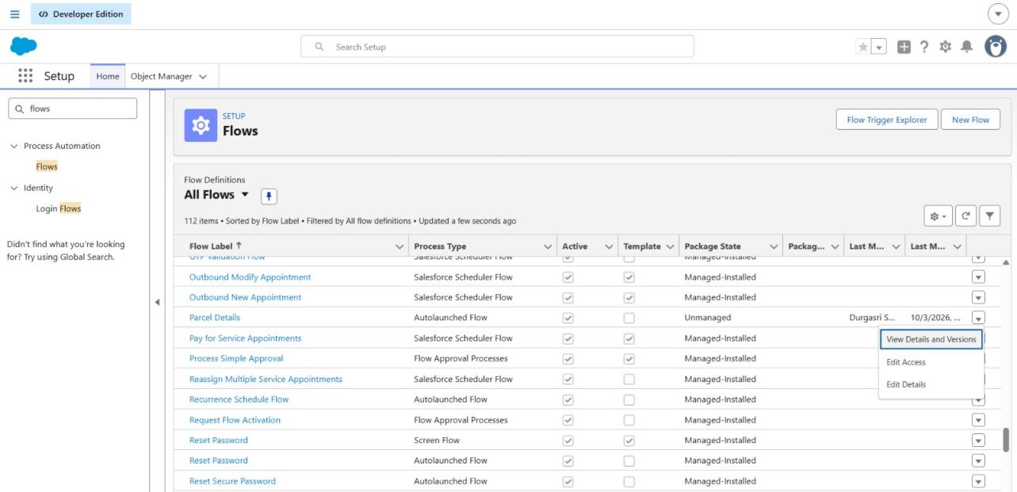
Figure 40: Edit access for the flow
- Under Flow User Access, assign the available profiles and click Save.
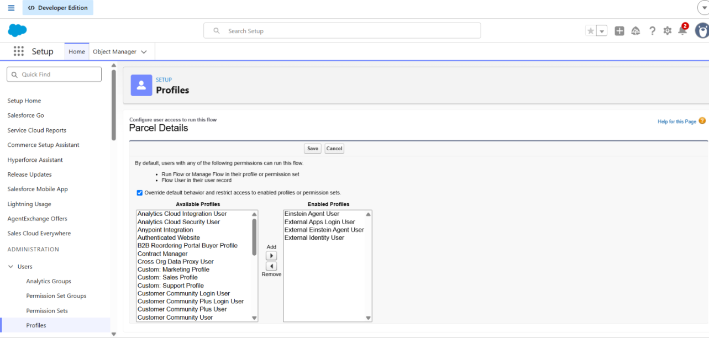
Figure 41: Flow user access

Phase 3: UI/UX Development & Customization
This phase enables agents to manage parcel operations efficiently and ensures secure access control using permission sets and AI-driven agent experiences built with Agentforce.

Milestone 1 – Creating Permission Sets
- In Setup, type Permission Sets in the Quick Find box and click Permission Sets under Users.
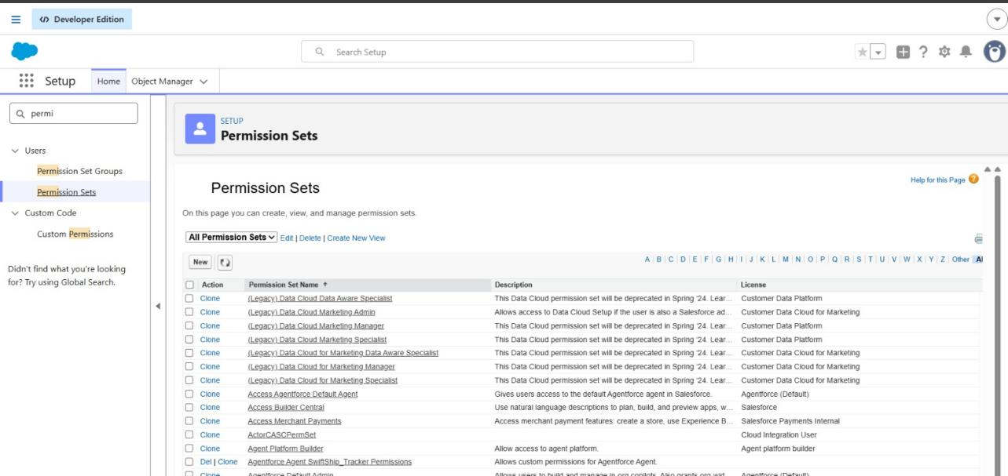
Figure 42: Permission Sets page
- Click New and enter – Label: Swift Ship; API Name: auto-fills; License: Einstein Agent. Click Save.
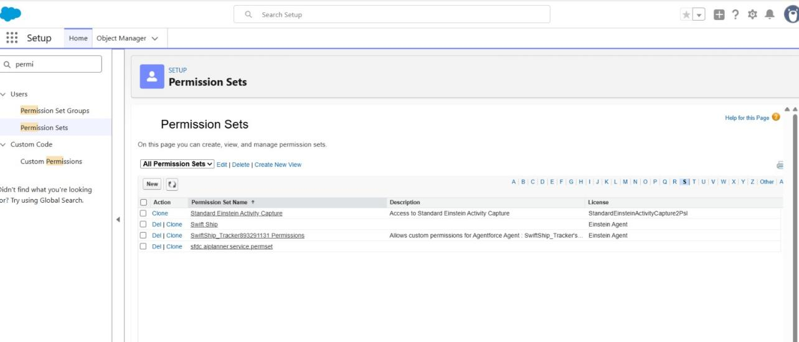
Figure 43: New permission set
- Open Object Settings, select each object one by one, and click Edit.
- Enable Read, Create, and Edit (optionally Delete if agents should remove records).
- Under Field Permissions, ensure at least Visible is checked for all key fields, then click Save after each object.
Object settings for the remaining objects are shown below.
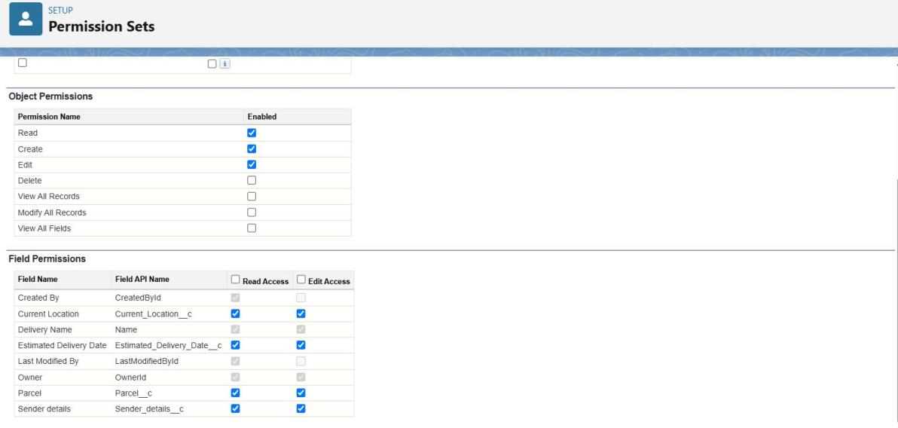
Figure 44: Delivery__c object settings
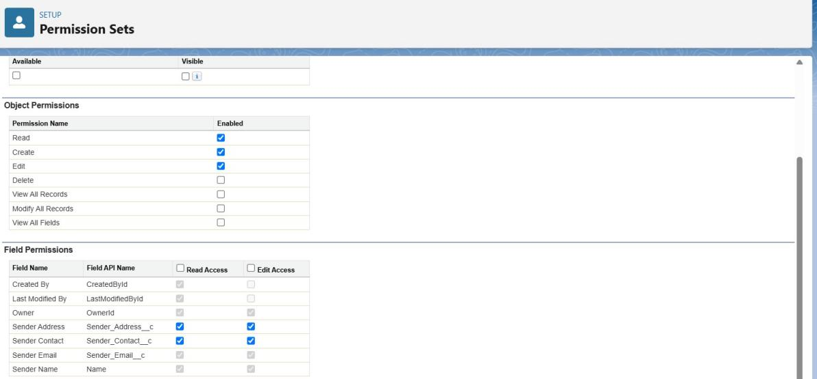
Figure 45: Sender__c object settings
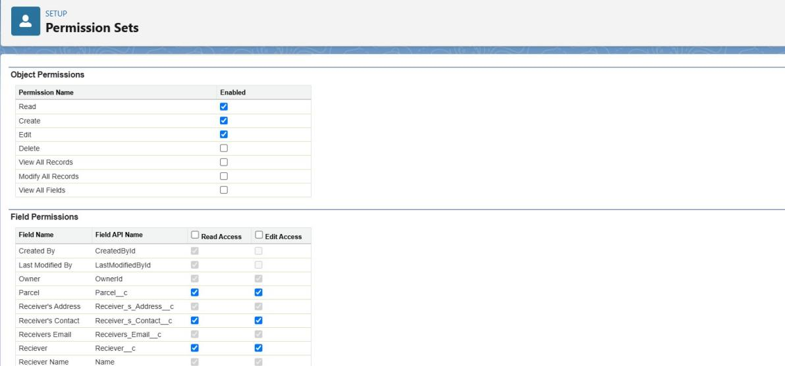
Figure 46: Receiver__c object settings

Milestone 2 – Assigning Permissions to the Agent User
- In Setup, type Users in the Quick Find box and click Users.
- Find the Einstein Service Agent user that represents your agent (e.g., "SwiftShip Agent") and open the record.
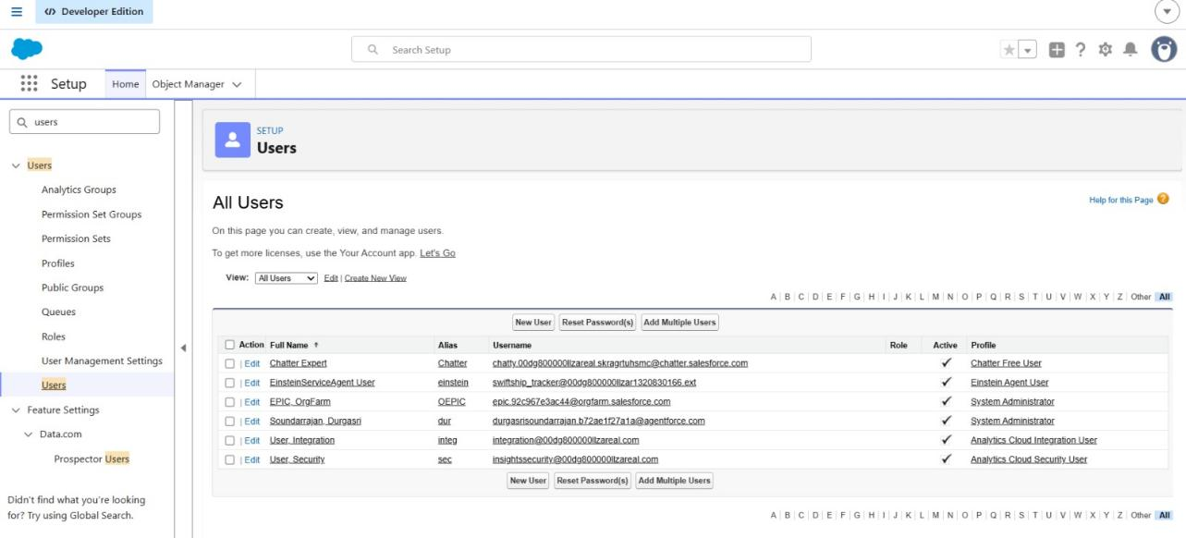
Figure 47: Agent user record
- Scroll to Permission Set Assignments and click Edit Assignments.
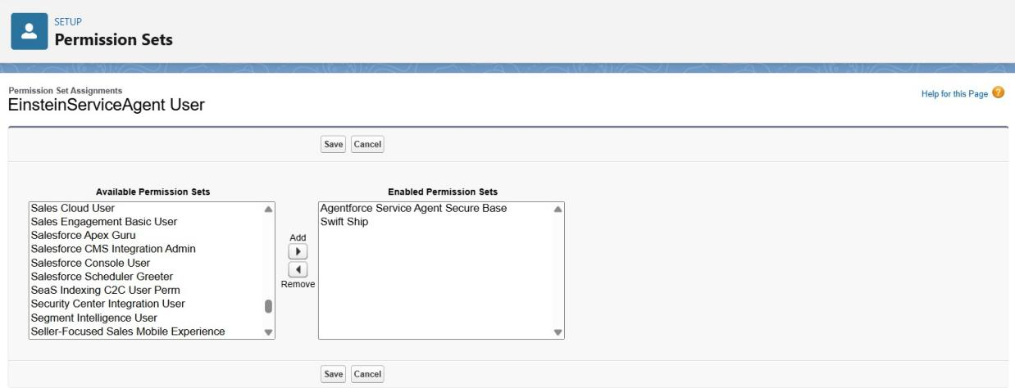
Figure 48: Permission set assignments
- Select the SwiftShip permission set under Available Permission Sets, click Add → to move it to Enabled Permission Sets, and click Save.
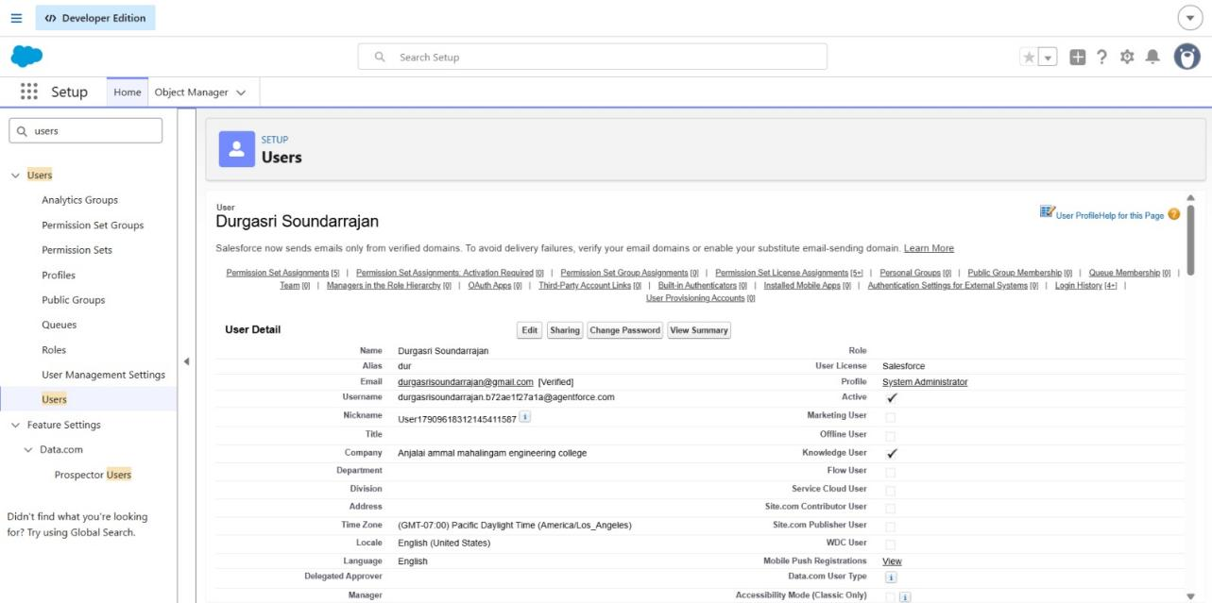
Figure 49: SwiftShip permission set assigned

Milestone 3 – Org Setup for Agentforce
Enable the Salesforce Default Agent
- In Quick Find, search for Salesforce Go and open it.
- Search for Default Agent, click Get Started, and turn it on.
- Refresh the page.
Enable Einstein
- Go to Setup → Einstein Setup and click Get Started if prompted.
- Turn on Einstein, Global Languages, and Deploy Prompt Template.
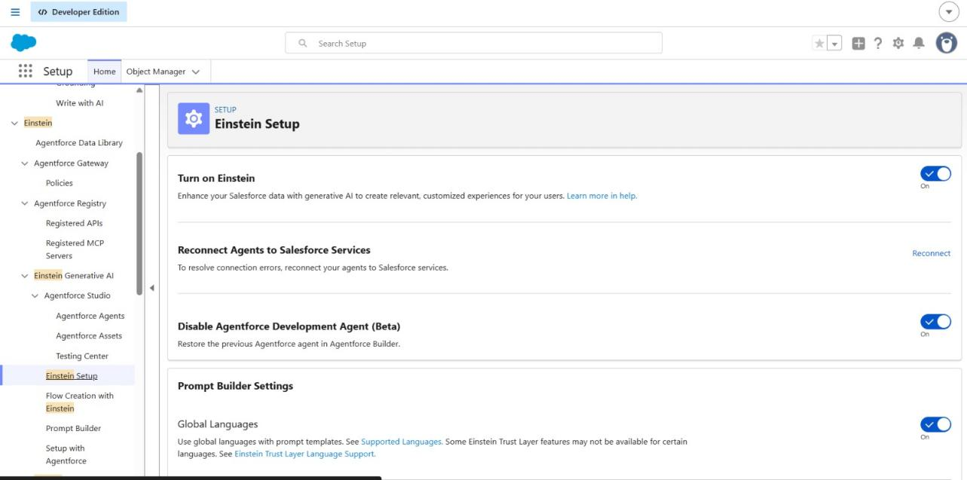
Figure 50: Einstein Setup
- Refresh the browser page.
- Go to Setup → Agentforce Agents and turn on Agentforce and Enable Agentforce Default Agent.
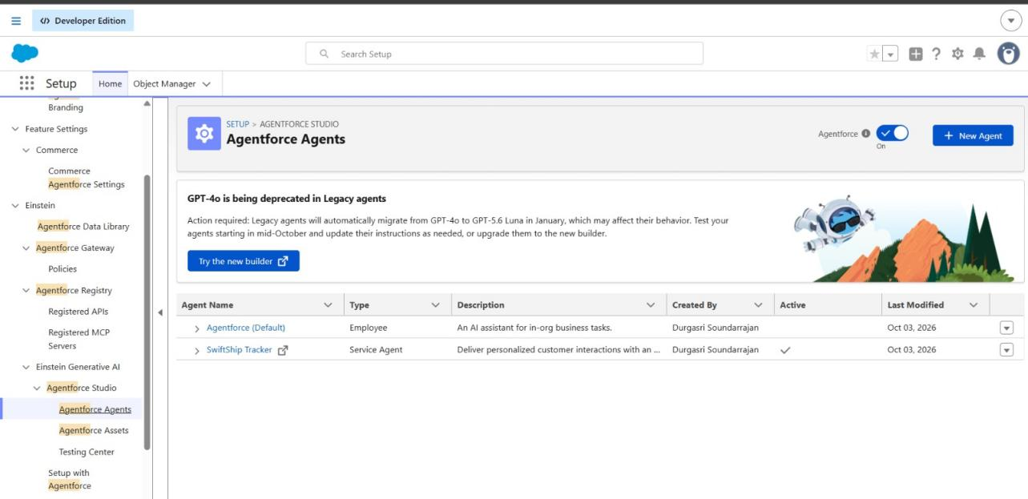
Figure 51: Agentforce Agents page

Milestone 4 – Building the Agent
- In Setup, search for Agentforce Agents in Quick Find.
- Click Agentforce Agents, select the default agent, and click Open in Builder.
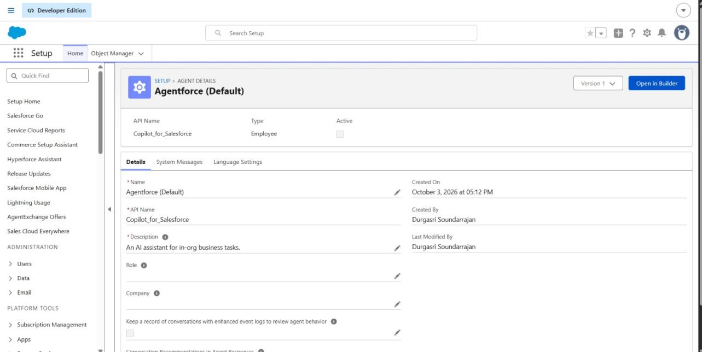
Figure 52: Agent Builder
Assign subagents to the agent
- In Subagents, click New, then New Subagent.
- Fill in the details as shown below.
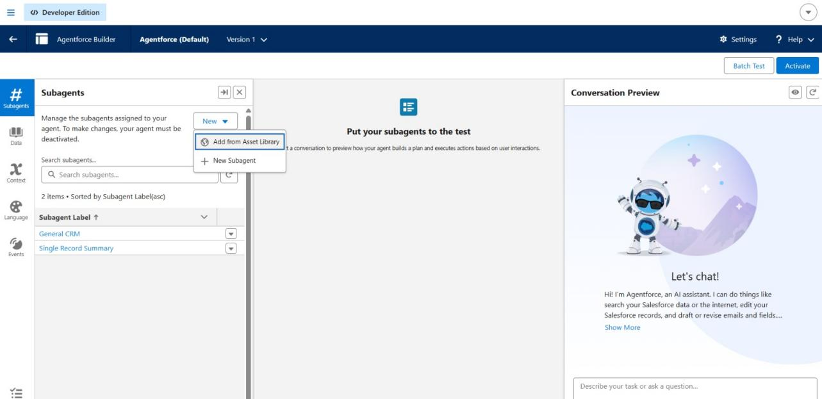
Figure 53: Creating a new subagent
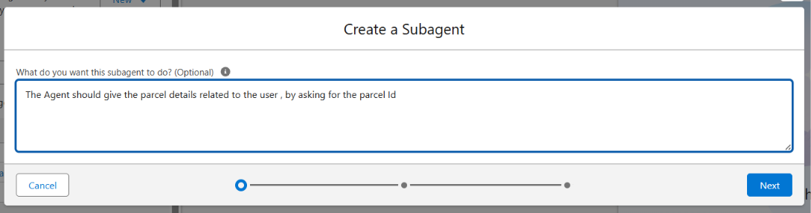
Figure 54: Subagent details
Add actions to Agentforce assets
While in Agent Builder, open the Topics and click Topic Actions.
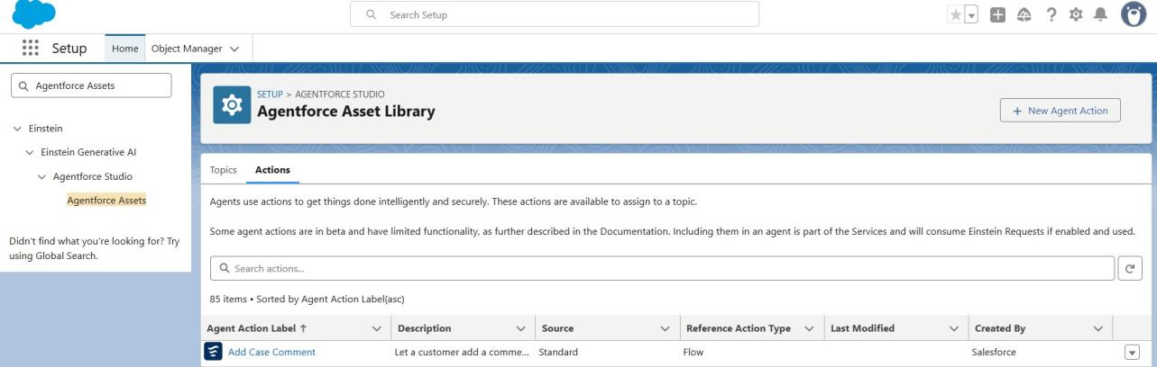
Figure 55: Topic actions
- Click New Agent Action.
- For Action Type, select Flow and click Next.
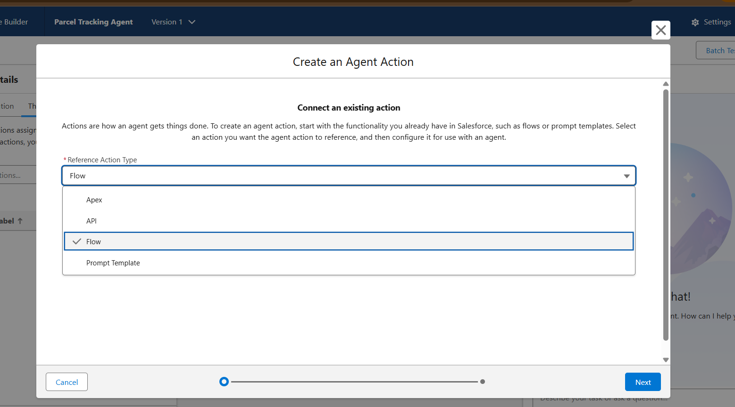
Figure 56: Selecting the Flow action type
- For Reference Flow, select the flow created earlier and click Next.
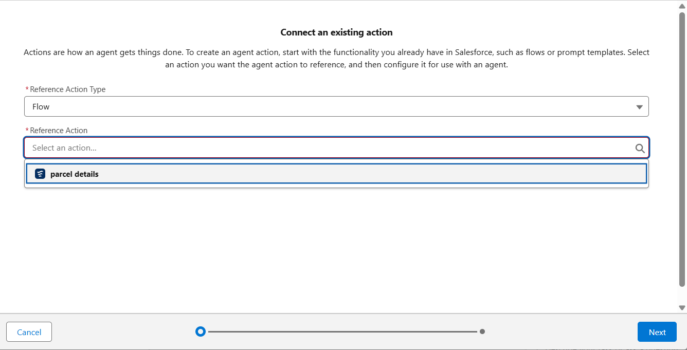
Figure 57: Selecting the reference flow
- Fill in the details for Agent Configuration.
Assign the action to the subagent
- In Agent Builder, open the Parcel Updates subagent (see Figure 53).
- Click the subagent's Actions and select Add from asset library.
- Select the flow action created earlier and click Finish.
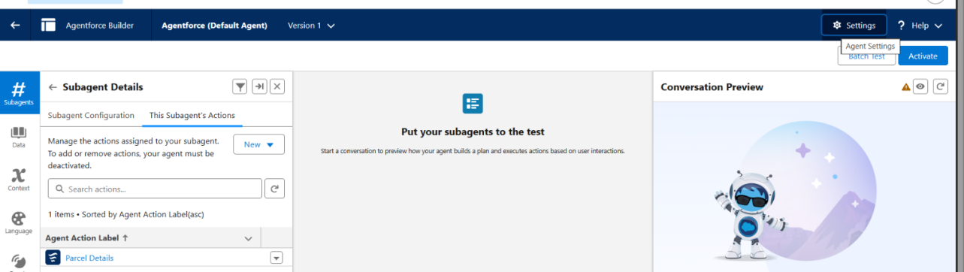
Figure 58: Adding the flow action from the asset library
- Click Settings and rename the agent to SwiftShip Tracker, then click Save.
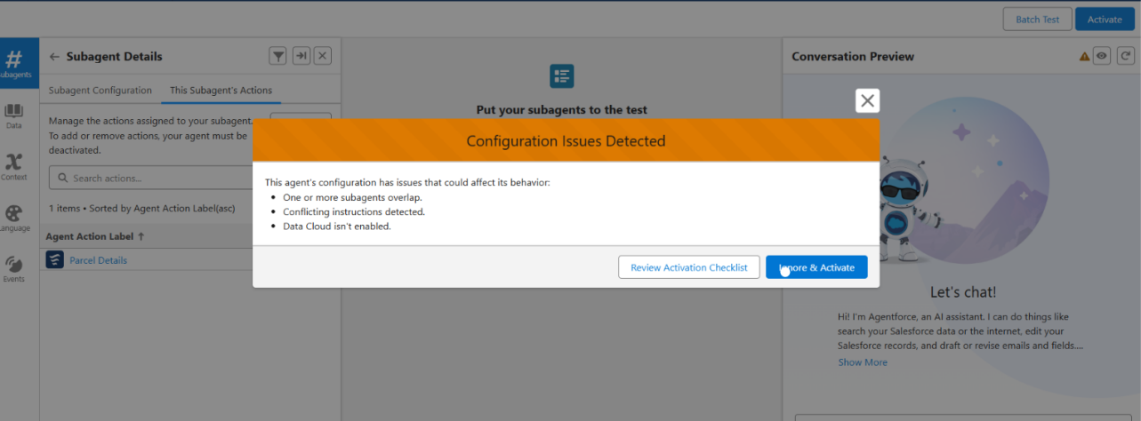
Figure 59: Renaming and saving the agent
Finally, click Ignore and Activate, then click Activate.

Phase 4: Data Migration, Testing & Security
This phase validates the functionality and reliability of the Parcel Tracking Agent created in Agent Builder. It ensures that the agent recognizes topics, triggers the assigned Flow (SwiftShip Tracker), retrieves or updates parcel data, and performs all intended actions without access or permission issues. The goal is to confirm that the AI-driven agent operates seamlessly within Salesforce and provides accurate, real-time responses to parcel management queries.

Verify the Agent
- Go to Setup → Agentforce Agents.
- Open the Agents list and confirm that the agent "Parcel Tracking Agent" appears (see Figure 51).

Validate the Assigned Topic
In Agent Builder → Subagent, confirm that the subagent you created (e.g., Parcel Tracking or SwiftShip Tracker) is listed. Open the topic and verify that:
- It contains a prompt or description related to parcel management.
- The Action/Flow (SwiftShip Tracker) is linked to this topic.
Click Save and ensure the topic is Active.
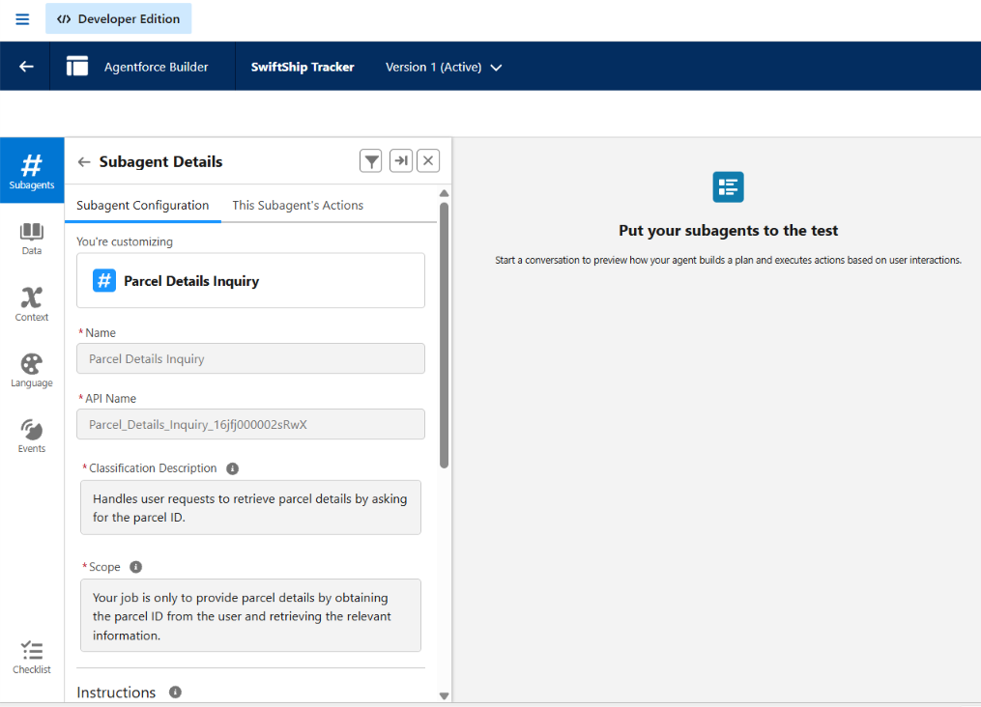
Figure 60: Subagent and topic validation
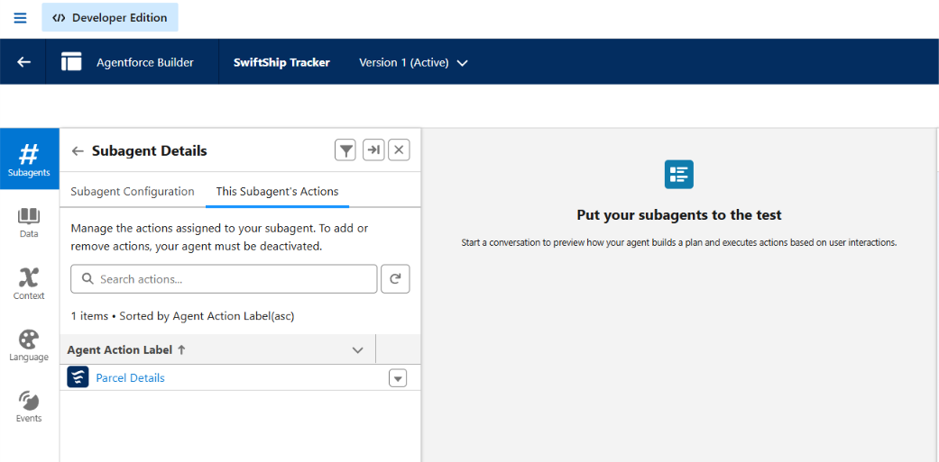
Figure 61: Topic configuration

Check the Flow Association
- Go to Setup → Flows and locate the flow named SwiftShip Tracker.
- Confirm the flow is Activated and includes elements that handle Parcel ID input, parcel details retrieval, and a status update or confirmation message.
- Open the flow's Advanced Settings and ensure Run in System Context (Without Sharing) is set if data access is restricted.
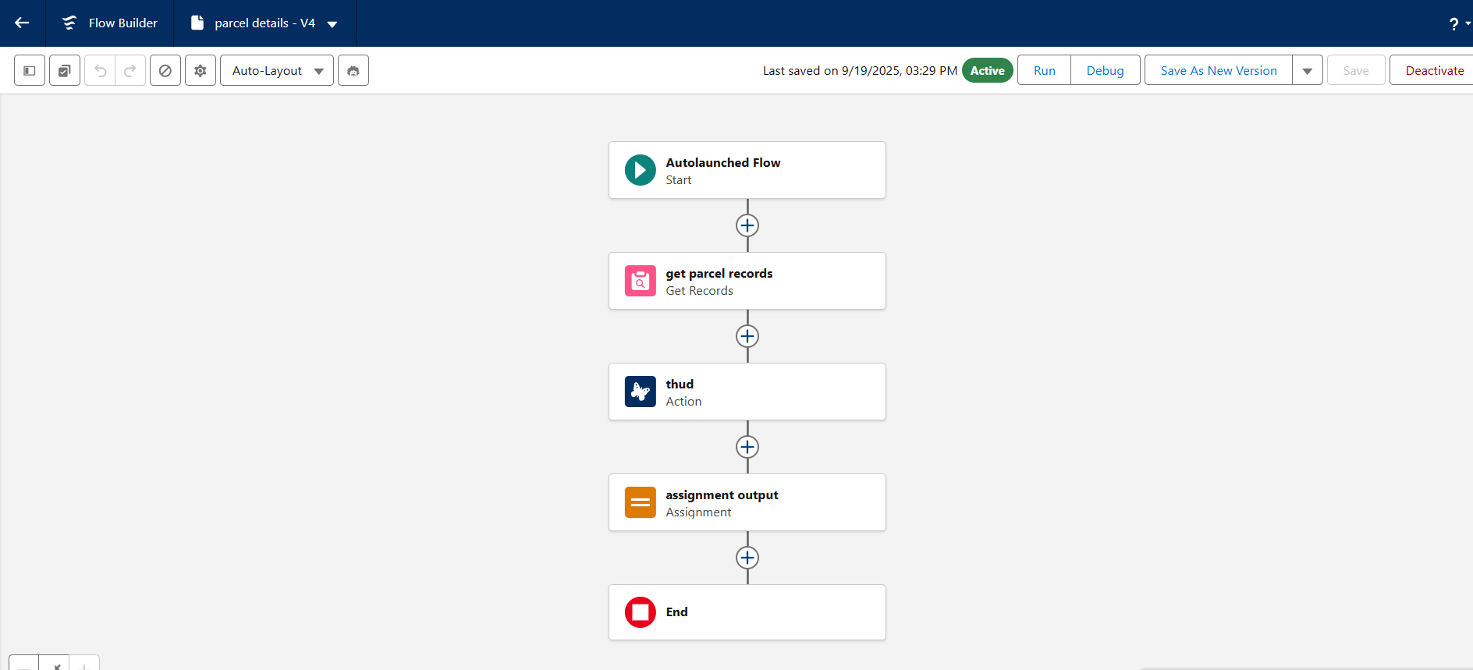
Figure 62: Flow association check

Activate and Test the Agent
- Return to Setup → Agent Builder → Parcel Tracking Agent.
- Click Activate (if not already activated).
- In Preview / Try it Out mode, enter a query such as "Track parcel ID P12345" or "Update delivery status for parcel P67890 to Delivered".
- Observe the agent's response.
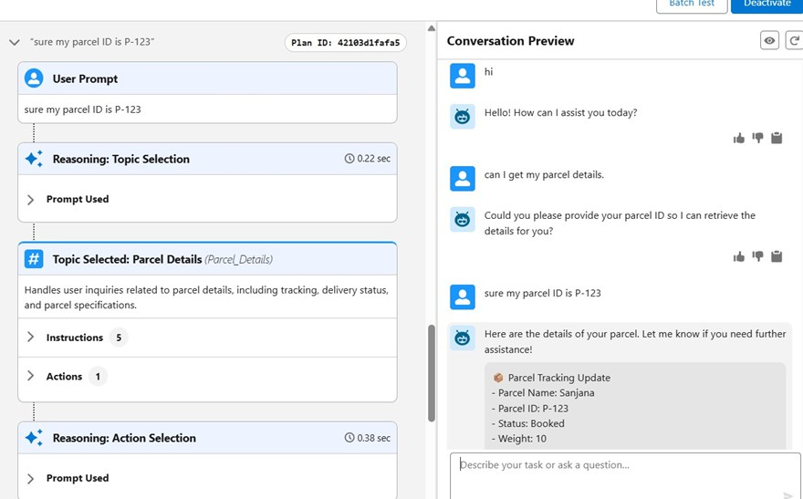
Figure 63: Agent test in preview mode

Validate Data in Salesforce
- After the agent runs the Flow, go to App Launcher → Parcels (Parcel__c).
- Search for the Parcel ID used during testing and verify that the Status or related field is updated and that any Flow-created records (bookings, updates) appear correctly.
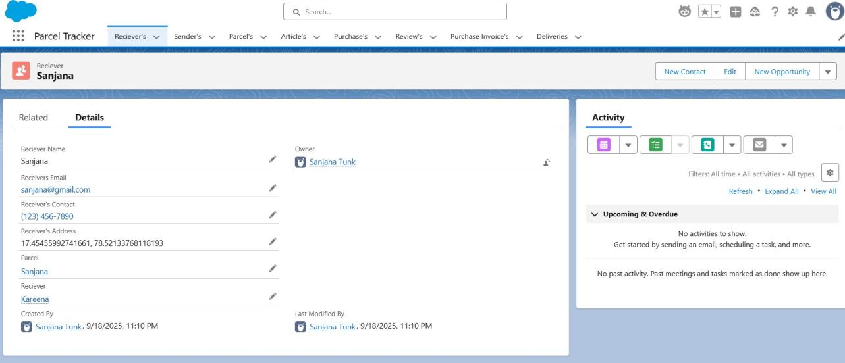
Figure 64: Parcel record validation

Phase 5: Deployment, Documentation & Maintenance
Testing of the SwiftShip Tracker (Agentforce) implementation was carried out in the Salesforce Developer Org to validate that the Parcel Tracking Agent, created using Agent Builder, works as intended. The main goal was to show how an AI-powered service agent can be tested for correct topic recognition, Flow execution, and data retrieval from Salesforce custom objects. Testing in the Developer Org simulates how the agent would perform in a live setup, ensuring that permissions, flows, and interactions function correctly before any deployment stage.
Production-level testing (UAT or sandbox deployment) was not performed because:
- Developer Edition orgs are standalone environments and do not support production-linked testing environments.
- Enterprise-level Agentforce deployment involves sandbox testing, staging environments, and CI/CD automation, which are outside the scope of this academic/prototype implementation.

Maintenance, Monitoring & Troubleshooting
Ongoing maintenance ensures that Parcel, Customer, and Delivery data remain accurate, synchronized, and up to date. Regular monitoring helps detect issues such as misrouted agent queries, failed Flow executions, or performance delays in Agentforce responses. Troubleshooting includes resolving configuration errors, updating Flow logic, refining agent topics, and improving prompts to enhance user interactions.
Although this project is implemented in a Developer Org for learning purposes, these maintenance and monitoring practices are essential in real-world deployments to keep AI-powered service agents reliable, scalable, and aligned with evolving customer service needs.

7. Functional & Performance Testing
Screenshots were captured from Salesforce during testing to validate parcel object and field creation, prompt template retrieval, flow execution, permission assignment, agent topic recognition, and parcel data updates. All features were verified for correct functionality and performance, as summarized below.
Test Area | Expected Result | Evidence
Agent configuration | Parcel Tracking Agent is listed and active | Figure 51
Subagent / topic | Subagent is active and linked to the SwiftShip Tracker flow | Figures 60–61
Flow association | Flow is activated and handles Parcel ID input and retrieval | Figure 62
Prompt retrieval | Prompt returns Parcel Name, ID, Status, Weight, and Estimated Delivery Date | Figure 32
Agent response | Agent returns accurate parcel details for a Parcel ID query | Figure 63
Data validation | Parcel__c records reflect the status and updates made through the flow | Figure 64

8. Advantages & Disadvantages

8.1 Advantages
- Centralized parcel and customer information in Salesforce.
- Better visibility into parcel booking and delivery tracking.
- Automates key logistics processes using Salesforce Flow.
- Agentforce enables conversational customer support and parcel-status assistance.
- Prompt Builder supports AI-powered responses and self-service.
- Reduces manual effort for customers, support teams, and administrators.
- Provides timely notifications and updates during the delivery process.
- Experience Cloud can give customers convenient access to tracking information.
- Supports integration with external logistics systems.
- Can scale to support multiple locations and growing parcel operations.

8.2 Disadvantages
- Requires accurate and up-to-date parcel and customer data.
- Depends on Salesforce configuration and automation.
- Agentforce responses depend on properly configured prompts and available data.
- External logistics integrations may increase implementation complexity.
- Flow and automation logic need regular maintenance when business processes change.
- Users need appropriate Salesforce or Experience Cloud access.
- Initial Salesforce implementation and configuration can require significant effort.
- Expanding to additional locations or integrations may require further customization.

9. Conclusion
The SwiftShip Tracker demonstrates how Salesforce can be used to build a centralized parcel management and tracking solution. The project integrates custom objects, relationships, Flows, Apex, Email Alerts, Experience Cloud, Agentforce AI, Prompt Builder, security controls, and reporting to support parcel booking, delivery tracking, status updates, and customer communication.
The integration of Agentforce AI with Prompt Builder and Salesforce Flow provides a conversational approach to parcel tracking, enabling customers to obtain shipment information without depending entirely on manual support. The project therefore provides a practical foundation for a scalable and user-friendly parcel management solution.

10. Future Scope
- Extend Agentforce capabilities for more parcel-management queries.
- Enhance real-time delivery tracking.
- Expand customer self-service through Experience Cloud.
- Add more advanced delivery-performance analytics.
- Integrate additional external logistics systems.
- Improve AI prompts and conversational experiences.
- Introduce enterprise-level sandbox and CI/CD deployment.
- Expand automation for additional parcel operations.

11. Appendix
Ref | Category | Components
A | Custom Objects | Parcel, Delivery, Sender, Receiver
B | Standard Objects | Account, Contact, Case, Task, EmailMessage, User
C | Automation | Flows, Approval Processes, Email Alerts
D | Apex | Apex Classes, Batch Apex
E | AI | Agentforce AI, Prompt Builder
F | UI | Lightning App, Lightning Record Pages, Experience Cloud
G | Security | Profiles, Roles, Permission Sets, Sharing Rules, Field-Level Security
H | Analytics | Reports & Dashboards
I | Testing | Flow, Agentforce, data retrieval, security and permission validation

— Thank You —

