BookNest – Online Book Browsing and Booking System.

Team Information
Team ID: LTVIP2026TMIDS34682
Team Leader: Ramireddy Durga Srilakshmi
Team Member1: Balasadi Sodevaki
Team Member2:Ganta Devi

1.Project Overview
- Purpose: BookNest is designed to provide a unified platform for users to browse books, manage wishlists, and handle bookings .It aims to bridge the gap between sellers, administrators, and customers through a streamlined MERN-based interface.
- Key Features:
  - Three-Tier Access: Dedicated dashboards for Users, Sellers, and Admins.
  - Book Management: Wishlist functionality and "My Bookings" tracking.
  - Seller Tools: Dashboard to manage items and view sales.
  - Admin Control: Complete oversight of users, orders, and seller activities.

2.System Architecture
The application follows the MERN (MongoDB, Express, React, Node) architecture.
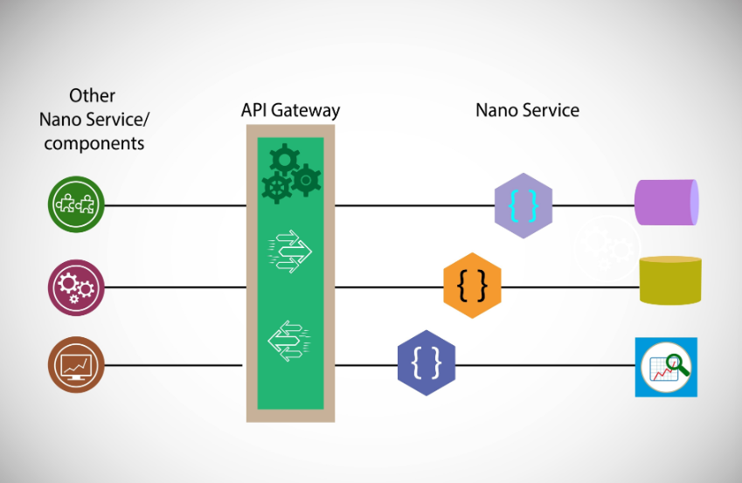

3.Flow Chart Diagrams
System Architecture Flow:
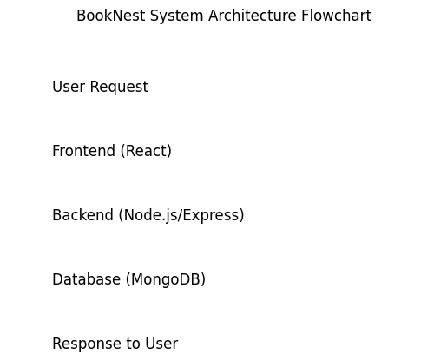

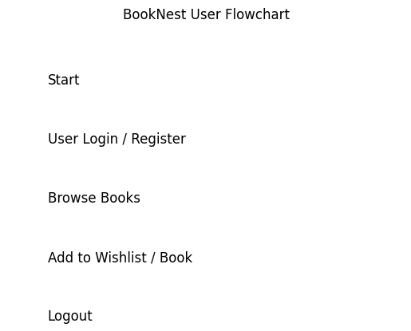
4. Setup Instructions
Prerequisites: Node.js, MongoDB Atlas account, and VS Code.
• Installation:
Clone: git clone [repository-link]
Backend: cd server -> npm install -> Define PORT and MONGO_URI in .env.
Frontend: cd client -> npm install.
5.Folder Structure
Client: /src/components (UI), /src/pages (Home, Login, Dashboard).
Server: /models (Schemas), /routes (API paths), /middleware (Auth logic).
6. Running the Application
Frontend: Run npm start in the client directory.
Backend: Run npm start (or nodemon index.js) in the server directory.
7. API Documentation
Method | Endpoint | Description
POST | /api/auth/register | User/Seller Signup
POST | /api/auth/login | Authentication & Token Generation
GET | /api/books | Fetch all available books
POST | /api/orders | Place a new booking

8. Authentication
We implemented JSON Web Tokens (JWT).

Registration: Stores hashed passwords in MongoDB.

Login: Validates credentials and returns a token.

Protected Routes: Middleware checks for a valid token before allowing access to the Seller/Admin dashboards

9. User Interface
Landing Page: Introduction to BookNest.
Home Page: Book listings and search.
Seller Dashboard: Interface for adding/managing book items.
Admin Dashboard: Overview of all users and orders.
10. Testing
- API Testing: Verified all routes (GET, POST, DELETE) using Postman.
- UI Testing: Ensured responsiveness across mobile and desktop views.
- Error Handling: Implemented middleware to catch 404 and 500 errors gracefully.
11. Known Issues
- Initial image upload latency on slow connections.
- Session timeout logic needs further refinement.
12. Future Enhancements
- Integrating a secure payment gateway (Stripe).
- Adding an AI-based book recommendation system based on user history

13. Conclusion
BookNest provides an efficient platform for managing and booking books online. It improves accessibility and reduces manual work.

