**Question 1**

What is the optimal value of alpha for ridge and lasso regression? What will be the changes in the model if you choose double the value of alpha for both ridge and lasso? What will be the most important predictor variables after the change is implemented?

Ans:

optimal value of alpha for ridge regression: 2

optimal value of alpha for ridge regression: 0.001

after Doubling: The r2 score got reduced for both test and training data sets

Imp Variables, Ridge:

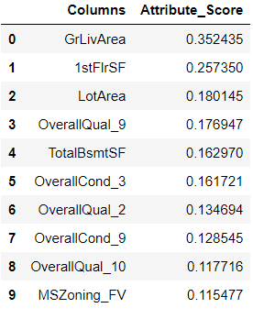

Imp Variables, Lasso:

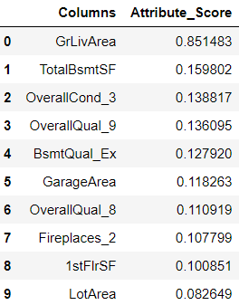

**Question 2**

You have determined the optimal value of lambda for ridge and lasso regression during the assignment. Now, which one will you choose to apply and why?

Ans :

I choose lasso, based on following points:

1. The r2 score difference between train and test is more for Ridge regression.
2. The final features are far more for Ridge compared to Lasso.

As the train and test difference and more variables resulting Ridge model is little complex model than Lasso.

**Question 3**

After building the model, you realised that the five most important predictor variables in the lasso model are not available in the incoming data. You will now have to create another model excluding the five most important predictor variables. Which are the five most important predictor variables now?

 Ans:

Top 5 Lasso variable Before:

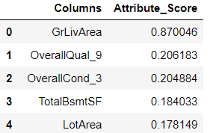

After excluding the above columns:

Top 5 most important Variables:

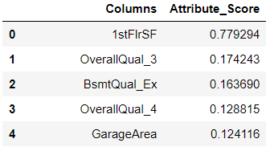

**Question 4**

How can you make sure that a model is robust and generalisable? What are the implications of the same for the accuracy of the model and why?

Ans:

1. The residuals of the model vs independent variables shows homoscedastic nature – low variance and low bias.

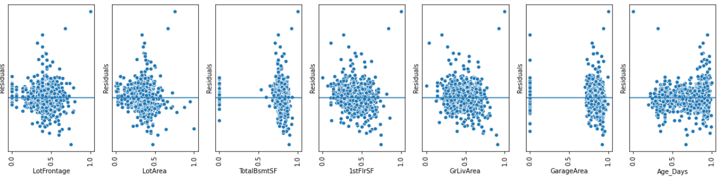

1. The residuals of the model are normally distributed.

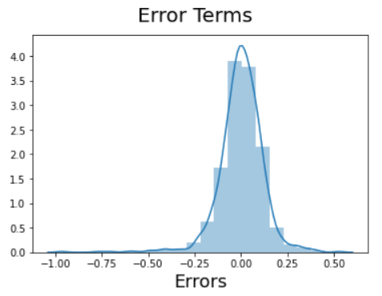

1. There is no multicollinearity between the independent variables.

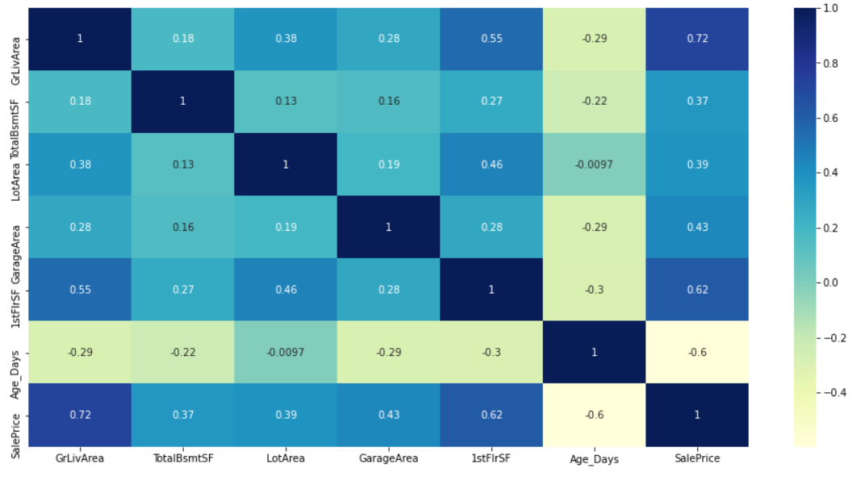

1. And from above heatmap, we can say the independent variables are linearly correlated with target variable.