**DURGADEVI K**

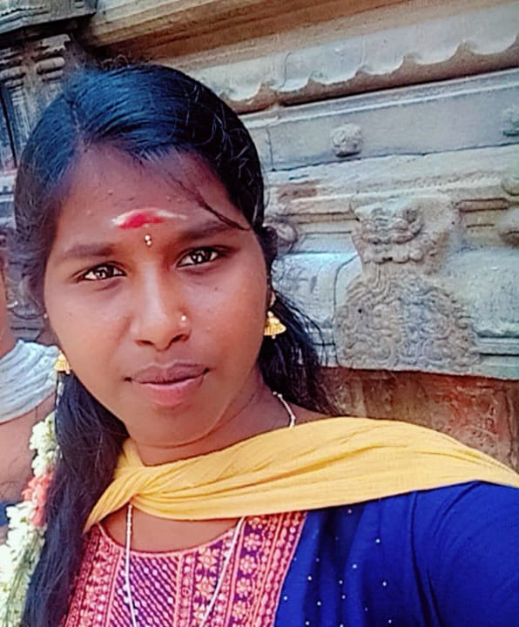

D/o.Karuppaiyan A 1/116/1, west street, pappa patti,

Kadampatti P, Karampakudi Tk, Pudukkottai Dt

PINCODE:622302

Phone:7695806409

Email:durga.k1809@gmail.com

**Objectives:**

* I seek challenging opportunities where I can fully use my skills for the success of the organization.

1. **Skill Sets:**
   * Computer proficiency.
   * Leadership experience.
   * Good communication skills.
   * English speaking.
   * Computer software knowledge.
   * Team player.
2. **Computer Skills:**
   * Programming language : JAVA, C, C++, Python
   * MS WORD
   * MS OFFICE
   * POWER POINT
3. **Education Qualification:**

|  |  |  |  |
| --- | --- | --- | --- |
| Name of Exam | Name of Board | Passing year | Percentage (%) |
| 10th | SSLC | 2020-2021 | ALL PASS |
| 12th | HSC | 2022-2023 | 78% |
| BCA(Bachelor of Computer Applications) | Bharathidhasan  University | 2023-2026 | 75% |

**Personal details:**

Date of Birth : 18.09.2005

Nationality : Inadia

Marital status : Single

Religion : Hindu

Gender : Female

Place : Tamilnadu