NAME : K.SREE DURGA GEETHIKA

REG NO :192111472

COURSE :COMPUTER ARCHITECTURE

CODE :CSA1288

FACULTY :DR.MARY VALANTINA.G

DATE :08/10/22

Write an assembly language program to find 1’s complement of 8 bit number.

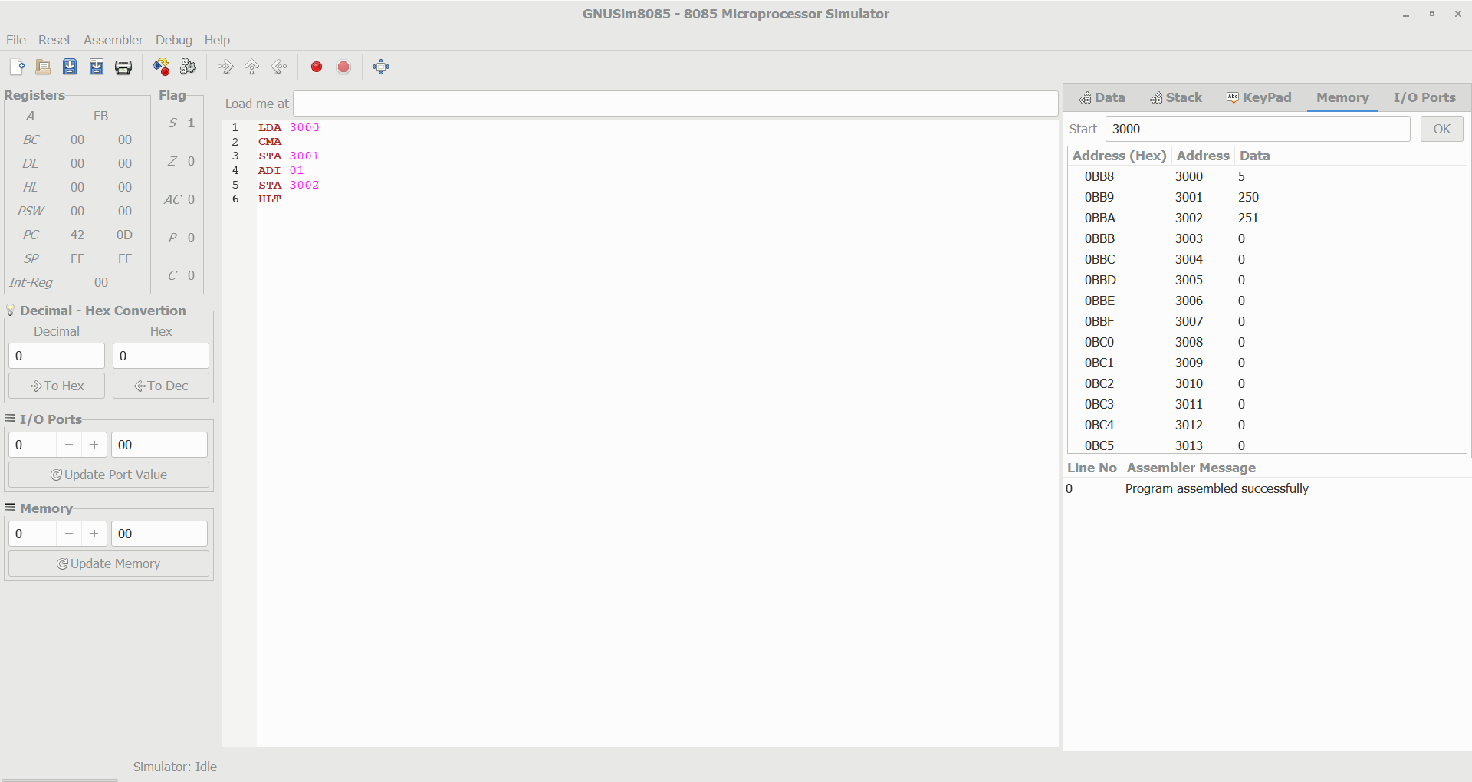

Write an assembly language program to find 2’s complement of 8 bit number.



Write an assembly language program to find the Greatest of 2 numbers.

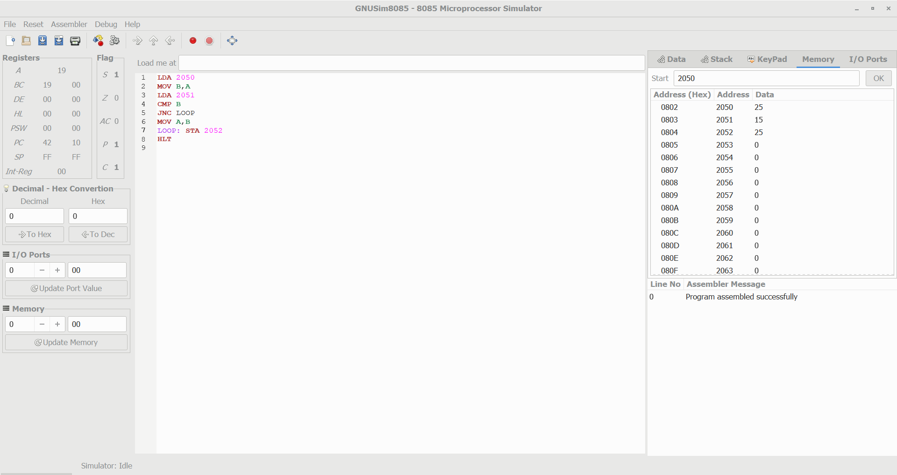

Write an assembly language program to find the Smallest of 2 numbers.

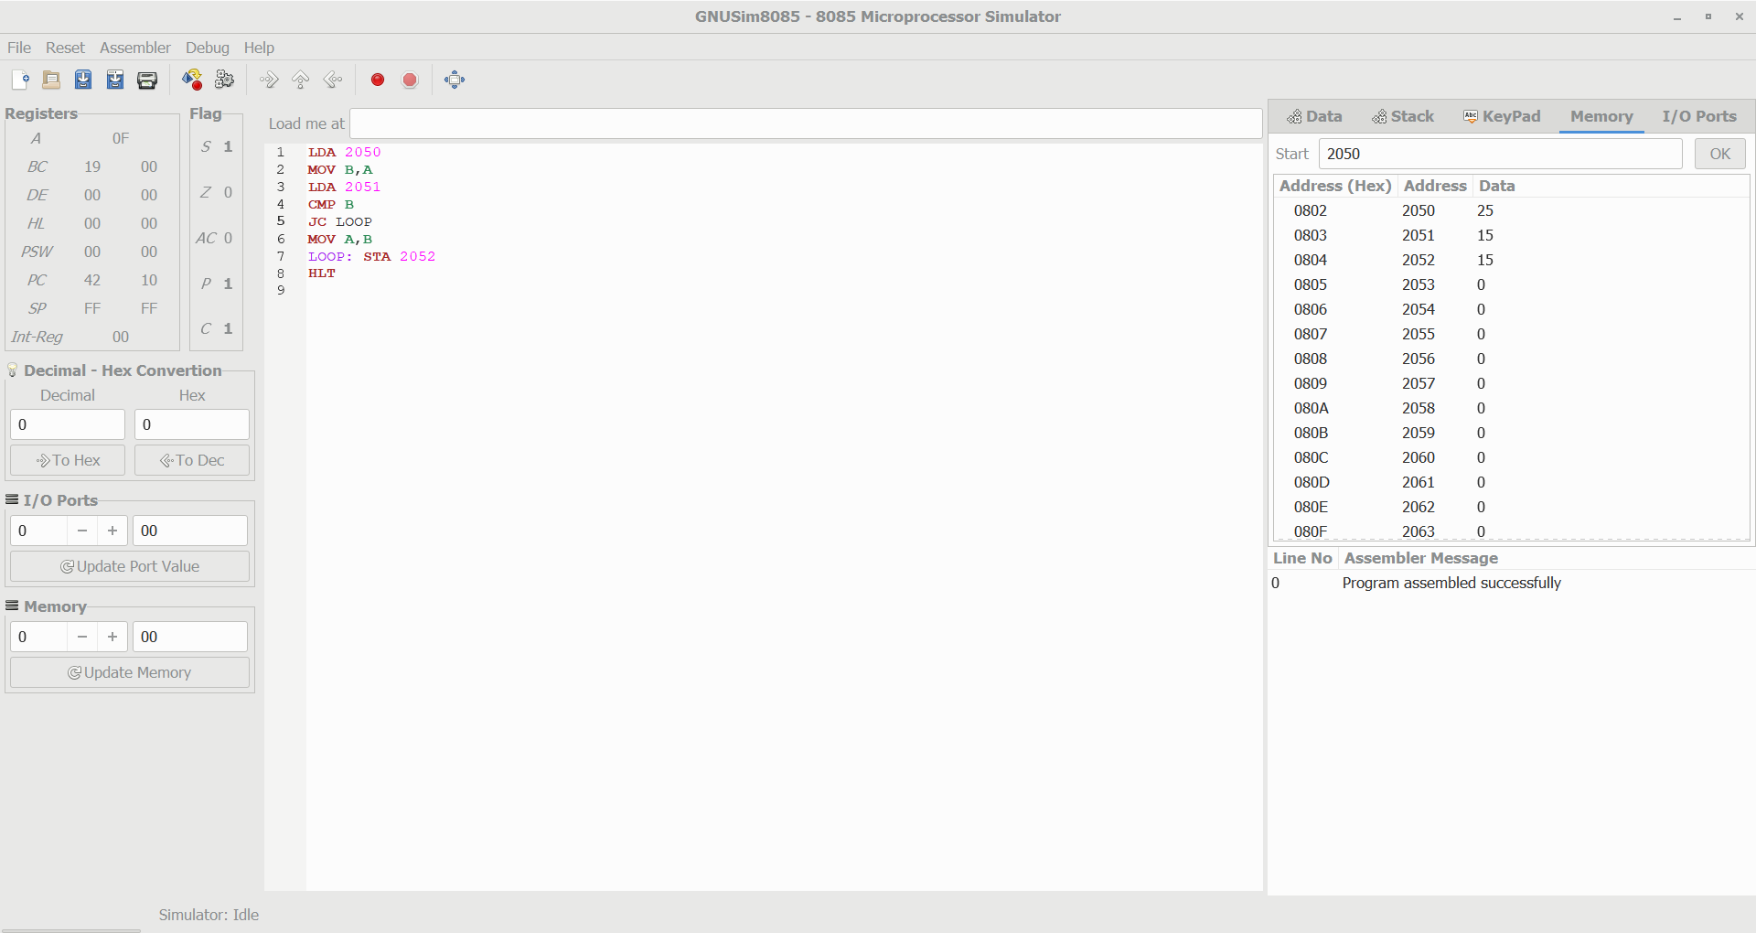

Write an assembly language program to find the LCM of 2 numbers.

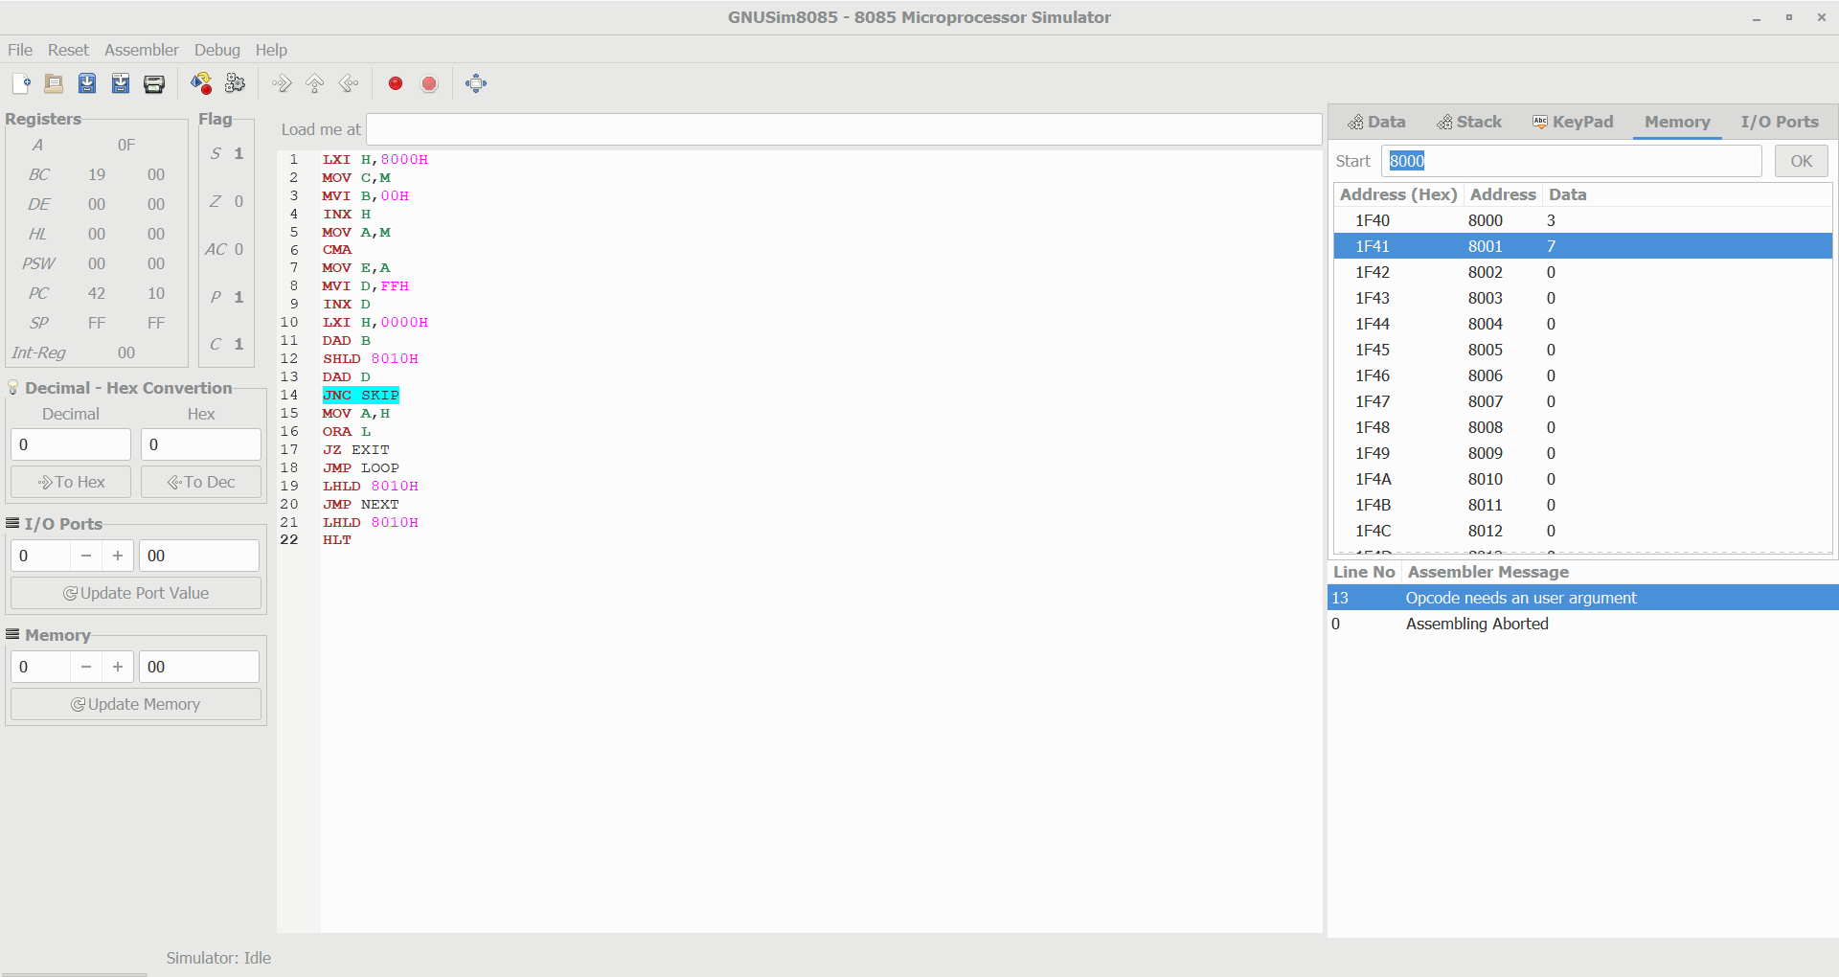

Write an assembly language program to find the GCD of 2 numbers.

