DSA0179-OBJECT ORIENTED PROGRAMMING WITH C++

PROGRAMS

K.Sree Durga Geethika

192111472,CSE.

1. Write a program to read in two integers and perform  
   the following operations on them: addition, subtraction, multiplication,  
   division, and modulo.

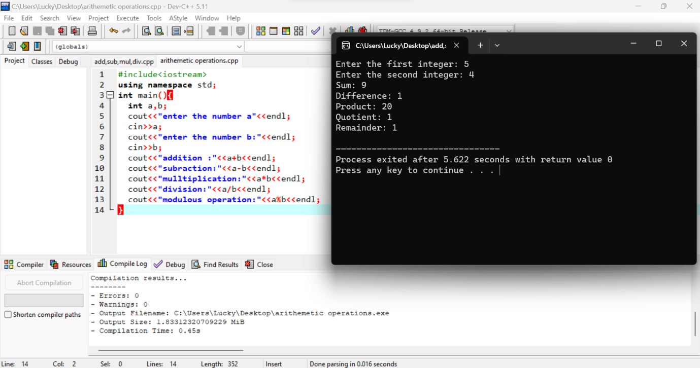

1. Program to determine the integer is odd or even

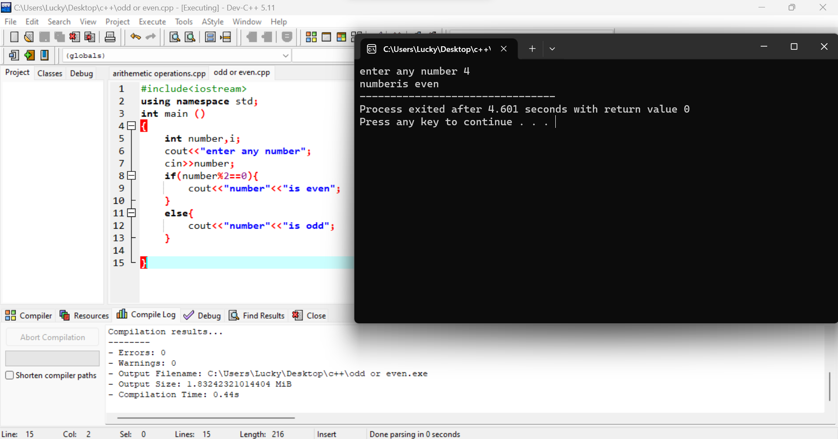

1. Program to compute the average of three integers

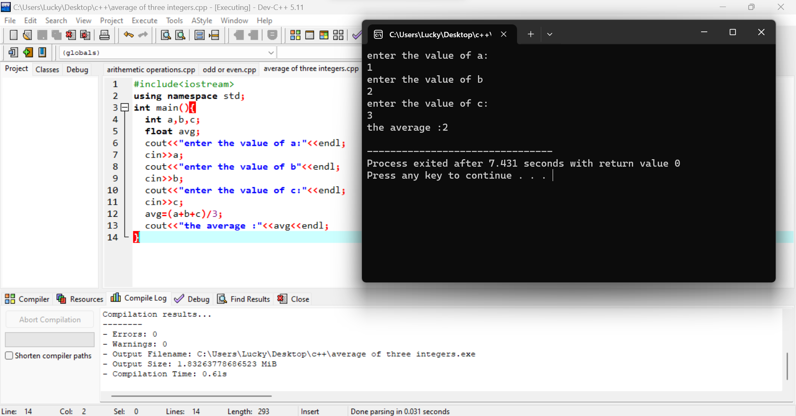

1. Program to check two numbers are equal or not

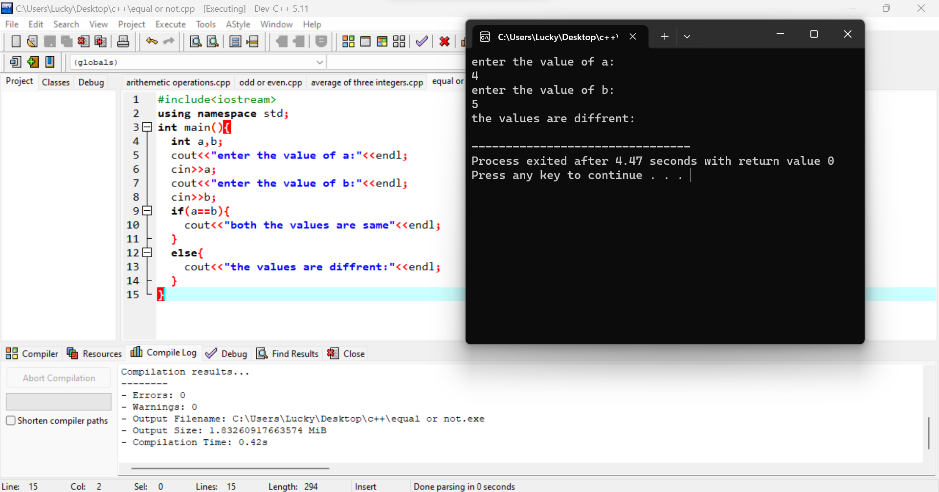

1. Write a program to read in two Floating numbers and  
   perform the following operations on them: addition, subtraction,  
   multiplication, division, and modulo.

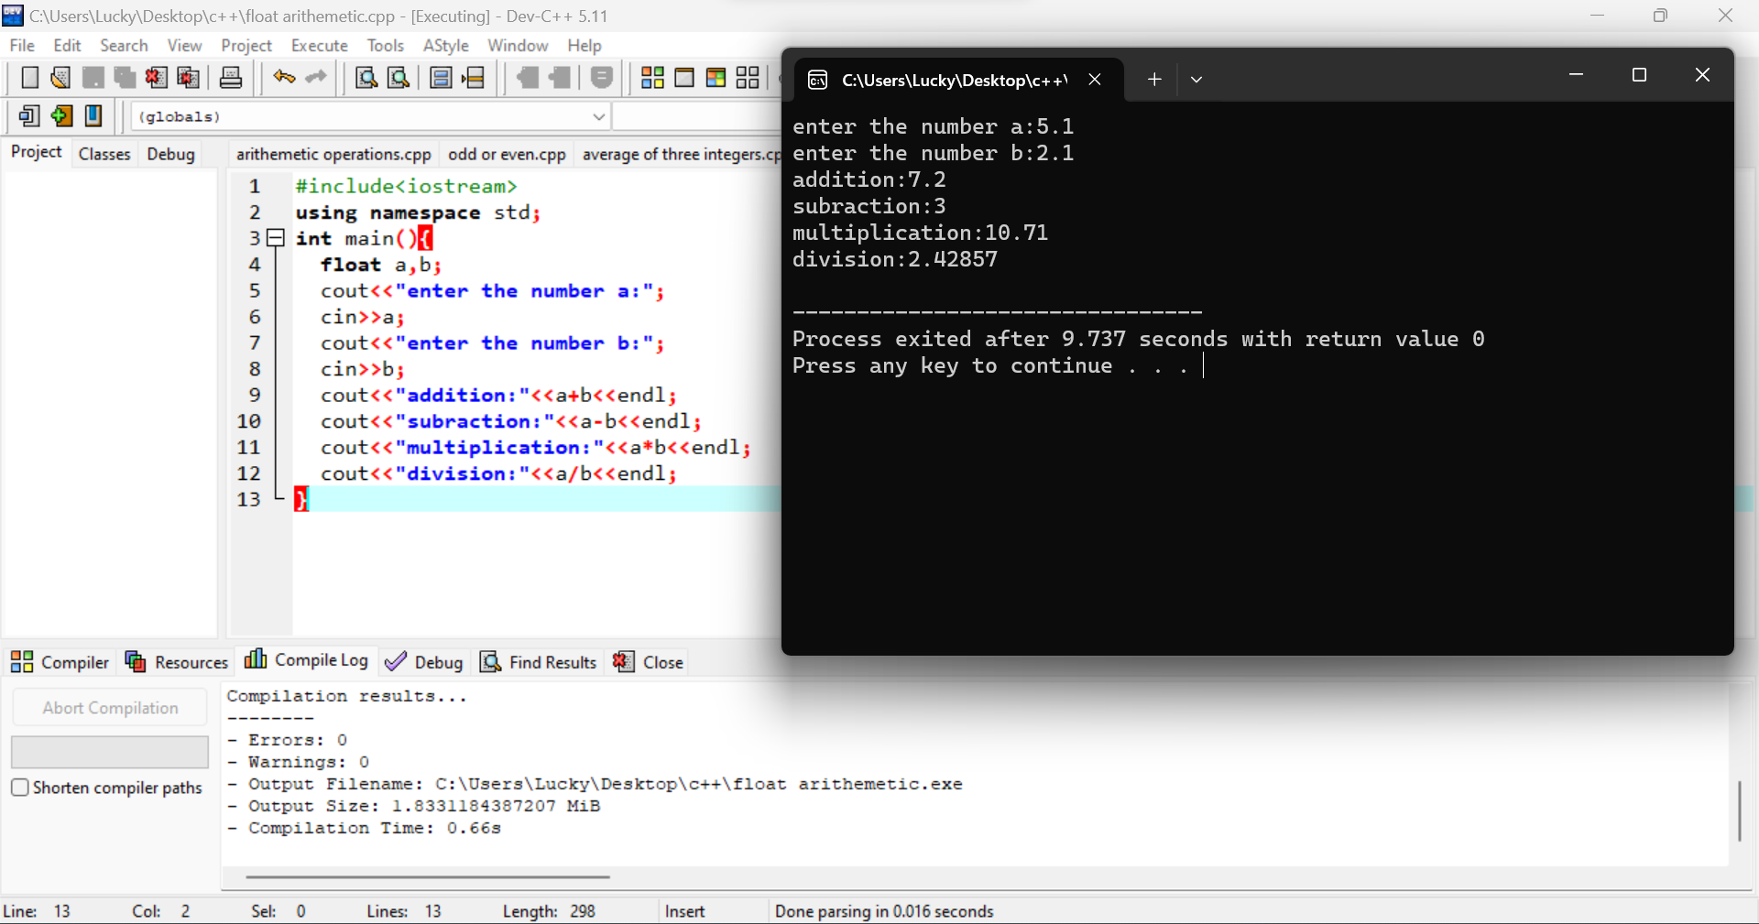

1. Program to check the character is a vowel or consonant

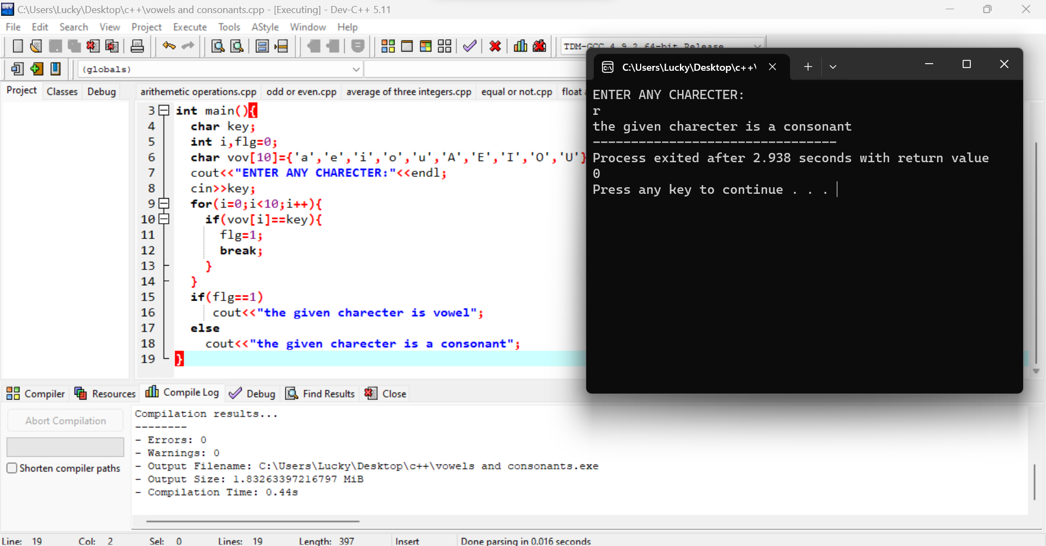

1. Program to check the number is positive, negative or  
   zero

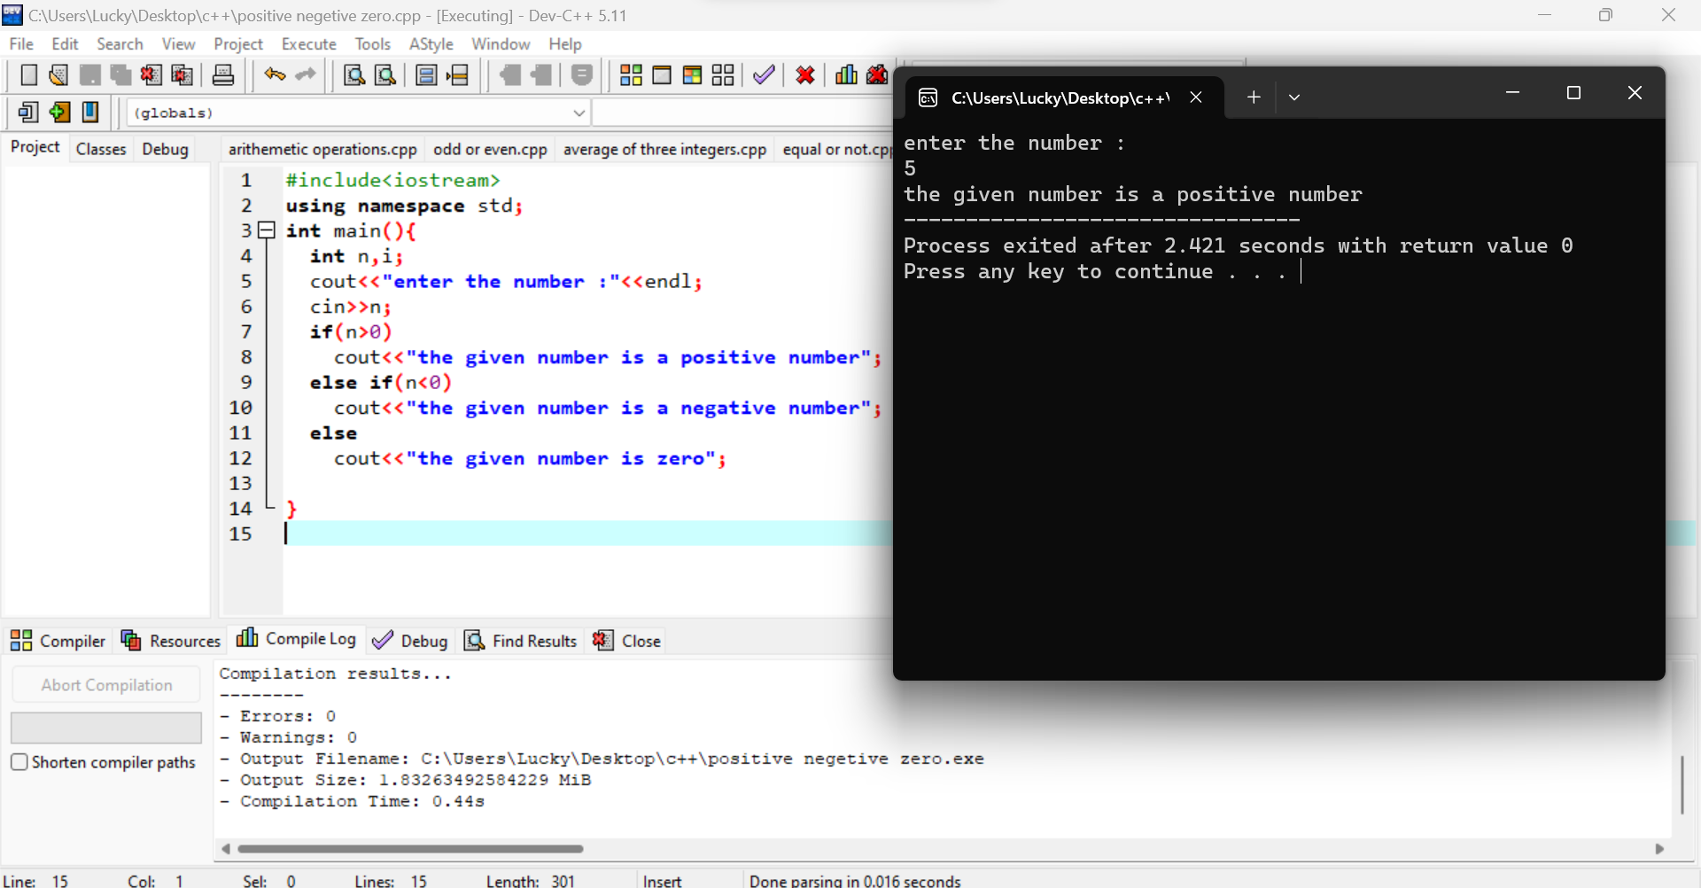

1. Program to determine which number is greater among two  
   integers

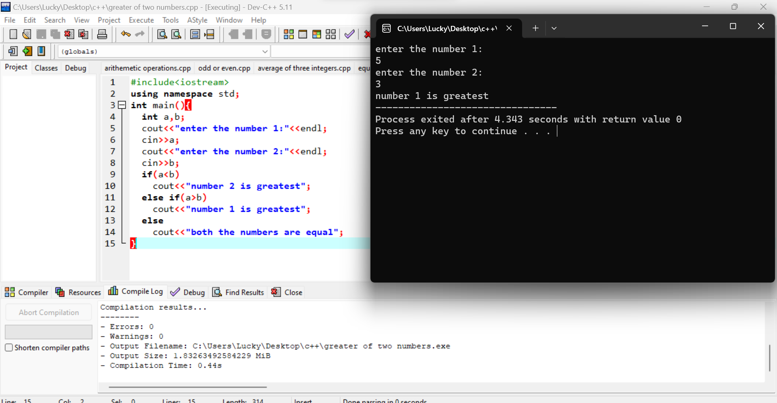

1. Program to read a floating-number and round it to the  
   nearest integer using the floor an ceil functions.

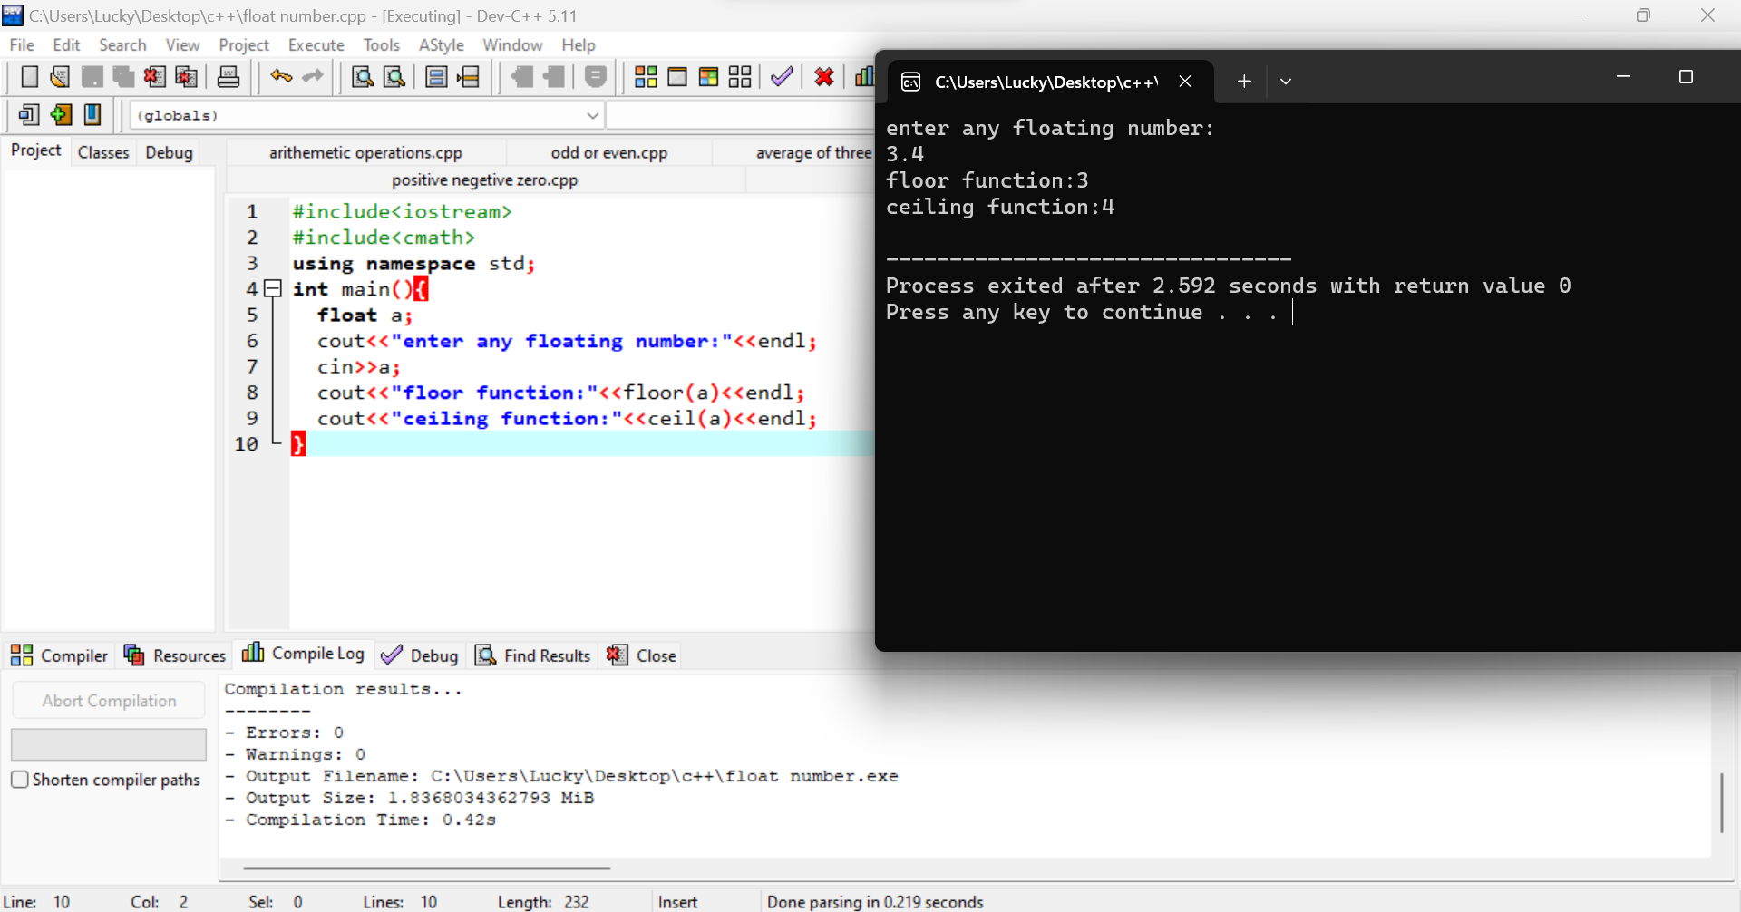

1. Program to swap two numbers using bitwise XOR operator

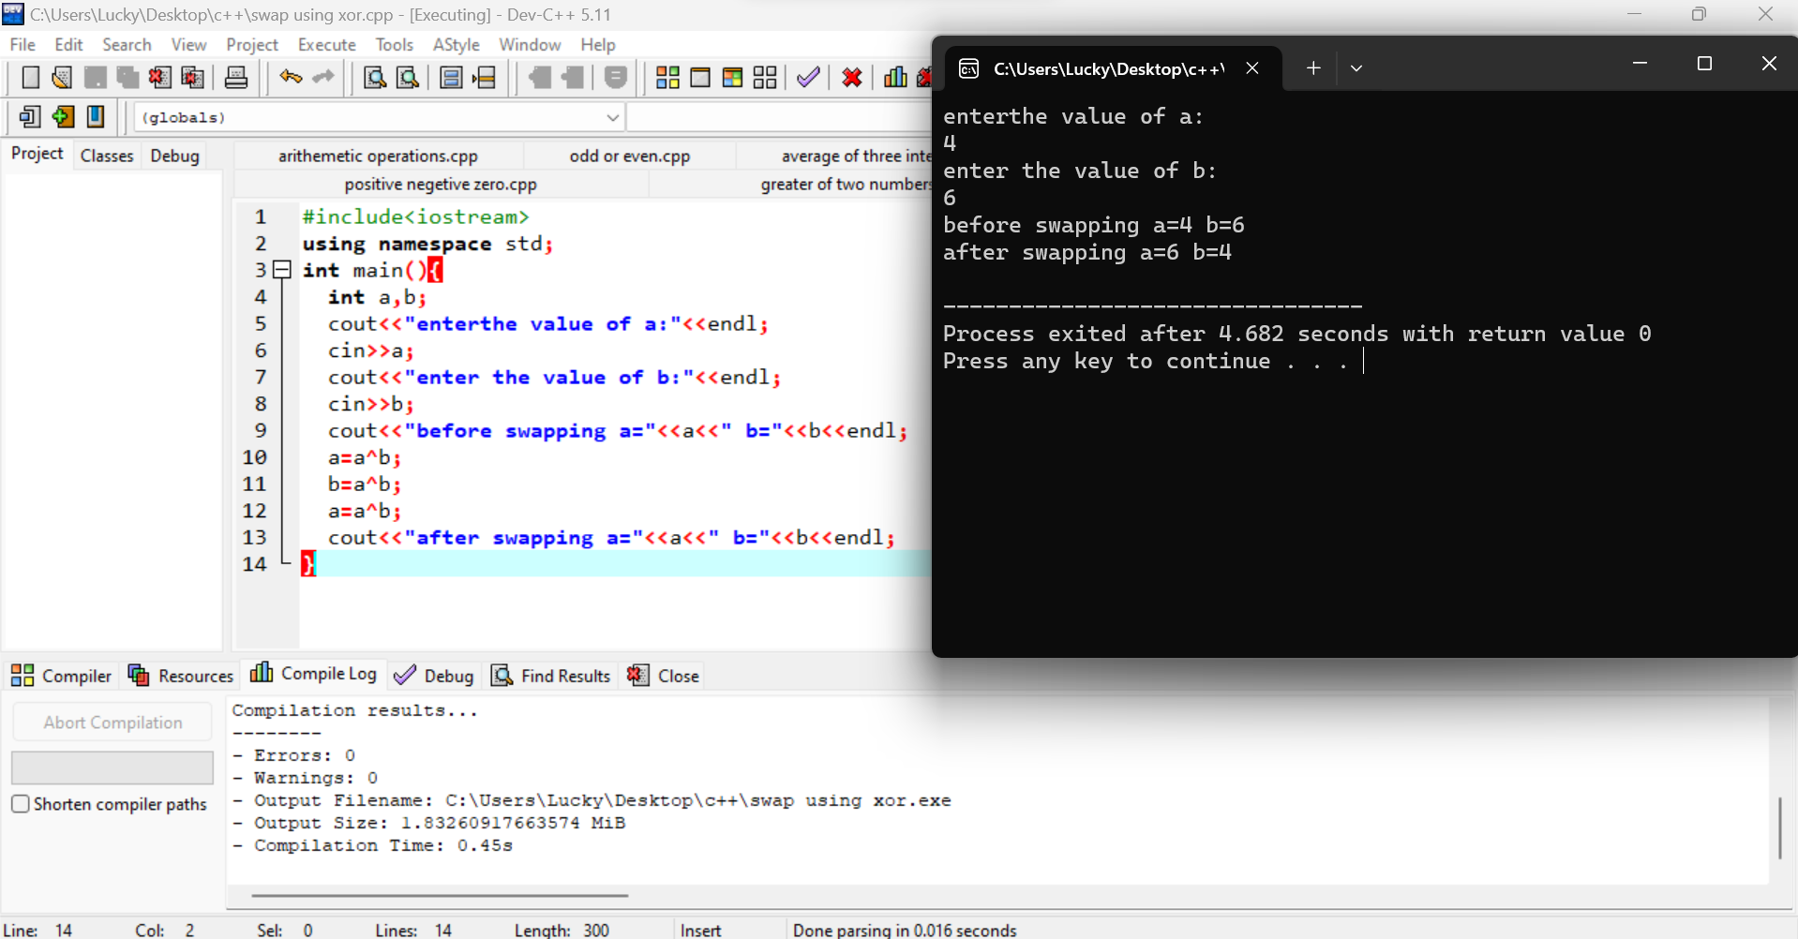

1. Largest among three numbers using ternary conditional operator

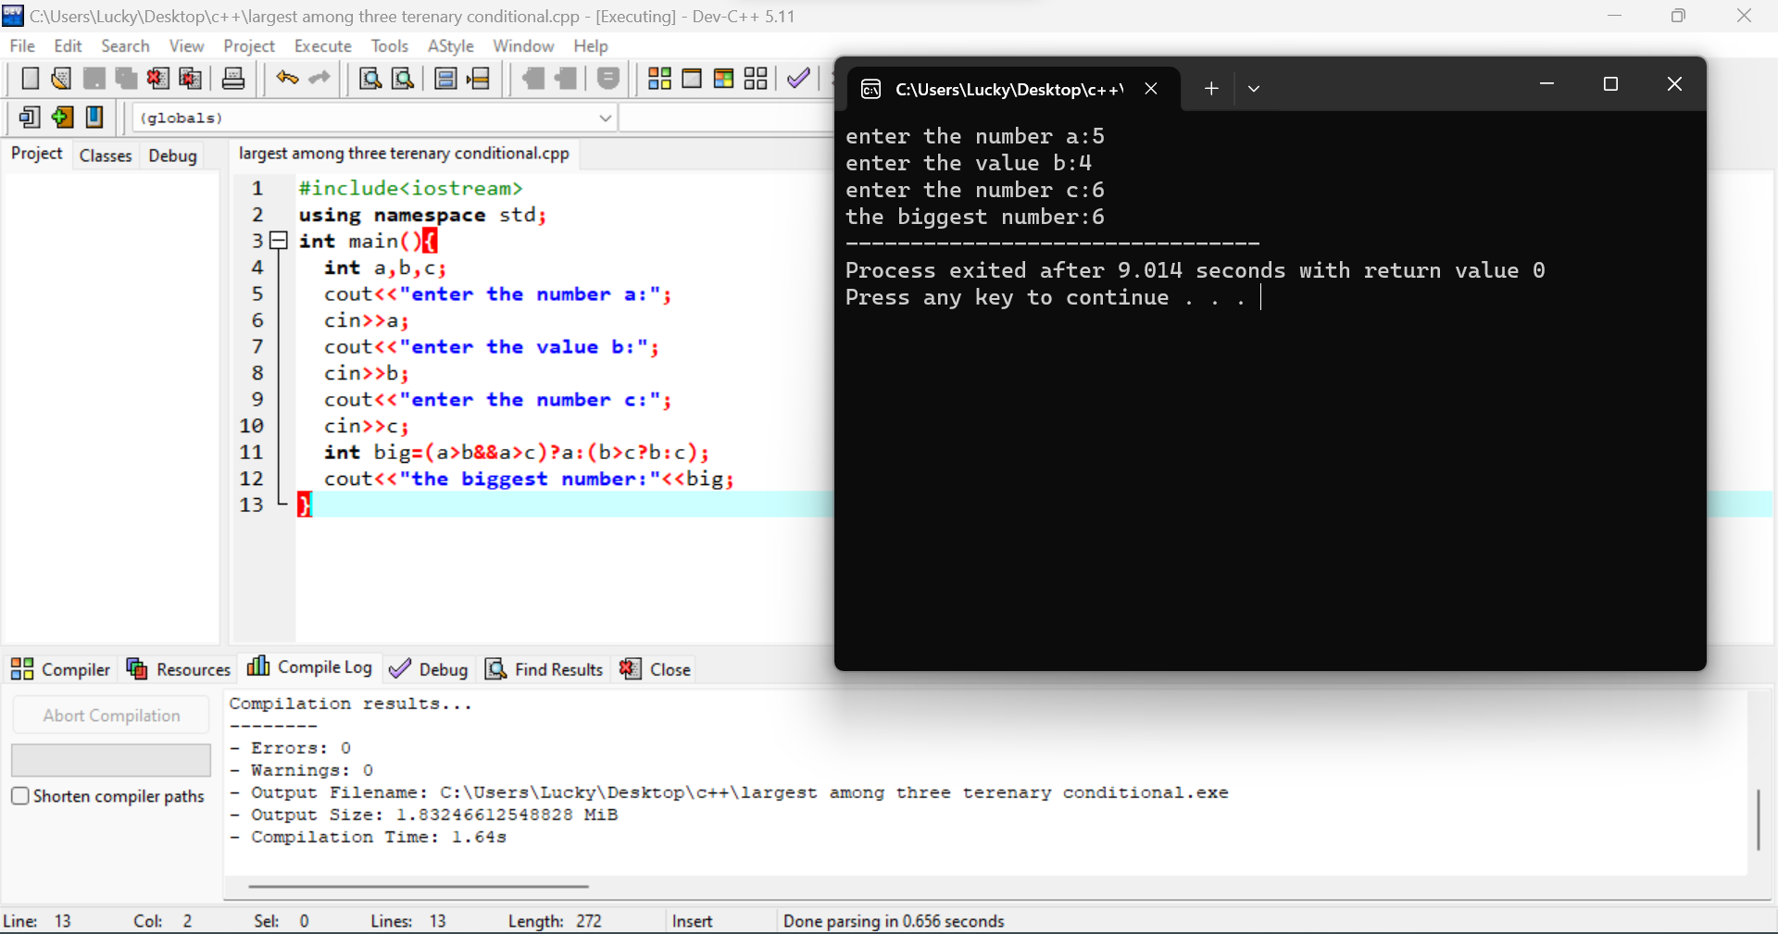

1. Program to check the integer is divisible by 3 or not using ternary conditional operator

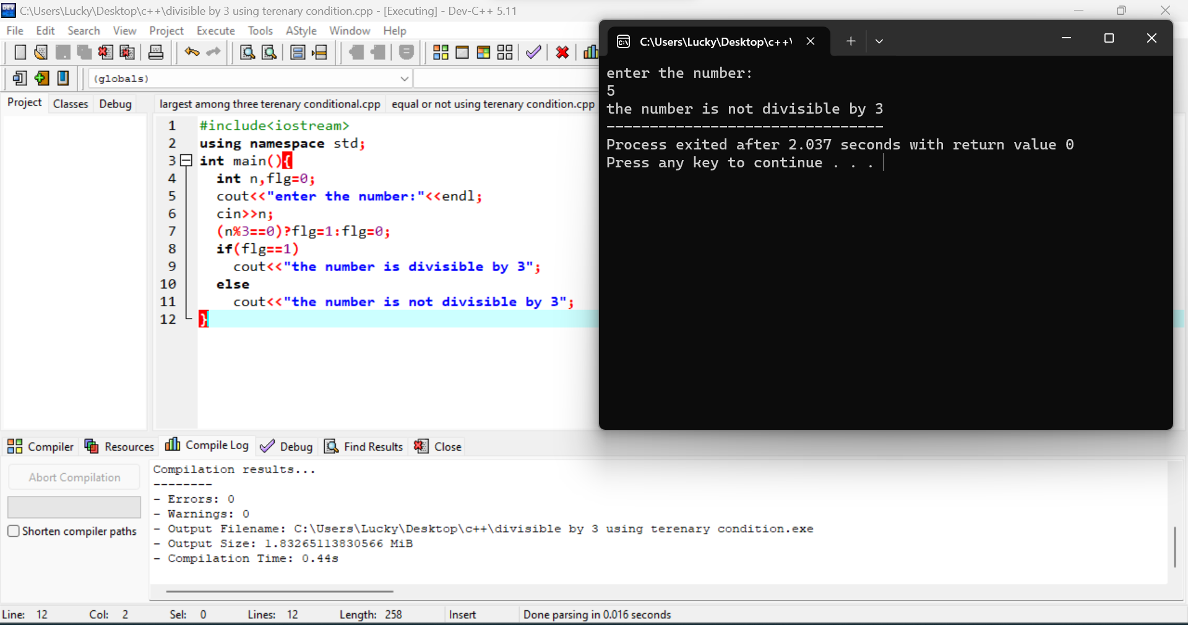

1. Program to print numbers from 1 to 10 using for loop

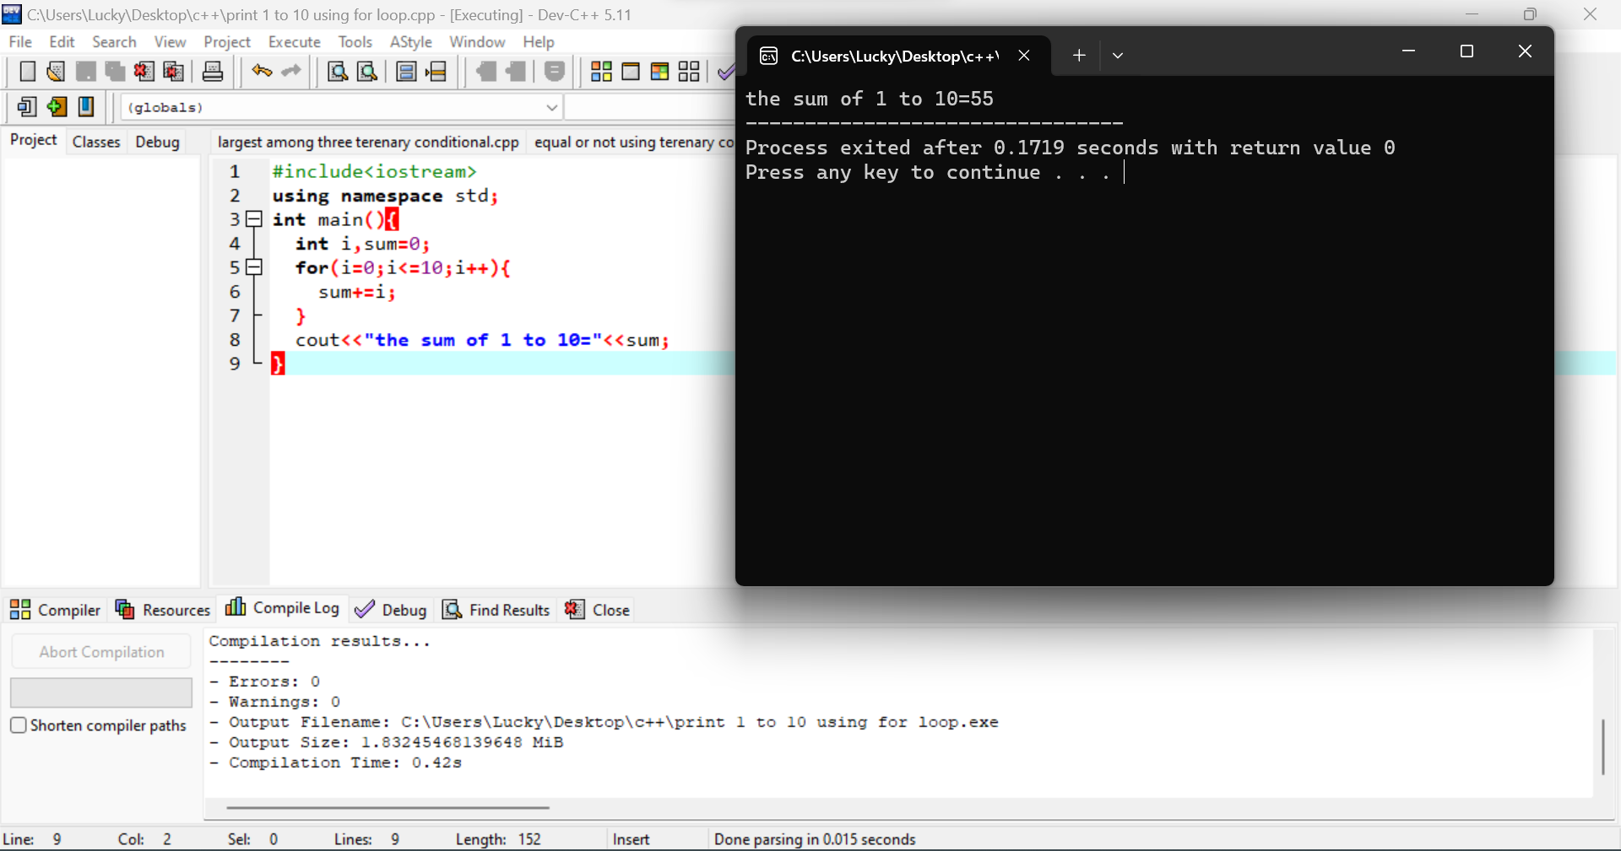

1. Factorial of a number using for loop

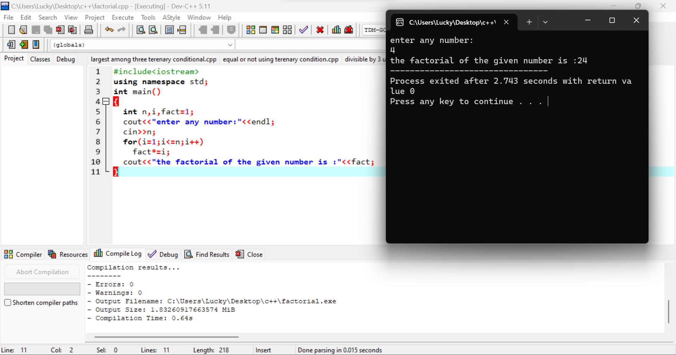

1. Program to check two numbers are equal or not using ternary conditional operator

