**Assignment -1**

Question 2:

* **Visualization 1: Scatter plot**

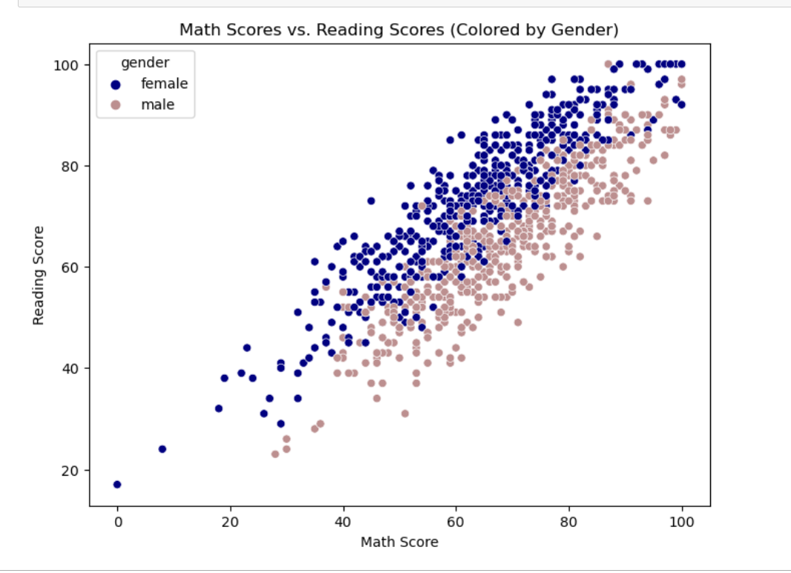

Analysis becomes easier with this visualization to Find Patterns and Connections and Grade comparision. When attempting to see patterns or correlations between two continuous data, scatter plots work very well. In this instance, we can rapidly determine whether there is any association between these two academic metrics by displaying math results against reading scores. For example, we can watch to see if students who do well in math also typically do well in reading, and vice versa.

The scatter plot makes it simple to compare the academic performance of male and female students in math and reading by color-coding the data points according to gender. We can determine whether the distribution or clustering of data points varies noticeably between genders. Understanding potential gender-based differences in academic achievement can be benefited by this.

**2. Bar Chart**

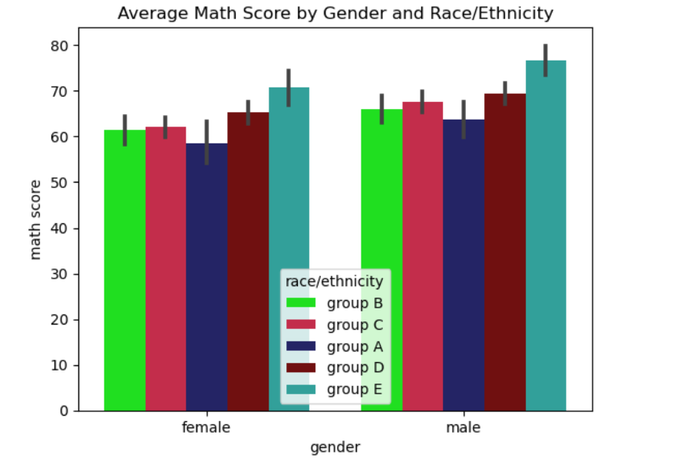

With the bar graph, clear comparison of average math scores between gender and racial/ethnic groupings made it easier to understand. We can rapidly determine which groups have higher or lower average math scores by comparing the heights of the bars visually. This makes it simple to comprehend how various demographic groups perform relative to one another in mathematics. The use of different colors for each race/ethnicity group enables easy identification of potential disparities in math scores among different racial or ethnic groups. Any significant gaps in average scores between groups can be quickly identified. By comparing the color-coded bars within each group, we can assess if there are any gender differences in math performance within specific racial or ethnic categories. This can provide insights into whether certain groups exhibit gender disparities in math achievement.

**3. Box plot**

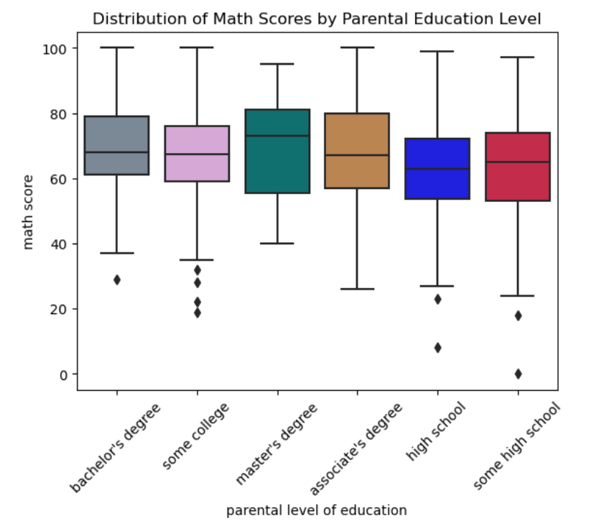

Box plots offer a clear and simple description of the distribution of a continuous variable—math scores in this case—across various parental education levels. Important statistical parameters, like the median, quartiles, and possible outliers within each parental education category, can be immediately understood by examining the box plot. The central line within each box represents the median math score for the corresponding level of parental education. Comparing these median values across different education levels allows for a straightforward assessment of central tendency. Additionally, the length of the box and whiskers provide insights into the spread or variability of math scores within each group.

**4. Stacked Bar Chart**

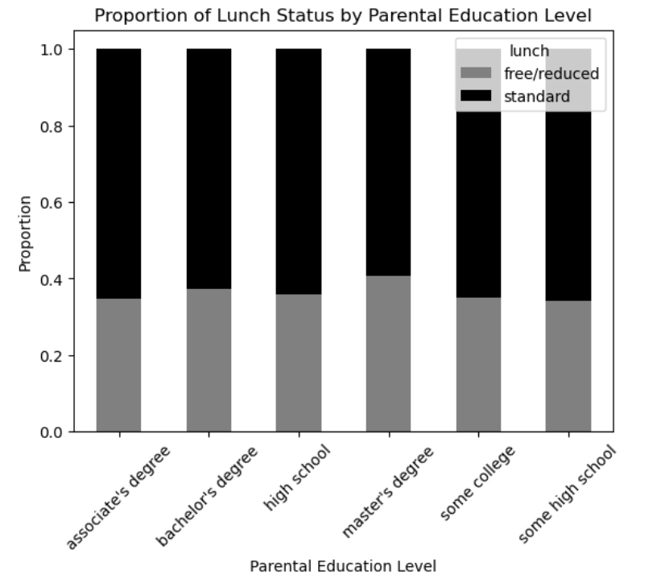

A clear comparison of proportions between various categories can be made with stacked bar charts. Here, the graphic shows the percentage of students in each parental education category who receive a standard lunch compared to a free or reduced meal. The height of each stacked bar makes it easy to see how much of each lunch status falls within each educational group.The distribution of lunch status across different parental education levels can be seen by examining the stacked bar chart. It facilitates understanding of how various educational categories differ in the percentage of kids receiving free or reduced lunch compared to those receiving normal meal. Lunch status distribution can be observed by looking at the stacked bar pattern for each degree of parental education. This allows one to see any recurring trends or patterns. For example, the chart may reveal whether certain levels of parental education are associated with a higher likelihood of students receiving free/reduced lunch.

**5. Line Plot**

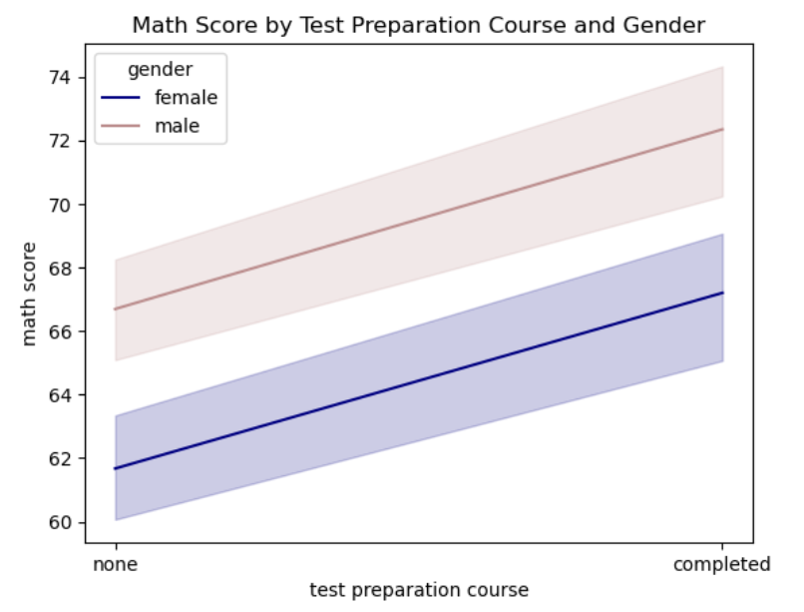

The line plot is useful for evaluating how taking a test preparation course affects math scores. Analysts can assess if there is a discernible difference in performance linked to course completion by comparing the average math scores of students who finished the course and those who did not. Line plots are excellent for visualizing trends over a continuous variable—here, math scores across different categories of test preparation course completion. By examining the lines' trajectory, one can quickly discern any patterns or trends in math scores concerning whether students completed a test preparation course. By plotting separate lines for each gender, the visualization facilitates a direct comparison of how the relationship between math scores and test preparation course completion differs between male and female students. Comparing the slopes, direction, and patterns of the lines can reveal any gender-specific trends or disparities in the effectiveness of test preparation courses.