# &9«

To

# S/ Enrolment No.: 2081/30121/26001

ఏరg å£eనంద åð

Yerva Vivekananda Kumar S/O: Narsimulu,

2-1,

morangapally, mominpet,

VTC: Morangpalle, PO: Morangpalli,

Sub District: Mominpet, District: K.v. Rangareddy, State: Telangana,

PIN Code: 501202,

Mobile: 9701814550

Signature Not Verified

Digitally signed by DS Unique Identification Authority of India 05

Date: 2024.12.03 00:17:03 GMT+05:30

9714 4969 4624

## VID : 9180 7401 9238 8094

ఏరg å£eనంద åð

Yerva Vivekananda Kumar

å న &/DOB: 31/08/2004

£@ / MALE

e£På:

S/O: న&3£ , 2-1, ðరంగపå$, %åSâd, ðరంKప@$, ðరంKపå$, €.å. రం➢дå0, 1లం➢ణ - 501202

**Details as on: 03/12/2024**

Address:

S/O: Narsimulu, 2-1, morangapally, mominpet, Morangpalle, PO: Morangpalli, DIST: K.v. Rangareddy,

Telangana - 501202

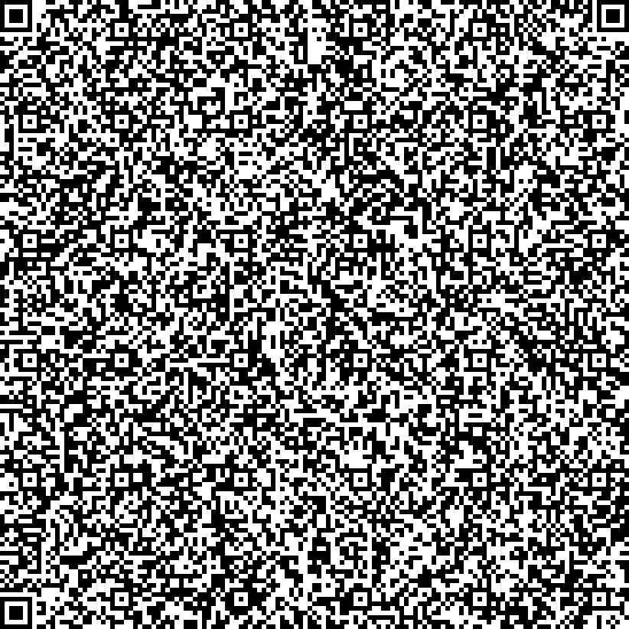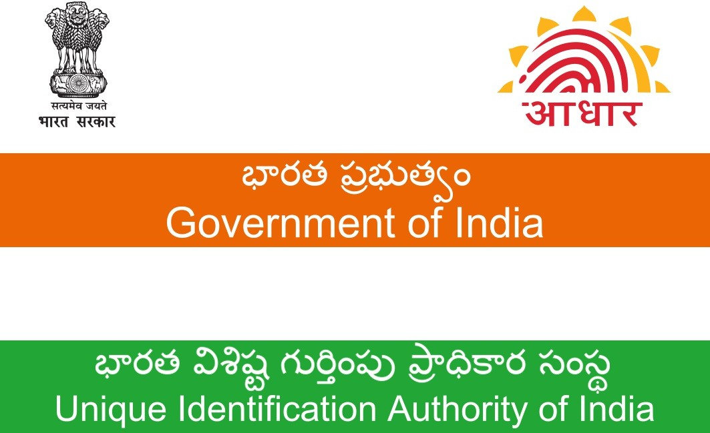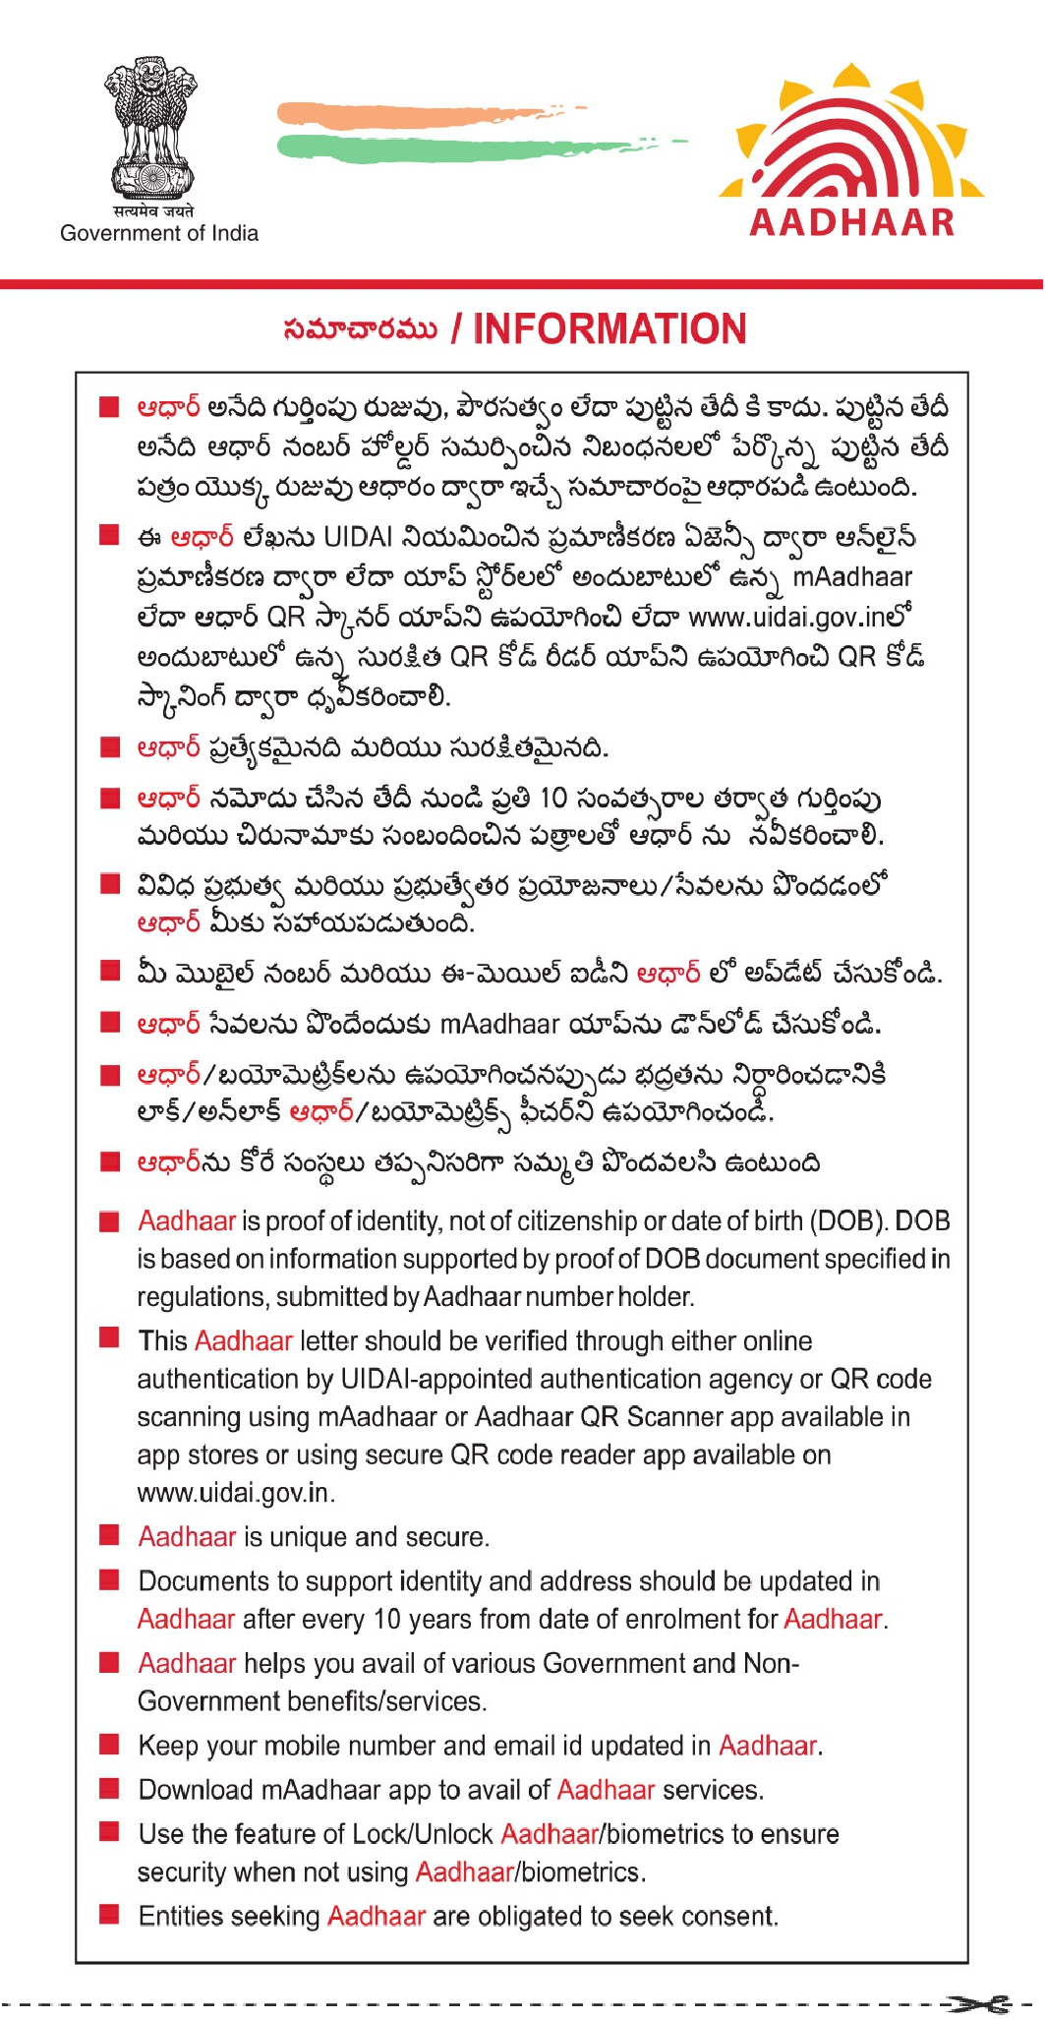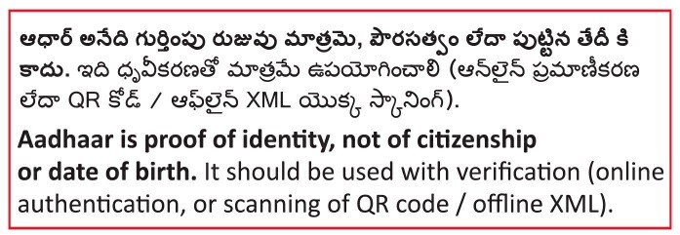

**Aadhaar no. issued: 20/01/2014**

**9714 4969 4624**

**9714 4969 4624**

## VID : 9180 7401 9238 8094