**Exercise 1: Control Structures**

**Scenario 1:** The bank wants to apply a discount to loan interest rates for customers above 60 years old.

* + **Question:** Write a PL/SQL block that loops through all customers, checks their age, and if they are above 60, apply a 1% discount to their current loan interest rates.

**Create Sample tables:**

CREATE TABLE customers (

customer_id NUMBER PRIMARY KEY,

customer_name VARCHAR2(50),

age NUMBER

);

CREATE TABLE loans (

loan_id NUMBER PRIMARY KEY,

customer_id NUMBER REFERENCES customers(customer_id),

interest_rate NUMBER

);

**Insert sample values:**

INSERT INTO customers VALUES (1, 'Ravi', 65);

INSERT INTO customers VALUES (2, 'Anu', 45);

INSERT INTO loans VALUES (101, 1, 7.5);

INSERT INTO loans VALUES (102, 2, 8.0);

COMMIT;

**PL/SQL Control Structure**

BEGIN

FOR customer_rec IN (

SELECT l.loan_id, l.interest_rate

FROM customers c

JOIN loans l ON c.customer_id = l.customer_id

WHERE c.age > 60

)

LOOP

UPDATE loans

SET interest_rate = customer_rec.interest_rate - 1

WHERE loan_id = customer_rec.loan_id;

END LOOP;

COMMIT;

END;

/

**Output:**

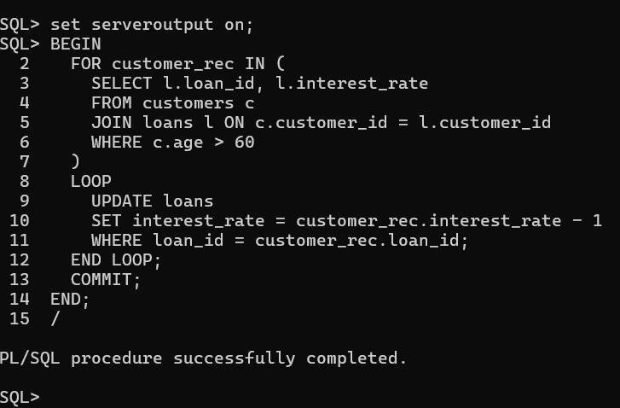

**Scenario 2:** A customer can be promoted to VIP status based on their balance.

* + **Question:** Write a PL/SQL block that iterates through all customers and sets a flag IsVIP to TRUE for those with a balance over $10,000.

**Alter the above table:**

ALTER TABLE customers ADD (balance NUMBER);

ALTER TABLE customers ADD (isVIP VARCHAR2(5));

**Update the Content:**

UPDATE customers SET balance = 8000 WHERE customer_id = 1;

UPDATE customers SET balance = 15000 WHERE customer_id = 2;

UPDATE customers SET balance = 12000 WHERE customer_id = 3;

UPDATE customers SET isVIP = 'FALSE';

**PL/SQL Structure**

BEGIN

FOR cust IN (SELECT customer_id, balance FROM customers)

LOOP

IF cust.balance > 10000 THEN

UPDATE customers

SET isVIP = 'TRUE'

WHERE customer_id = cust.customer_id;

END IF;

END LOOP;

COMMIT;

END;

/

**Output:**

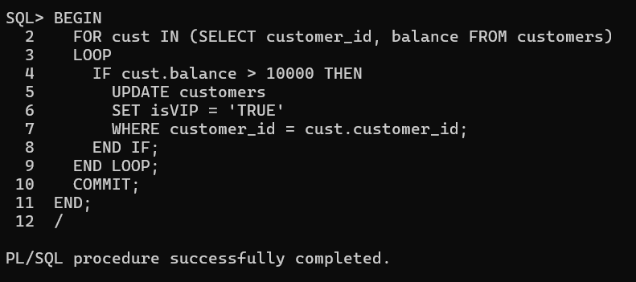

**Scenario 3:** The bank wants to send reminders to customers whose loans are due within the next 30 days.

* + **Question:** Write a PL/SQL block that fetches all loans due in the next 30 days and prints a reminder message for each customer.

**Alter and update the tables:**

ALTER TABLE loans ADD (due_date DATE);

UPDATE loans SET due_date = SYSDATE + 10 WHERE loan_id = 101;

UPDATE loans SET due_date = SYSDATE + 40 WHERE loan_id = 102;

UPDATE loans SET due_date = SYSDATE + 25 WHERE loan_id = 103;

**PL/SQL Structure:**

BEGIN

FOR loan_rec IN (

SELECT c.customer_name, l.due_date

FROM loans l

JOIN customers c ON l.customer_id = c.customer_id

WHERE l.due_date BETWEEN SYSDATE AND SYSDATE + 30

)

LOOP

DBMS_OUTPUT.PUT_LINE('Reminder: Loan for customer ' || loan_rec.customer_name ||

' is due on ' || TO_CHAR(loan_rec.due_date, 'DD-MON-YYYY'));

END LOOP;

END;

/

**Output:**

