**Exercise 3: Stored Procedures**

**Scenario 1:** The bank needs to process monthly interest for all savings accounts.

* + **Question:** Write a stored procedure ProcessMonthlyInterest that calculates and updates the balance of all savings accounts by applying an interest rate of 1% to the current balance.

create table accounts (

account_id number primary key,

balance number,

account_type varchar2(20)

);

insert into accounts values (1, 10000, 'savings');

insert into accounts values (2, 20000, 'current');

insert into accounts values (3, 15000, 'savings');

create or replace procedure processmonthlyinterest is

begin

for acc in (

select account_id, balance

from accounts

where account_type = 'savings'

) loop

update accounts

set balance = acc.balance + (acc.balance * 0.01)

where account_id = acc.account_id;

end loop;

commit;

end;

/

EXEC ProcessMonthlyInterest;

**Output:**

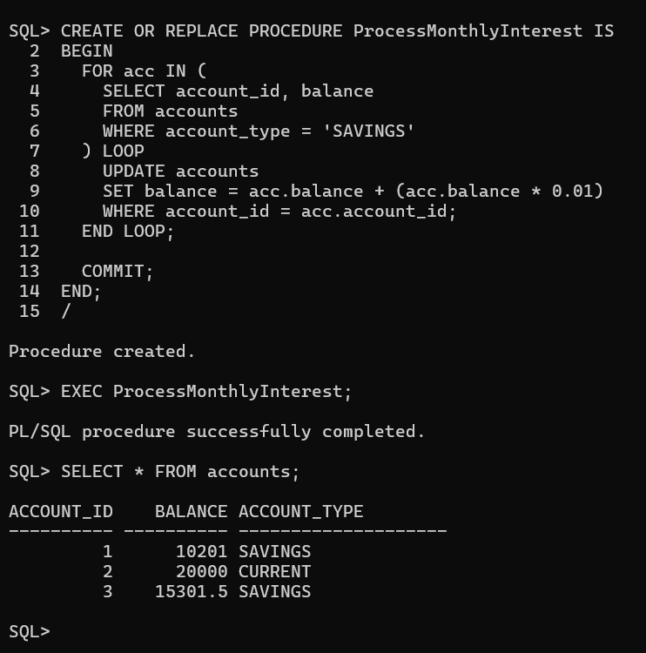

**Scenario 2:** The bank wants to implement a bonus scheme for employees based on their performance.

* + **Question:** Write a stored procedure **UpdateEmployeeBonus** that updates the salary of employees in a given department by adding a bonus percentage passed as a parameter.

create table employees (

employee_id number,

department_id number,

salary number

); insert into employees values (1, 101, 50000);

insert into employees values (2, 102, 60000);

insert into employees values (3, 101, 55000);

commit; create or replace procedure updateemployeebonus (

p_dept_id in number,

p_bonus_percent in number

) is

begin

update employees

set salary = salary + (salary * p_bonus_percent / 100)

where department_id = p_dept_id;

commit;

end;

/

exec updateemployeebonus(101, 10);

**Output:**

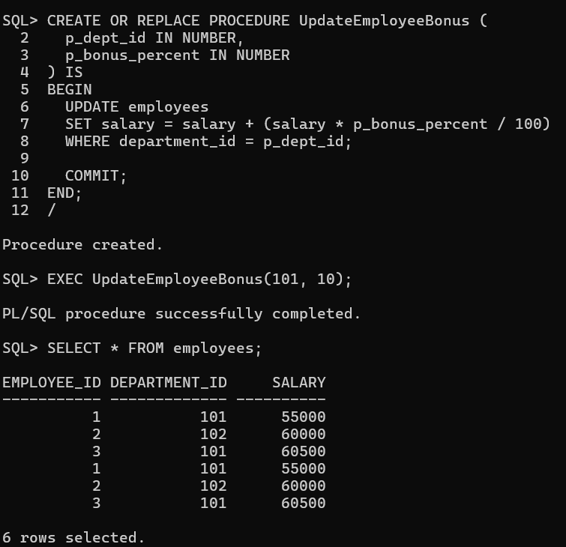

**Scenario 3:** Customers should be able to transfer funds between their accounts.

**o Question:** Write a stored procedure TransferFunds that transfers a specified amount from one account to another, checking that the source account has sufficient balance before making the transfer.

CREATE OR REPLACE PROCEDURE TransferFunds (

p_from_account IN NUMBER,

p_to_account IN NUMBER,

p_amount IN NUMBER

) IS

v_balance NUMBER;

BEGIN

SELECT balance INTO v_balance

FROM accounts

WHERE account_id = p_from_account

FOR UPDATE;

IF v_balance < p_amount THEN

RAISE_APPLICATION_ERROR(-20001, 'Insufficient balance in source account.');

END IF;

UPDATE accounts

SET balance = balance - p_amount

WHERE account_id = p_from_account;

UPDATE accounts

SET balance = balance + p_amount

WHERE account_id = p_to_account;

COMMIT;

END;

/

