Connecting mechanosensitive channel copy number to probability of survival under osmotic shock in *E. coli.*

Heun Jin Leea, Griffin Chureb, and Rob Phillipsa, b, c, *

Departments of Applied Physicsa, Biochemistry and Molecular Biophysicsb, and Division of Biology and Biological Engineeringc, California Institute of Technology, Pasadena, California, USA

* Send correspondence to phillips@pboc.caltech.edu

**Abstract**

All cells have devised clever ways of tolerating a rapid change in extracellular osmolarity, and are typically mediated through tension-sensitive ion channels known as mechanosensitive channels. *Escherichia coli* expresses seven different types of these channels, the most abundant and important of which being the mechanosensitive channel of large conductance, MscL. While this channel has been heavily characterized through structural methods, electrophysiology, and theoretical models, our understanding of its physiological role in preventing cell death through osmotic shock remains tenuous. In this work, we examine and connect the absolute channel copy number of MscL in single cells to their probability of survival under a large hypo-osmotic shock. While theoretical models and electrophysiological studies suggest a small number of channels is needed to survive, we find that a large number of channels is needed to fully protect against cell death, with approximately 500 channels conveying upwards of 90% survival. This number agrees with the average copy number of this protein in certain stages of growth of *E. coli*, and prompts the important question of regulation of channel activity.

**Importance**

**Introduction**

Rapid change in osmolarity is a potentially fatal insult that cells often face, leaving them with no choice but to equalize the pressure across the cell membrane. Cells across all branches of the tree of live have evolved ways to combat such an insult, often involving mechanosensitive channels -- transmembrane proteins which open in response to increased membrane tension, allowing osmotic pressure to equalize and the cell to eventually recover. .

While both eukaryotic and prokaryotic cells have an array of mechanosensitive channels, those of *E. coli* have been the most well-characterized and have been extensively probed using electrophysiology and x-ray crystallography. *E. coli* has seven different mechanosensitive channels (MscL, MscK, MscS, MscM, YdbG, XX, XX) which respond to different stimuli. Perhaps the most important of these channels is the MechanoSensitive Channel of Large conductance, MscL. This channel responds to large changes in membrane tension (Insert estimates or measurements of this here -- both from theory and ephys). The copy number of MscL depends greatly on the available carbon source in the growth medium and the density of the culture, ranging from a few hundred to over a thousand, determined by quantitative Western blots and fluorescence microscopy (Cite Maja and HJ paper).

Connecting the dynamics and structural information known of mechanosensitive channels to the physiological responsibility of dictating survival or death remains enigmatic.

Assays for survival in response to an osmotic shock are often done in bulk by mixing a culture of cells with a hypo-tonic (upshock) or hypo-tonic (downshock) medium and performing serial dilutions onto agar plates followed by counting the colonies. While this has revealed many interesting features of the physiological consequences of osmotic shock, it provides no information on single-cell variability in response to the osmotic shock.

One particular quantity of interest that is lost in these bulk measurements is the copy number of the mechanosensitive channels. The average copy number of a population of cells has been measured through electrophysiology (citation for Ian Booth papers), quantitative Western blotting (Maja and HJ paper), epifluorescence microscopy (Maja and HJ paper), and super-resolution methods (Poolman paper). Remarkably, the values reported in these works vary greatly between methods, often disagreeing by an order of magnitude or more.

To understand the connection between the copy number of mechanosensitive channels and the

**Materials and Methods**

**Strains, media, and growth conditions.**

Expression of MscL was tuned through designed RBS modification based on the protein sequence (Salis RBS calculator). The primers used to make these RBS mutations are found in Table S1 in the supplementary information.

After the sequence was confirmed, the *mscL* gene with a mutated RBS was integrated into an *E. coli* MG1655 K12 (Check -- may be W310) genetic background in which all mechanosensitive channels (*mscS, mscK, mscM, mscL, ydbG,* ***BIO, other?)***were deleted. This ensured that only one type of mechanosensitive was expressed and the distribution of observed expression levels was not confounded by having the gene on a plasmid with variable copy number.

XXX HJ will insert biochemistry stuff here.

**Growth conditions**

Cells were grown overnight in LB-Miller (**25mM NaCl -- Check)** to saturation overnight at 37° C with aeration. This culture was then diluted 1:100 into XXX HJ needs to fill out specifics XXX

**Flow cell.** HJ will provide information.

**Imaging conditions.** HJ will provide information.

**Data analysis and image processing.**

**Calibration of channel number.**

Using previously known fluorescence calibration

Calculation of “per cell” measurement using a reference area.

**Logistic regression.**

Common problem in machine learning. Assume that there is a smooth, linear increase in the log-odds of survival with channel number.

The parameters were estimated through Markov Chain Monte Carlo using the Generalized Linear Models utility in the open-source software PyMC3.

**Data Curation and Availability**

All analysis scripts used in the analysis presented here and in the generation of Figures 3 and 4 can be accessed on this paper’s GitHub repository. All data is stored on the CaltechDATA repository under the DOI XXXXX.

**Results**

To our knowledge, there has been no single-cell measurement of survival with a known number of channels. We have engineered a system in which the expression of the MscL protein is modulated across two orders of magnitude in copy number using RBS modification. By pooling this data together, we can directly map a cells’ MscL copy number and measure its probability of survival. Previous work (Booth et al.,) have measured this quantity using a combination of super-resolution microscopy and bulk survival essays. Understanding the precise number of channels needed to have appreciable survival is critical to our understanding of the biological and physical implications of mechanosensation.

The need for a standard candle.

Agreement/disagreement between dilution method, quantitative western, and photobleaching assays.

Distribution of channel number (per cell or per area – need to choose one and specify the issues. Should show cells in some figure). Distribution among survivors and fatalities across all shock rates.

Compare channel distribution of survivors and fatalities between fast ( >= 1.0 Hz ) and slow (< 1.0 Hz) shock rates. This is particularly interesting for the low expressing strains (SD4, SD6).

Inferring survival probability using Logistic regression on pooled data set, low shock rate, and fast shock rate.

Comment on the apparent number of channels needed for appreciable survival.

**Discussion**

Reconciling our count with that of Poolman and company. Include a comment on bulk vs single cell assays and the important distinction in what survival means.

**Acknowledgements**

Aishwarya (?), Maja (?), Muir Morrison, Nathan Belliveau, Manuel Razo-Mejia, Jaspar Landman.

**References**

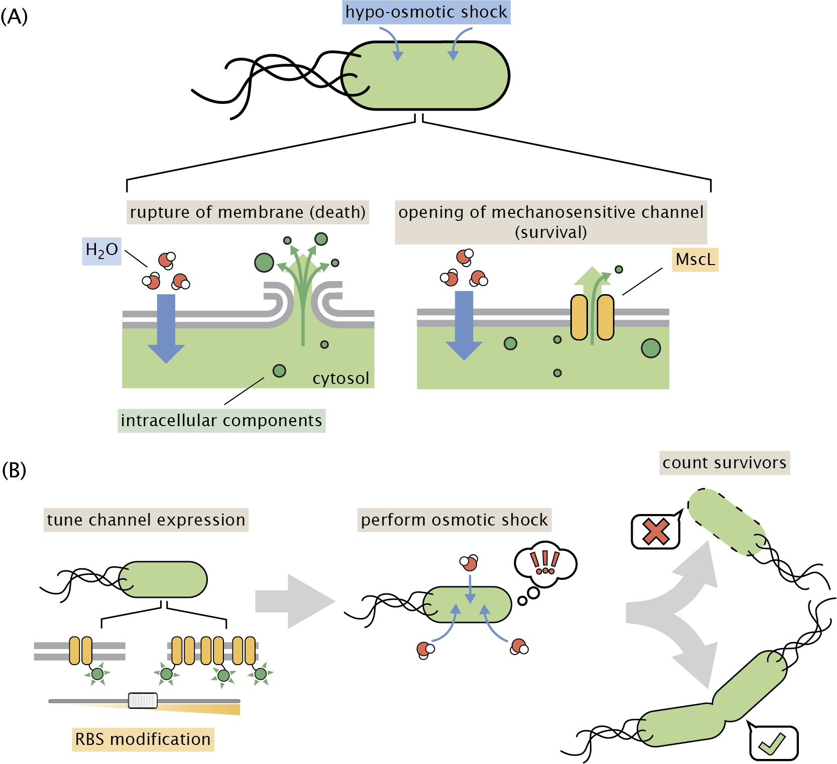

**Figure 1**: **Role of mechanosensitive channels during hypo-osmotic shock.** (A) Water rushes into a cell during hypo-osmotic shock resulting in increased turgor pressure and tension in the cell membrane. If no mechanosensitive channels are present and membrane tension is high (left panel), the membrane ruptures and cell death occurs. If mechanosensitive channels are present (right panel) and membrane tension is beyond the gating tension, the mechanosensitive channel MscL opens, releasing cytoplasm and small intracellular molecules into the environment, relieving pressure and membrane tension. (B) The experimental approach in this work. The number of mechanosensitive channels tagged with a fluorescent reporter is tuned through RBS modification of the mscL gene. The cells are then subjected to a hypo-osmotic shock and the number of surviving cells is computed.

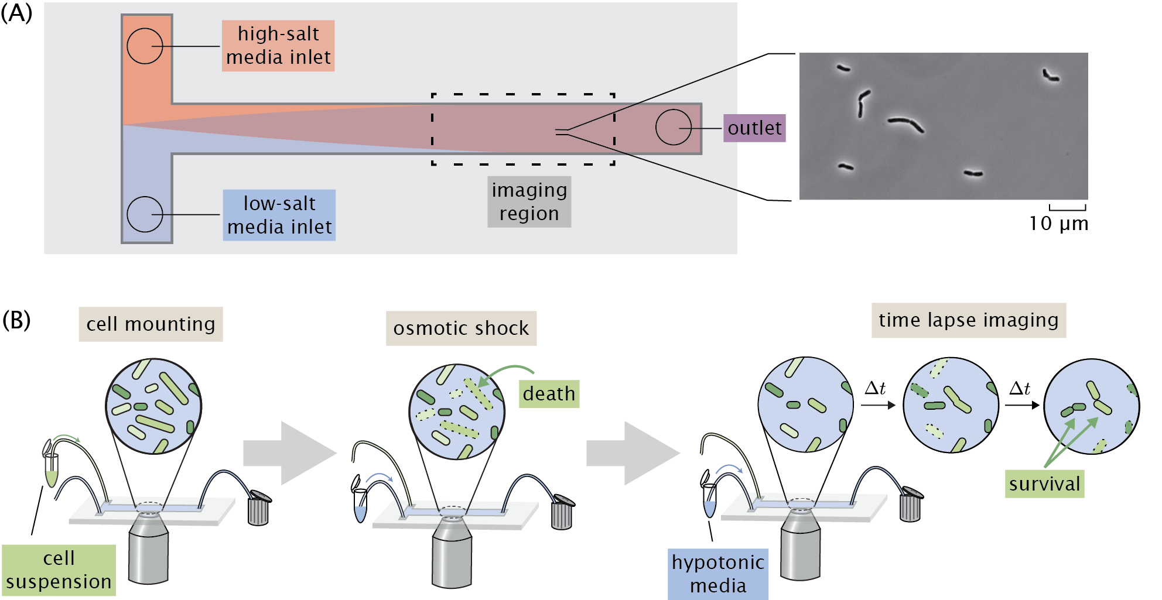

**Figure 2**: **Experimental approach to measuring survival probability.** (A) Layout of a home-made flow cell for subjecting cells to osmotic shock.(A) Cells attached to a glass coverslip within the flow chamber are shocked by addition of a low salt medium into the flow chamber. (B) The typical experimental procedure. Cells are loaded into a flow chamber as shown in (A) and mounted to the glass coverslip surface. Cells are subject to a hypo-osmotic shock by flowing hypotonic medium into the flow cell. After shock, the cells are monitored for several hours and surviving cells are identified.

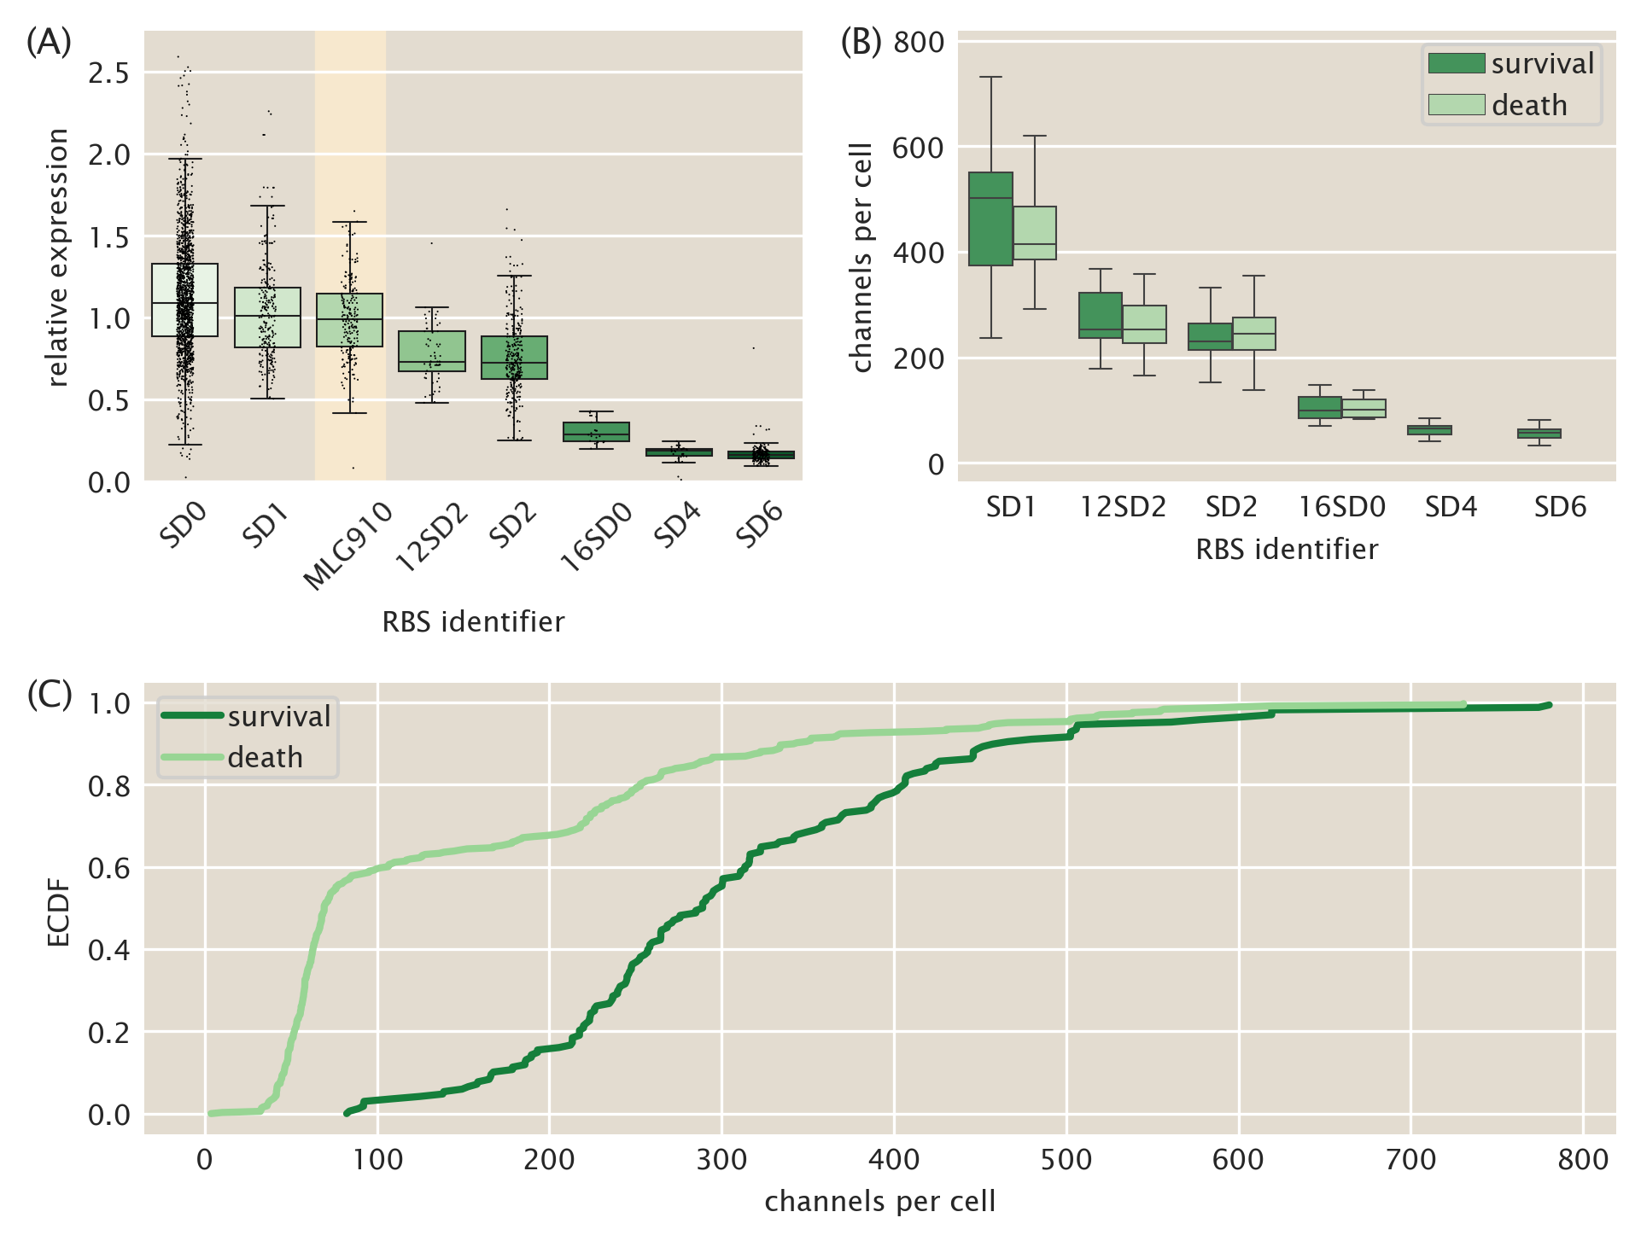

**Figure 3**: **Control of MscL expression and distribution of survival under osmotic shock.** (A) Variability in expression across designed RBS mutants. The boxes represent the interquartiles of the distribution, the center line displays the median, and the whiskers represent XXX. Individual cells are denoted as black points. The strain used for calibration of channel copy number (MLG910) is highlighted. (B) XXX. (C) The Empirical Cumulative Distribution Function (ECDF) of the data shown in (B). The cells were separated by survival or death and the CDFs were computed individually.

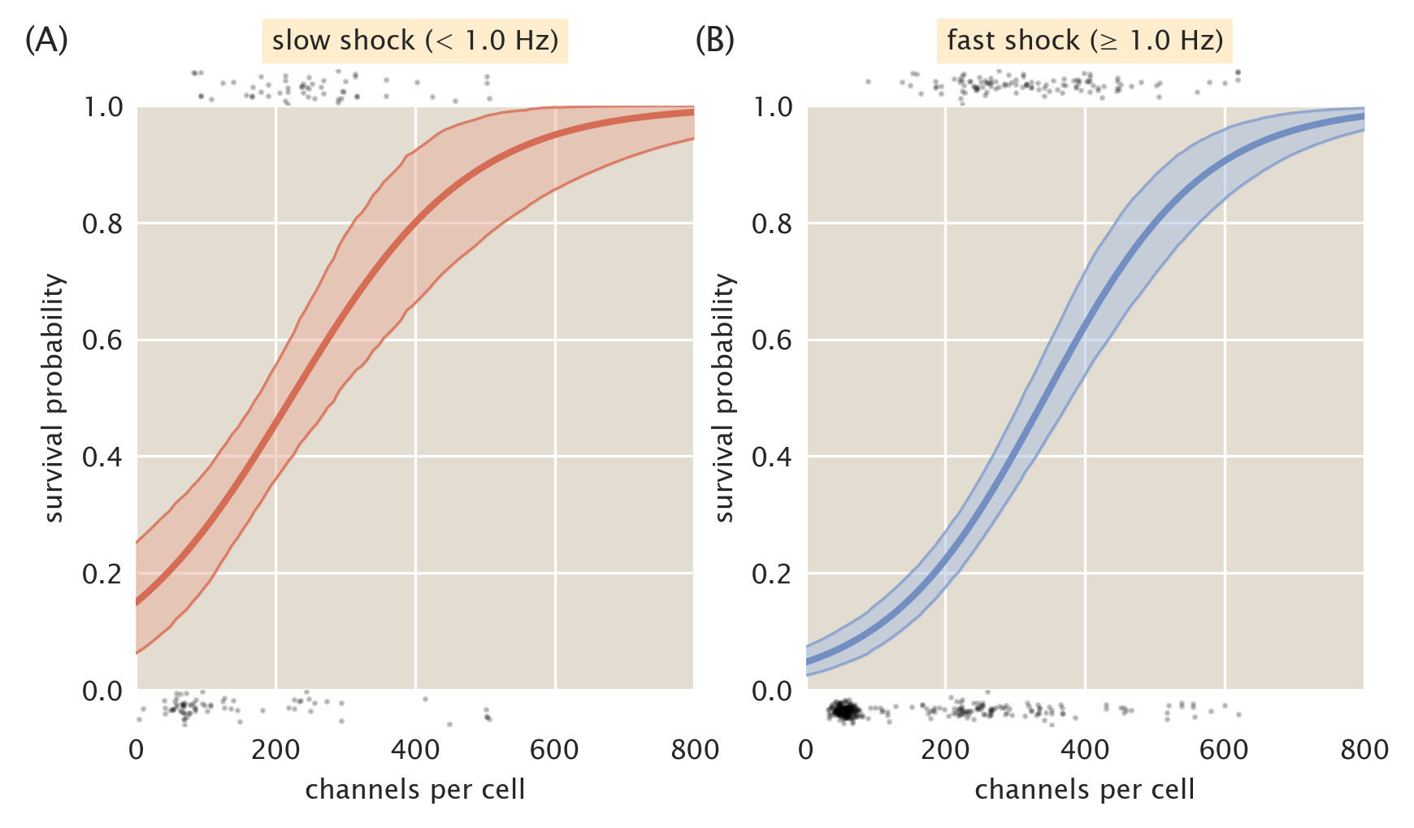

**Figure 4**: **Probability of survival as a function of MscL copy number.** Predicted survival probabilities from a one-dimensional logistic regression for samples exposed to a slow shock (< 1.0 Hz, A) and fast shock ( ≥ 1.0 Hz, B). Shaded regions represent the 95th percent credible regions. Black points at the top and bottom of plots represent individual cell measurements which survived (top) and died (bottom).