Mapping mechanosensitive channel number to survival probability

Heun Jin Leea, Griffin Chureb, and Rob Phillipsa, b, c, *

Departments of Applied Physicsa, Biochemistry and Molecular Biophysicsb, and Division of Biology and Biological Engineeringc, California Institute of Technology, Pasadena, California, USA

* Send correspondence to phillips@pboc.caltech.edu

**Abstract**

**Importance**

**Introduction**

Current state of the field, disparity between channel counts, and why cells need so many. “We chose to examine the contribution of a single mechanosensitive channel (MscL) responsible for sensing and responding to large membrane tension.”

**Materials and Methods**

**Strains, media, and growth conditions.** HJ will provide information.

**Flow cell.** HJ will provide information.

**Imaging conditions.** HJ will provide information.

**Data analysis and image processing.**

Cells were identified manually as “survivors” or “fatalities”. Fatalities were defined as cells which did not perform two complete division events in during the acquisition time.

Phase contrast and fluorescence images were acquired before the shock. Individual cells were segmented using the phase-contrast image and total cellular fluorescence intensities were computed. The segmented cells were then matched with the manually curated identification of survival or death. Each day’s data set was processed individually.

**Calibration of channel number.**

Using previously known fluorescence calibration

Using the dilution method.

**Logistic regression.**

Common problem in machine learning. Assume that there is a smooth, linear increase in the log-odds of survival with channel number.

**Results**

The need for a standard candle.

Agreement/disagreement between dilution method, quantitative western, and photobleaching assays.

Distribution of channel number (per cell or per area – need to choose one and specify the issues. Should show cells in some figure). Distribution among survivors and fatalities across all shock rates.

Inferring survival probability using Logistic regression on pooled data set, low shock rate, and fast shock rate.

Comment on the apparent number of channels needed for appreciable survival.

**Discussion**

Emphasize highly quantitative measurement of a single channel number and survival probability using the same methodology. Allows for the estimation of single-cell survival probability.

Touch with theory work in some manner, point out that this is (as reported in Booth paper) well above what one would expect given the theory.

**Acknowledgements**

**References**

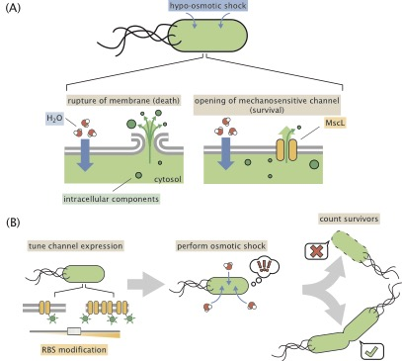

**Figure 1**: **Role of mechanosensitive channels during hypo-osmotic shock.** (A) Water rushes into a cell during hypo-osmotic shock resulting in increased turgor pressure and tension in the cell membrane. If no mechanosensitive channels are present and membrane tension is high (left panel), the membrane ruptures and cell death occurs. If mechanosensitive channels are present (right panel) and membrane tension is beyond the gating tension, the mechanosensitive channel MscL opens, releasing cytoplasm and small intracellular molecules into the environment, relieving pressure and membrane tension. (B) The experimental approach in this work. The number of mechanosensitive channels tagged with a fluorescent reporter is tuned through RBS modification of the mscL gene. The cells are then subjected to a hypo-osmotic shock and the number of surviving cells is computed.

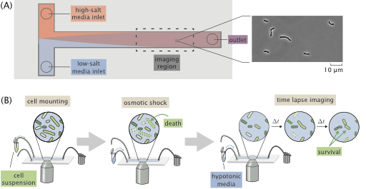

**Figure 2**: **Experimental approach to measuring survival probability.** (A) Layout of a home-made flow cell for subjecting cells to osmotic shock.(A) Cells attached to a glass coverslip within the flow chamber are shocked by addition of a low salt medium into the flow chamber. (B) The typical experimental procedure. Cells are loaded into a flow chamber as shown in (A) and mounted to the glass coverslip surface. Cells are subject to a hypo-osmotic shock by flowing hypotonic medium into the flow cell. After shock, the cells are monitored for several hours and surviving cells are identified.