DAY14

Class Exercise 1

@PostMapping("/employee")

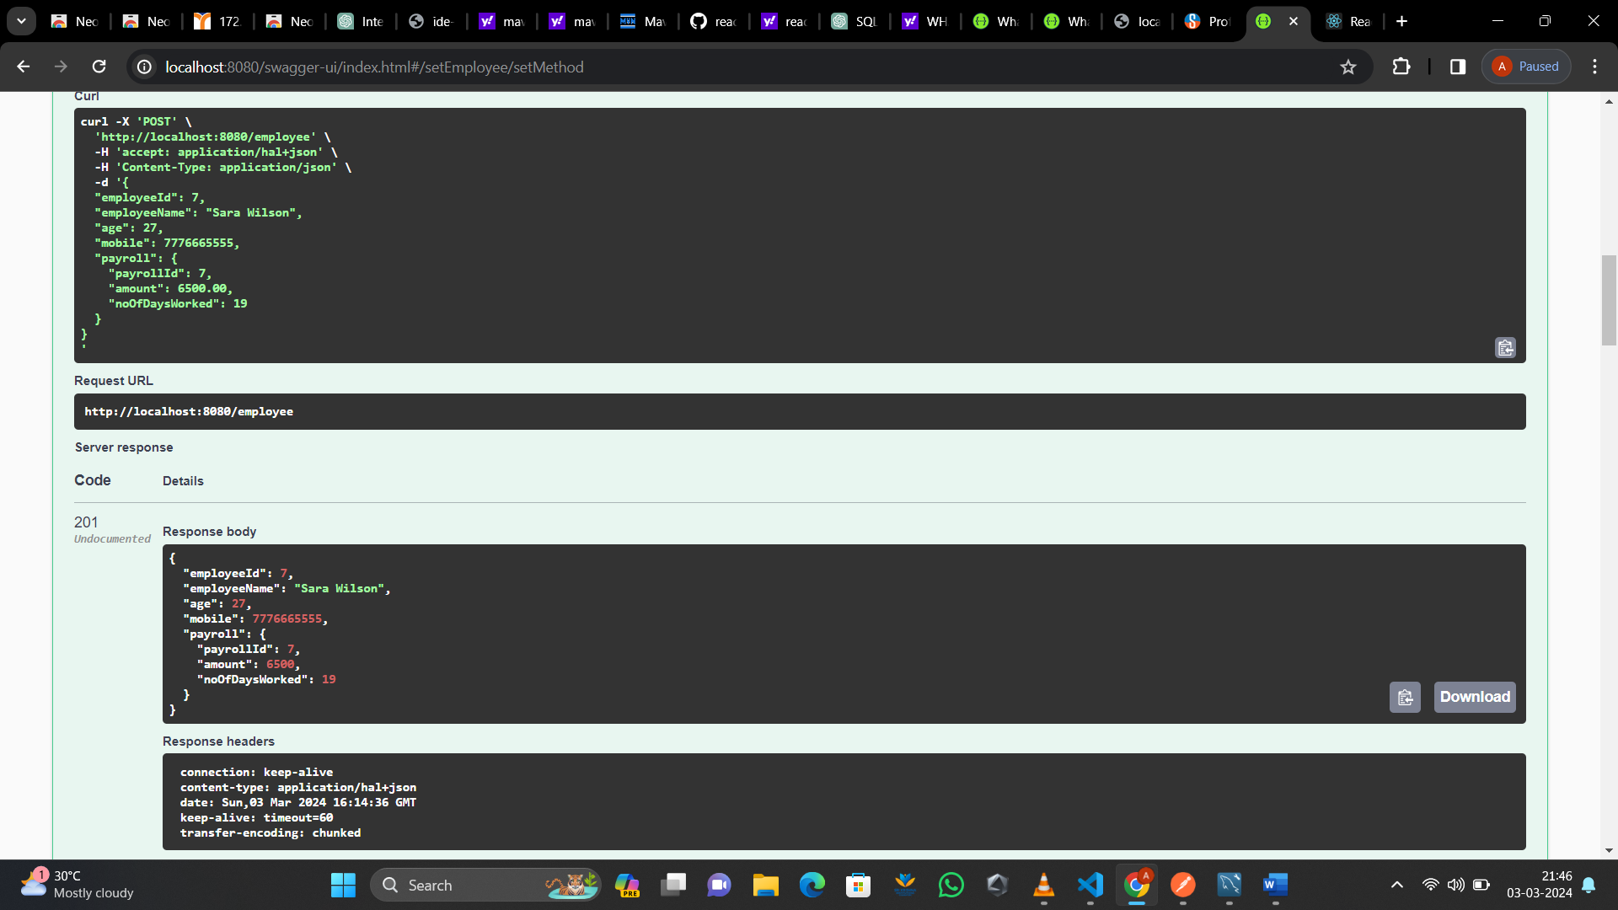

@GetMapping("/employee")

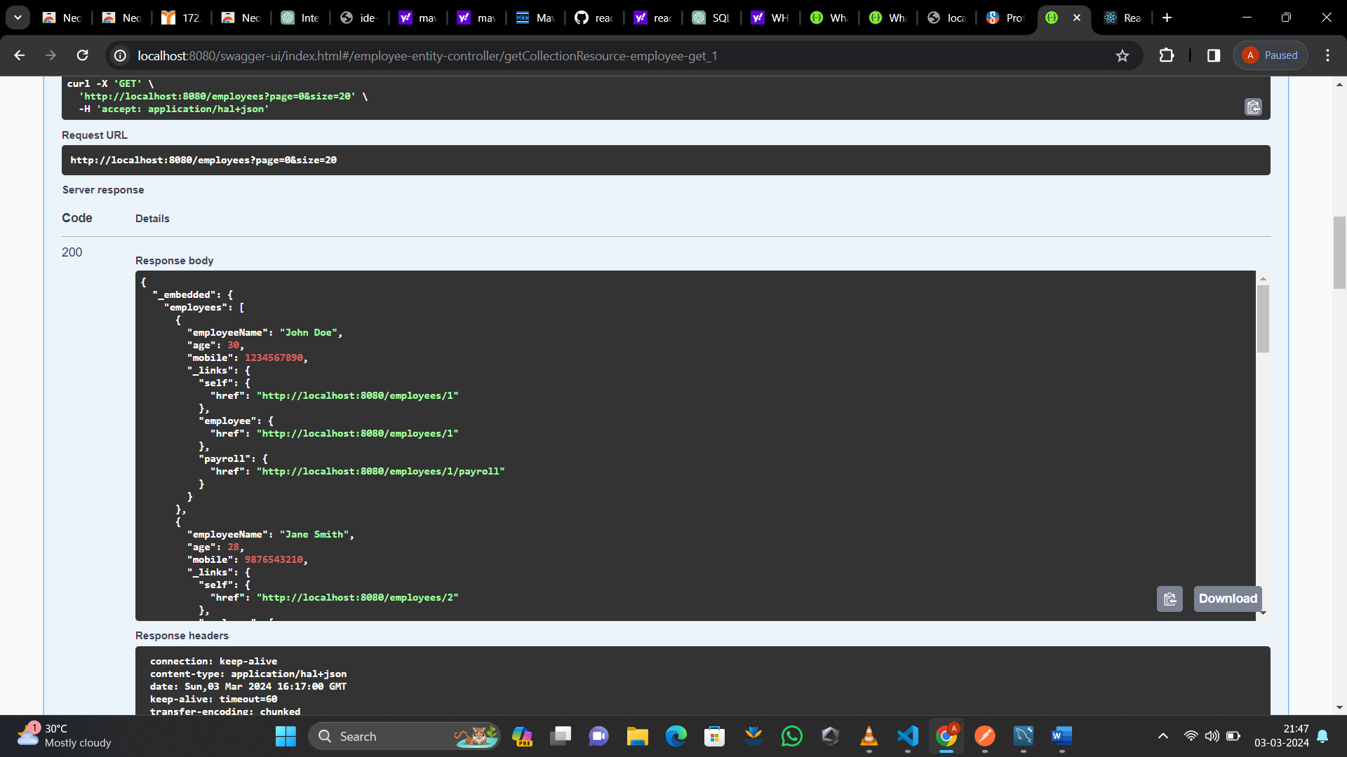

@GetMapping("/employee/{employeeId}")

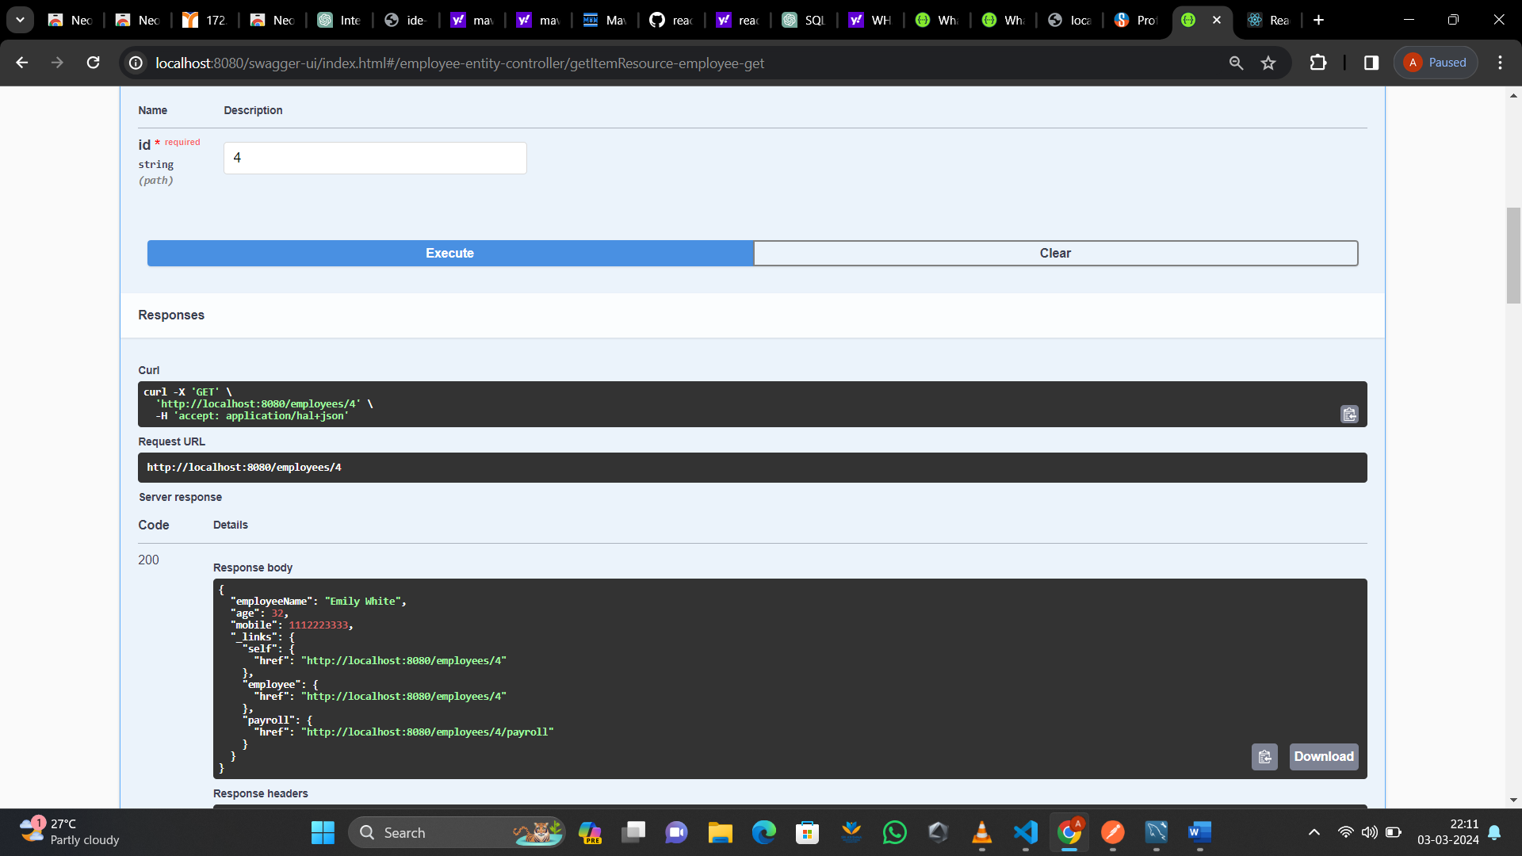

@PostMapping("/employee/{id}/payroll")

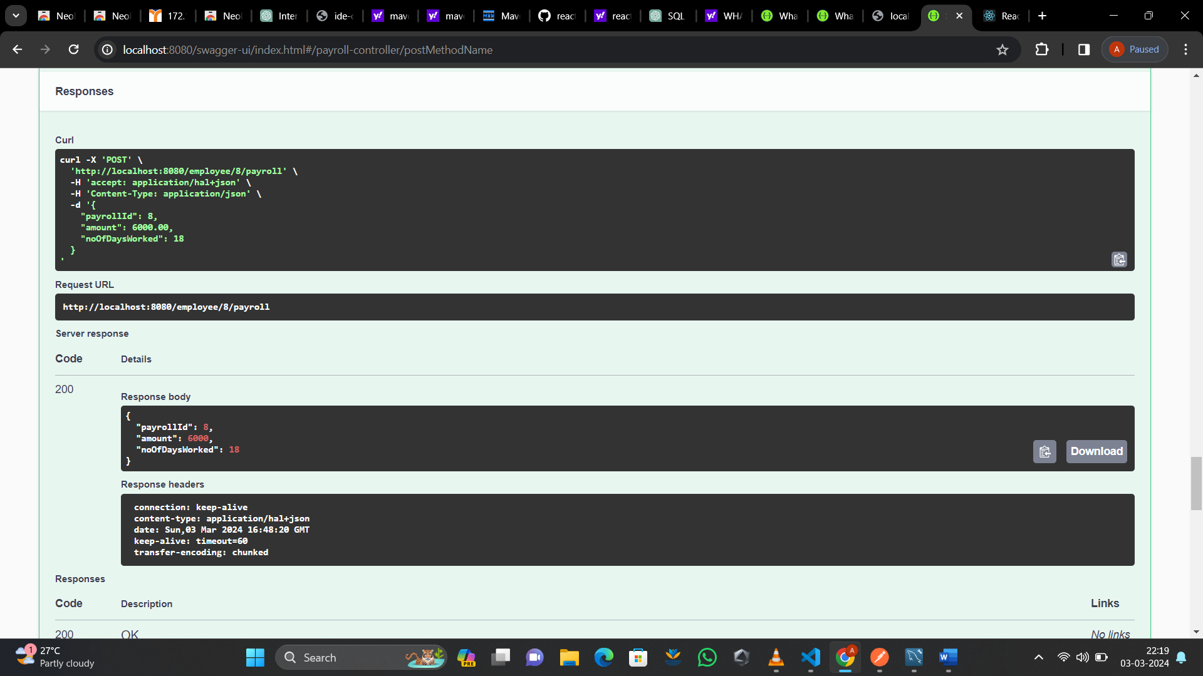

@GetMapping("/employee/{id}/payroll")

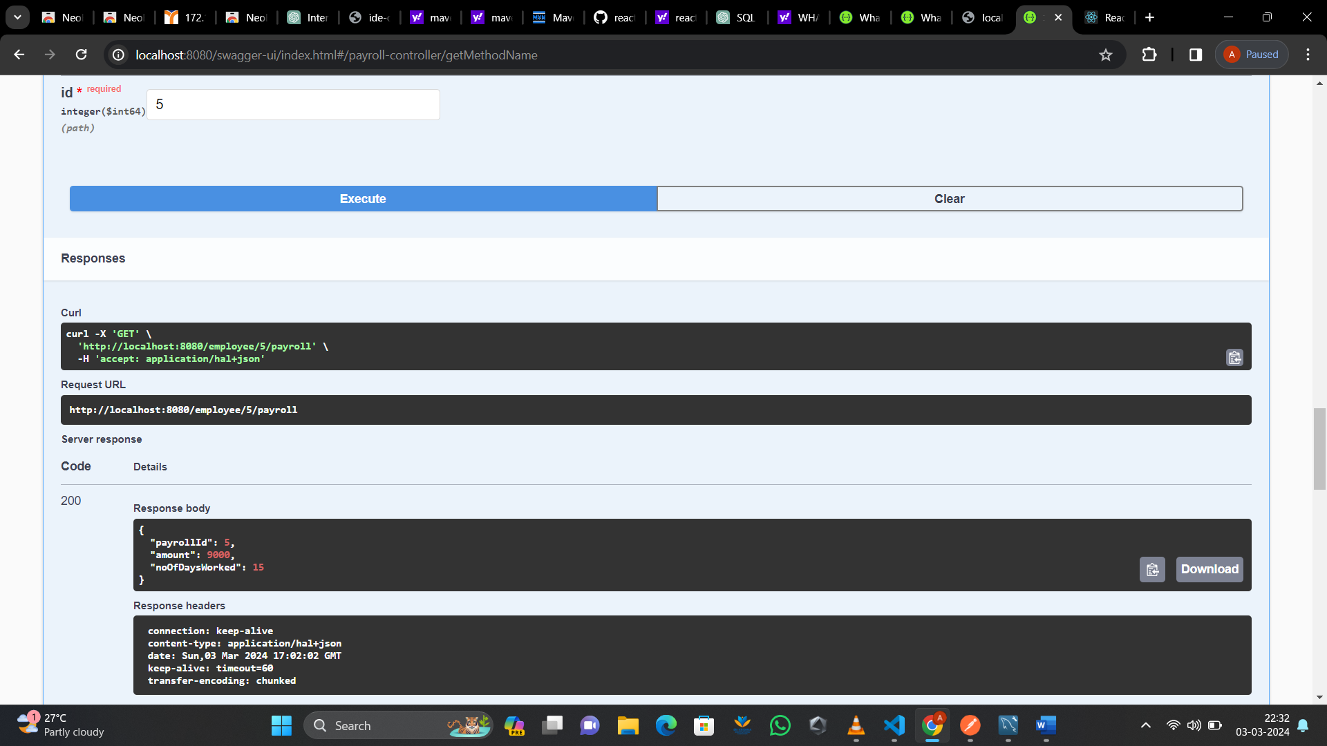

Class work 2

@postmapping (“api/book”)

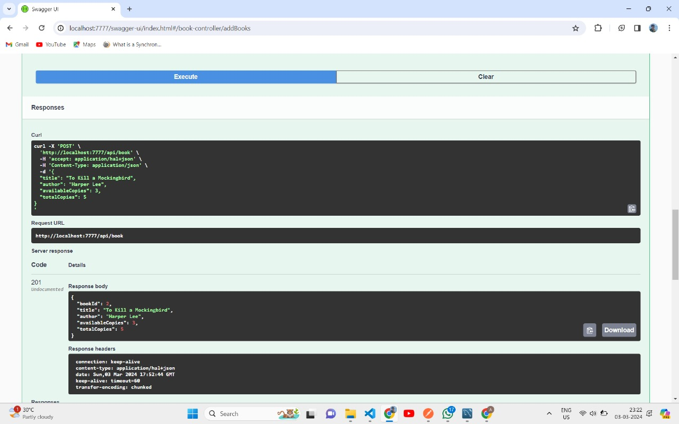

@getmapping(“api/book”)

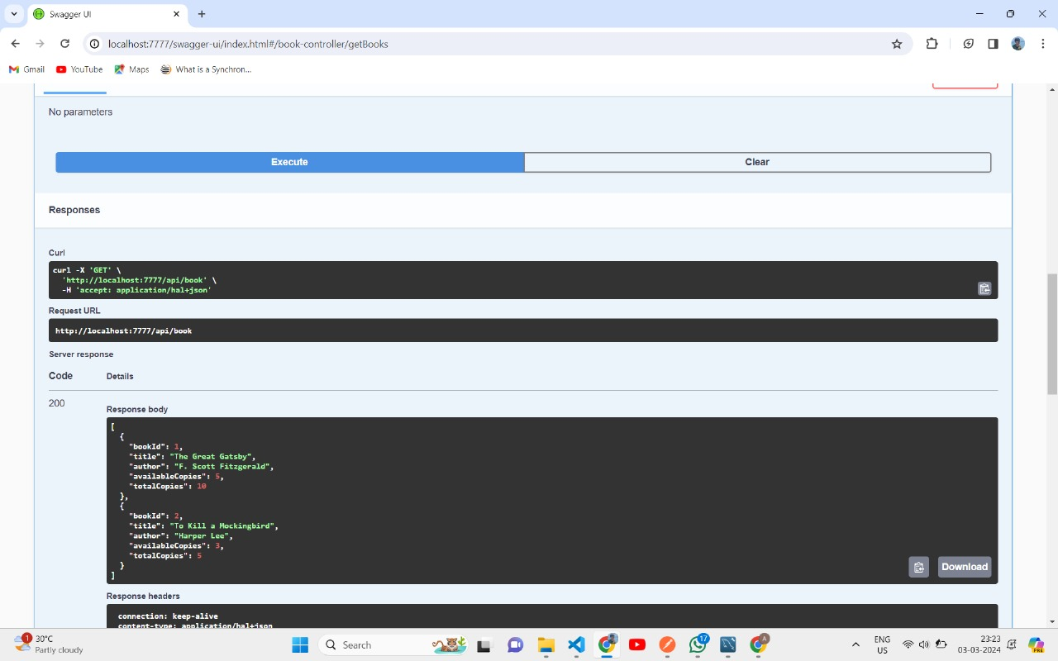

@Getmapping(‘api/book/{bookId}’)

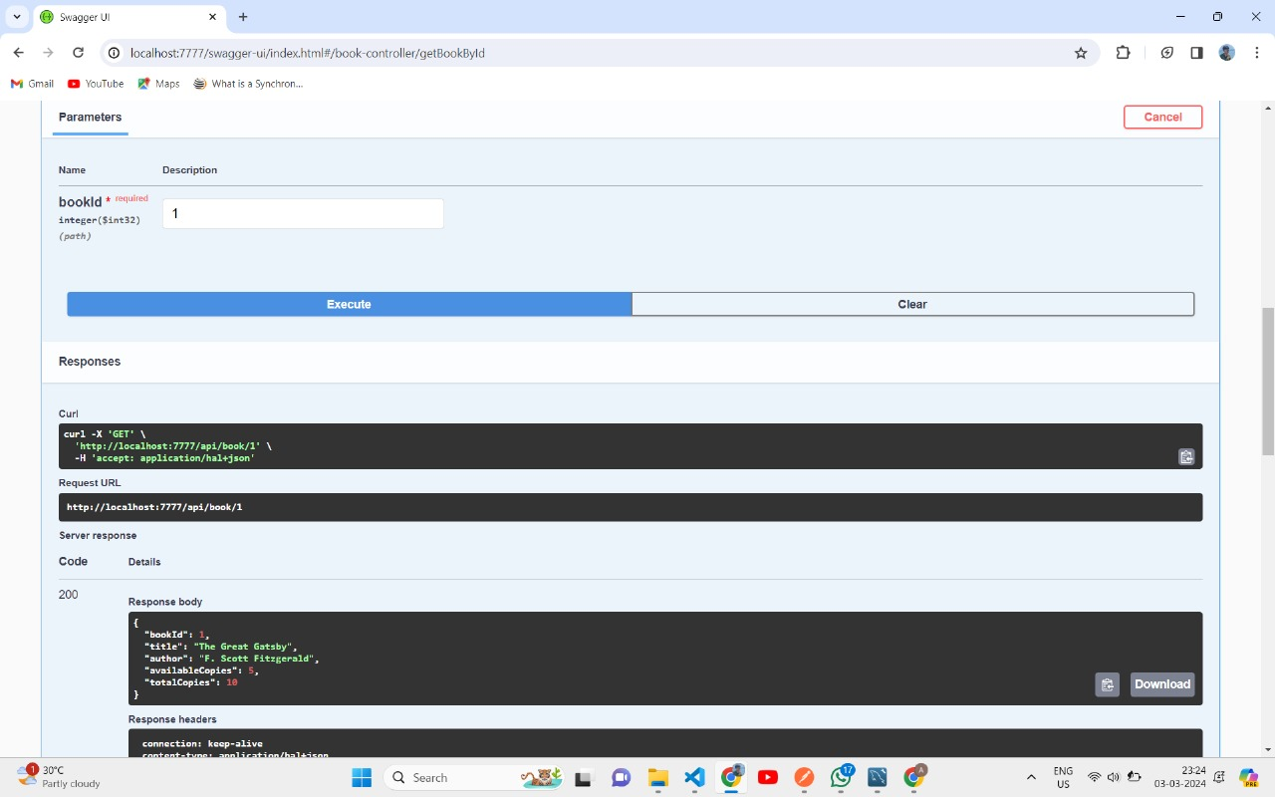

@Putmapping(“api/book/{bookId}”)

