STARTUP CONNECT AI
Technical Architecture
v1 launch architecture — cloud-agnostic managed services, essentials-only diagrams, pragmatic scope for the first 1,000 users

Prepared by: Durgesh
B.E. Information Technology, SPPU • 2027 Batch
Document 4 — follows Research, Business Architecture, and Wardley Mapping. Focused on v1 launch only; robustness (threat model, capacity planning, DR) deferred until MVP is live.

Table of Contents
1 | Scope, Principles & Non-Goals | 3
2 | System Context (C4 L1) | 4
3 | Container Architecture (C4 L2) | 6
4 | Data Model | 9
5 | Key Flows — Sequence Analysis | 11
6 | ML Pipeline | 13
7 | API Surface (v1) | 15
8 | Deployment & Environments | 17
9 | Security, Auth & Data Handling (v1 minimum) | 19
10 | What's Deferred to Post-MVP | 21

1. Scope, Principles & Non-Goals

1.1 What this document covers
The v1 launch architecture for Startup Connect AI — the concrete technology choices, service boundaries, data model, key flows, and deployment strategy required to ship the MoSCoW-defined MUST use cases (M1–M10 from the Business Architecture doc) and serve the first ~1,000 users. It is intentionally pragmatic: nothing here is designed for 50k users. Scaling concerns, threat modelling, capacity planning, and disaster recovery are deliberately deferred to the post-MVP architecture doc.

1.2 Guiding principles
- Managed over self-hosted, always. Wardley decisions W1–W5 from the mapping doc apply: we do not build vector DBs, auth, chat SDKs, schedulers, or embedding models.
- Cloud-agnostic through free-tier managed services. We use Vercel, Supabase, Qdrant Cloud, Cloudflare R2, Upstash, Clerk, Groq — all with generous free tiers, no cloud vendor lock-in.
- OpenAI-compatible API spec for everything LLM-adjacent. Swap providers by changing an env var.
- Async by default for anything that can block. Embedding generation, aggregation, notifications, retraining — all go through a job queue.
- Every write leaves a feedback trace. Interaction data is the compounding moat (Wardley W9); nothing that could feed future retraining gets dropped.
- Ship in ≤ 6 months with a 2–4 person team. Any component that requires more than 2 engineers to own gets simplified or bought.

1.3 Non-goals for v1
Deferring these keeps scope honest. Each is listed with the trigger that would move it into scope.
Non-goal | Deferred until
Multi-region deployment | > 5,000 active users OR > 200ms latency complaints
Horizontal scaling of API (multi-instance) | > 100 requests/sec sustained
Full observability stack (Prometheus, Grafana, distributed tracing) | First production incident that basic logs don't diagnose
Kubernetes / container orchestration | > 3 services need coordinated deploy AND managed PaaS becomes limiting
Custom fine-tuned models | > 100k domain-specific interaction examples
Formal threat model (STRIDE) + pen test | Before public paid launch (Phase 3 in GTM)
SOC 2 / ISO 27001 | Enterprise (accelerator) tier sales requires it
Multi-tenancy hardening | First enterprise (accelerator) customer signs

2. System Context (C4 L1)
Zooming out first — who and what interacts with Startup Connect AI. This is the highest-altitude view; everything else in this document is a zoom-in on the central circle.
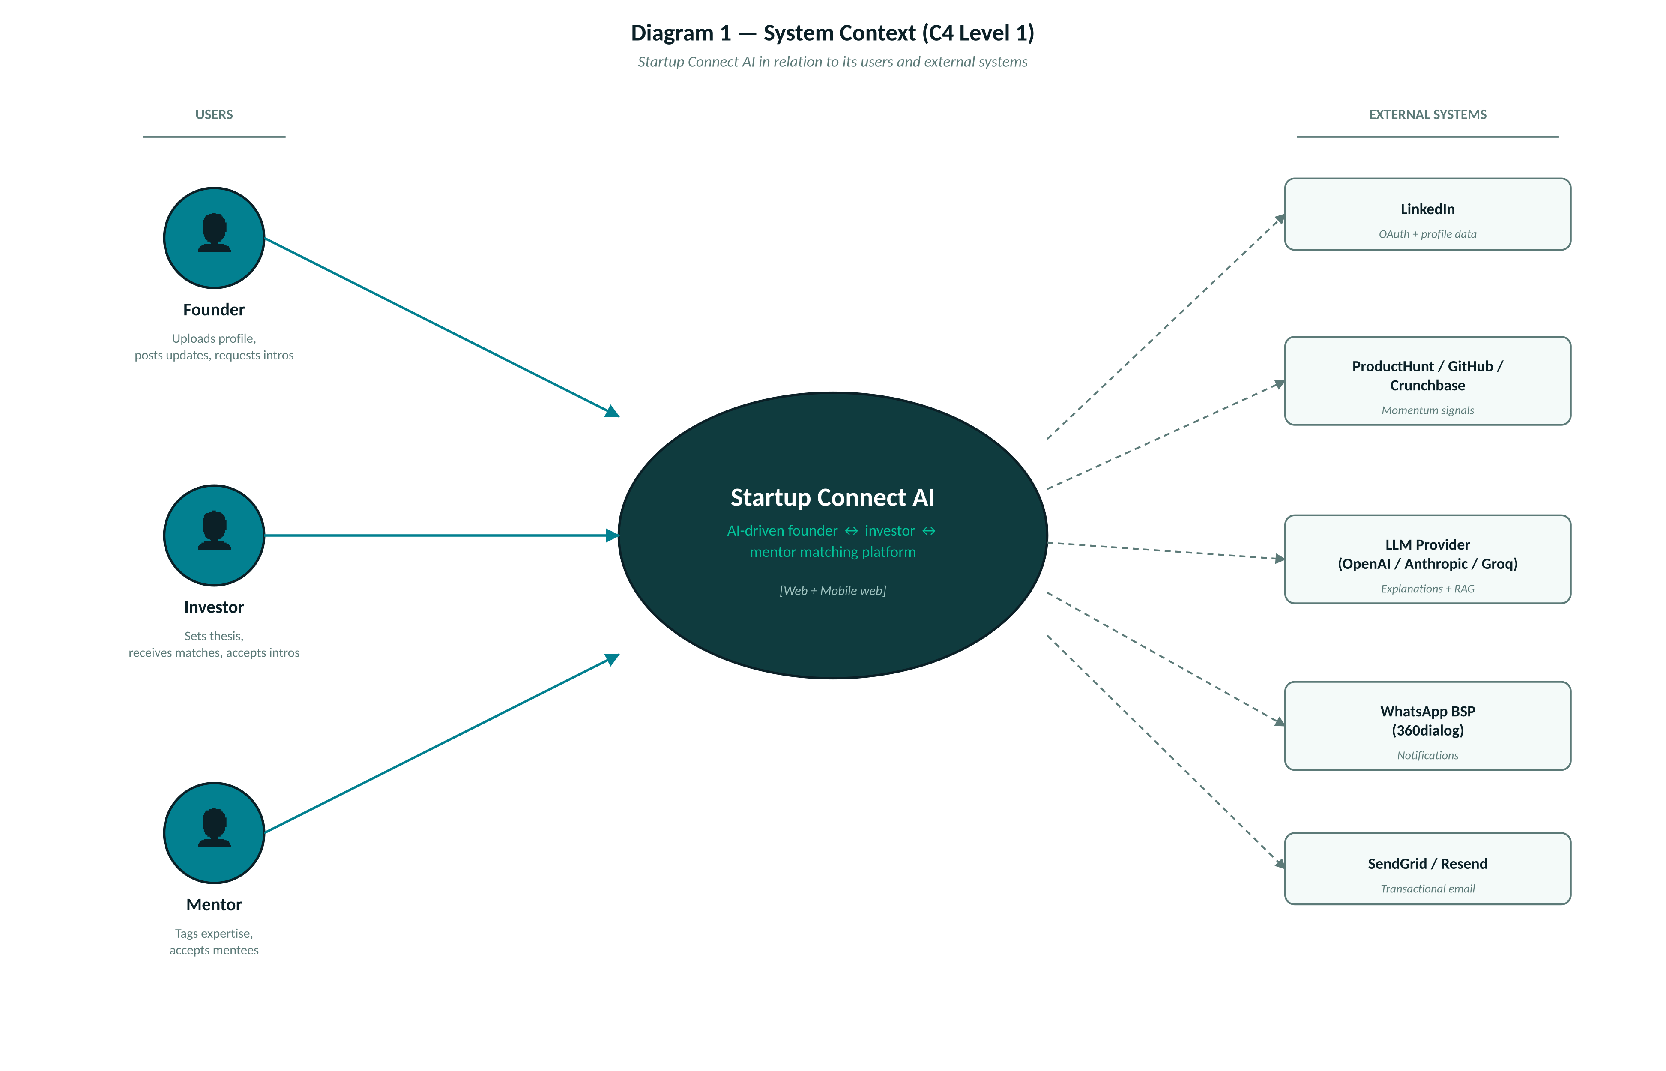
Diagram 1 — System Context. Users on the left, external systems on the right, our platform in the middle. Solid arrows = user-initiated flows; dashed = system-initiated integrations.

2.1 Users
User | How they interact | Frequency
Founder | Web (desktop + mobile) — publish profile with L1/L2/L3 layers, browse matches, request intros, post updates, chat with matched investors/mentors | Multiple sessions/week during active fundraise; monthly otherwise
Investor | Web — set thesis, review inbound matches with fit scores + explanations, accept/reject, chat with founders | Weekly triage session
Mentor | Web — set expertise + availability, accept mentee requests, log sessions | 1–2 sessions/month

2.2 External systems
System | Purpose | Integration type
LinkedIn | OAuth sign-in; pull basic profile data (name, headline, company, recent posts) for L2 momentum | OAuth 2.0 + REST API (rate-limited)
ProductHunt | Pull launch events, upvote counts, launch pages for L2 | REST API
GitHub | Pull commit activity, repo stars, contributor stats for L2 (technical founders) | REST + GraphQL API
Crunchbase | Pull past investments for investors, funding history for startups | REST API (paid tier eventually; free equivalent via Tracxn / manual for v1)
Groq (primary LLM) | Explanation generation, RAG synthesis, content moderation | OpenAI-compatible REST
OpenAI / Anthropic (fallback) | Fallback LLM when Groq unavailable or model unavailable | OpenAI SDK / Anthropic SDK
360dialog (WhatsApp BSP) | Send WhatsApp notifications (match alerts, intro requests, meeting reminders) | REST + webhook
SendGrid / Resend | Transactional email (verification, digests, notifications) | REST
Cal.com widget (embedded) | Meeting scheduling (SHOULD tier — v1.1) | Iframe embed + webhook for outcomes

3. Container Architecture (C4 L2)
Zoom one level in — the actual deployable units that make up the system. Each container is one runtime process (or one hosted service). Four horizontal zones: user-facing, backend API + services, async workers, and data + ML.
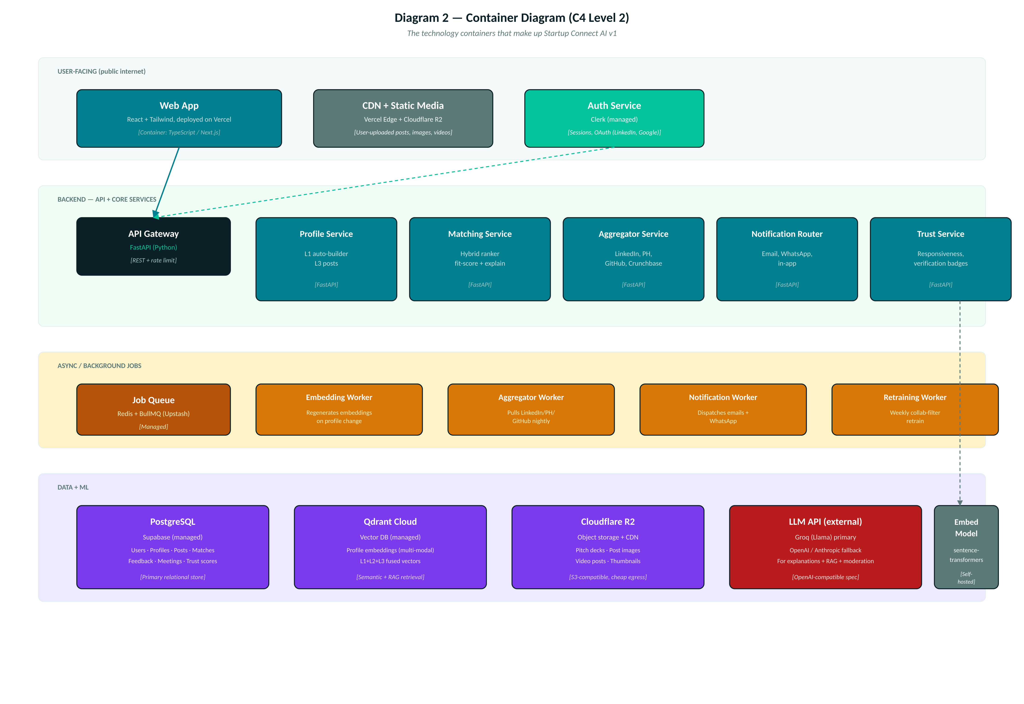
Diagram 2 — Containers. Colours indicate role: dark teal (user-facing services), teal (backend services), orange (async workers), purple (data stores), red (external LLM). All managed services except workers and API which run on Railway/Render.

3.1 Container inventory
Container | Tech / Vendor | Responsibility | Deploy target
Web App | Next.js 14 (React + TypeScript + Tailwind) | All user-facing UI, SSR for SEO on public landing pages, client-side for authenticated app | Vercel (free tier → Pro at $20/mo when needed)
CDN + Media | Cloudflare R2 + CDN | Serves user-uploaded posts, images, videos with edge caching | Cloudflare (S3-compatible, cheap egress)
Auth Service | Clerk | User sign-up, sign-in, sessions, OAuth (LinkedIn, Google), MFA, JWT issuance | Clerk-hosted (free ≤ 10k MAU)
API Gateway | FastAPI (Python 3.12) — single process for v1 | REST endpoints, JWT verification, rate limiting, request validation, orchestration between services | Railway (free trial → $5/mo)
Profile Service | Python module inside API Gateway (v1) — extracted later | L1 profile CRUD, AI Auto-Builder (LLM parsing of pitch deck + LinkedIn), L3 post management | Same process as API
Matching Service | Python module inside API Gateway (v1) | Hybrid ranking (content similarity + collab signal), fit-score computation, explanation coordination | Same process as API
Aggregator Service | Python module + separate worker | Pulls momentum signals from LinkedIn, PH, GitHub, Crunchbase; normalizes into momentum_items table | API + worker on Railway
Notification Router | Python module + worker | Multi-channel dispatch (email, WhatsApp, in-app), template rendering, delivery tracking | API + worker on Railway
Trust Service | Python module inside API Gateway | Compute + update trust scores nightly from feedback events + verification status | Runs as scheduled job
Job Queue | Upstash Redis + BullMQ (or Python equivalent: RQ or Celery-with-Redis) | Async job dispatch, retry, dead-letter | Upstash (free ≤ 10k commands/day)
Embedding Worker | Python long-running worker with sentence-transformers + CLIP loaded | Regenerates profile embeddings on profile change; batch-processes uploads | Railway worker container
Aggregator Worker | Python worker on cron schedule | Nightly pull from external APIs; normalizes and inserts momentum_items | Railway worker container
Notification Worker | Python worker | Reads from notification queue, dispatches via SendGrid/360dialog, logs delivery | Railway worker container
Retraining Worker | Python worker on weekly cron | Rebuilds collaborative-filter matrix; runs offline eval; hot-swaps ranker weights if metrics pass | Railway worker container
PostgreSQL | Supabase (Postgres 15 + PostgREST + auth complement to Clerk) | Primary relational store for all structured data | Supabase (free ≤ 500MB → Pro $25/mo)
Vector DB | Qdrant Cloud (free tier 1GB, then $25/mo) | Profile embeddings (multi-modal, 384-dim), similarity search for matching + RAG retrieval | Qdrant Cloud
LLM API | Groq (primary) + OpenAI/Anthropic (fallback) | Explanation generation, RAG synthesis, content moderation, AI Auto-Builder parsing | External API
Embedding Model | sentence-transformers/all-MiniLM-L6-v2 + CLIP ViT-B/32 | Self-hosted inside Embedding Worker (models ~120MB combined; CPU inference fine for v1) | Runs in Embedding Worker process

3.2 v1 → v2 evolution of the container layout
For v1, Profile / Matching / Trust services all run as Python modules inside the single FastAPI process — this keeps deployment trivial. As traffic grows, extract each into its own process behind the same API Gateway. The service boundaries in the code are drawn now so the extraction is mechanical later.

4. Data Model
A simplified ER diagram of the v1 schema follows. Fifteen tables total; the interesting relationships and design choices are called out below.
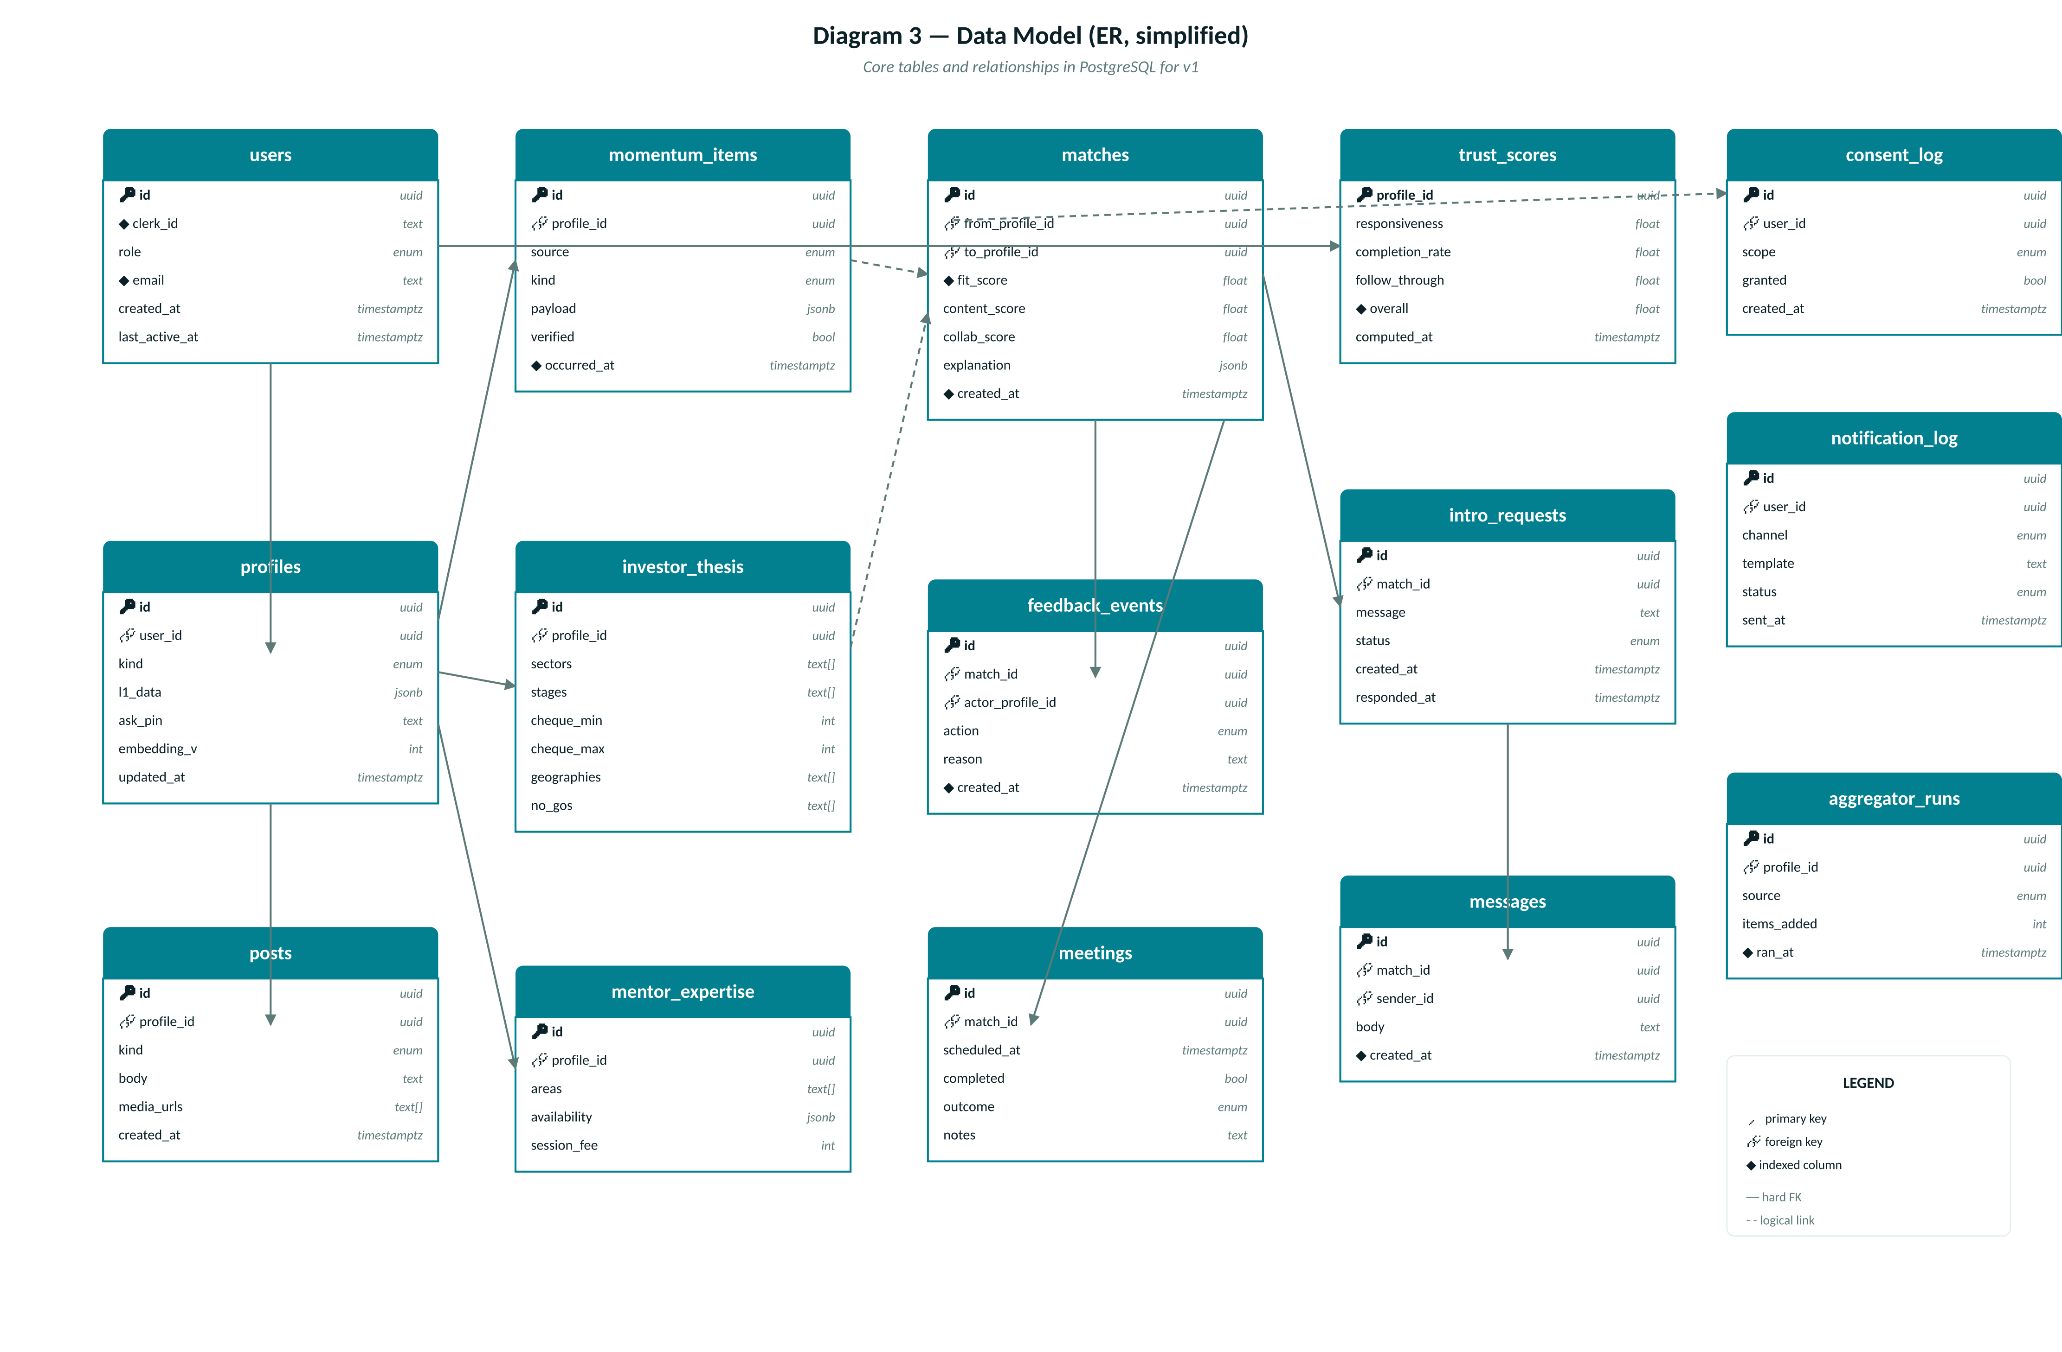
Diagram 3 — Data model (simplified). Solid arrows are hard foreign keys; dashed are logical relationships that cross service boundaries. All timestamps are timestamptz (UTC). All primary keys are UUIDs.

4.1 Key design decisions
- Single profiles table with kind enum (founder / investor / mentor) — one row per user role. A user can be both a founder and an investor (with two profile rows), which happens more often than you'd think in the Indian ecosystem.
- L1 profile data stored as jsonb (l1_data) rather than as columns. Reason: the schema for a founder profile (sector, stage, ask) is different from investor (thesis, cheque size) and mentor (expertise, availability). jsonb keeps it flexible without an explosion of nullable columns. Related structured fields (like investor_thesis) get their own table when we need to query them relationally.
- L2 momentum_items is a separate table because it's append-only, high-volume, and needs its own retention policy. Indexed on (profile_id, occurred_at desc) for timeline queries.
- L3 posts is separate for the same reason plus content moderation ownership.
- embedding_v on profiles is a version counter — increments when profile / momentum / posts change. Signals to the embedding worker that a re-encode is needed. Actual vector lives in Qdrant, not Postgres (Postgres pgvector was considered but Qdrant's filtering is better for our use case).
- matches is materialized (not computed on request). Reason: fit-scoring the full candidate set is expensive; we precompute nightly + on-demand for the top-K when a user opens the app, and cache. Each match row has content_score, collab_score, and fit_score separately so we can debug and A/B test.
- feedback_events is the primary training signal. Every accept/reject/save/ignore lands here with a reason. Never dropped. Retention: forever (small volume, huge value).
- consent_log is versioned — every DPDP-relevant consent grant/withdrawal creates a new row. Enables audit + right-to-erasure.

4.2 Table-by-table summary
Table | Rows expected (Year 1) | Purpose
users | ~5,000 | One row per authenticated identity (mirrors Clerk)
profiles | ~6,500 | One row per role a user takes on the platform
posts | ~15,000 | L3 founder-authored content (text, image, video)
momentum_items | ~50,000 | L2 auto-aggregated activity timeline entries
investor_thesis | ~600 | One per investor profile; queryable thesis attributes
mentor_expertise | ~500 | One per mentor profile
matches | ~200,000 | Precomputed and cached match candidates with scores
feedback_events | ~40,000 | Every user reaction to a match; training signal
meetings | ~2,000 | Scheduled + completed meetings with outcomes
intro_requests | ~15,000 | Founder→investor intro requests, status tracking
messages | ~50,000 | In-app messages between matched parties
trust_scores | ~7,000 | One per profile; recomputed nightly
consent_log | ~10,000 | DPDP-relevant consent grants + withdrawals
notification_log | ~200,000 | Delivery tracking for email + WhatsApp + in-app
aggregator_runs | ~30,000 | Log of each nightly aggregator run per profile

5. Key Flows — Sequence Analysis
Four flows drive the v1 architecture. The critical one — matching — is diagrammed. The others are described in prose.

5.1 Matching flow (diagrammed)
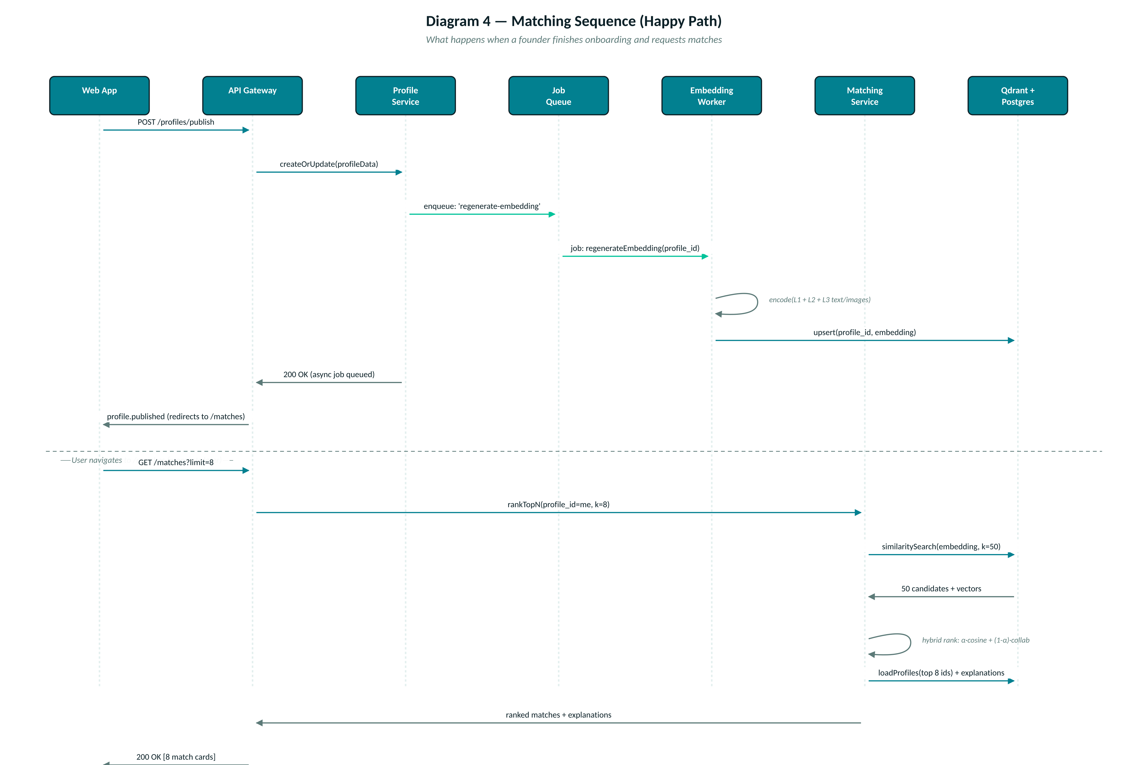
Diagram 4 — Matching sequence. Two phases: (1) async profile embedding when the user publishes; (2) real-time ranked match retrieval when the user opens the matches page.
Key latency budget: the second phase (from GET /matches to response) must complete in ≤ 400ms P95 to feel snappy. Budget breakdown:
- Qdrant similarity search (k=50): ~50ms
- Postgres load of top-8 profiles + metadata: ~80ms
- Hybrid re-rank in Python: ~30ms
- LLM explanation generation (batched for top-8, Groq): ~150ms P95
- Serialization + network: ~40ms
- Buffer: ~50ms
If LLM latency ever exceeds the budget, we cache explanations per (from_profile, to_profile) pair — same match doesn't need re-explanation until either profile changes.

5.2 Onboarding flow (prose)
The founder pastes a LinkedIn URL and uploads a pitch deck PDF. The Profile Service:
- Extracts the LinkedIn profile via the LinkedIn API (name, headline, company, location, recent activity summary).
- Passes the PDF to the LLM (Groq Llama-3.1-70b) with a structured extraction prompt that returns JSON matching the L1 schema (sector, stage, ask, team_size, city, business_model, competitors).
- Presents the prefilled L1 form to the founder for review and correction. Saves on submit.
- Enqueues an aggregator job to pull L2 (ProductHunt, GitHub, Crunchbase, LinkedIn activity).
- Enqueues an embedding job. Response returns to client while embedding runs async.
Total user-perceived time: ~90 seconds from upload to "profile published" screen. Actual embedding + first-matches computation completes in the background within 30–60 seconds; the matches page is ready by the time the founder navigates to it.

5.3 Feedback loop (prose)
Every match card has three actions: Request Intro, Save for Later, Not a Fit. Each writes to feedback_events with a reason. "Not a Fit" opens a lightweight dropdown (wrong sector, wrong stage, wrong geo, other) — this qualitative signal is what keeps the collaborative model from drifting.
The Retraining Worker runs weekly (Sunday 2am IST). It:
- Aggregates the past 7 days of feedback_events into a training table.
- Computes a new matrix factorization on the profile × profile feedback matrix using the implicit library.
- Runs offline evaluation on a held-out set (last 7 days' feedback held out from training) — computes P@10, R@10, NDCG@10.
- If new metrics are ≥ current production baseline on all three, hot-swaps the ranker weights table.
- If any metric regresses, alerts (Slack webhook for v1) and keeps existing weights.

5.4 Notification flow (prose)
Whenever an event should notify a user (new match batch, intro request received, message received, meeting reminder), the source service enqueues a notification job with template, channels, and payload. The Notification Worker:
- Renders the template (Handlebars-style) for each requested channel.
- Checks user preferences (email OK? WhatsApp opted in? in-app only?) from user settings.
- Dispatches via SendGrid (email) and/or 360dialog (WhatsApp). In-app notifications are just DB writes to a notifications table read by the web app.
- Writes result to notification_log with status (sent, delivered, bounced, opened).

6. ML Pipeline
Three concurrent paths keep the model useful: real-time inference on every match request, weekly batch retraining, and nightly aggregation of external momentum signals.
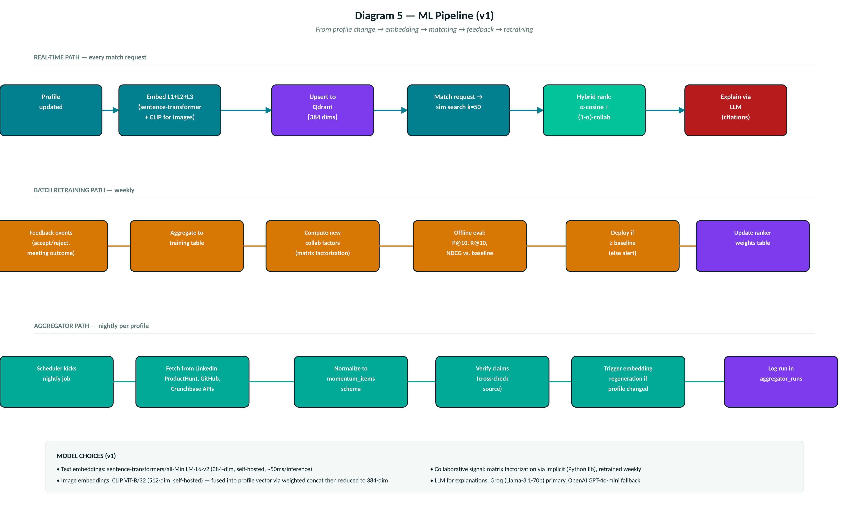
Diagram 5 — ML pipeline. Three horizontal tracks: real-time (teal), weekly retraining (orange), nightly aggregation (green). Each writes back to Postgres or Qdrant (purple).

6.1 Model choices
Concern | v1 choice | Why
Text embeddings | sentence-transformers/all-MiniLM-L6-v2 (384 dims) | Small (~80MB), fast (~50ms CPU inference), MTEB benchmark leader for its size, permissive license, well-supported
Image embeddings | CLIP ViT-B/32 (512 dims → reduced to 384 via projection) | Standard multi-modal encoder, good text-image alignment, matches our text embedding dimensionality after projection
Fusion strategy | Weighted concatenation of L1 (0.5) + L2 (0.3) + L3 (0.2) text embeddings, plus average of image embeddings for L3 media | Weights reflect signal reliability: L1 is user-verified, L2 is verified-external, L3 is self-reported
Collaborative signal | Matrix factorization via `implicit` Python library (implicit-feedback-native, fast, well-benchmarked) | Handles our accept/reject signal as implicit feedback; scales to millions of interactions on a single machine
Ranker | Weighted sum: fit_score = α × content_score + (1 − α) × collab_score, α = 0.7 initially (weighted toward content because we have little collab data at launch), tunable per user segment | Simple, interpretable, easy to A/B test; matches Wardley decision W6 (build the moat) and Business Architecture D1
Explanation generator | Groq Llama-3.1-70b (primary), OpenAI GPT-4o-mini (fallback). Structured prompt with top contributing features cited. | Fastest inference on the market; consistently under 200ms for our prompt size; costs ~$0.001 per explanation
Content moderation | OpenAI Moderation API for L3 posts (text + image). Second pass through Groq for context-aware review of edge cases. | Product-tier; battle-tested; free

6.2 Cold-start handling
For new users with < 10 accept/reject events, the collab signal is unreliable. Two strategies:
- Set α = 1.0 (pure content-based) for users with < 10 feedback events. Blend in collab gradually as data accumulates.
- For investors: use their historical Crunchbase/LinkedIn investments as bootstrap collab signal — treat each past investment as an implicit "accept" for a synthetic founder profile matching the invested company.

6.3 Evaluation
Two evaluation loops:
- Offline (every retrain): P@10, R@10, NDCG@10 on held-out 7-day feedback. Retrain only deploys if all three metrics are ≥ current baseline. Reference paper P4 baseline: P@10 = 0.71; our Year-1 target = ≥ 0.75.
- Online (continuous): match_accept_rate (weekly), match_accept_rate_by_segment (Tier-1 city vs. Tier-2, first-time vs. repeat founder), reason_distribution on rejections. Feeds product decisions on what to improve.

7. API Surface (v1)
REST over HTTPS, JSON everywhere. All endpoints require a valid Clerk JWT except auth callbacks and public landing metadata. Base URL: https://api.startupconnect.ai/v1

7.1 Endpoint inventory
Method + Path | Actor | Purpose
POST /profiles | Authenticated user | Create profile (kind: founder|investor|mentor)
POST /profiles/autobuild | Founder | Trigger AI Auto-Builder from uploaded deck + LinkedIn URL
GET /profiles/me | Any | Fetch own profile
PATCH /profiles/me | Any | Update L1 fields; triggers embedding regeneration
POST /profiles/me/publish | Any | Publish profile (makes it eligible for matching)
POST /profiles/me/posts | Founder | Create L3 post (text, image, video)
GET /profiles/:id | Any (matched only) | View another user's profile (only if a match exists between requester and target)
POST /investor/thesis | Investor | Create or update investor thesis
POST /mentor/expertise | Mentor | Create or update mentor expertise + availability
GET /matches | Any | List ranked matches for me (paginated, default 8)
POST /matches/:id/action | Any | Accept / reject / save a match; body includes reason
POST /matches/:id/intro | Founder→Investor | Send intro request with message
GET /intros | Investor | List pending / accepted intro requests received
POST /intros/:id/respond | Investor | Accept or decline an intro request
GET /messages/:matchId | Matched parties | Fetch messages within a match thread
POST /messages/:matchId | Matched parties | Send message
POST /meetings | Matched parties | Schedule a meeting
POST /meetings/:id/outcome | Matched parties | Log meeting outcome
POST /search | Any | RAG semantic search query (returns cited profiles); SHOULD tier, v1.1
POST /consent | Any | Grant / withdraw DPDP consent for a scope
GET /me/data-export | Any | Trigger export of own data (DPDP right)
DELETE /me/account | Any | Delete account and all associated data (DPDP right)
POST /webhooks/clerk | Clerk | User lifecycle events (sign-up, delete)
POST /webhooks/whatsapp | 360dialog | Delivery status callbacks

7.2 Cross-cutting concerns
- Authentication: Clerk JWT verified by FastAPI middleware. User context available as request.state.user_id.
- Rate limiting: 60 req/min per user for reads, 20/min for writes. Managed via Redis via BullMQ's rate-limiter. Aggressive on /profiles/autobuild (5/day) since it calls the LLM.
- Input validation: Pydantic v2 models on every request body. Rejections return 422 with field-level errors.
- Errors: RFC 7807 problem+json format. Error responses never leak internal details in production.
- Versioning: URL-versioned (/v1/…). Breaking changes bump to /v2/ with 6-month deprecation window for /v1/.

8. Deployment & Environments

8.1 Environments
Env | Purpose | Data | Access
local | Developer laptop; Docker Compose for Postgres + Redis + Qdrant | Ephemeral seed data | Devs only
preview | Vercel preview deployments per PR; connects to preview Supabase branch + isolated Qdrant collection | Snapshotted from staging, PII-scrubbed | Devs + reviewers via Vercel auth
staging | Full-stack; mirrors production topology | Anonymized copy of prod (nightly), refreshed | Devs, QA, invited beta testers
production | The real thing | Real user data | End users; only ops team has DB access

8.2 CI/CD
- GitHub Actions for CI: on every PR, run tests (pytest for backend, vitest for frontend), lint (ruff + eslint), type-check (mypy + tsc), and build a preview deployment.
- Frontend deploys via Vercel (automatic on merge to main).
- Backend deploys via Railway (automatic on merge to main; rollback via Railway dashboard is one click).
- Database migrations via Supabase migrations CLI, applied automatically on staging, manually gated on production for v1.
- Secrets managed via Vercel environment variables + Railway secrets. No secrets in git.

8.3 Cost projection (v1, first 1,000 users)
Service | Tier | Monthly cost
Vercel | Pro | $20
Supabase | Pro (compute + 8GB DB) | $25
Qdrant Cloud | 1GB cluster | $25
Cloudflare R2 | 10GB storage + minimal egress | ~$1.50
Upstash Redis | Pay-per-request; low volume | ~$5
Railway (API + 4 workers) | Hobby + services | ~$25
Clerk | Free (< 10k MAU) | $0
Groq | Pay-per-token; ~10M tokens/mo estimated | ~$5
OpenAI (fallback + moderation) | Minimal usage | ~$5
SendGrid | Free (< 100/day) → Essentials | $0–$20
360dialog WhatsApp | Setup + per-message | ~$50 setup + $10/mo
Domain + Cloudflare DNS |  | $1
TOTAL (v1, 1k users) |  | ~$160–$180 / month

9. Security, Auth & Data Handling (v1 minimum)
Robustness — full threat modelling, pen testing, SOC 2 — is deliberately deferred. This section covers only what v1 must do to be safe enough to launch to real users without embarrassing failures.

9.1 Authentication & authorization
- Clerk handles all auth. JWTs verified on every backend request via middleware.
- Row-level authorization enforced in Postgres via Supabase RLS policies (users can only read/write their own rows; matches are readable by both matched parties; posts are readable per profile visibility rules).
- No password storage on our side — Clerk owns it.
- MFA available via Clerk (optional for users; recommended for investors).

9.2 Data at rest and in transit
- All communication TLS 1.3 (Vercel, Railway, Supabase, Qdrant enforce).
- Data at rest: Supabase encrypts by default (AES-256). R2 encrypts by default. Qdrant Cloud encrypts by default.
- No custom encryption in v1; add field-level encryption for PII only when we have a paying enterprise customer that demands it.

9.3 DPDP Act compliance (v1 minimum)
- Explicit consent captured at signup and logged to consent_log with timestamp and scope.
- Right to access: GET /me/data-export returns full JSON dump within 24 hours.
- Right to erasure: DELETE /me/account triggers cascading soft-delete then hard-delete after 30-day grace period. All backups age out within 90 days.
- Named grievance officer listed in privacy policy (per IT Act intermediary rules 2021).
- Privacy policy versioned; users notified on material change and re-consent required.

9.4 Secrets & credentials
- All API keys and DB credentials stored as Vercel / Railway environment variables. Never committed to git.
- LLM API keys rotated quarterly. Rotation is a simple env var swap.
- No shared accounts for admin panels — each team member gets individual Supabase / Clerk / Vercel access.

9.5 What we're NOT doing in v1 (explicit)
These are known gaps. Each will be addressed when the trigger fires — usually before public paid launch (Phase 3 in GTM).
Gap | Risk accepted | Addressed when
No WAF / DDoS protection beyond Vercel + Cloudflare defaults | Volumetric attack could take us offline temporarily | Traffic > 1,000 concurrent users OR first attack observed
No formal threat model (STRIDE) | Undiscovered attack vectors | Before Phase 3 paid launch
No third-party penetration test | Undiscovered vulns | Before first enterprise (accelerator) customer signs
No SIEM / centralized security logging | Slower incident response | First security incident
No formal secrets rotation policy beyond quarterly LLM keys | Long-lived credentials | Before enterprise deals
Basic RLS only — no field-level encryption | PII exposure if DB compromised | Enterprise customer demands it

10. What's Deferred to Post-MVP
Consolidated list of everything explicitly deferred. This is the roadmap for the post-MVP technical architecture doc, whenever we write it.
Category | Item | Trigger
Scale | Multi-region deployment | > 5,000 active users OR sustained > 200ms latency complaints
Scale | Horizontal API scaling (multiple instances behind LB) | > 100 req/sec sustained
Scale | Read replicas on Postgres | DB CPU > 70% sustained
Scale | Extract Profile / Matching / Trust services from monolithic API into separate processes | Deploy coupling causes > 1 hr/week of pain
Scale | Kubernetes / K8s orchestration | Managed PaaS (Railway) becomes limiting AND we have > 5 services
Observability | Distributed tracing (OpenTelemetry + Honeycomb / Grafana Tempo) | First production incident that basic logs don't diagnose
Observability | SLO definitions + error budget tracking | Before Phase 3 paid launch
Observability | Custom Prometheus + Grafana dashboards | When Vercel / Railway dashboards no longer suffice
Reliability | Formal disaster recovery + backup strategy | Before enterprise customers
Reliability | Automated failover between LLM providers | First LLM outage that affects user experience > 15 min
Security | Threat model (STRIDE) | Before Phase 3 paid launch
Security | Penetration test | Before first enterprise customer
Security | SOC 2 Type II | Enterprise sales requires it
Security | Field-level encryption for PII | Enterprise customer demands it
ML | Custom fine-tuned embedding model | > 100k domain-specific interactions AND baseline model underperforms
ML | Real-time online learning (vs. weekly batch) | Match accept rate volatility > 15% week-over-week
ML | Drift detection on production ranker | Retrain fails offline eval > 2 consecutive weeks
Product | Mobile native apps (iOS + Android) | Mobile web usage > 40% AND drop-off > desktop
Product | Multi-language onboarding (Hindi, Marathi, Tamil) | Tier-2/3 city user share > 30%

End of Document 4 — Technical Architecture (v1). Series complete: Research + Business Architecture + Wardley Mapping + Technical Architecture. Ship.

