STARTUP CONNECT AI
Wardley Mapping
Value-chain plotted against evolution, with strategic gameplay for what to build, buy, and let commoditise

Prepared by: Durgesh
B.E. Information Technology, SPPU • 2027 Batch
Document 3 of 3 — final document in the research + architecture series

Table of Contents
1 | What Is a Wardley Map (and Why We're Using One) | 3
2 | The Map — Startup Connect AI | 3
3 | Reading the Map — Component Inventory | 4
4 | Strategic Analysis | 8
5 | Doctrine — Principles We Follow | 10
6 | Gameplay — Concrete Moves | 11
7 | Climatic Patterns — How the Map Will Evolve | 12
8 | Decisions Locked from This Map | 13

1. What Is a Wardley Map (and Why We're Using One)
A Wardley Map is a strategy tool developed by Simon Wardley. It's a two-dimensional map of a business, plotted with the value chain on the vertical axis (what the user sees at the top, invisible infrastructure at the bottom) and the evolution stage on the horizontal axis (novel/uncertain on the left, commodity/utility on the right).
It answers questions that no other artefact answers:
- What should we build ourselves vs. buy vs. rent vs. leave to commodity providers?
- Where is our actual defensibility — which components are genuinely novel and hard to copy?
- Which components will inevitably commoditise, and how do we prepare for that?
- What strategic moves (gameplay) are available to us, and which ones would be self-destructive?

The two axes
Axis | What it captures | Why it matters
Y (vertical) — Value Chain | How close to the end user each component is. User needs at the top, then user-visible product, then underlying services, then data, then infrastructure at the bottom. | Higher = user value; lower = plumbing. Users pay for the top; you build the bottom to enable it.
X (horizontal) — Evolution | Genesis (novel, uncertain) → Custom Built (bespoke, differentiating) → Product / Rental (well-understood, purchasable) → Commodity / Utility (ubiquitous, cheap, interchangeable) | Everything drifts right over time. Custom becomes Product becomes Commodity. Where a component sits determines whether you should build, buy, or ignore it.

Why we're building one for Startup Connect AI
Two reasons. First, without a map, it's easy to burn engineering time building something that's already a mature product — writing our own vector database, for instance, when Qdrant exists. Second, without a map, it's easy to under-invest in the components that actually differentiate us — like the multi-modal matching across L1+L2+L3 profile layers, which nobody else does.
The map that follows is the strategic answer to: where does our team's time go, and where doesn't it?

2. The Map — Startup Connect AI
Everything that matters to the platform, plotted once. Anchors (user needs) sit at the top. Components sit below in dependency order. The x-position of each component is its evolutionary stage — the further right, the more commoditised and the less we should build it ourselves.
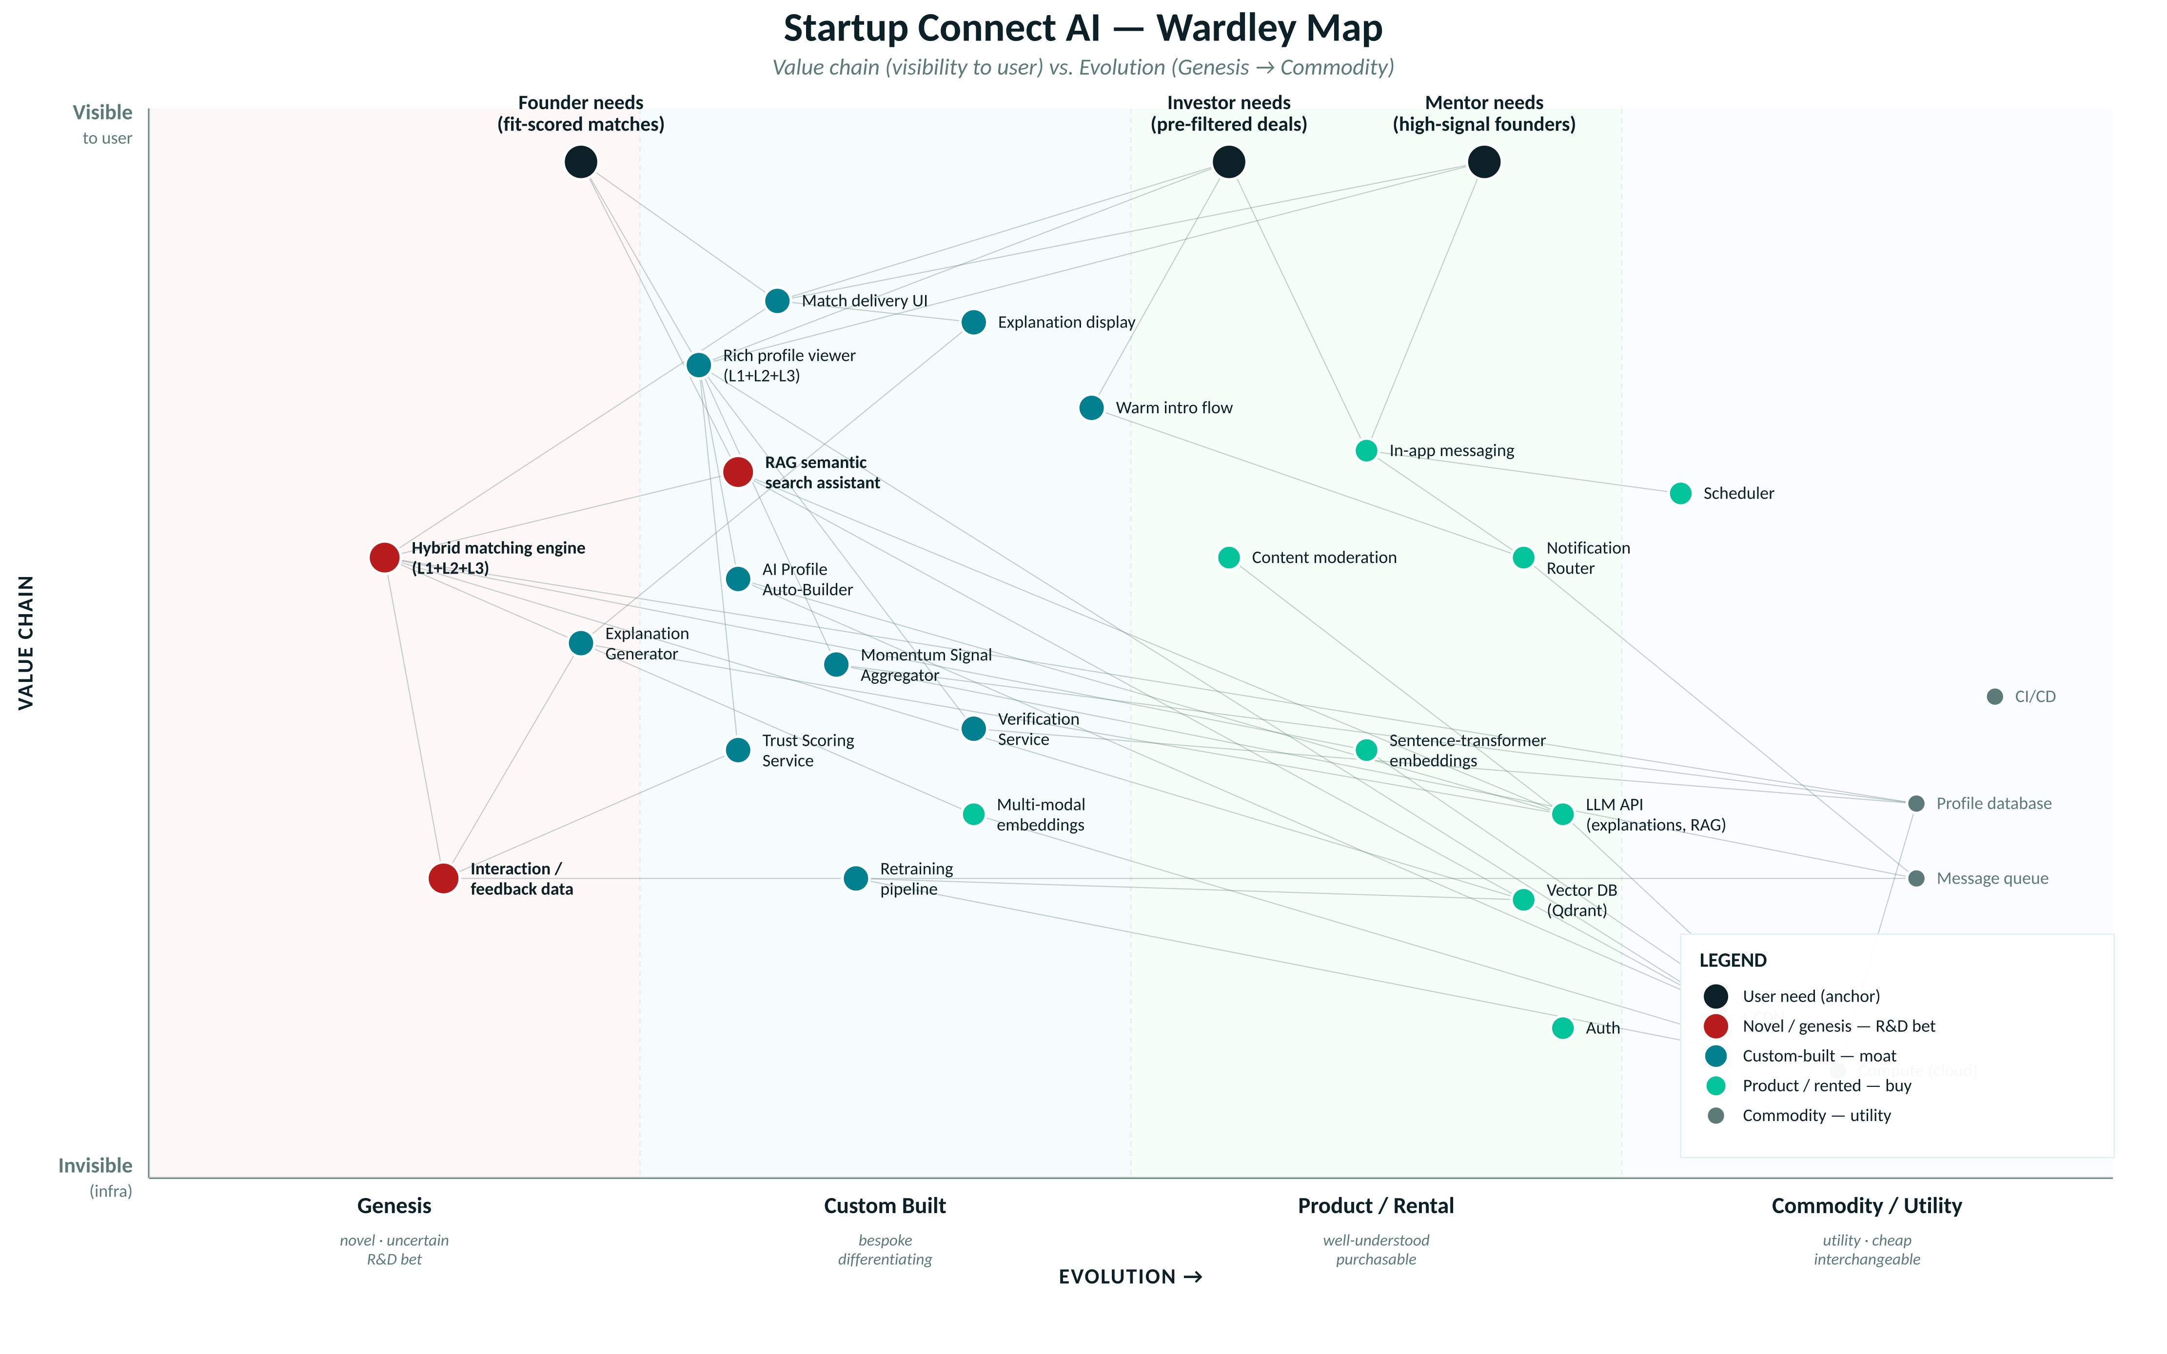
Figure 1 — Startup Connect AI Wardley Map. Each dot is a component; lines show dependencies. Colour indicates category: black (user need), red (novel/genesis R&D bet), teal (custom-built moat), mint (product/rented), grey (commodity/utility). Vertical position = visibility to user; horizontal position = evolutionary stage.

3. Reading the Map — Component Inventory
Every component on the map, grouped by its evolutionary stage. The stage determines the strategic verb: what we do about it. This is the closest thing the map has to a build order.

3.1 Genesis — novel, uncertain, high-risk / high-reward
These are R&D bets. Nobody else has done exactly this. High uncertainty, high potential defensibility. We invest here, but with the understanding that some of it won't work.
Component | Why it's Genesis | Our approach
Hybrid matching engine across L1+L2+L3 profile layers | No existing platform matches founders to investors using multi-modal signal blending structured profile + auto-aggregated momentum + rich founder-authored posts | Build in-house. This is the core R&D bet. Ship a working version, then iterate on ranking quality relentlessly.
Interaction / feedback data (as a proprietary asset) | The value of this data compounds only when we own it, at scale, in our domain. No one has it yet for Indian founder-investor matching. | Design every interaction to leave a feedback trace. Store, version, protect.
RAG semantic search assistant scoped to our profile domain | General RAG exists as a Product, but domain-tuned RAG over founder-investor profiles with fit-score awareness is novel | Build our own retrieval + ranking layer over off-the-shelf LLM + vector DB. The prompt engineering and retrieval logic are custom.

3.2 Custom Built — bespoke, differentiating
These are our moat components. They're built specifically for our product and give us defensibility. We commit engineering time here.
Component | Why it's Custom
Match delivery UI + rich profile viewer | Interface is where user perception forms. Not a place to compromise or template.
Explanation display | The 'why this match' UX is a core differentiator; no product does this well for us
AI Profile Auto-Builder | Parses pitch decks + LinkedIn into our specific profile schema; no off-the-shelf tool matches our data model
Explanation Generator | Wraps LLM output into structured, feature-cited explanations tied to our matching signals
Momentum Signal Aggregator | Custom connectors to LinkedIn, ProductHunt, GitHub, Crunchbase — with our own normalisation into the profile timeline
Trust Scoring Service | Our specific formula (responsiveness × meeting completion × follow-through) — no product replicates this
Verification Service (verified vs. self-reported badging) | Trust primitive unique to our platform; needs to be integrated with the profile UX
Warm intro flow | Product-specific interaction pattern for the founder → investor path
Retraining pipeline | Orchestrates our specific hybrid model on our specific feedback data; not generic

3.3 Product / Rental — well-understood, purchasable
These are mature products with clear vendors. Buying is faster than building and the vendor's product is better than what we'd write. Time spent building any of these is time not spent on our moat.
Component | Vendor / option we'd use | Why not build
Sentence-transformer embeddings | sentence-transformers (open-source), Cohere, Voyage AI | Pre-trained models trained on billions of examples; matching that from scratch is impossible for a team of 3
Multi-modal embeddings (text + image) | CLIP, SigLIP, open-source multi-modal transformers | Same reason as above; training multi-modal encoders is a research org's job, not ours
Vector DB | Qdrant (self-hosted or cloud), Pinecone, Weaviate | Mature products with billions of vectors in production; writing our own means writing another database
LLM API (explanations, RAG) | OpenAI GPT-4o, Anthropic Claude, Groq (Llama) | Frontier models cost > $100M to train; the API is fine and we can swap providers
Content moderation | OpenAI Moderation, Perspective API, Amazon Rekognition | Well-understood classifiers with continuous updates; ours would be worse and take months
Notification Router | SendGrid (email), Twilio + WhatsApp Business API via 360dialog | Deliverability at scale is its own discipline; buy it
Scheduler | Cal.com (open-source) or embedded Calendly widget | Booking widget is a solved problem
In-app messaging | Sendbird, Stream Chat, or Firebase-backed custom | Chat SDKs are mature; our value is in the matching, not the chat UI
Auth | Auth0, Clerk, Supabase Auth | Never write your own auth

3.4 Commodity / Utility — cheap, ubiquitous, interchangeable
These are the plumbing. Any team writing a modern web platform buys these; the only decisions are which vendor and cost management.
Component | Choice
Compute (cloud) | AWS or GCP (start on Railway/Render for simplicity, migrate to raw cloud at ~1000 paying users)
Object storage + CDN | AWS S3 + CloudFront (or Cloudflare R2 + CDN for cost)
Message queue | Redis (Upstash-managed for early stage), RabbitMQ or SQS later
Profile database (relational) | PostgreSQL (Supabase or Neon for zero-ops start)
CI/CD | GitHub Actions
DNS, domains, TLS | Cloudflare

4. Strategic Analysis

4.1 Where our defensibility actually lives
Looking at the map, three components sit in Genesis (red dots). Two clusters of Custom-Built components sit adjacent to them (teal). This is our moat.
- The hybrid matching engine across L1+L2+L3 is genuinely novel. No competitor does profile-layered multi-modal matching for this domain.
- Our proprietary interaction data — every accept/reject, every meeting outcome, every profile view — compounds only for us. A new competitor with the same algorithm gets zero benefit until they accumulate their own data.
- The trust scoring formula and verification service are specific to our platform's history and can't be lifted.
Everything else on the map — vector DB, embeddings, LLM, cloud infra — is either a Product we rent or a Commodity we buy. If a competitor spins up tomorrow with identical infrastructure and identical embeddings, they still can't match us because they lack our data and our custom matching recipe.

4.2 Where teams like ours usually waste time
Every early-stage AI team is tempted to write things that are already Products. The Wardley Map calls this out immediately:
- Writing custom auth — never. Use Auth0 / Clerk.
- Writing a vector database from scratch — never. Use Qdrant.
- Training custom foundation embeddings — never (until we have real domain data and a reason). Use sentence-transformers.
- Building our own chat SDK — never. Use Sendbird or Stream.
- Building custom content moderation classifiers — never (for v1). Use OpenAI Moderation.
Every one of these takes 4-8 weeks and produces something worse than the Product. That's 4-8 weeks not spent on matching quality — the thing that actually matters.

4.3 The commodity trap — and how we avoid it
Wardley's key insight: everything evolves right over time. Today's Custom is tomorrow's Product; today's Product is tomorrow's Commodity. If your business is built on a component that's about to commoditise, you're in trouble.
For us, two components are on the Custom-to-Product boundary and worth watching:
Component | Where it is today | Where it's heading | Implication
RAG frameworks | Custom Built (we glue our own retrieval logic) | Becoming Product (LangChain, LlamaIndex, Vercel AI SDK are maturing fast) | In 12–18 months this will be a Product; our custom RAG code becomes technical debt. Design the abstraction so we can swap our implementation for a framework later.
Explanation generation | Custom (our prompts + parsing) | Becoming Product (specialised explanation services emerging) | Same pattern — abstract behind an interface so we can swap providers.

4.4 What we deliberately do NOT map
- Escrow, term-sheet generation, cap-table management — these aren't on our map because they aren't in our product. If we're tempted to add them, this map is the argument against.
- Public deal-room / social feed — same. Off the map deliberately, per Business Architecture doc's WON'T list.
- Cross-border investor matching (US, SEA) — off the v1 map. Different regulatory regime, different value chain. Would need its own map.

5. Doctrine — Principles We Follow
Doctrine, in Wardley's framework, is the set of universal principles that any organisation should follow regardless of context. Here are the ones that most directly apply to Startup Connect AI, with our specific application of each.
Doctrine | Our application
Focus on user need | Every component on the map traces back to one of three anchors: founder need, investor need, mentor need. If a component doesn't trace back, it doesn't ship.
Use appropriate methods per stage | Genesis components → agile, experimental, in-house R&D. Custom → lean product engineering. Product → integration and API contracts. Commodity → operations and cost management. Don't apply the same method everywhere.
Know your users (and their needs) | Three named personas (Riya, Aditya, Meera in the Business Architecture doc) drive every anchor. Not abstract 'users'.
Remove bias and duplication | The map exposes duplicated intent — e.g. any temptation to build both a custom messaging system AND integrate Sendbird gets caught here.
Use standards where appropriate | OAuth for auth, REST for internal APIs, OpenTelemetry for observability, standard vector DB interfaces so we can swap Qdrant → Pinecone if needed.
Be transparent — challenge and be challenged | This document is public within the team. Anyone can propose a component move (e.g. "move messaging from Buy to Build") and defend it with the map.
Think small (as in teams) | Every component in Custom-Built must be ownable by ≤2 engineers. If it requires more, it's too big — decompose or push to Product tier.
Design for constant evolution | Interfaces around Custom and Genesis components are designed so they can be swapped for maturing Products later (see §4.3).

6. Gameplay — Concrete Moves
Gameplay is the set of context-specific plays we can run on our map. Here are the six that apply to us in the first 18 months.
# | Move | Description | When to run
G1 | Land-grab on data | Onboard as many founders and investors as possible early, even at negative unit economics, to accumulate the interaction data that feeds our moat | First 6 months. Aggressive incubator partnerships, free tier for founders, waived investor onboarding fees.
G2 | Buy the boring bits | Refuse to build anything on the Product or Commodity part of the map. Use Auth0, Sendbird, Qdrant, OpenAI, Cloudflare. Reserve engineering time for Genesis + Custom. | Continuously. Every sprint planning: is this in our Custom column? If not, buy or drop.
G3 | Abstract the movers | Design interfaces around Custom components that are on the edge of becoming Products (RAG, explanation gen) so we can swap our implementation for a Product later without rewriting | During v1 build. Cost is low if done upfront, prohibitive if done later.
G4 | Standardise interfaces to protect against vendor lock-in | Use the OpenAI-compatible API spec for LLMs so we can swap Anthropic ↔ Groq ↔ Together ↔ Fireworks. Use standard vector DB interfaces (Qdrant's is OpenAPI-compatible with several) | v1 architecture. Zero cost to build in, huge cost to retrofit.
G5 | Two-factor market — investors as the paying side | Extract value from the side that's small, high-value, and gets more benefit (investors). Keep the demand side (founders) free to protect the network effect. | Monetisation kicks in Phase 3 (Month 9). Details in Business Architecture §7.
G6 | Fast-follow on emerging RAG patterns | The RAG space is moving fast. Don't invent our own; adopt what's proven within 60 days of publication. Track: LangChain updates, arXiv on retrieval augmented recommenders, ACM RecSys. | Continuously; assign one engineer as the tracker.

Anti-plays — things that look attractive but are wrong for us
Anti-play | Why it's tempting | Why we don't
Build our own foundation model (finetune Llama on founder data) | Sounds cutting-edge; investor-conversation-worthy | We have <10,000 examples. Finetuning at that scale gives negligible lift vs. cost. Use prompting until we have >100k examples.
Build a custom chat SDK because 'we need control' | Sendbird is expensive at scale | Chat isn't our value. Even at 5000 users, Sendbird costs less than one engineer-month/year.
Vertically integrate into legal doc generation | Adjacent to fundraising; obvious upsell | Different product, different liability, different regulatory surface. Not our map.
Build our own vector DB because 'Qdrant is too heavy' | Sometimes tempting when a specific query pattern is awkward | Qdrant handles billions of vectors in production. Our v1 will have <1M. Zero justification.

7. Climatic Patterns — How the Map Will Evolve
Climatic patterns are the rules of how the environment changes, regardless of what we do. Two of Wardley's climatic laws are worth calling out for us:

7.1 Everything evolves
The default direction is left-to-right. Today's Custom becomes tomorrow's Product; today's Product becomes tomorrow's Commodity. Nothing sits still.
18-month projection of the map:
Component | Today | In 18 months | So we...
RAG orchestration | Custom Built | Product (LangChain / LlamaIndex mature) | Move ours behind a swappable interface now
Explanation generation | Custom | Product (specialised services emerge) | Same — interface-first design
Multi-modal embeddings | Product (early) | Product (mature) or Commodity | No change needed; we're just users
Vector DB | Product | Approaching Commodity | May switch to cheapest provider based on cost
LLM API | Product | Commodity (many interchangeable providers) | Standardise on OpenAI API spec for portability
Trust scoring for founder-investor domain | Genesis (ours is novel) | Custom (competitors copy the pattern) | By then our advantage is the accumulated data, not the algorithm
Hybrid founder-investor matching | Genesis (ours) | Custom (2-3 competitors exist) | By then our moat is data volume + trust brand, not novelty

7.2 Efficiency vs. innovation trade-off
Genesis is inefficient by nature — you're figuring things out. Commodity is efficient by nature — the market has optimised the component. The instinct to make Genesis 'efficient' too early (write clean code, add process, add documentation) kills innovation. The instinct to leave Commodity 'flexible' (customise, extend, wrap) wastes money.
Practical implication: our Genesis components (matching engine, RAG assistant) should be scrappy, changed weekly, minimal test coverage — because the shape isn't stable. Our Commodity components (compute, storage) should be locked-down, provisioned via Terraform, unchanged for months — because the shape is fixed.

8. Decisions Locked from This Map
Fifteen concrete decisions that come out of this mapping exercise. Each one traces to a section above.
# | Decision | Rationale
W1 | We will NOT build our own vector database — Qdrant only | Product tier (§3.3); building would take 3+ months for a worse result
W2 | We will NOT train our own embedding model — sentence-transformers / OpenAI embeddings only, until we have >100k domain examples | Product tier; foundation model training is not our fight
W3 | We will NOT build our own auth — Clerk or Supabase Auth | Product tier; security surface too large to own
W4 | We will NOT build our own chat / messaging SDK — Sendbird or Stream Chat | Product tier; chat is not our value proposition
W5 | We will NOT build our own scheduler — embed Cal.com widget | Product tier; scheduling is a solved problem
W6 | We WILL build the matching engine end-to-end in-house | Genesis tier; this is the moat
W7 | We WILL build the explanation generator wrapping LLM APIs, using our own prompt templates and feature-citation logic | Custom tier; the interface between LLM output and our UI is differentiating
W8 | We WILL build the Momentum Signal Aggregator with custom connectors to LinkedIn, ProductHunt, GitHub, Crunchbase | Custom tier; the specific transformation into our profile timeline is unique
W9 | We WILL treat interaction / feedback data as a proprietary asset — schema-versioned, backed up, never sold | Genesis tier; this is the compounding moat
W10 | We WILL design abstractions around our RAG code so it can be swapped for a framework in 12-18 months | Climatic pattern §7.1; anticipating commoditisation
W11 | We WILL standardise on the OpenAI-compatible LLM API spec, and never lock into a single provider | Gameplay G4; vendor risk mitigation
W12 | We WILL adopt an 'engineering time is only spent on Custom + Genesis' rule in sprint planning | Doctrine §5; every sprint enforces the map
W13 | We WILL run land-grab on data acquisition for the first 6 months (free tier for founders, aggressive incubator deals) | Gameplay G1; data compounds only with volume
W14 | We WILL revisit this map every 6 months and re-plot any component that has moved | Climatic pattern §7.1; the map is a living document, not a one-time artefact
W15 | We WILL not add any component to the platform without first placing it on the map and justifying it lives in Custom or Genesis | Doctrine — remove bias and duplication

End of Document 3 of 3. Series complete: Research Report + Business Architecture + Wardley Mapping.

