Lipkart

Introduction

I will create a flipkart home page clone and give it a name as Lipkart. It is an e commerce website.

POP UP Page

I will make a pop up page that comes up when open the website.

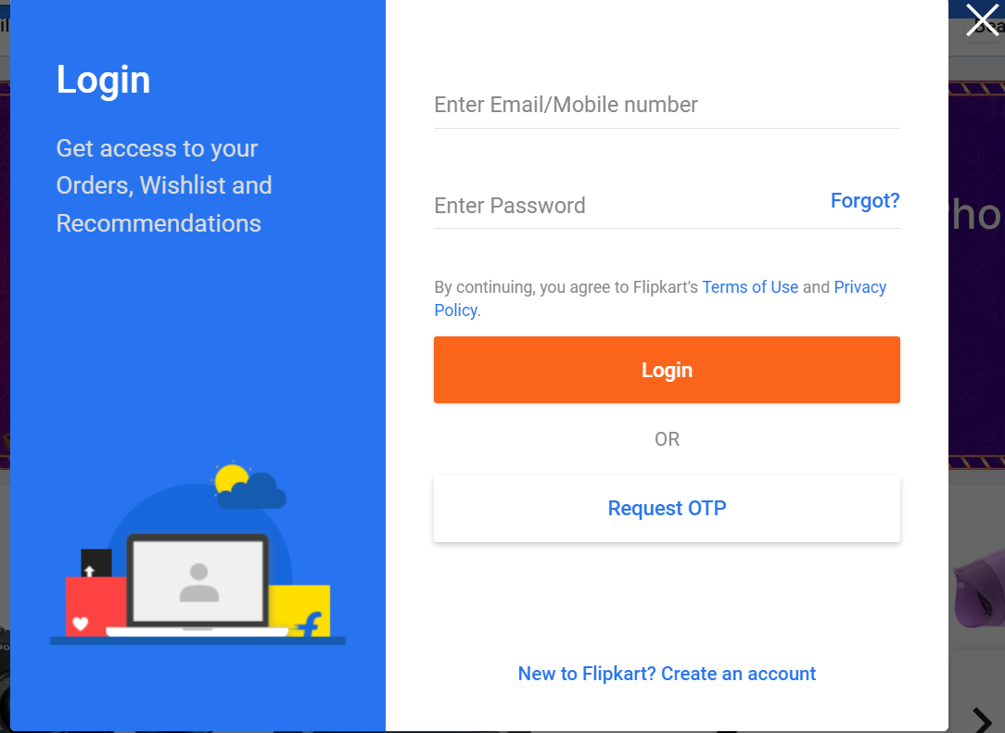

Header Section

Making the header that contains menu bar and login button and add to kart button



Slider Section

Making a slider section with 3 images with left and right arrow on it



Listing Page and detail page

I will create 2 containers (listing page) that show products and lands on detail page

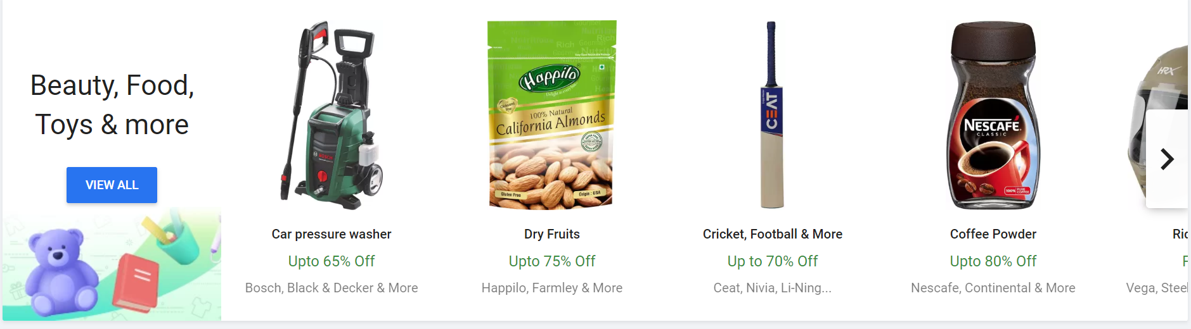

Detail page

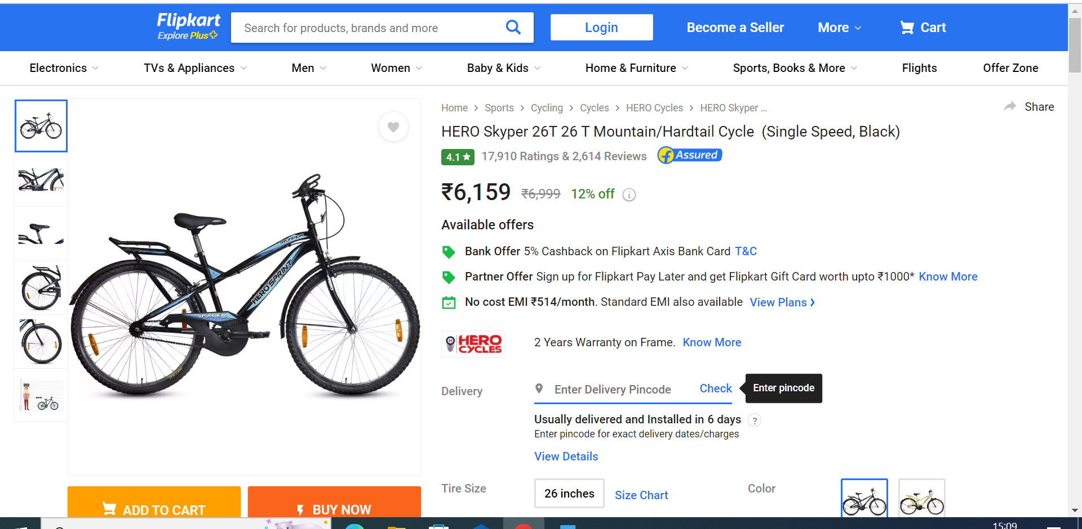

Add to cart and Payment gateway

I will integrate the payment gateway to the product for payment processing and I will also create add to kart page.

Footer Page

I will create a footer page like shown below

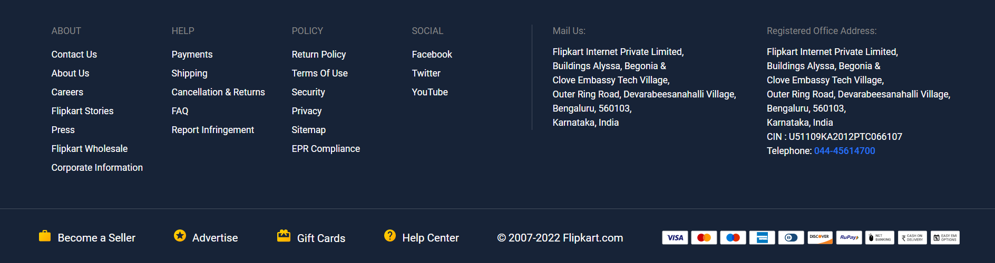

Thank you!

Durgesh