WEEK 2 PROJECT
Advanced Data Visualization & Storytelling with Python
The Development Story: Income, Health and Population

Tools: Python • Pandas • NumPy • Matplotlib • Seaborn • Plotly
Dataset: Gapminder sample dataset • 1,704 country-year observations

1. Executive Summary
This project demonstrates how visualization can turn a multidimensional dataset into a coherent story for a non-technical audience. The analysis uses the Gapminder sample dataset, which contains 1,704 country-year observations covering population, GDP per capita and life expectancy. The central narrative is that economic development, population scale and health outcomes changed substantially over time, but the improvements were uneven.
In 2007, the correlation between GDP per capita and life expectancy in the dataset was 0.68. This is an association, not proof that income alone causes better health. The visual narrative therefore emphasizes patterns, differences and questions for policy or further investigation rather than causal claims.

2. Introduction
The objective of Week 2 is to move beyond isolated charts and build a visual narrative. The analysis starts with a time trend, moves to the relationship between income and health, adds population scale, examines within-continent variation, identifies high-income outliers, and finishes with geographic and animated interactive views.

3. Dataset Description
The Gapminder dataset used by Plotly represents each country at multiple points in time and includes country, continent, year, life expectancy, population, GDP per capita and country codes. Plotly's current documentation describes 1,704 rows and these eight columns. Gapminder explains that its data combines information from multiple sources into coherent time series and documents the methodology behind the combined indicators.
Variable | Type | Purpose
country | Categorical | Country-level identification
continent | Categorical | Regional grouping
year | Time | Trend analysis
lifeExp | Numeric | Health outcome
pop | Numeric | Population scale
gdpPercap | Numeric | Economic development indicator
iso_alpha | Categorical | Country code for maps

4. Methods and Data Preparation
- Loaded the reproducible dataset through Plotly Express.
- Checked structure, missing values and duplicate rows.
- Grouped records by year and continent for time-series summaries.
- Filtered the latest available year (2007) for cross-sectional comparisons.
- Used a logarithmic x-axis for GDP per capita because income values span a wide range.
- Used population as bubble size to add a third quantitative dimension without adding another axis.
- Used Plotly for interactive geographic and animated storytelling.
Data quality check: 0 missing cells and 0 duplicate rows were found in the loaded dataset.

5. Visualization 1 — Life Expectancy Trend
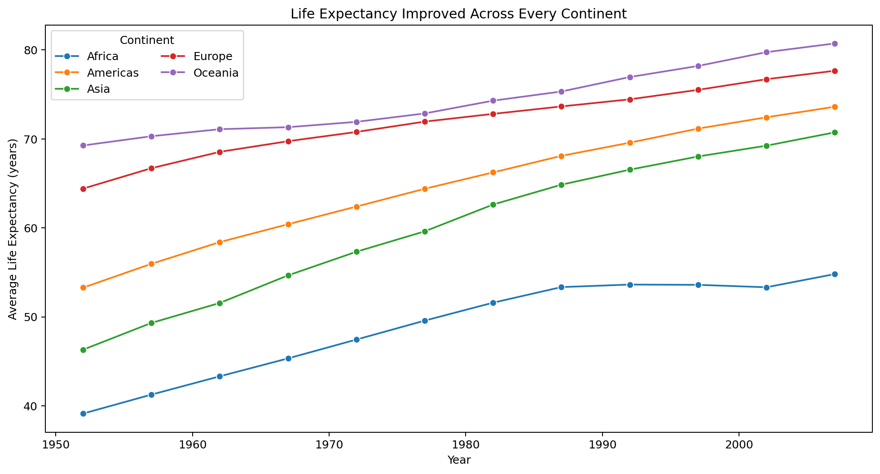
Caption: Average life expectancy by continent from 1952 to 2007.
Why this visual? A line chart is appropriate because the first question is about change over time. The separate continent lines make it possible to compare both direction and pace of change. All continental averages increased over the study period; the largest absolute increase in this dataset occurred in Asia.
Narrative role: This establishes the story's baseline—global health outcomes improved, but the trajectory was not identical everywhere.

6. Visualization 2 — GDP per Capita vs Life Expectancy
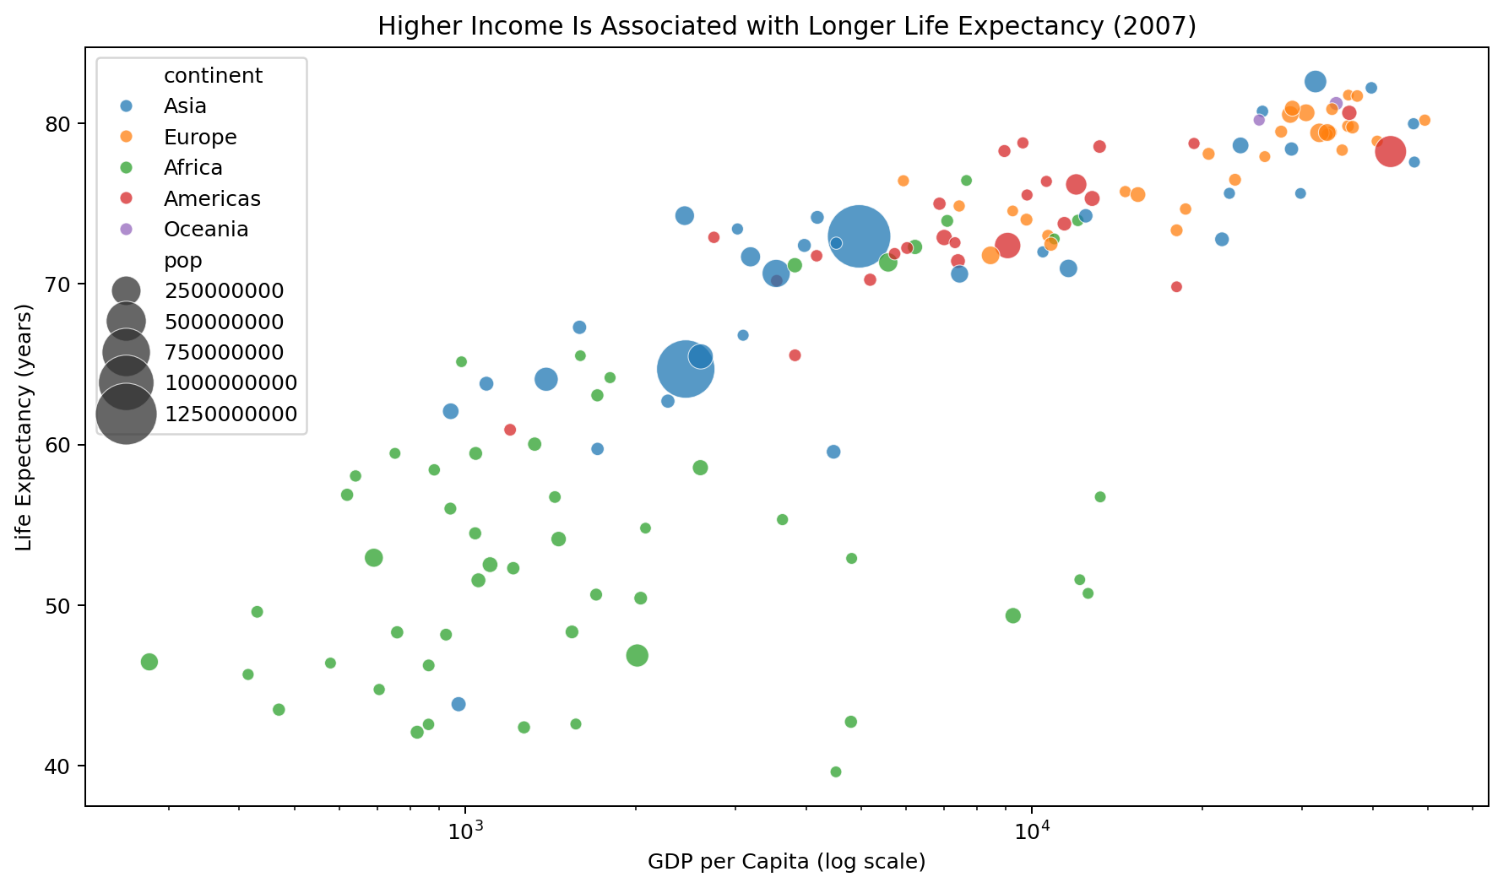
Caption: Country-level relationship between GDP per capita, life expectancy and population in 2007.
Why this visual? A scatter plot is ideal for testing whether two numeric variables move together. The log scale prevents high-income observations from compressing most countries into one corner. The 2007 cross-section shows a strong positive association (Pearson r = 0.68).
Narrative role: The audience can see that economic and health indicators are related, while also seeing exceptions and differences in population scale.

7. Visualization 3 — Population Growth
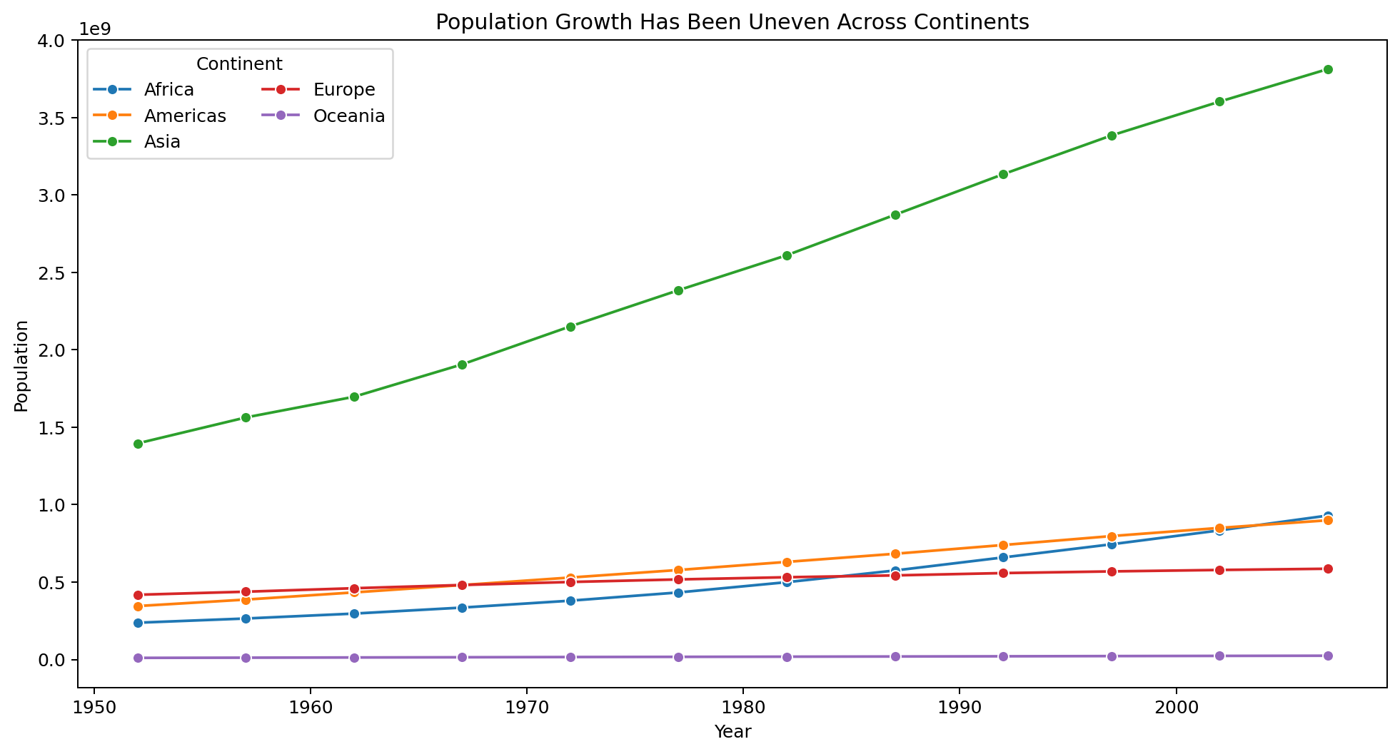
Caption: Total population by continent across the study period.
Why this visual? Population is a scale variable. A line chart makes long-run demographic change visible and avoids treating a large population and a small population as equivalent. The lines show that population growth was uneven, meaning that the same health or economic indicator can have very different implications when applied to different population sizes.
Narrative role: This adds human scale to the economic and health story.

8. Visualization 4 — Life Expectancy Distribution
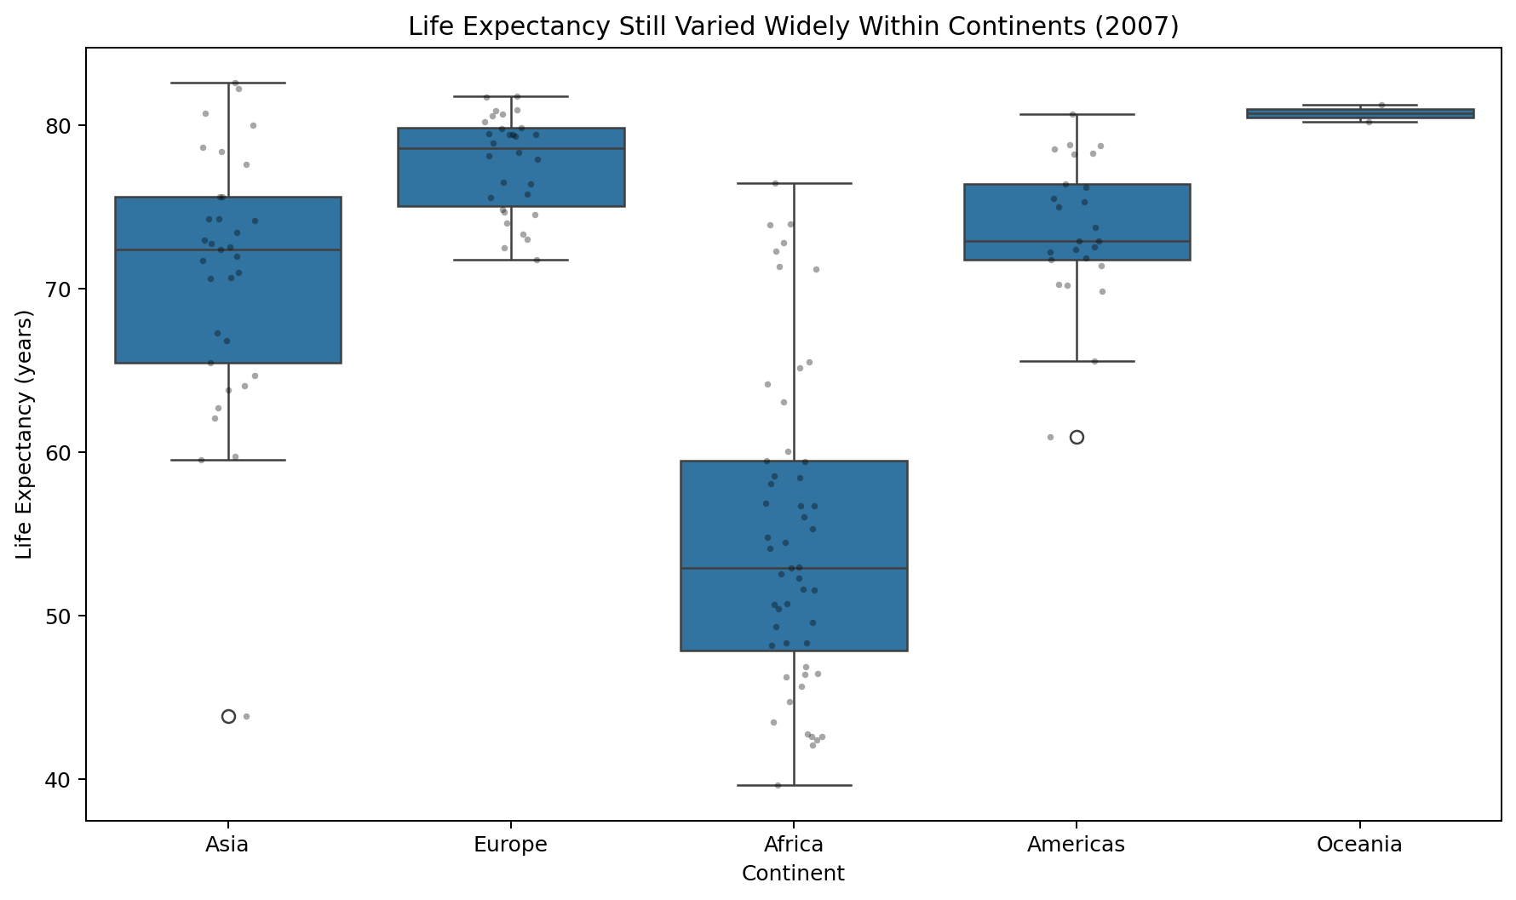
Caption: Distribution of country-level life expectancy within each continent in 2007.
Why this visual? Averages can hide inequality. The box plot shows median, spread and potential outliers, while the individual points preserve country-level variation. This prevents the audience from interpreting a continental average as if every country had the same outcome.
Narrative role: The story moves from broad averages to within-group differences.

9. Visualization 5 — Highest GDP per Capita
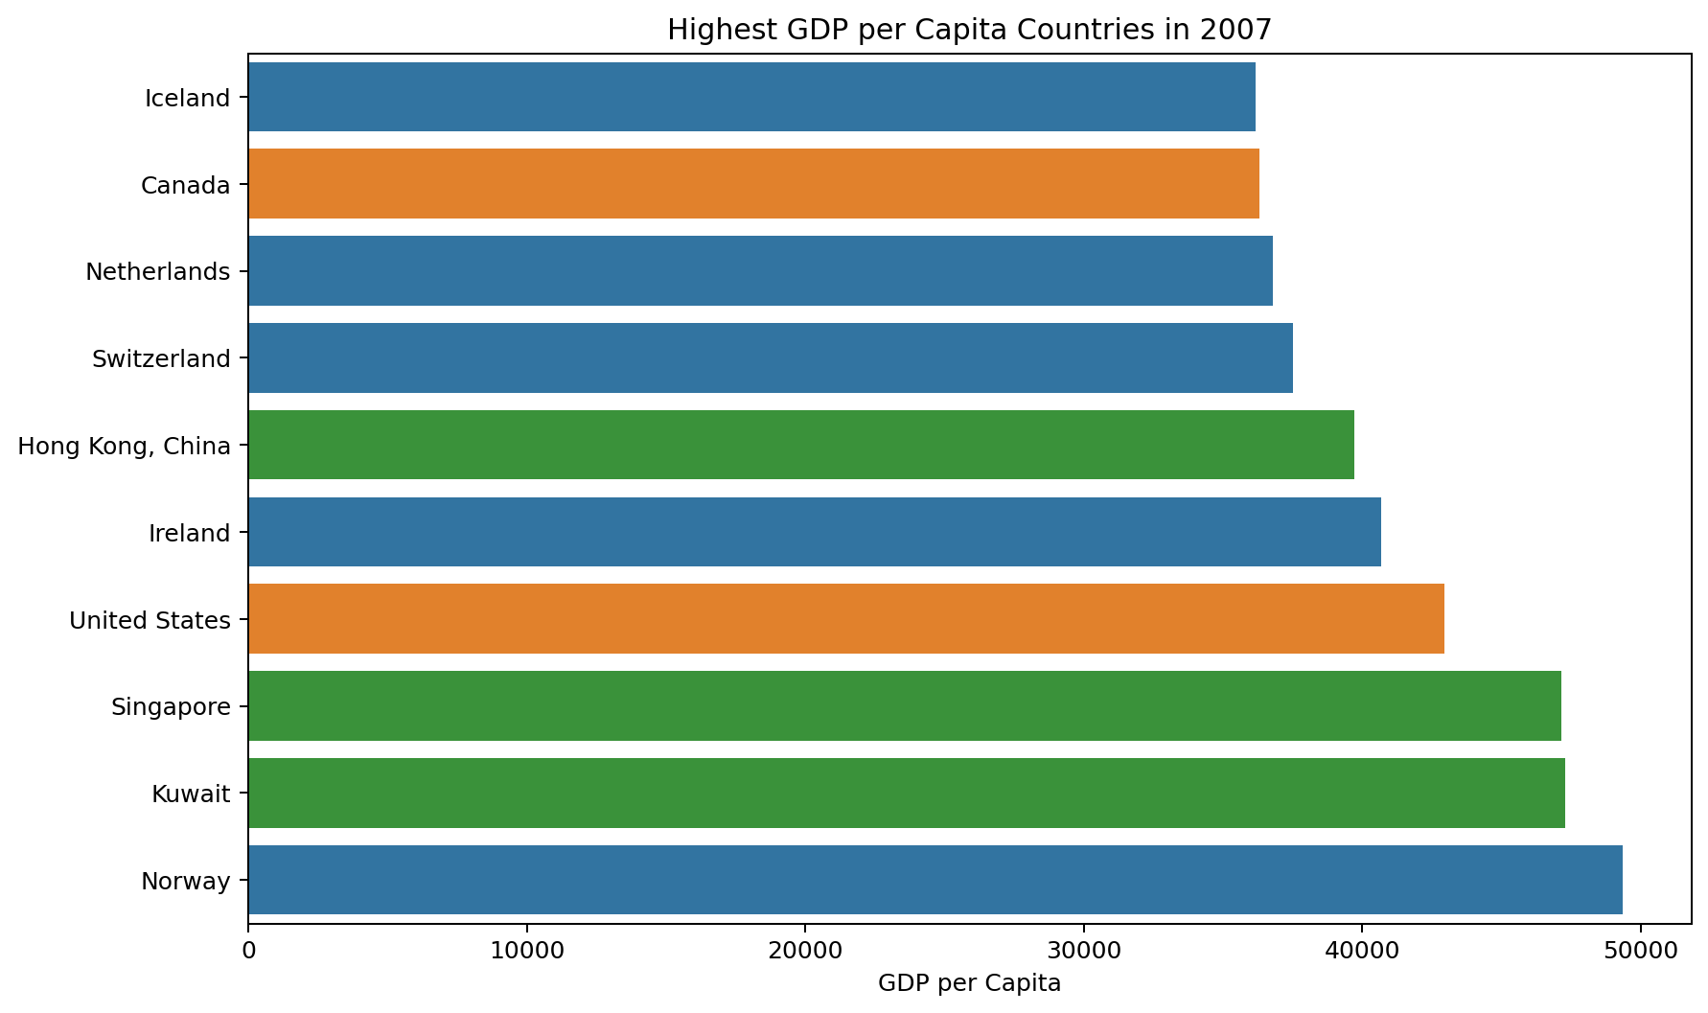
Caption: Ten countries with the highest GDP per capita in 2007.
Why this visual? Ranking questions are best answered with sorted bars. The chart highlights the upper end of the income distribution and makes country-to-country differences easier to compare than a pie chart or unordered category chart.
Narrative role: It identifies high-income outliers and creates a natural transition to the interactive geographic view.

10. Visualization 6 — Interactive Global Map
The accompanying HTML map uses a choropleth to encode life expectancy geographically. Users can hover over countries to inspect the country name, life expectancy, GDP per capita and population. This visual is intentionally interactive because geography is easier to interpret when the audience can explore individual countries.
Open: visualizations/06_global_life_expectancy_map.html

11. Visualization 7 — Animated Bubble Story
The accompanying Plotly animation combines three quantitative dimensions—GDP per capita, life expectancy and population—and adds year as an animation frame. This is the project's strongest storytelling visual because the audience can watch the relationship evolve rather than infer change from separate static charts.
Open: visualizations/07_animated_development_bubble.html

12. Key Insights
- Life expectancy increased across every continent in the dataset; the largest absolute continental increase was observed for Asia over 1952–2007.
- In 2007, GDP per capita and life expectancy showed a strong positive association (r = 0.68).
- The country with the highest life expectancy in 2007 was Japan (82.6 years).
- The lowest life expectancy in 2007 was recorded for Swaziland (39.6 years).
- The largest population in 2007 belonged to China, illustrating why population scale matters when interpreting country-level indicators.
- The highest GDP per capita in 2007 belonged to Norway, showing the long upper tail of the income distribution.

13. Business / Scientific Implications
- Policy prioritization: large gaps in health outcomes can help decision-makers identify countries or regions that warrant deeper investigation.
- Resource allocation: population scale should be considered alongside per-capita indicators because an improvement affecting a large population can have a different aggregate impact.
- Benchmarking: organizations can compare countries or regions against peers rather than relying only on a global average.
- Causal caution: the GDP–life expectancy relationship is observational. Further analysis would be required to test mechanisms such as healthcare access, education, sanitation, nutrition and inequality.
- Communication: interactive maps and animated charts can help non-technical stakeholders explore complex relationships without requiring them to read statistical tables.

14. Recommendations
- Use a two-level reporting approach: headline trends for executives and country-level drill-downs for analysts.
- Pair economic indicators with health and population measures rather than reporting GDP alone.
- Investigate countries that deviate substantially from the overall GDP–life expectancy pattern; these can reveal either positive policy outcomes or structural risks.
- When presenting trends, always show the distribution or country-level variation behind the average.
- For future work, add healthcare expenditure, education, inequality and mortality indicators to move from descriptive storytelling toward explanatory analysis.

15. Conclusion
The project demonstrates that effective data storytelling is more than producing attractive charts. Each visualization was selected to answer a specific question and advance the narrative: What changed? How are income and health related? How large are the populations involved? How much variation is hidden by averages? Which countries are outliers? Where are these patterns located? And how do they evolve through time?
The final story is therefore both visual and analytical: development outcomes improved substantially, but progress remained uneven across countries and continents. The findings support further scientific and policy investigation while avoiding unsupported causal conclusions.

16. Skills Demonstrated
- Data loading and validation
- Pandas grouping and transformation
- Matplotlib visualization
- Seaborn statistical visualization
- Plotly interactive visualization
- Geospatial storytelling
- Time-series storytelling
- Annotation and captioning
- Insight generation
- Business/scientific interpretation
- Report documentation

17. References
Gapminder data documentation: https://www.gapminder.org/data/documentation/
Plotly Express Gapminder dataset documentation: https://plotly.github.io/plotly.py-docs/generated/plotly.express.data.html
Plotly sample datasets: https://plotly.github.io/datasets/

