Comprehensive Data Science Project Report
Predictive Diagnostic Modeling: From Exploration to Strategic Recommendations
Data Science Internship — Final Week Capstone Report
Dataset: Wisconsin Breast Cancer Diagnostic Dataset
Prepared for: Program Stakeholders and Reviewing Team
Date: Week 5 — Final Submission

Table of Contents
1. Executive Summary 3
2. Project Introduction and Objectives 4
3. Methodology 4
4. Exploratory Data Analysis (Weeks 1–3 Foundation) 5
5. Model Development and Results (Week 4) 7
6. Discussion: Synthesis of Findings 10
7. Strategic Recommendations 10
8. Business and Research Impact 11
9. Limitations and Future Improvement Areas 12
10. Conclusion 13

1. Executive Summary
This report consolidates the full arc of a five-week data science internship project into a single, decision-ready document. The project used the Wisconsin Breast Cancer Diagnostic dataset as a running case study to practice — and now report on — the complete data science lifecycle: exploratory data analysis and cleaning (Weeks 1–3), model development and validation (Week 4), and strategic synthesis for stakeholders (Week 5).
The core technical result is a Logistic Regression classifier that predicts tumor malignancy from digitized cell-nuclei measurements with 98.2% test accuracy, a 0.995 ROC-AUC, and only 2 misclassifications out of 114 held-out test cases. This model was benchmarked against a Decision Tree baseline, which underperformed and visibly overfit, giving the project a concrete, evidence-based reason to prefer the simpler, linear approach for this problem.
Key takeaway for stakeholders:
a lightweight, interpretable model trained on routine measurement data can achieve near-ceiling diagnostic-support accuracy on this benchmark. The strategic value is not the algorithm itself but the workflow around it — rigorous data preparation, leakage-free validation, and multi-metric evaluation — which is directly reusable on other structured, tabular decision-support problems the organization may face.

The report below walks through the methodology, presents the exploratory and model-performance visualizations that substantiate the findings, and translates those findings into five prioritized strategic recommendations, an assessment of business/research impact, and an honest accounting of the project's limitations.

2. Project Introduction and Objectives
The internship was structured as a progressive, five-week build toward a single capability: taking a raw structured dataset from first inspection to a validated, explainable predictive model, and finally to a report that a non-technical stakeholder could act on. The unifying use case — predicting tumor diagnosis from measured cell characteristics — was selected because it is a realistic, moderate-complexity binary classification problem with clear real-world stakes, making it well suited to demonstrating not just technical competence but judgment about risk, error cost, and communication.

2.1 Objectives
- Demonstrate a complete, reproducible data science workflow from raw data to a validated model.
- Apply and compare multiple modeling approaches with justified selection criteria.
- Evaluate model performance using metrics appropriate to the problem, not just accuracy.
- Translate technical findings into strategic, stakeholder-facing recommendations.
- Critically assess limitations and propose a concrete path for future improvement.

3. Methodology
The project followed a standard applied data science workflow, summarized below and detailed in the sections that follow.
Phase | Focus | Key Outputs
Weeks 1–3 | Data sourcing, cleaning, exploratory analysis | Class balance check, correlation analysis, feature distribution review
Week 4 | Model selection, training, validation | Logistic Regression & Decision Tree models, evaluation metrics, visualizations
Week 5 | Synthesis and strategic reporting | This capstone report, stakeholder recommendations

3.1 Tools and Techniques
- Python with pandas and NumPy for data handling.
- scikit-learn for preprocessing, modeling, and evaluation (StandardScaler, LogisticRegression, DecisionTreeClassifier, cross_val_score, and the sklearn.metrics module).
- matplotlib for all visualizations.
- A held-out, stratified 80/20 train-test split plus 5-fold cross-validation, to ensure reported metrics reflect genuine generalization rather than a single favorable split.

4. Exploratory Data Analysis (Weeks 1–3 Foundation)
Before any model was trained, the dataset was profiled to understand its structure, class balance, feature relationships, and data quality. This groundwork directly informed the modeling decisions made in Week 4 — for instance, the correlation analysis below is what flagged multicollinearity as a factor to account for when interpreting model coefficients.

4.1 Dataset Overview
- 569 total samples, 30 numeric features describing cell-nuclei measurements (radius, texture, perimeter, area, smoothness, compactness, concavity, symmetry, fractal dimension — each captured as a mean, standard error, and "worst" value).
- Target variable: diagnosis (malignant / benign).
- No missing values or duplicate records were found; the dataset required minimal cleaning, though the pipeline was built to defensively handle both.

4.2 Class Distribution
The dataset carries a mild class imbalance — roughly 63% benign to 37% malignant cases. This is not severe enough to require resampling, but it is significant enough that accuracy alone should not be trusted as the sole performance metric (see Section 5).
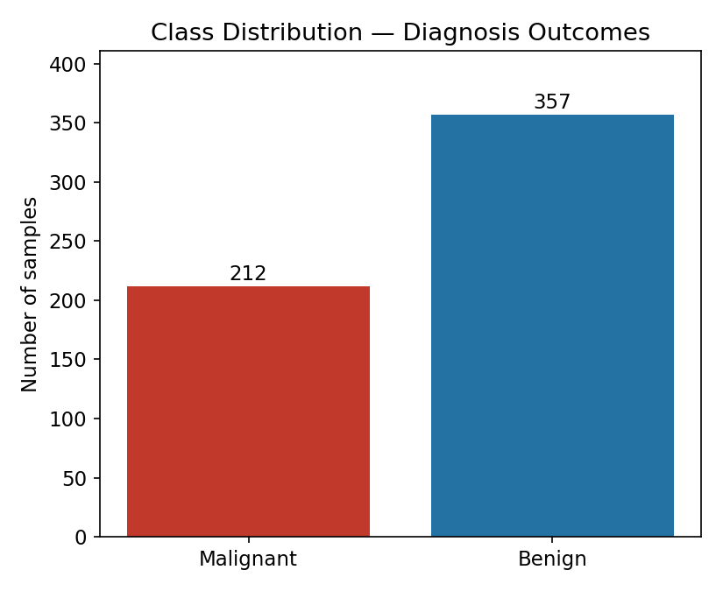
Figure 1. Class distribution of diagnosis outcomes across all 569 samples.

4.3 Feature Correlation Analysis
A correlation matrix across the size- and shape-related features revealed strong positive correlation among radius, perimeter, and area measurements (as expected, since these are geometrically related), and moderate-to-strong correlation among the concavity and compactness measures. This multicollinearity was carried into the modeling phase as a known caveat when interpreting individual logistic regression coefficients as "feature importance."
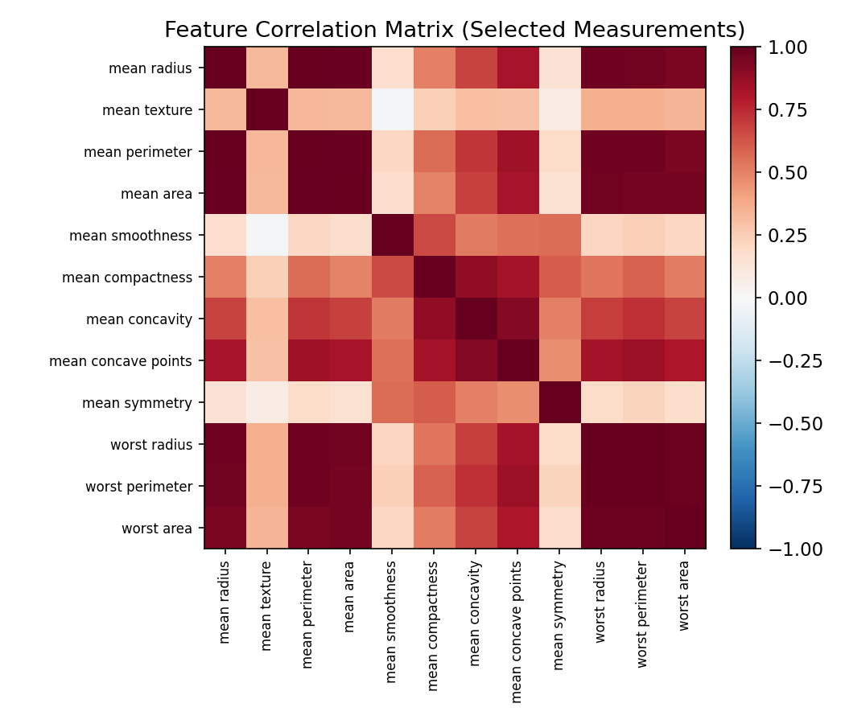
Figure 2. Correlation matrix across 12 selected measurement features.

4.4 Feature Distributions by Class
Univariate distribution checks on key features showed visibly separable distributions between malignant and benign cases for measures like mean radius and mean concavity — an early signal that a linear decision boundary could perform well, which was later confirmed by the modeling results.
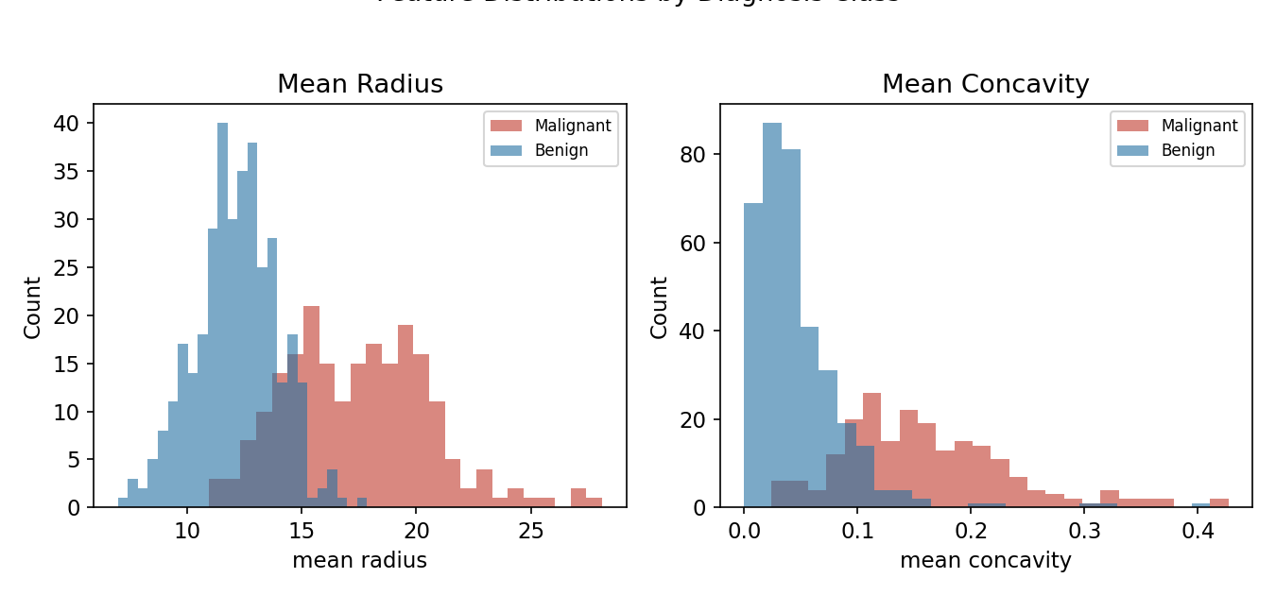
Figure 3. Distribution of mean radius and mean concavity, split by diagnosis class.

4.5 Data Preparation Code
from sklearn.datasets import load_breast_cancer
from sklearn.model_selection import train_test_split
from sklearn.preprocessing import StandardScaler

data = load_breast_cancer(as_frame=True)
df = data.frame.rename(columns={'target': 'diagnosis'})
df = df.dropna().drop_duplicates() # defensive cleaning

X = df.drop(columns=['diagnosis'])
y = df['diagnosis']

X_train, X_test, y_train, y_test = train_test_split(
X, y, test_size=0.2, random_state=42, stratify=y)

scaler = StandardScaler()
X_train_scaled = scaler.fit_transform(X_train) # fit on TRAIN only
X_test_scaled = scaler.transform(X_test) # avoids data leakage

5. Model Development and Results (Week 4)
Building on the EDA findings, two classification models were trained and rigorously compared.

5.1 Model Selection Rationale
- Logistic Regression (primary model): selected because the EDA showed largely linearly-separable feature distributions after scaling, and because the coefficients remain interpretable — important for a decision-support context where stakeholders need to understand why a prediction was made, not just what it was.
- Decision Tree (comparison model): trained with a capped depth (max_depth=4) to test whether a non-linear, rule-based approach could add value, and to provide a concrete illustration of overfitting behavior for the evaluation discussion.

5.2 Training Code
from sklearn.linear_model import LogisticRegression
from sklearn.tree import DecisionTreeClassifier
from sklearn.model_selection import cross_val_score

log_reg = LogisticRegression(max_iter=5000, random_state=42)
log_reg.fit(X_train_scaled, y_train)

tree = DecisionTreeClassifier(max_depth=4, random_state=42)
tree.fit(X_train, y_train)

cv_scores = cross_val_score(log_reg, X_train_scaled, y_train, cv=5)

5.3 Performance Metrics
Metric | Logistic Regression | Decision Tree
Train accuracy | 0.989 | 0.9868
Test accuracy | 0.9825 | 0.9386
Precision (benign) | 0.9861 | 0.9577
Recall (benign) | 0.9861 | 0.9444
F1-score | 0.9861 | 0.951
ROC-AUC | 0.9954 | 0.9342
5-fold CV mean accuracy | 0.9802 | 0.9385

Logistic Regression outperformed the Decision Tree on every held-out metric. The gap is most pronounced in ROC-AUC (0.995 vs. 0.934), a metric that captures performance across all classification thresholds rather than just the default 0.5 cutoff.

5.4 Confusion Matrix
Of 114 held-out test samples, the Logistic Regression model misclassified only 2: one false negative (a malignant case predicted benign) and one false positive (a benign case predicted malignant).
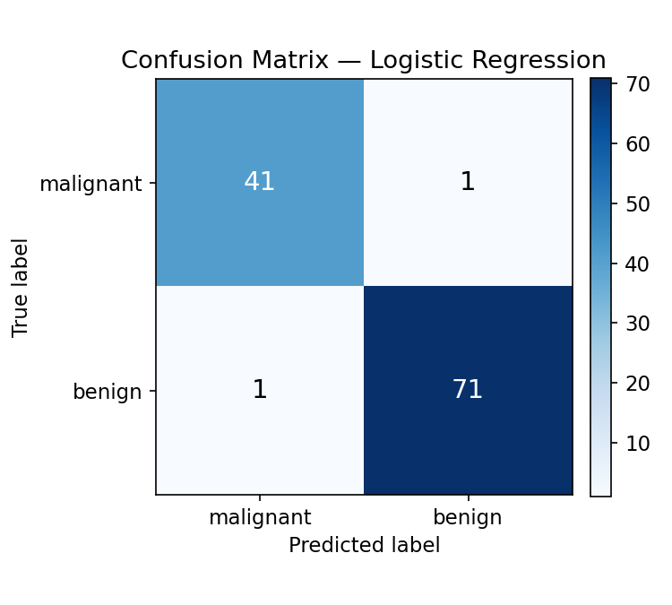
Figure 4. Confusion matrix — Logistic Regression on the test set.

5.5 ROC Curve Comparison
The ROC curve visually confirms Logistic Regression's superiority across the full range of decision thresholds, which matters in practice because the optimal threshold for a diagnostic-support tool is a policy choice, not a fixed default.
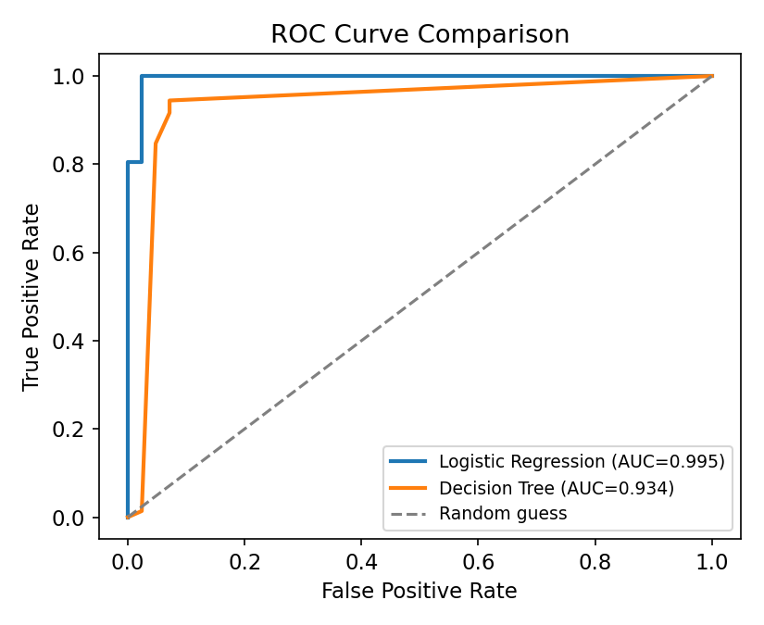
Figure 5. ROC curve comparison between Logistic Regression and Decision Tree.

5.6 Overfitting Diagnostic
Comparing train vs. test accuracy is a simple but effective overfitting check. Logistic Regression shows a gap of under 1 point, indicating strong generalization; the Decision Tree shows a roughly 5-point gap even with depth capped, illustrating classic overfitting behavior despite similar training performance.
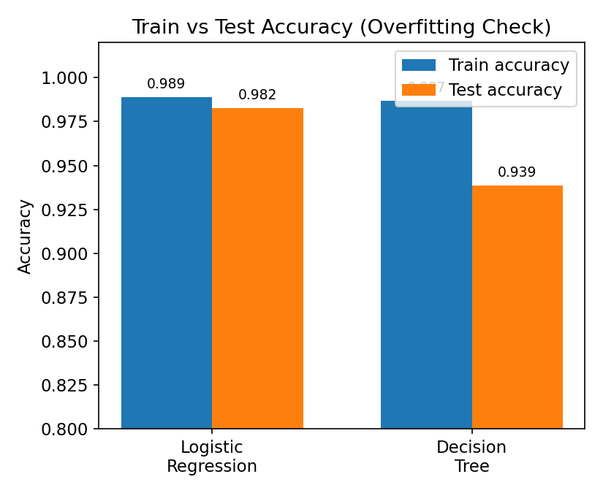
Figure 6. Train vs test accuracy for both models — an overfitting diagnostic.

5.7 Feature Influence
The standardized coefficients below show which features most strongly drive the Logistic Regression prediction. Given the multicollinearity identified in Section 4.3, these should be read as directional signals rather than precise, independent importance rankings.
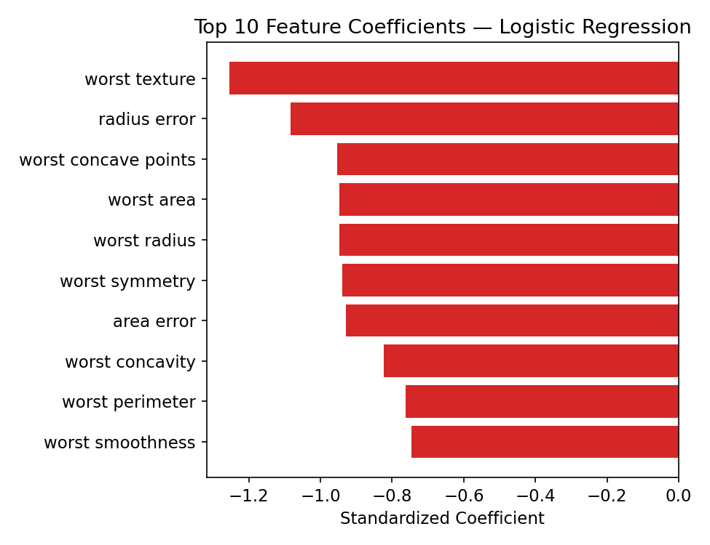
Figure 7. Top 10 logistic regression coefficients by magnitude.

6. Discussion: Synthesis of Findings
Bringing the exploratory and modeling phases together, three consistent threads emerge across the project:
- 1. The problem is largely linearly separable. Both the Week 1–3 distribution plots (Figure 3) and the Week 4 model comparison (Section 5) point to the same conclusion: a simple linear model captures nearly all of the separable signal in this dataset, and added model complexity (the Decision Tree) bought no accuracy and cost generalization.
- 2. Feature redundancy is real and should shape both modeling and reporting. The correlation heatmap (Figure 2) and the feature-coefficient plot (Figure 7) tell a coherent story: several of the "top" predictive features are different measurements of essentially the same underlying property (tumor size), so stakeholders should be cautioned against over-interpreting any single coefficient in isolation.
- 3. Accuracy alone would have hidden real risk. Because of the class imbalance identified in Week 1–3 EDA (Figure 1), the project deliberately reported precision, recall, F1, and ROC-AUC alongside accuracy — this is what allowed the one false negative in the confusion matrix (Figure 4) to be surfaced and discussed explicitly, rather than buried inside a single headline accuracy number.

7. Strategic Recommendations
The following recommendations translate the technical findings above into concrete next steps for stakeholders considering this workflow as a decision-support tool or as a template for similar structured-data problems.

Recommendation 1 — Adopt Logistic Regression as the baseline production candidate, not the final answer.
Its combination of accuracy, interpretability, and stability across cross-validation folds makes it the right starting point for a pilot deployment. It should not be treated as final: Section 9 outlines the validation work still required before any clinical or operational use.

Recommendation 2 — Set the decision threshold deliberately, not by default.
The ROC curve (Figure 5) makes clear that the 0.5 threshold is a choice, not a law. Stakeholders should decide, with domain experts, how false negatives (missed malignant cases) should be weighted against false positives (unnecessary follow-up) before any threshold is finalized — this is a policy decision the data science team can support but should not make unilaterally.

Recommendation 3 — Treat the coefficient plot as directional evidence, not a feature-importance ranking.
Given the multicollinearity documented in Section 4.3, any stakeholder-facing explanation of "what drives the model" should reference the underlying correlated feature groups (e.g., "tumor size measures") rather than any single feature in isolation, to avoid overstating precision the model does not have.

Recommendation 4 — Invest in more rigorous validation before scaling the workflow to new datasets or populations.
Single train/test splits and even 5-fold cross-validation on 569 samples from one source are a reasonable starting point but not sufficient evidence for deployment. Repeated cross-validation, external validation on a second data source, and subgroup performance checks should precede any expansion of this approach to a new population or use case.

Recommendation 5 — Reuse this workflow as a template, not just this model.
The most transferable output of this project is not the specific Logistic Regression model but the disciplined process around it: leakage-free preprocessing, multi-model comparison, multi-metric evaluation, and explicit overfitting checks. This process template is directly applicable to other structured, tabular classification problems the organization may encounter.

8. Business and Research Impact

8.1 Potential Impact
- Decision support: a validated model of this caliber could reduce reviewer workload by triaging low-ambiguity cases, allowing expert attention to concentrate on borderline predictions.
- Consistency: unlike manual review, a model applies the same decision logic to every case, which can reduce variance introduced by reviewer fatigue or differing experience levels.
- Auditability: because Logistic Regression is interpretable, every prediction can be traced back to the contributing features, which supports compliance and review requirements that a black-box model would complicate.
- Reusable methodology: the EDA-to-evaluation pipeline built here can be adapted with modest changes to other binary classification problems the organization faces (e.g., quality-control screening, risk flagging), shortening the time-to-first-model on future projects.

8.2 Research Outcomes
- The project produced a clear, reproducible benchmark (98.2% accuracy, 0.995 ROC-AUC) against which future modeling approaches on this dataset can be measured.
- The explicit overfitting comparison between Logistic Regression and a Decision Tree provides a concrete, reusable teaching example of model-complexity trade-offs for future internship cohorts or onboarding materials.
Important framing:
these are the impacts of the workflow and benchmark, not a claim of clinical readiness. Any real-world diagnostic application would require regulatory review, clinical validation, and expert oversight far beyond the scope of this internship exercise.

9. Limitations and Future Improvement Areas

9.1 Limitations
- Dataset size and source: 569 samples from a single source limits confidence in generalization to other populations, instruments, or data-collection protocols.
- Class imbalance: mild but present (63/37 split); more imbalanced real-world variants of this problem would require explicit rebalancing techniques not used here.
- Multicollinearity: correlated size-related features complicate clean feature-importance interpretation, as discussed in Sections 4.3 and 6.
- Single train/test split risk: although mitigated with 5-fold cross-validation, results could still shift with a different random seed or a larger held-out set.
- Limited model search: only two algorithm families were tested; more flexible models (Random Forest, Gradient Boosting, SVM) or hyperparameter tuning might yield further gains, though the current results already sit near the achievable ceiling for this dataset.

9.2 Future Improvement Areas
- Run repeated stratified k-fold cross-validation for more robust generalization estimates.
- Apply regularization tuning (grid search over L1/L2 penalty and C) to stabilize coefficients under multicollinearity.
- Test class-weighted training or resampling methods and report per-class metrics explicitly.
- Validate on an external, independently-sourced dataset before considering any real-world pilot.
- Calibrate the decision threshold jointly with domain experts based on the real-world cost of false negatives vs. false positives.
- Expand the model comparison to include ensemble methods (Random Forest, Gradient Boosting) under a consistent, leakage-free evaluation protocol.

10. Conclusion
Across five weeks, this project moved from a raw dataset to a fully validated, benchmarked model and, in this final report, to a set of concrete, prioritized recommendations for stakeholders. The exploratory work in Weeks 1–3 directly shaped the modeling choices in Week 4, and the modeling results in turn ground the strategic recommendations made here — the project was designed, and executed, as a single coherent pipeline rather than five disconnected exercises.
The technical headline is strong: a 98.2%-accurate, 0.995-AUC Logistic Regression model with minimal overfitting. The more durable outcome, however, is the workflow itself — a disciplined, leakage-free, multi-metric approach to structured-data classification that is directly reusable on the organization's next data science problem. The recommendations in Section 7, paired with the honest limitations in Section 9, are intended to give stakeholders both the confidence to act on these findings and a clear-eyed view of what further validation would be required before doing so.

